Name ______________________
Lab # 2 -- Tool Sharpening Template
Description:
The tool sharpening template demonstrates skill in project layout. In addition, the template is a useful tool and will be used for the tool sharpening lab.

Materials:
22 ga. Galvanized sheet metal, approximately 4" x 7"
Tools:
Combination Square
Scribe
Snips
Metal punch
Sheet metal gauge.

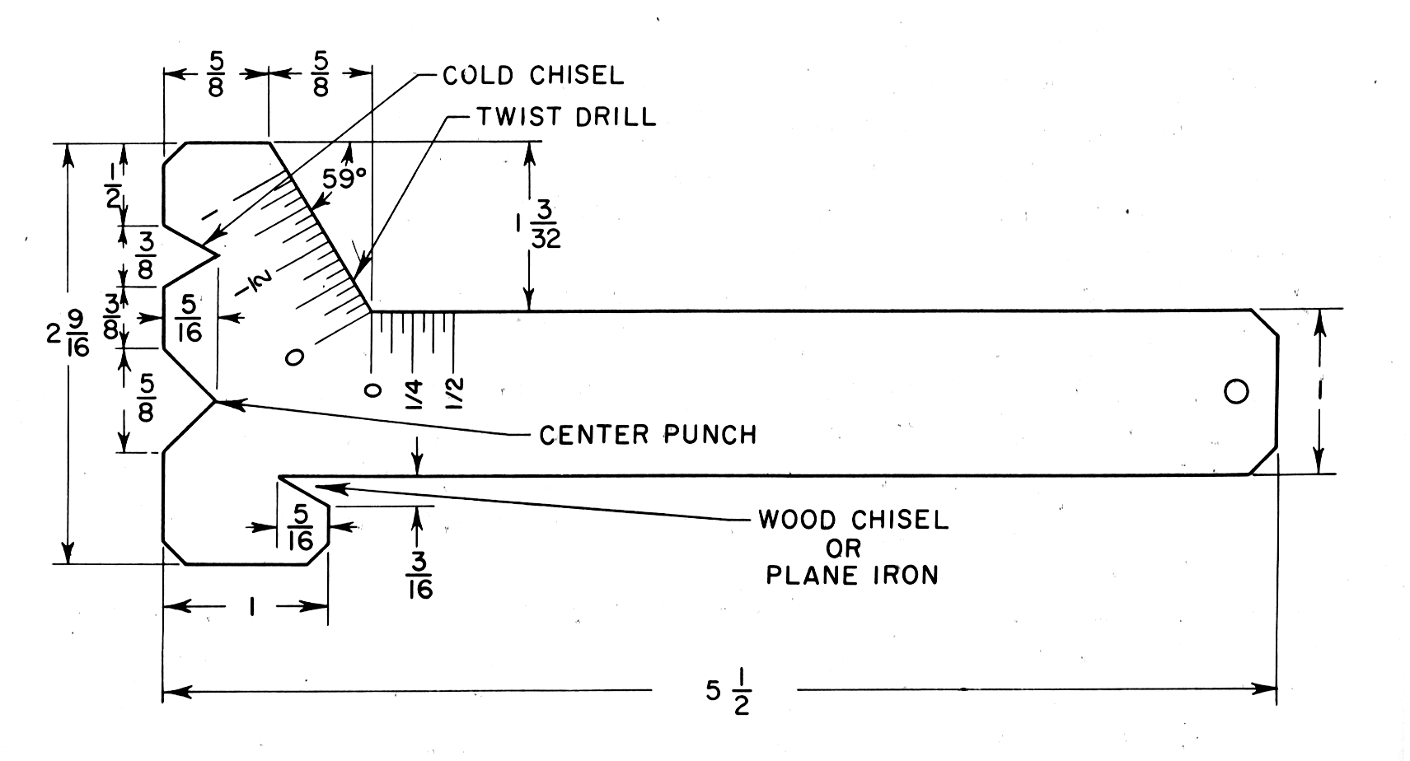
Tool Sharpening Template
Name ________________________
Directions:
- Review the drawing and the grading criteria.
- Use the sheet metal gauge to verify the thickness of the material,
- Use the square to create a square corner on the upper right corner (4" side on top) of the sheet metal. Trim to square if necessary.
- Make all measurements from the right or top edges. Total length is 5 1/2".
- Layout the project using the diagram. Measure carefully.
- Cut out the project using snips.
- Flatten, if needed
- Use the scribe to mark the scale as shown on the template.
- Punch a hole in the bottom of the handle centered about 1/2" from the bottom.
- Using the scribe, write your name on the project and hand in with this CLEAN sheet.
Grading:
Criteria (Tolerance 1/32") | Possible | Score
Length 5 1/2" | 3
Width 2 9/16" | 3
Handle Width 1" | 3
Center punch "V" | 3
Cold Chisel "V" | 3
Plane Iron "V" | 3
Drill bit angle 59º | 3
Cutting (minimum over cut, cuts on line) | 4
Marking Scale | 2
General appearance and workmanship | 3
TOTAL | 30

