Name ______________________
Lab # 3 -- Ropework
Description:
In this exercise the student will learn to work with rope by making a rope halter, splicing the rope, and tying common knots.
Materials:
15' -- 1/2 polypropylene rope
2 -- hog rings
Masking or Electrical tape (to prevent fraying)
Tools:
Sharp utility knife
Propane torch (to melt ends)
Hog ring pliers
Directions:
- Cut rope to length. Wrap the area to be cut with tape before cutting. This will prevent the ends from fraying. Use a propane torch to lightly melt the ends. Caution: Hot molten plastic will burn.
- Use hog rings to prevent the halter end from fraying.
- Tie a halter as described in the attached directions.
- Crown splice one end of the rope (see attached diagram).
- Tie a bowline in the end of the rope with the crown splice.
- Tie a clove hitch (see diagram) in the middle of the rope around the provided stick.
- Label the project with tape and a marking pen.
- Tie a trucker's hitch on the rack in the shop and have the instructor sign your grade sheet.
- Turn in the grade sheet and the project.
Name: ______________________
Grading:
Criteria | Possible | Score
Truckers Hitch Checked by _________ | 4
Clove hitch | 4
Bowline | 4
Halter:
Knots | 6
Crown Splice | 4
Size (spacing between knots) | 4
Workmanship | 4
Total | 30

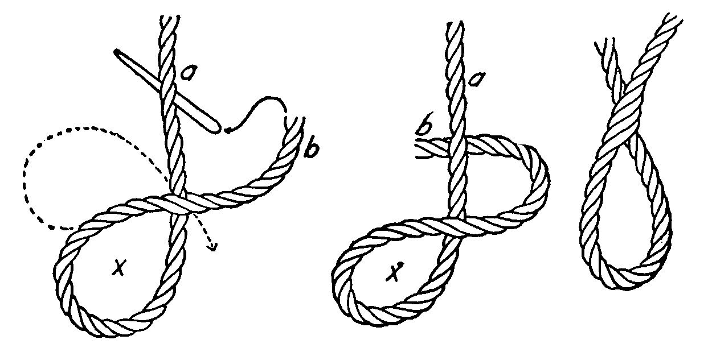
Clove Hitch
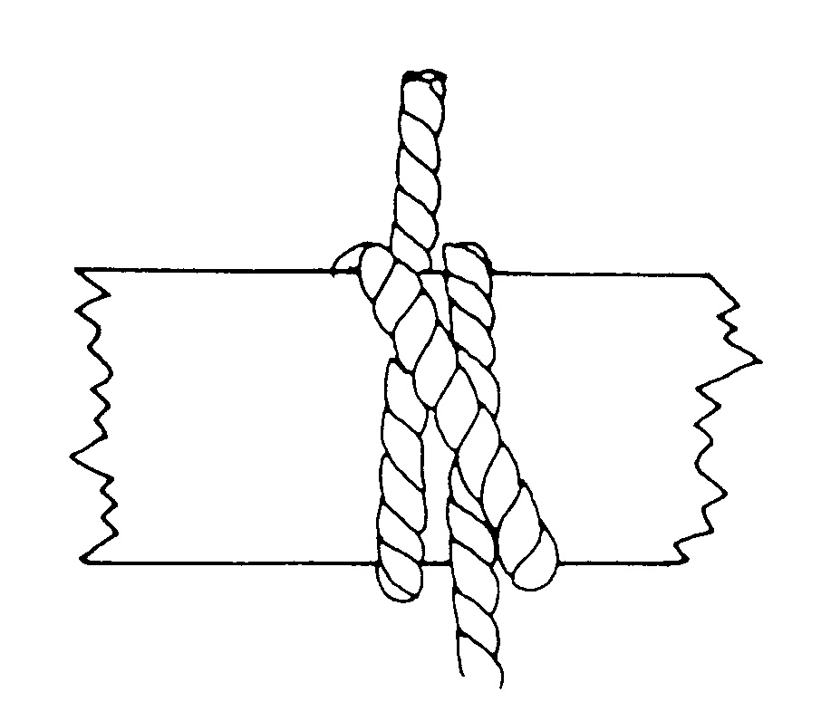
Loop Splice
Rope Halter*
- Use 2 hog rings to keep one end of the rope from fraying. Mark 14” from the hog rings.
- Lay the rope with the short end to your right.
- Make a loop with a 1/2” opening have the 14” mark at the center of the loop. Keep the short end above the long end.
- Pass the long end under 1 strand and over 2 strands of the short end, as close to the loop as possible, pull it tight.(Don’t pull your loop closed). (A) Keep the rope flat on a table. Next pass the short end under 1 strand and over 2 strands of the long end, as close to the last weave you made as possible, pull it tight. Keep the rope flat on a table.(B),(C)
(A) 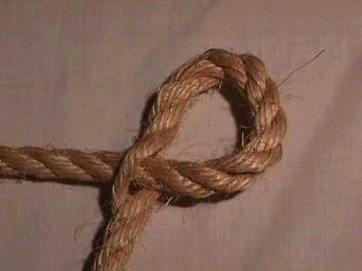 (B) 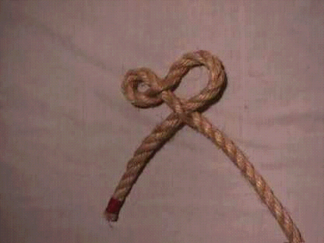
(C) 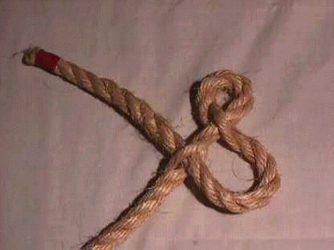
- Measure from the end of the loop back 2" on the short end of the rope and mark it.
- Have the loop on your left and the long end above the short end.
- Keeping the rope flat on a table. Lift the first strand up past the mark. Twist it counter clockwise 1/2 turn.(D)
(D) 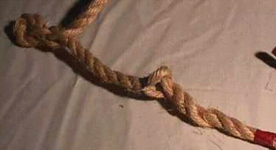
(E) 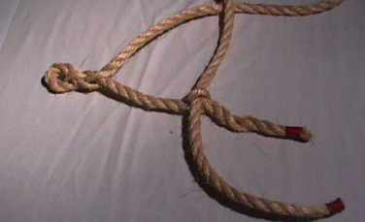
- From above pass the long end down through the loop. (E) Keeping the rope flat on a table. Take the next strand twist it counter clockwise 1/2 turn and put the long end up through the loop. Keep the rope flat on a table. Then twist the next strand counter clockwise 1/2 turn and pass the long end down through the loop. (G),(H) NOTE: The pictures below show the rope end longer than it should be. Ideally the twists should be as close as possible to the hog rings.
(G) 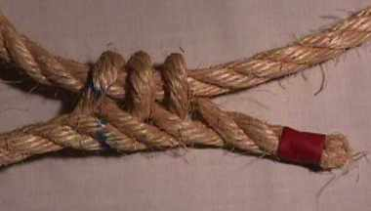 (H)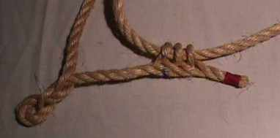
- Put a hog ring as close to the last loop as possible. Then cut off the extra rope. I didn't have any hog rings at the time we took these pictures, so I couldn't show it on the halter.
- Pass the long end through the first loop you made. (I)
(I) 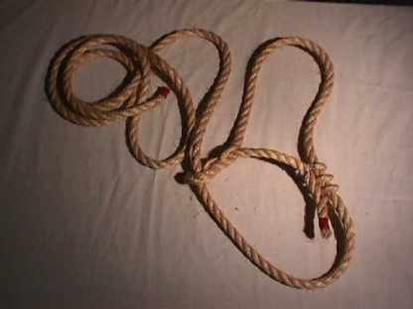
- Complete the halter by making a Crown Splice in the free end.
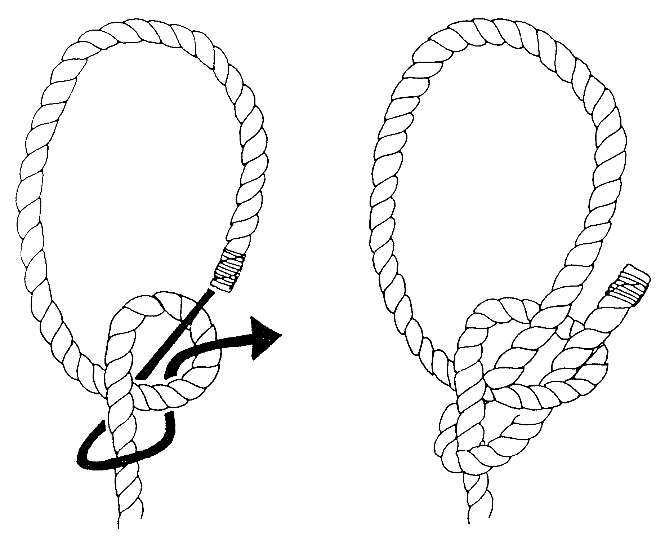
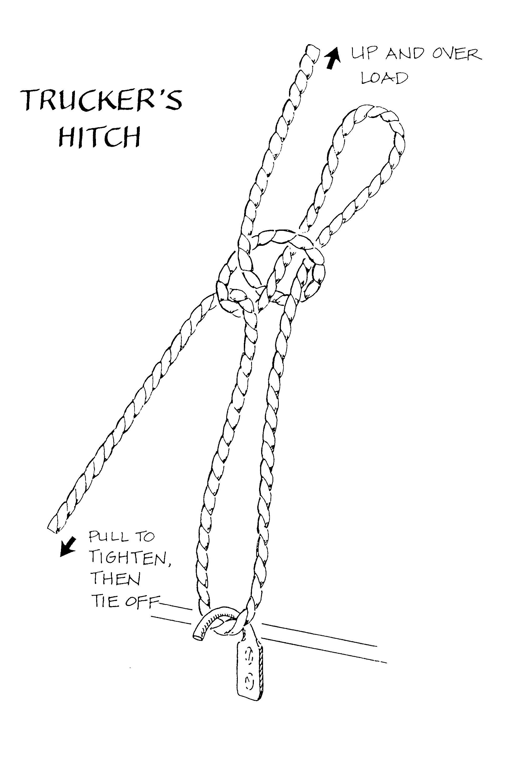
Bowline
Crown Knot
(beginning of Crown Splice)
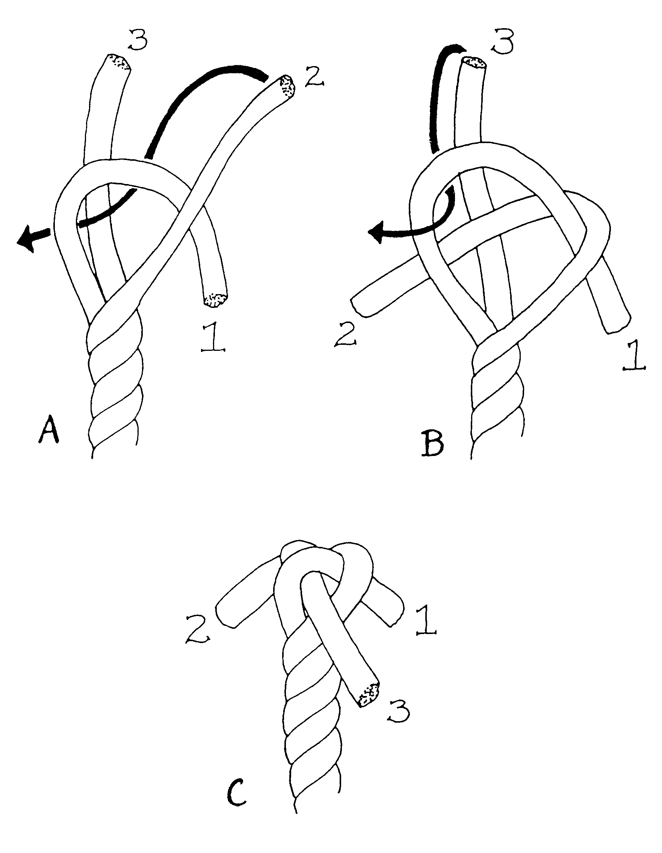
Crown Splice

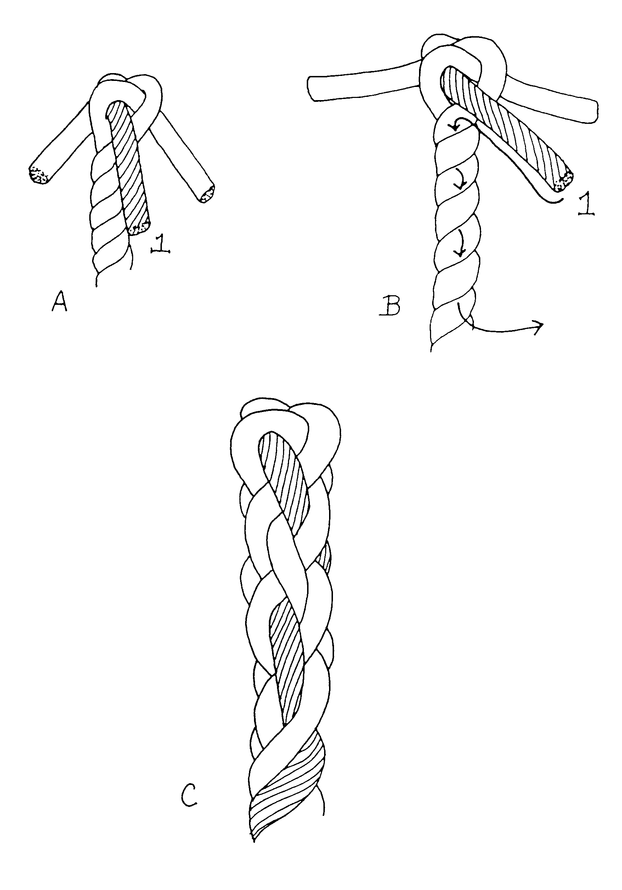
Crown Splice

Modified from http://www.madbbs.com/users/timhull/equipment/halter.htm

