Name ______________________

Soil Sampling (Field Data Collection)
Purpose: To collect samples for analysis using a grid sampling technique. To plot the analysis in the GIS.

Equipment:
Recon GPS Units
HGIS
Farm Field Layer.

Procedure:

- Work in groups and allow each member to participate.
- Load the farm field layer on the Recon.
- Determine which field will be sampled: _______________________
- Determine the size of the sample (acres): ___________
- Create a sampling grid in HGIS.
- Create a new layer (point theme) to collect the actual sample locations.
- Navigate to each sample and collect the sample for analysis as described below. Mark the location on the new layer. Hint: Leave the GPS stationary while you collect the sample and then mark the point. This will improve the accuracy of the location. Mark the sample with the sample location number.
- Download the sample file for later use.

Later after the soil analysis has been done.

- In ArcView, edit the table of the sample file and add fields for all the data in the analysis. Some fields will be numeric and some text (texture).
- Enter the data from the soil samples.
- Choose two numeric variables for analysis
- Create a grid for each variable using the field boundaries and a 5-10 m cell size.
- Make map with one variable classifying the grid values.
- Make a second map using second variable. Generate contours from the grid and overlay on the soils or photo theme.

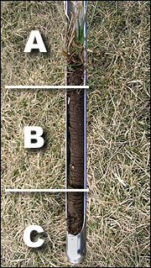
How to take a soil sample
Obtaining a 6- to 12-inch core for soil sampling.
- Discard organic duff on top of soil.
- Put 6 to 12 inch soil core in sampling bucket.
- Discard soil below the 6-12 inch sample.
Coring devices are best for soil sampling. Augers are recommended on rocky soils. Hand samplers at least 3 feet long are desirable because they reduce back strain.
A power drill facilitates sampling in rocky or dry soils. Use a plastic container with a hole in the middle to collect the soil as the auger pulls it out of the ground. Empty the soil out of the plastic container into the soil sample bucket after each successful attempt to get a core.
A well taken soil sample results in appropriate recommended rates of fertilizer and limestone.
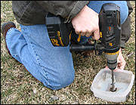
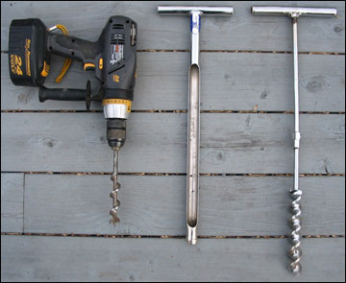
It is best to use a soil coring device because it takes an equal amount of soil from the surface through the sampling depth (6 to 12 inches or tillage depth if deeper) and uniform soil cores at each sampling location. You can use a shovel, however it is not as good as a probe or auger. If you use a shovel, dig a hole to the proper depth, shave a 1-inch slice from the side of the hole and save the vertical, 1-inch wide center portion of this slice.
Collect samples from uniform areas using your field map. Each composite soil sample should represent uniform areas of a field and should consist of 15 to 20 separate cores. For each composite sample, avoid sampling areas with obvious differences of soil color and texture, slope, crop rotation or fertilizer, lime and manure applications. Sample differing areas separately (different composite samples). Mix individual samples (15 to 20 separate cores) to obtain one composite sample in a clean plastic pail (metal pails contaminate the soil with micronutrients) and retain 1 pint in a paper bag. LABEL the sample. A composite sample should not represent more than 20 acres.
Adapted from: http://soilplantlab.missouri.edu/soil/fieldsoil.htm#how

