Name ______________________

Creating Grids from Sample Data
Purpose: To convert data from collected samples for analysis using a GIS Grid

Data:
Sample Points theme
Soil Analysis Data

IMPORTANT: Place all data in a short directory name just below the root drive of your USB drive: Ex. E:\mydata. Spatial Analyst will not work with long directories.

Procedure:

Data preparation:
- Using the sample reports add the data to an Excel spreadsheet.
- Save the spreadsheet as a comma delimited (CSV) file.
- Rename the file so the filename ends in .txt

ArcView Setup
- Open ArcView and add the sample point theme.
- Edit the sample point theme if needed to add the sample ID. Don’t forget to save the edits.
- Add the spatial analysis extension (File| Extensions)
- Add the Fields_major Theme (farm data).
- Set the View properties to UTM (zone 10).
- Load your text data file as a table and join to the attribute table of the sample points.
- Select the sample field then choose Theme | Convert to Shapefile. This will be used to limit your grid.

Spatial Analysis
- Select the sample point theme
- Choose Surface | Interpolate Grid. Use the following settings as a starting point:
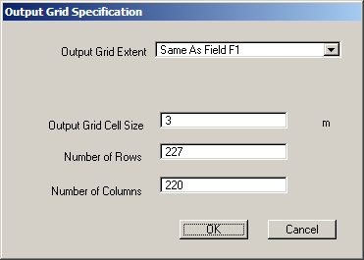
Extent: Choose the theme for the field
Output Size: Start with 3 meters
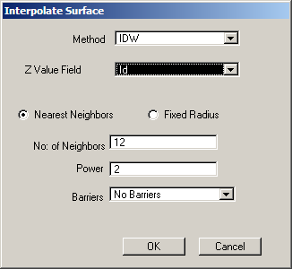
Method: IDW
Z Value: Choose Nitrogen Field
Other values can be as shown above.
Save the grid on your USB Drive.
- Experiment with different grid sizes to see the effects.
- Repeat for Potassium and Phosphorus data using the a grid size of your own choosing.
- You may want to experiment with the classification.
- Create maps for each of the three grids.
- Create a nitrogen contour map by using the Surface | Create Contours option (select the N grid, not the sample points).
- Create a contour map.

For all maps show a title, legend, scale bar, and a text description of the data (ex. date samples, type, etc.)

