Name ______________________

Variable Rate Technology
Variable Rate Technology (VRT) combines GPS and GIS with material application equipment to change rates of application based on a “prescription” map. VRT can be used to apply materials more effectively, reduce materials use, and avoid material application in sensitive areas (buffers).

Purpose: To determine performance of a VRT system and understand the equipment and variables involved in VRT applications.

Equipment:

VRT Sprayer
Recon/GPS
Farm Works Software
Laptop (for data download)
Manuals for Raven & Farm Works (online)

Procedure:

- Construct a block diagram (see sample) with the direction of information flow and what information is exchanged for the following control system components:
  - VRT Controller/Software (note make/model)
  - GPS (note make/model)
  - Spray Controller (note make.model)
  - Flow Meter
  - Control Valve
  - Speed Sensor (note type)

- Determine the programmed boom width? _______________________ ft
- Mark the boundary of each test zone.
- Test the system at 4 MPH and 6 MPH (Ok to use tractor speedometer) using the vrt_test.shp application map. (see attached map). Collect the as applied data.
- Record your observations.

On Your Own
- In ArcMap plot the prescription and the as applied maps (to be posted on Vista). Classify the data for your analysis.
- Lab report is due in lab (do not turn in online).

Questions:
- What is the expected change in sprayer flow (GMP) between 4 and 6 MPH?
_____________________________________________________________
- Compare the as applied data at both speeds to the prescription and answer the following:
  - How well does the sprayer match the prescription?
_____________________________________________________________
_____________________________________________________________
_____________________________________________________________
  - What pattern if any do you see in the as applied rates?
_____________________________________________________________
_____________________________________________________________
_____________________________________________________________
  - Does speed make a difference
_____________________________________________________________
_____________________________________________________________
_____________________________________________________________
  - Does the zone size make a difference?
_____________________________________________________________
_____________________________________________________________
_____________________________________________________________
  - Does the magnitude of the rate change make a difference?
_____________________________________________________________
_____________________________________________________________
_____________________________________________________________

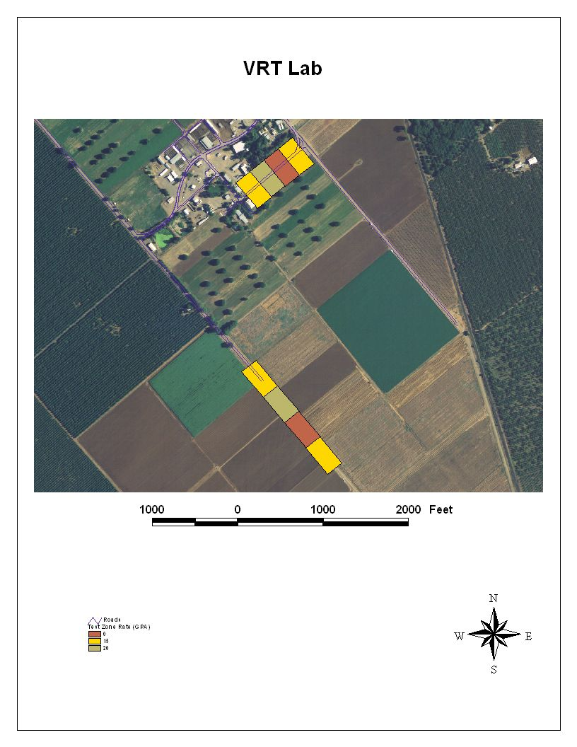
Sample Block Diagram
Spray Controller
Flow Meter
Speed Sensor
Flow Control Valve
Speed
Flow
Valve Position
User Input
Rate, Booms, etc.
Useful Info:
GPM (per nozzle) = GPA X MPH X W ÷ 5940
GPA = Gallons / Acre
W=width in inches, nozzle spacing
GPM (Boom) = GPA X MPH X W ÷ 495
GPA = Gallons / Acre
W=width in feet
Notes:
_____________________________________________________________
_____________________________________________________________
_____________________________________________________________
_____________________________________________________________
_____________________________________________________________
_____________________________________________________________
_____________________________________________________________
_____________________________________________________________
_____________________________________________________________
_____________________________________________________________
_____________________________________________________________

