Introduction
to
Agricultural Mechanics
Lab Manual

Spring 2015

AGET 120
Instructor: Michael Spiess
College of Agriculture

Table of Contents

Lab Policies and Information 2
Safety Presentations 3
Use of the Combination Square for Project Layout 5
Shop Orientation & Safety 7
Ropework & Securing Loads 11
Tool Sharpening Template 15
Land Measurement 17
Electrical 27
Concrete 31
Woodworking – Planter Box 35
Sheet Metal - Tool Box 39
Arc (SMAW) Welding 43
Gas Welding & Cutting 45
Plasma Cutting 47
GMAW Welding 49
Cold and Hot Metal - Triangle Dinner Bell 51
Cold Metal – Hose Hanger 55
Plumbing 61
Rafter 65
Painting 67

Lab Policies and Information
- Safety is the number one concern in the lab. Report all safety problems to the instructor immediately.
- Safety glasses and closed toed shoes will be worn at ALL times in the lab. Without the proper personal protective equipment students will not be allowed to participate.
- Specific safety hazards will be discussed before beginning each lab.
- Most labs will begin with a student led safety presentation. Students must be prepared for their scheduled presentation since no makeup is possible.
- Labs will begin with a demonstration of the project/exercise. Don’t be late.
- Completed student projects must be placed in the designated area with the appropriate grade sheet to be graded. Projects must be marked with the student’s name (use masking tape or write directly on the project).
- READ THE DIRECTIONS BEFORE STARTING! ASK QUESTIONS! The directions include construction tips, safety tips, as well as the order of the project construction.
- Students will be tested on the proper names of the tools. Use your lab sheet to learn the names and identify the tools (listed on each lab sheet).
- Lab materials are ordered for the number of students. DO NOT ASSUME that additional materials are available if you ruin yours. Remember the old saying “Measure Twice, Cut Once”. ASK before using additional materials.
- Lab points and grading criteria are listed on each lab sheet. It is recommended that you review the criteria before starting and again before turning in the lab assignment.
- Lab assignments that are projects are due by the last lab (e.g. plumbing). Written assignments are due at the following lab (e.g. Land Measurement).
- To be graded lab assignments MUST be turned in with a grading sheet.
- Students may work in the lab other times by arrangement. However, for safety reasons, at least two students must be in the lab and an instructor must be in the building. If materials are needed for a lab exercise, make prior arrangements since materials are often not readily available after the scheduled lab date.
- Students are expected to help clean up the shop before leaving the lab.
- Students are responsible for bringing their lab assignments (this manual) to lab.
- DO NOT leave lab sheets lose in the lab. Always return sheets to your binder and place graded sheets in your binder.
- Continued safety violations are grounds from removal from the course.

Identification of Tools and Materials
Lab exercises list tools and materials used for the lab. Students are expected to learn the proper names of these tools and how to describe the materials. Note: This is a good study guide for lecture tests.

Safety Presentations

Name ________________________
Assignment:
(25 points)
The purpose of this assignment is to familiarize students with safe practices and involve them in the safety training process.
- Students are to prepare and deliver a brief (2-3 min) safety presentation in Lab on the assigned topic (tool) (see signup sheet). Be concise. Include this sheet with your outline. Due with your talk.
- Students must be familiar with the tool to effectively present the topic. You should be able to point out hazards naming parts of the tool correctly.
- Presentations should cover the safety items (hazards) associated with the topic.
- Typically this will include demonstration of safe practices including identification of hazards and prevention of injury.
- Material can be drawn from the text and materials available from the instructor (see course web site).
- At the beginning of the presentation a typed paper outlining the hazards (typically a list or bullets) is due attached to this sheet.
- No makeup is possible since the presentation is scheduled with a specific lab.
- The assignment will be graded as follows:
 | Acceptable |  | UNACCEPTABLE | Score
Students will effectively evaluate content for oral presentations. Content is appropriate for topic. | 5 |  | 1
Students will effectively organize content used in oral presentations. Content is delivered in an organized fashion. | 5 |  | 1
Students will effectively deliver oral presentations. Presentation is clear and easily understood. Good use of terms and visual aids (the tools). | 10 |  | 2
Topic Outline included with grade sheet | 5 |  | 1
TOTAL | 25

Safety Presentation Topics
See syllabus for scheduled dates. Mark your topic!

Topic | Date
Portable Drills (including battery powered)
Electrical Safety
Hydraulic Shear
Chop Saw
Drill Press
Stationary (bench) Grinders
Spot Welder
Power Miter Saw
Band Saw
Sheet Metal Brake
Foot Shear
Oxy-Acetylene (Equipment, PPE)
Arc Welding (PPE, Hazards, Equipment)
Plasma Cutter(PPE, Hazards)
Painting (Materials, MSDS)
Sanders(in general and Palm)
Table Saw
Concrete Materials & Mixer
Plumbing Materials (MSDS), tools, propane torch
Pipe Threading Machine
Circular Saw
Jointer/Surface Planer (if needed)
Saber Saw (if needed)

Use of the Combination Square for Project Layout
In 1877, Laroy S. Starrett designed and patented the combination square. His invention was a multipurpose layout and measuring tool for machinists and it was rapidly adopted in the trade. This tool is still in common use today and used in the layout of wood and metal projects.
The basic combination square includes a hardened steel graduated rule and movable combination square and miter head with a spirit level and scribe. The square heads have a precision ground 90° square face and a 45° miter face. It is a versatile and useful layout tool for scribing right angles and parallel lines, and a measuring tool that can be used as a try square, miter, depth gage, height gage, and a level. Common rules have 1/8”, 1/16”, and 1/32” scales. Also available are metric scales.
The process of layout is essentially a matter of copying the plan to the material. The square can be used to easily and accurately determine “construction” points on your material. For best results you must start with material that is cut square so you can measure from the square edges.
1.

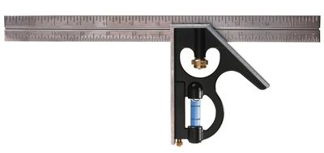
Square parts:
- The “rule” or blade. This can be removed and used separately.
3.
- The head, fence, or level. This part slides on the rule.
- The clamp is the nut, spring, and bolt that slides in to the grove of the rule.
2.
4.
- The scribe is found in the head and used to mark metal.

Testing the Square:
To insure the square is actually square do the following:
- Set the square with 10” of the rule extending past the head and tighten the clamp.
- Using scrap of sheet metal with a straight edge (a 12” x 12” piece is fine) Scribe a line perpendicular to the straight edge of the metal.
- Now rotate the head on the metal 180 degrees and check that the square is aligned with the scribed line. If not the square is not “square” (or the sheet metal is not square).

Basic Setup of the Square:
- Set the rule so the scale you wish to use is on the inside of the square.
- Slide the rule so an even inch mark is aligned with the head (level).
- Clamp the rule tight.

Marking:
Marks made during layout should be clean and as accurate as possible. Some tips:
- Use a scribe to mark metal. A marker makes a broad line and will be less accurate.
- Don’t make multiple marks. A single clear mark is desired.
- Mark wood with a sharp pencil or a utility knife.

The “Working Edge”:
A working edge is usually the bottom edge of the layout project in relation to the material as it is laid in front of you. It should be a suitable edge from which the majority of your measurements can be made. It is also helpful if this edge is square with the left or right edge.
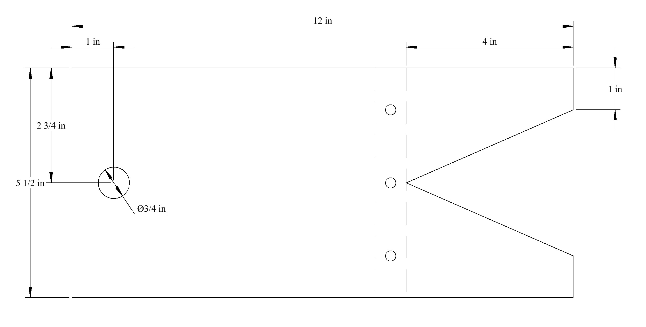

Locating a Center Point:
Refer to the drawing above. The steps below describe how to mark the center of the left hand hole.
- Select one edge as a “working edge”.
- After setting the square (as described above) place the head against the straight (lower) edge of the material in the approximate location of the hole.
- Measure up the rule the desired distance and make a mark (horizontally). In this case 2 ¾”.
- Now place the head against the other edge of the material (left edge, 90º to the first edge) and align the rule with your mark. It’s important that these two edges be perpendicular.
- Now measure over on the rule to the second dimension (1”) of the point and mark the center.
Hint: It is faster to count the marks on the rule than to calculate a distance. For example if the 10” mark on the rule is aligned with the head and you want to measure in 4 ¼” you could calculate the measurement at 5 ¾” or simply count in 4 inch marks plus ¼”.

Locating Construction Points:
Commonly you will want to locate points (end) of a cut that is not square. This process is simply a matter of locating two points then connecting them using the rule. The directions below refer to layout of the “V” shape in the above drawing.
- After setting the square (as described above) place the head against the straight (lower) edge of the material in the approximate location of Point 1. (the center of the “V”)
- Measure up the rule the desired distance and make a horizontal mark (in this case 2 ¾” from the lower edge).
- Now place the head against the other edge of the material (right, 90º to the first edge) and align the rule with your vertical mark.
- Now measure over on the rule the second dimension of Point 1 and mark the location (4”).
- Repeat the process for Point 2 (upper point of the “V”) and Point 3 (lower point of the “V”). Note: Since Points 2 and 3 are on the edge of the project there is no need to measure in from the edge.
- Now using just the rule draw or scribe a line that connects Points 1 and 2, then connect Points 1 and 3.

Shop Orientation & Safety
(30 points)

Objectives:
- Review Lab Policies
- Become familiar with the layout of the shop and the safety equipment located in the shop.
- Practice measuring with different tools and with different levels of precision.
- Practice reading project plans.

Review of Lab Policies

Shop Tour:
Layout of Shop II.
Location of Exits
Fire Extinguishers
Electrical Panels and other control panels
Location of First Aid Kits.
Location of Phones. (In Case of Emergency Dial 9-9-1-1)
Where projects are stored and turned in.
How labs are graded.

General Shop Safety
Eye protection
Safety is a "culture"
Continued safety violations are grounds for removal from the course
Lab dress review
Review Lab Policies

Tools:
Steel Tape
Combination Square
Framing Square
Outside Calipers

Assignment:
Working by yourself, use the provided tools to measure the objects listed on the grade sheet. Reduce fractions (ex. 4/16” = ½”). List the names of the measuring tools used for each station below.
A. _____________________________________________________________________
B. _____________________________________________________________________
C. _____________________________________________________________________
D. _____________________________________________________________________
E. _____________________________________________________________________
Using the attached plan determine the measurements listed on the grade sheet.
This lab is due in the next scheduled lab.

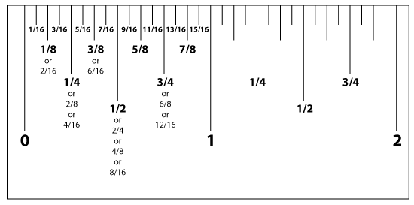
Shop Orientation Grade Sheet
Name: __________________________
Complete and turn in for lab credit.
Description | Possible Points | Score
Measurements:  - 2x4 length to nearest 1/8" Thickness x Width x Length  ____________ x ____________ x ____________  - Metal length to nearest 1/16" _______________  - Machined part diameter to nearest 1/32" ________________  - Plywood dimensions to nearest 1/16" Thickness x Width x Length _________X __________ X __________  E) Sheet metal dimensions to nearest 1/16" _________X_________ | 10
Plan Reading:  A) Project length (longest dimension: __________  B) Project width (across the end): ____________  C) Thickness of the side and end material (shortest dimension): ______ | 6
TOTAL | 16

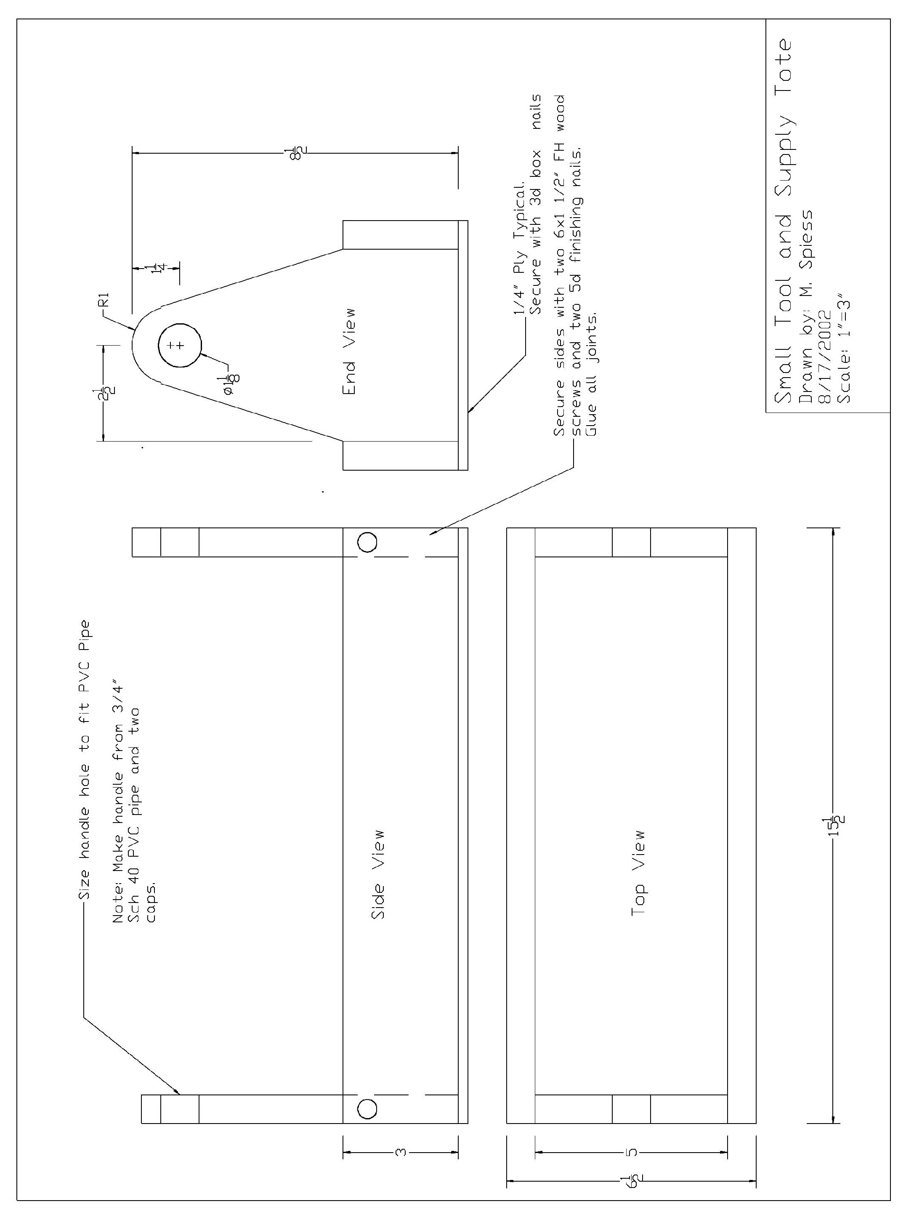

Ropework & Securing Loads
Name ______________________

Description:
In this exercise the student will learn to work with rope by tying common knots. Students will demonstrate securing loads with common binders and rope.

Materials:
12’ – 3/8” polypropylene rope or pre-cut pieces
6”x ½” dowel or PVC pipe
Masking or Electrical tape (to prevent fraying)

Tools:
Sharp utility knife or cable cutters
Propane torch (to melt ends)
Steel tape
Lashing Straps & Chain binders

Directions:
- Cut rope into two 4 foot pieces if needed. Wrap the area to be cut with tape before cutting. This will prevent the ends from fraying. Use a propane torch to lightly melt the ends. Caution: Hot molten plastic will burn.
- Tie a bowline in the end of one rope. REMEMBER: This knot forms a loop.
- Tie the first rope to another rope with a square knot.
- Tie a figure 8 knot in the free end of the rope.
- Tie a clove hitch between the square knot and the figure 8 around the dowel/pipe.
- Pull all the knots tight and inspect to see that they are tied correctly.
- Label the project with tape and a marking pen.
- Tie a trucker's hitch and have the instructor sign your grade sheet.
- Secure the load with the chain binder and have the instructor sign your grade sheet.
- Secure the load with the webbing binder and have the instructor sign your grade sheet.
- Turn in the grade sheet and the project.

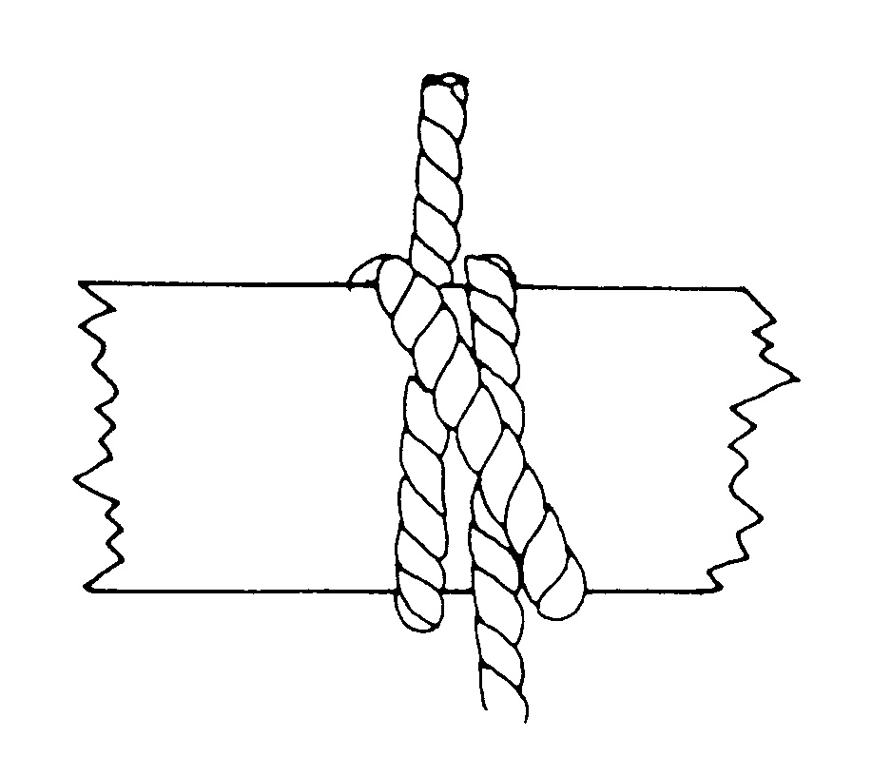
Clove Hitch
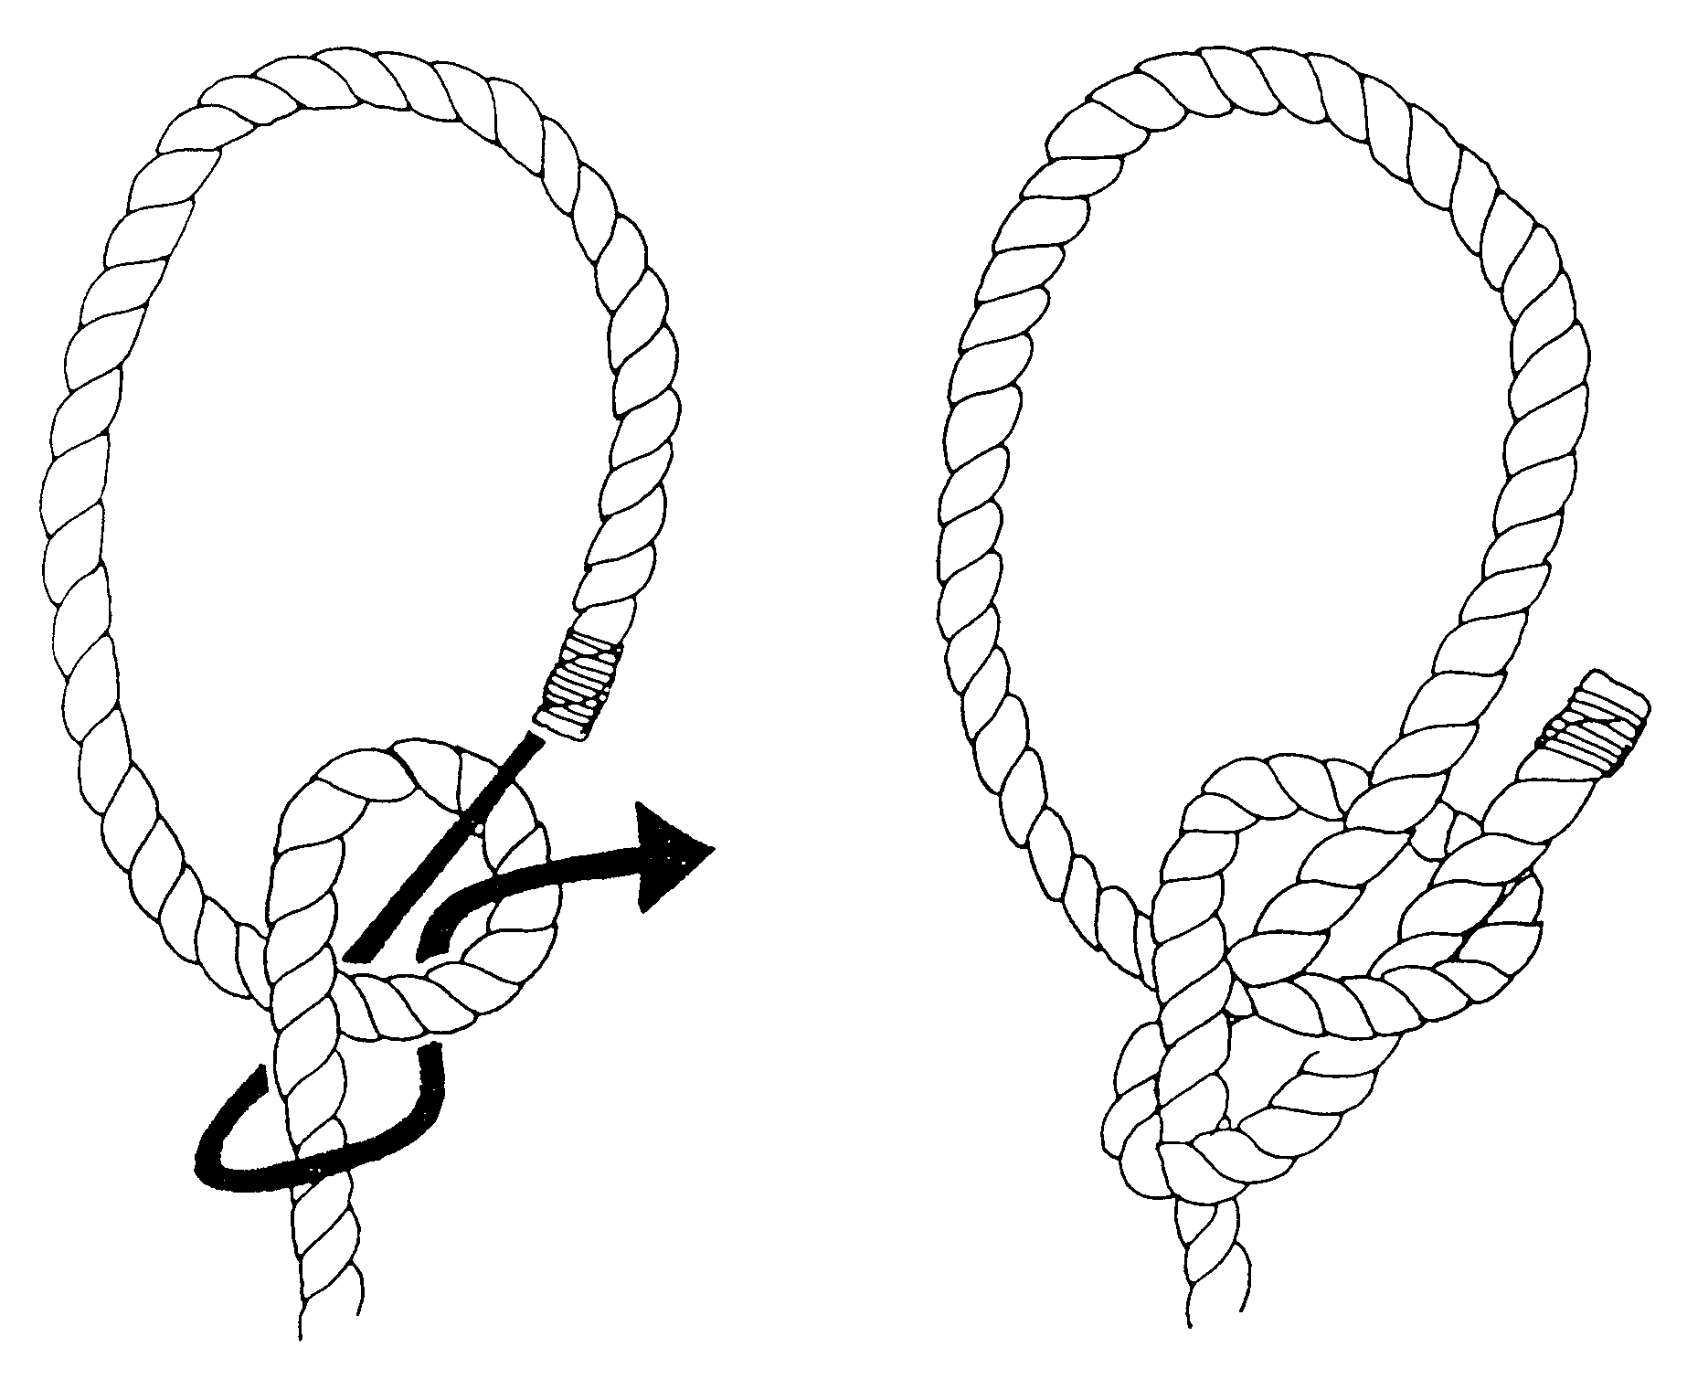
Bowline

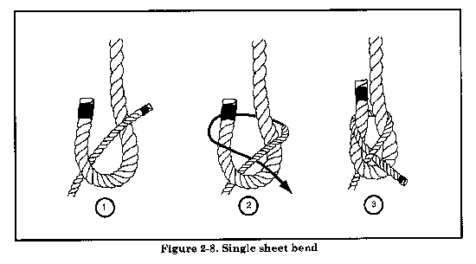
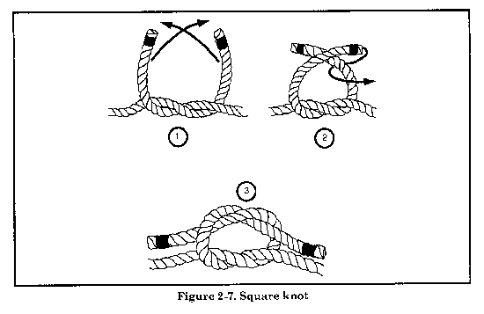
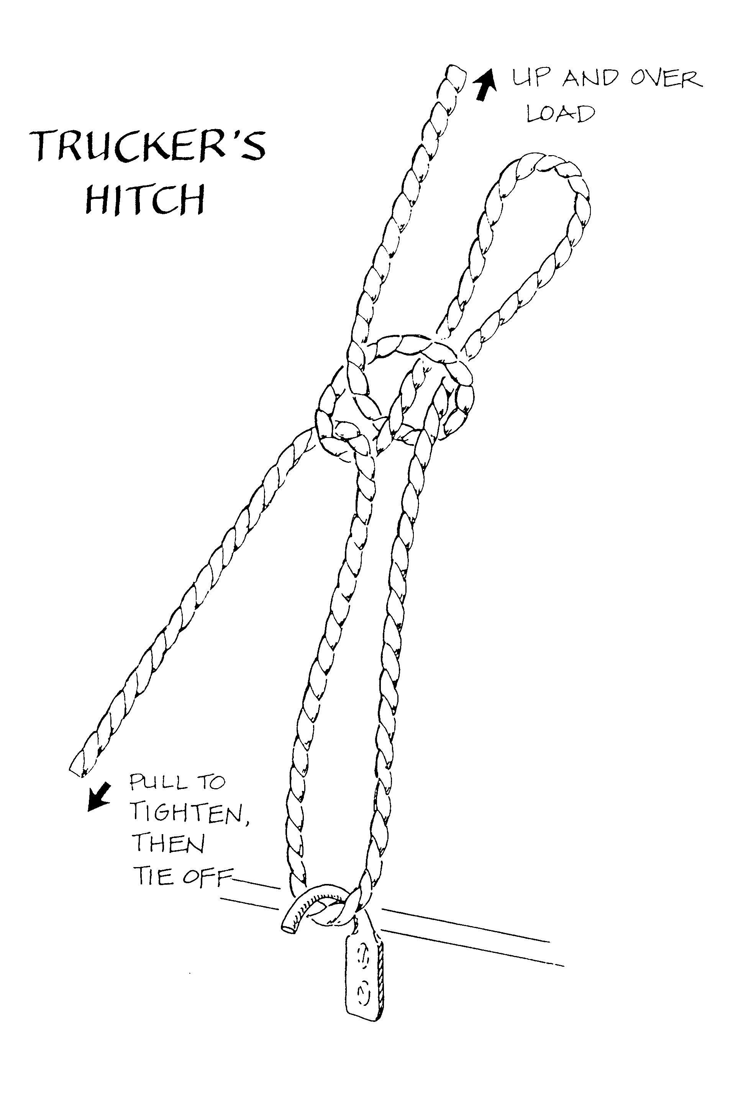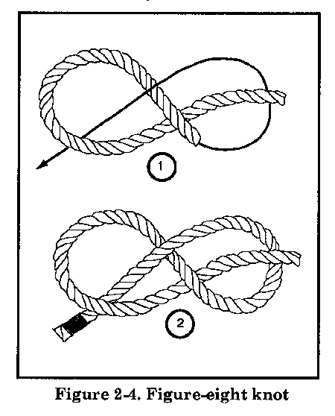

Name:____________________________

Rope & Binder Grading:

Criteria | Possible | Score
Chain binder Checked by _________ | 4
Lashing Straps Checked by _________ | 4
Truckers Hitch Checked by _________ | 4
Clove hitch | 2
Bowline | 2
Square knot | 2
Figure 8 | 2
Total | 20

Tool Sharpening Template
Name ______________________

Description:
The tool sharpening template demonstrates skill in project layout. In addition, the template is a useful tool and will be used for the tool sharpening lab.

Materials:
22-26 ga. Galvanized sheet metal,
approximately 4" x 7"

Tools:
Combination Square
Scribe
Snips (Straight, Duckbill)
Metal punch
Sheet metal gauge.
Foot shear
Scratch Awl

Directions:
- Review the use of the combination square (in this book).
- Review the drawing and the grading criteria.
- Use the sheet metal gauge to verify the thickness of the material,
- Use the square to create a square corner on the upper right corner (4" side on top) of the sheet metal. Trim to square if necessary.
- Make all measurements from the right or top edges.
- Layout the project using the diagram. Measure carefully.
- Cut out the project using snips.
- Flatten, if needed
- Use the scribe to mark the scale as shown on the template.
- Optional: Punch a hole in the bottom of the handle centered about 1/2" from the bottom.
- Using the scribe, write your name on the project and hand in with this CLEAN sheet.

Grading:
Criteria (Tolerance 1/32") | Possible | Score
Length 6" | 3
Width 2 9/16" | 3
Handle Width 1" | 3
Center punch "V" | 3
Cold Chisel "V" | 3
Plane Iron "V" | 3
Drill bit angle 59º | 3
Cutting (minimum over cut, cuts on line) | 4
Marking Scale | 2
General appearance and workmanship  (flat, no sharp edges, no excess markings) | 3
TOTAL | 30

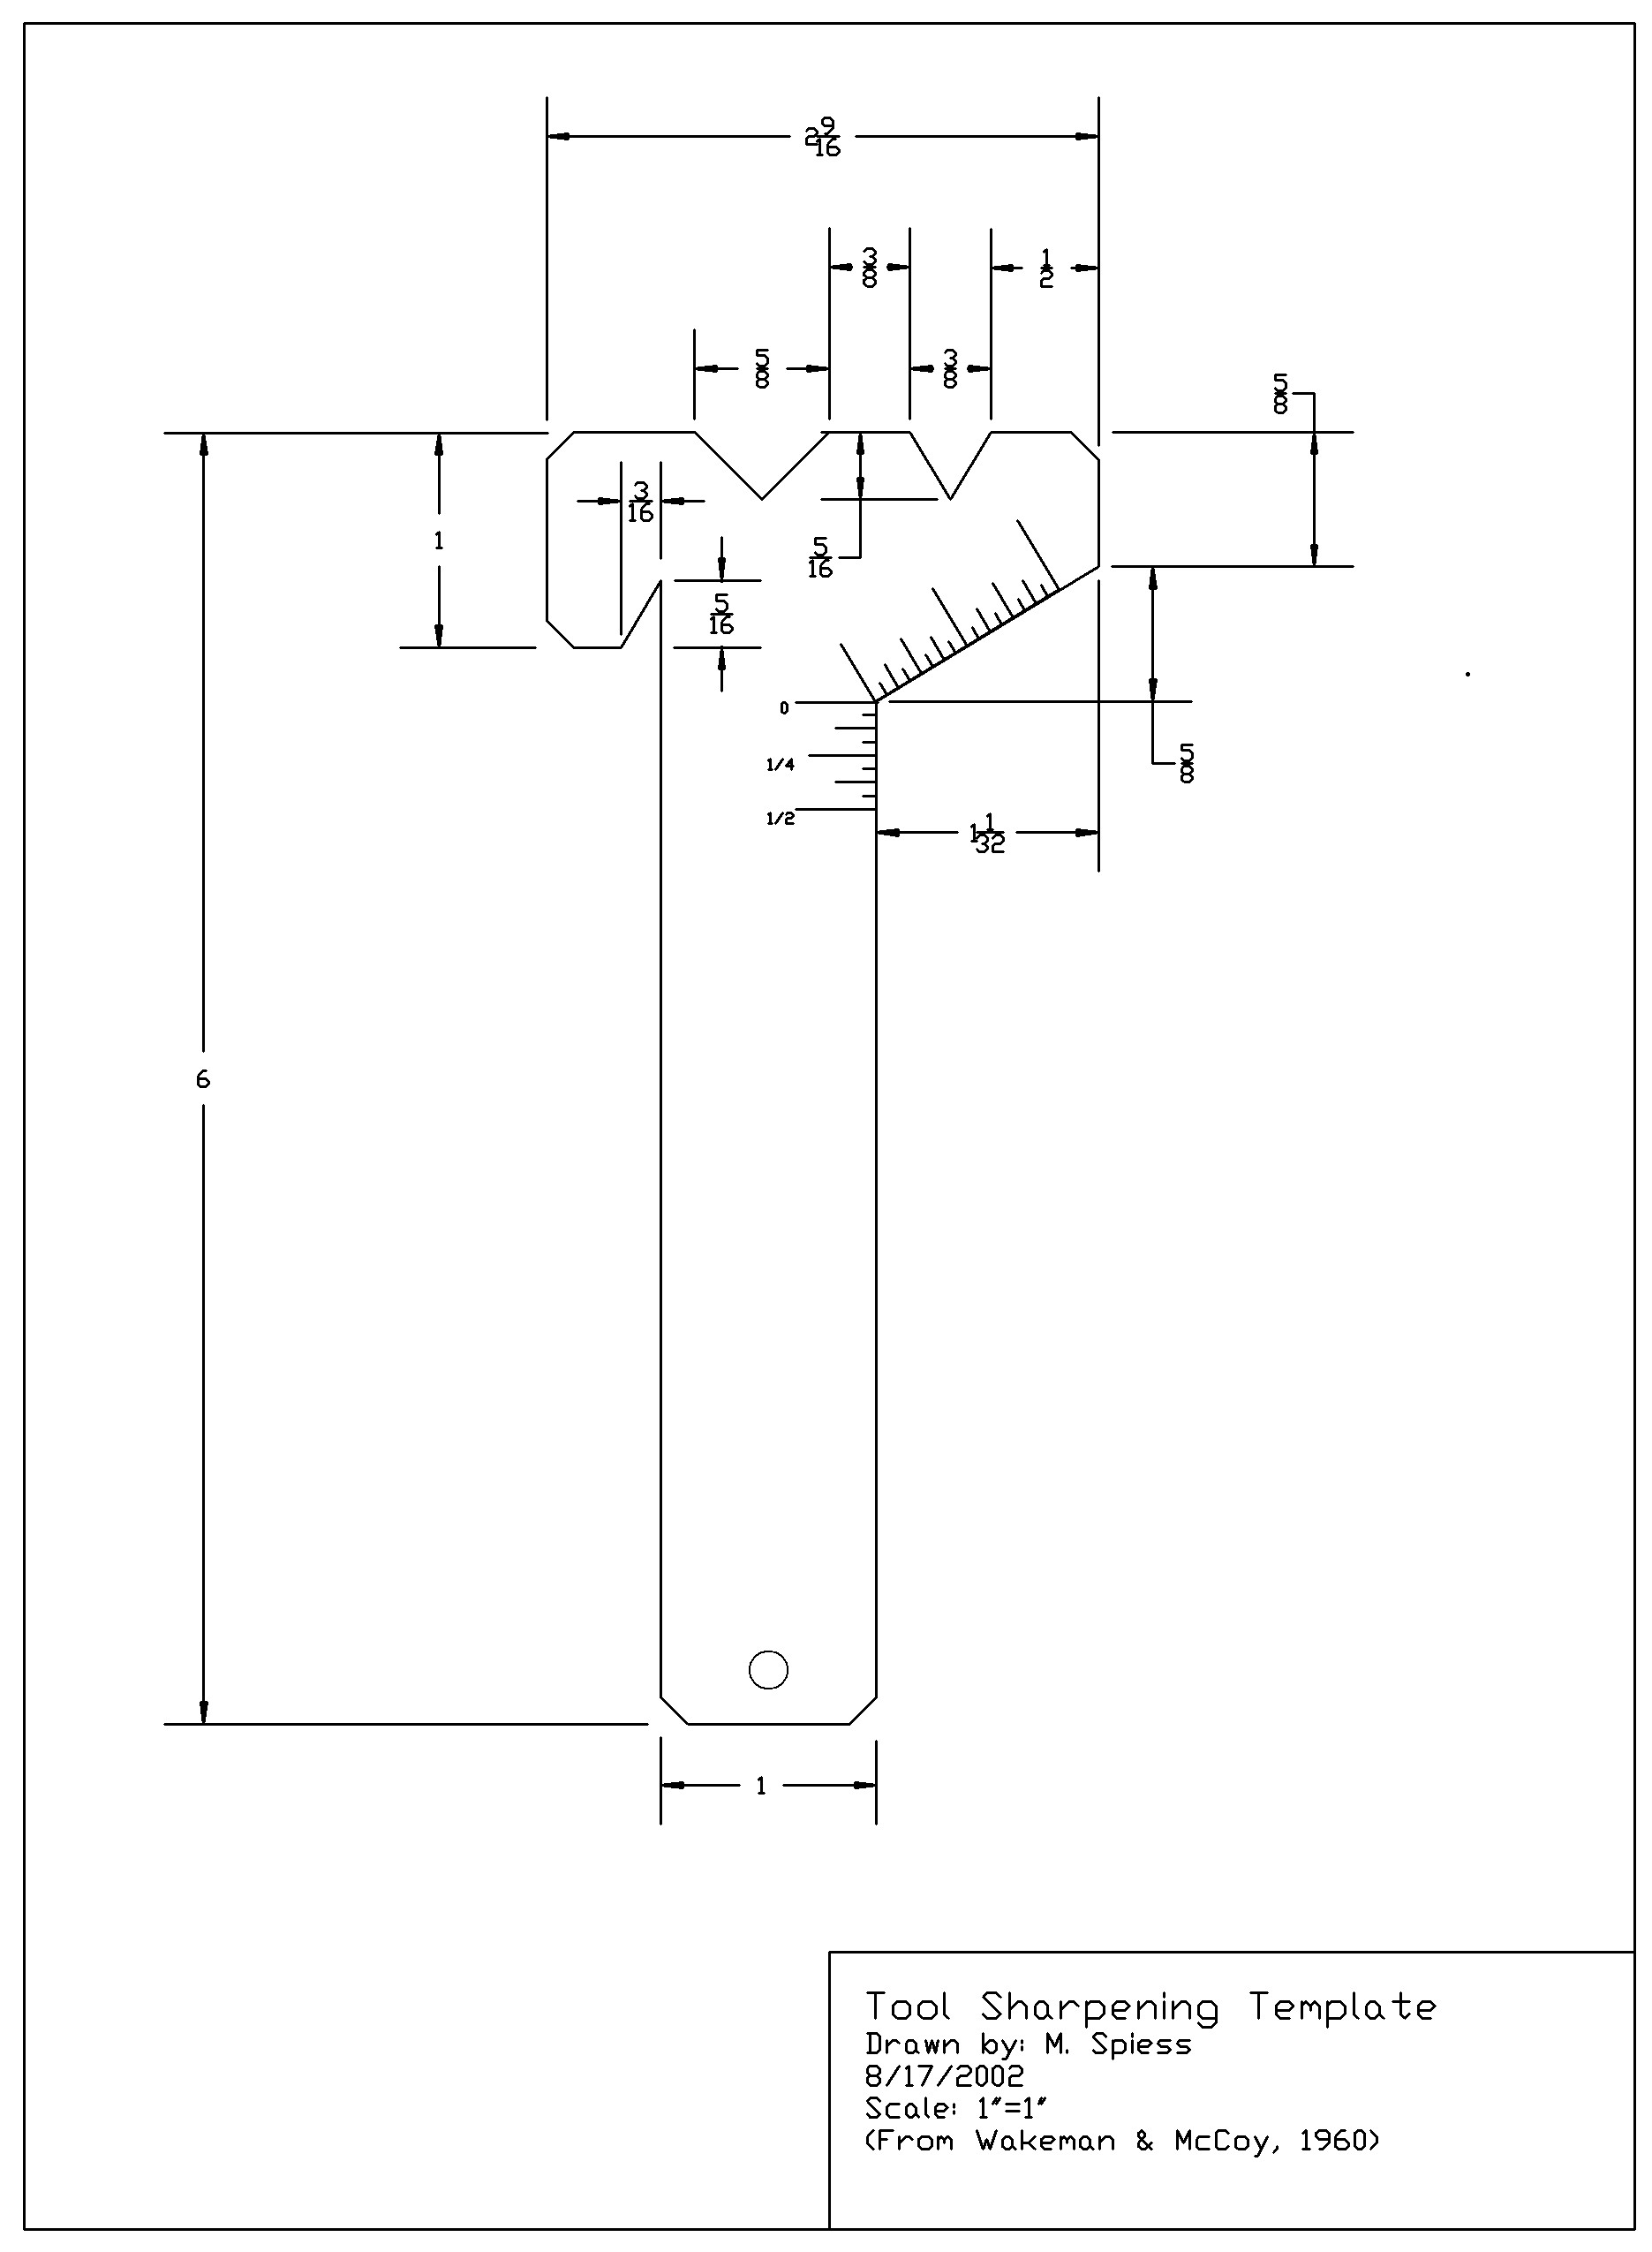

Land Measurement
Name ______________________

Description:
Land measurement is a useful skill in agriculture used for construction, farming, and grading. In this lab you will use a level to measure elevations, a tape to measure distance, and a GPS to measure location.

Materials:
Graph paper (10 sq/inch)

Tools:
Auto Level and Philadelphia Rod
Laser Level & Direct Elevation Rod
Tape
GPS
Surveyor's arrows (pins)

Directions:
Divide into 4 equal groups.
Part 1 – Measuring Elevation Profiles using an Auto Level (15 points)
Profiles are used to determine slopes for irrigation, drainage, and building layout. In this exercise you will measure elevations using a level then graph the profile.
- Layout the profile course as a team. Rotate the using the rod during your elevation measurements.
- Setup up the laser level mid-way between the ends of the profile
- Using the tape, locate, mark, and measure 20-25 points between the ends of the profile. Record these distances in the table below.
- Place the rod on the benchmark (BM) and record your reading. Calculate the the Height of Instrurment (HI) and record on the data sheet..
- Measure the Foresights (FS) of each of the remaining points and enter on your data sheet. Calculate the elevation of each point.
- Individually, use graph paper plot the elevations. Horizontal scale will be about 1”=20’, vertical scale should be about 2”=1’. Label the points and the graph. (See example).
- Label the high point(s).
- Turn in your data sheet and graph.

Part 2 – Measuring Elevation Profiles using a Laser Level (15 points)
In this exercise you will measure elevations using a laser level then graph the profile.
- Layout the profile course as a team (same course as the auto level). Rotate the using the rod during your elevation measurements.
- Setup up the laser level mid-way between the ends of the profile
- Using the tape, locate, mark, and measure 20-25 points between the ends of the profile. Record these distances in the table below.
- Place the rod on the starting point and adjust the elevation to an even foot (ex. 5’). Record this elevation on your data sheet.
- Measure the elevations of each of the remaining points and enter on your data sheet.
- Individually, use graph paper plot the elevations. Horizontal scale will be about 1”=20’, vertical scale should be about 2”=1’. Label the points and the graph. (See example).
- Label the high point(s).
- Turn in your data sheet and graph.
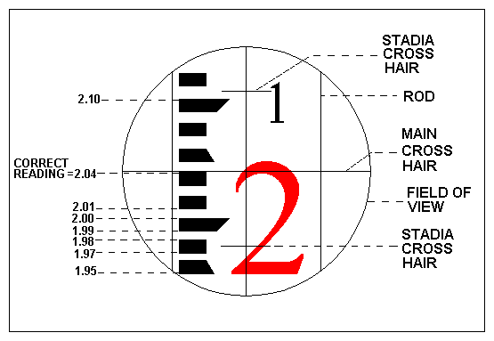
Reading the rod. Note that the scale on the direct elevation rods reads backwards to the Philadelphia rod (above)

Part 1 -- Auto Level Profile Leveling Data Sheet

Station Number | Distance (ft) | B.S. | H.I. | F.S. | Elevation (ft) | Comments
 |  |  |  |  | 10.00

Part 2 -- Laser Level Profile Leveling Data Sheet

Station Number | Distance (ft) | Elevation (ft) | Comments / Location
 |  |  | Starting Point

Name ________________________
Part 3 – Introduction to GPS (15 points)
Global Positioning Systems (GPS) are becoming common in agriculture for field mapping and precision agriculture applications. This exercise uses WAAS corrected GPS units so accuracy is limited, but demonstrates the utility of GPS and how it works.
- Take turns using the GPS unit if you don’t have one for each person. Turn on the GPS Unit. For this exercise the GPS units must be set to decimal degrees (dd.dddd).
- In the field, complete part “A” of the data sheet
- Following the instructor instructions, collect location information for each point and record the Northing and Easting in the data table Part “B”.
- Complete Part “C” before leaving the field.
- Turn off your GPS.
- Using Google Maps (http://www.google.com/maps) create a map of your data.
- Complete the questions in Part “D”
- Attach the map to the lab.
Part A – Before starting.
How many satellites are being tracked (dark)? ____________________
List the satellites by number. |____|____|____|____|____|____|____|____|____|____|____|____|
What is the reported accuracy? ____________________

Part B – Collecting GPS Data
Record your data points (decimal degrees) in the table below.
Latitude #1 | Longitude #1 | Latitude #2 | Longitude #2 | Description
Part C – After collecting data.
How many satellites are being tracked (dark)? ____________________
List satellites by number. |____|____|____|____|____|____|____|____|____|____|____|____|
What is the reported accuracy? ____________________

Part D – Questions.
- How did the accuracy change during your measurements?
____________________________________________________________________________________
Why did the accuracy change?
____________________________________________________________________________________

How did you points change between the two collection passes and why?
____________________________________________________________________________________

Part 4 – Determine your pace length (10 points)
Pacing is a useful way to estimate a distance in the field without the need for measuring equipment. In this exercise you will determine your pace distance then determine a distance by pacing.
- Layout a 100' course.
- Walk the course 4 times recording the number of paces on the data sheet. NOTE: a pace is two steps. Walk with a normal stride. For example:
20 + 21 + 20 + 20 = 81 (Total paces)
- On the data sheet divide total paces by 400' to determine average pace. For example
Total paces 400' ÷ 81 = 4.9 feet/pace
- Determine the unknown distance by pacing. Record on the data sheet. For example:
34 paces X 4.9 feet/pace = 167 feet

Determine your pace:
__________ + __________ + __________ + __________ = ___________ (Total paces)

400' ÷ Total paces _________= _____________feet/pace

Determine the unknown distance:

Paces _________ X _____ ft/pace = _____________ Feet

Using Google Maps
- Open the Google Map Site at: http://www.google.com/maps
- Login using your campus gmail account.
- Select the MyMaps Link. Then choose Create Map, Click on the title and title your map. Under base map choose the satellite view.
- If your data is in Degree Minutes or Degrees Minutes Seconds then you will need to convert. See the web site:
http://www.earthpoint.us/Conconvert you reading to the correct vert.aspx
Degrees Lat Long  (the desired format) | 39.6851833,  -121.6518500
Degrees Minutes | 39°41.11100',-121°39.11100'
Degrees Minutes Seconds | 39°41'06.6600",  -121°39'06.6600"
UTM | 10S  615606 E  4393685 N
See more info on this tool at the end of the document.
- Enter the latitude and longitude of each point in the search box. For example: 40.245, -121.234
- When Google finds the point, left click on the point then choose Add to Map. The point should now be listed in the list on the left.
- Repeat until all points have been entered.
- When you have entered all the points, click on the title and save the map.
You may use Alt-PrtScn to capture the screen and paste into a Word Document or use the View in Google Earth link to view your points in Google Earth (available in the campus labs or download for free at: http://Earth.Google.com/ )

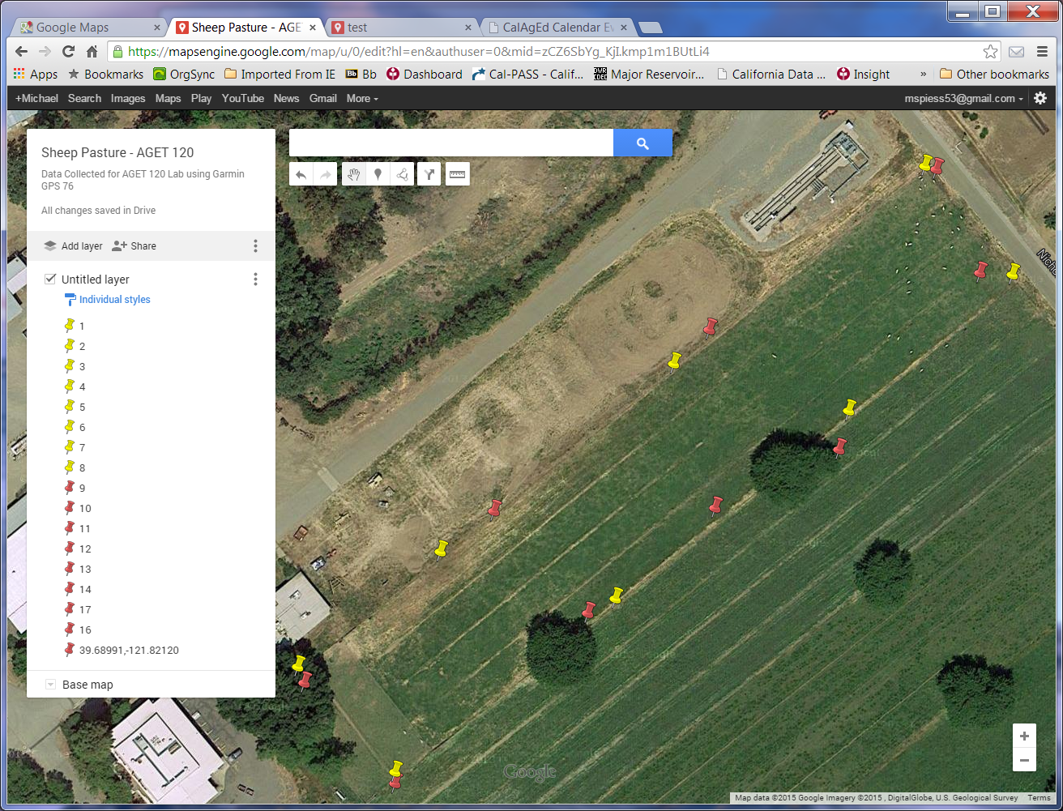
Entry of the data points on Google Maps. Your map should look similar.

Quick Guide to GPS Map 76

- Press the Light Bulb button to turn on the GPS. (Press and hold to turn off)
- Use the Page button to change the display between the various pages.
- The Satellite page displays the current status of the GPS. 3D should be displayed (see screen below)
- The Navigation page displays the distance and bearing to the next waypoint (see screen below). Always point the GPS in the direction of travel to get an accurate indication of the direction to the waypoint. NOTE: You need to be moving for the GPS to determine your direction of travel.
- Press Nav button to load a waypoint. Use the cursor (big round button) to select GoTo Point then press Enter, Press Enter to select Waypoints, use the cursor to select the desired waypoint, then press Enter. Press Enter again to "goto" the waypoint.

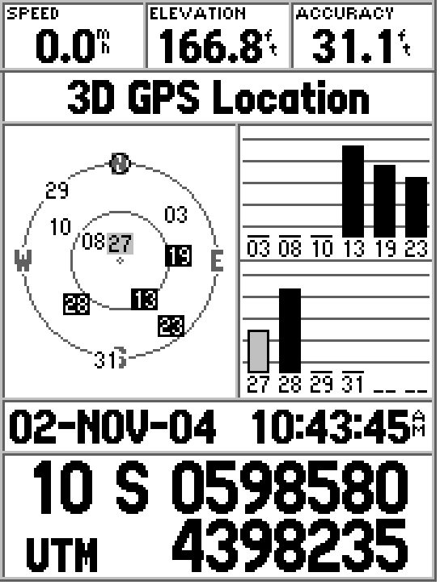  Satellite Page | 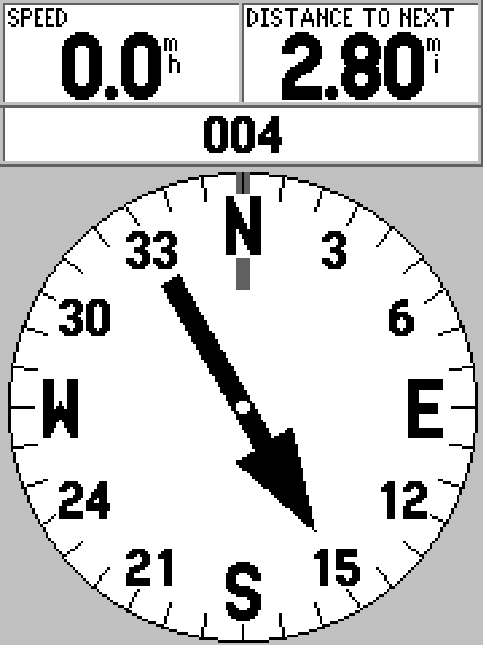  Navigation Page

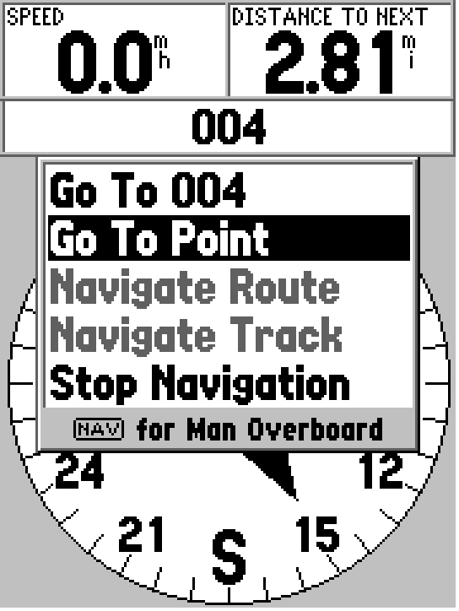  Pressing the "Nav" button | 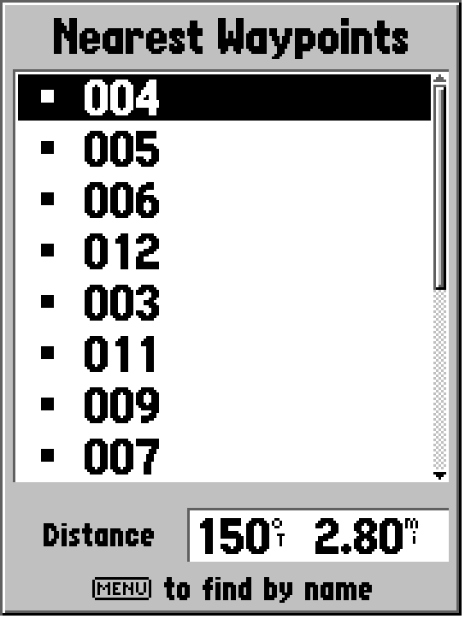  Selecting a Waypoint | 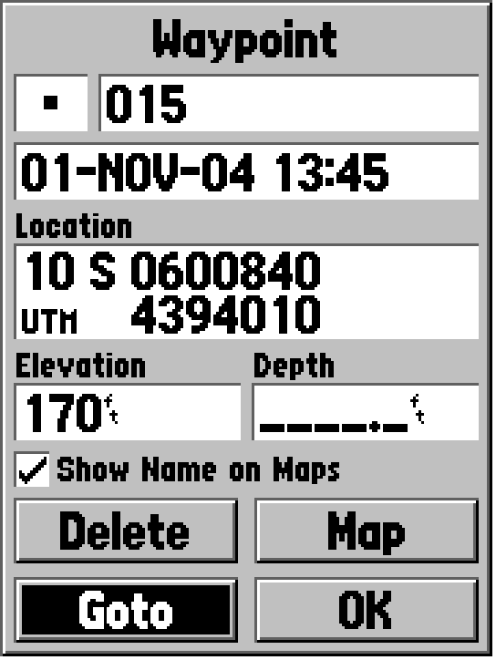  Waypoint Screen

Sample Profile Graph for Auto Level and Laser Level

Electrical
Name ______________________

Description:
Installation and wiring using common industrial devices. Practice using common electrical testers.

Materials:
3 – handy boxes**
3 - 1/2" EMT Box connectors**
2 - PVC Box Connectors**
1' 1/2" EMT**
1' 1/2" PVC Conduit**
1 - Duplex Receptacle
1 - Lamp Holder
1 - Switch
Wire of various colors
Wire nuts
** Provided pre-mounted on a wooden lab board.

Tools:
Screwdriver
Needle Nose Pliers
Wire cutter/stripper
EMT Bender
Volt Ohm Meter (Multi-meter)

Directions Part 1 – Testing Circuits:
CAUTION: You will be testing high voltage circuits. Use caution.
- Use the provided testers to make the measurements listed on the grade sheet.
- You should be able to explain the results of your testing. (See sample questions on the grading sheet.)

Directions Part 2 -- Wiring:
- Neatly diagram your circuit on the provided worksheet. Show wire connections with a line and label with wire color. Identify all the parts and materials used.
- Pull wires of the appropriate colors to each box.
- Wire a duplex receptacle (DR) in Box C. A switch in box B to control the lamp in box A.
- Power source is supplied as indicated. [Use short black, white, and green wire to demonstrate incoming power. Wires are spliced in Box C. Wires will be connected to an actual power source.]
- Observe color-coding, grounding, and all other NEC rules.
- Secure the devices to the boxes with screws for testing.
- Attach a temporary power cord to your source wires with wire nuts. OVBSERVE color-coding.
- Using the Testing Circuit Breaker box, plug in your board and test the circuit using a lamp and duplex receptacle tester. Have this portion graded.
- Disconnect your board. Use a piece of tape to label the board with your name. Remove the screws from the devices and turn in the board for grading.
- Bend a 90º bend in the end of a piece of EMT conduit. Cut off the bend 8" from the outside of the bend. Label with tape on the 8" leg and turn in.

Lamp (A)
Switch (B)
DR (C)
½” EMT Conduit
½” PVC Conduit
Handy Box

Notes:

Wiring Worksheet
Connect the black dots on the diagram below to illustrate how you will wire your project. Label each wire color.

Lamp
Switch
DR
White
Black
Green

Electrical Lab Grading: Name: ________________________
Criteria |  |  | Possible | Score
Correct circuit (live test, during lab) |  |  | 4
Correct Grounding |  |  | 2
Correct usage of wire colors and terminal color coding |  |  | 2
6" of free conductor |  |  | 2
Screw terminals neat and correct (wire clockwise, etc). |  |  | 2
Correct use of wire nuts (no bare conductor, not loose). |  |  | 2
Workmanship (neatness) |  |  | 4
EMT 90 degree bend |  |  | 2
Length of EMT bend 8" (+/- ¼”), cuts square & clean |  |  | 2
Testing (OK to work in pairs)
Station 1 | With lamp off: What is the AC voltage between A and B? | Volts | 2
Station 1 | With the lamp on: What is the AC voltage between A and B? | Volts | 2
Station 1 | With the lamp on: What is the AC voltage between A and C? | Volts | 2
Station 1 | With the lamp on: What is the AC voltage between B and C? | Volts | 2
Station 1 | Sample question: Why are the measurements between A & B similar to A&C when the lamp is on? Which wire is not connected to the lamp and why?
Station 2 | If a 50% charged battery will measure > 12.3 volts, is this battery at least 50% charged? | Yes / No | 2
Station 3 | Test the continuity of each wire. Which wire is broken (color)? |  | 2
Station 3 | Test to see if any of the wires are shorted (connected) to each other and list the colors. |  | 2
Station 3 | Sample question: What is the likely cause of the short?
Station 4 | What is the resistance of this wire (2000’ of number 14)? | Ohms | 2
Station 4 | Sample question: If you connect a 10 A load to this wire, what is the voltage loss?
Station 5 | The Ignition coil is likely good if the primary winding is not broken. Is this coil good? Test the resistance. | Yes / No | 2
TOTAL |  |  | 40

Concrete
Name ______________________

Description:
This lab will require you to mix concrete, create a simple form, pour, and finish concrete by building a stepping stone. Additionally the lab will give you practice in calculating the concrete volume for large and small projects.

This lab will provide practice using the same skills needed to pour a larger project. For this reason you should try and finish the project as smoothly as possible. To complete the lab in the time allotted you will need to complete the form is a timely fashion, make the proper mix, and not over work the project.

Materials:
Cement
Sand
Gravel
Form Lumber
6d Duplex Nails
Builders' Paper

Tools:
Power miter saw
Claw hammer
Mixer
Screed board (2 ½ scrap 2x4)
Square nose shovel
Floats
Trowels

Directions:
- Review the rubric and plan below.
- Build your form as shown in the plan. DO NOT drive duplex nail heads into the work benches. WRITE YOUR NAME ON THE FORM.
- "Paint" the form with diesel fuel to prevent sticking.
- Place the form on builder's paper.
- Mix a batch of concrete in the mixer. USE a 1:2:2 1/2 mix and a 5-gallon paste. Pour your stepping-stone. Use a scrap of lumber to screed the form.
- Use the wood float to tamp down the aggregate, tap the forms with a hammer to settle the concrete. DO NOT OVER WORK.
- Let sit for at least 1-2 hours. Use this time to complete the calculations with this lab or work on other lab projects. We will review them in class. (Due next lab.)
- Use an edging towel to finish the edges and a steel trowel to smooth the surface. DO NOT OVER WORK.
- WASH ALL TOOLS THOROUGHLY.
Next Lab: Remove the form from the stepping-stones so they can be graded. Label the project with your name and attach your finished gradesheet and calculations.

Stepping Stone Form:
Using a power miter saw cut from 1x2:
2-1x2x18"
2-1x2x24+"
Assemble as shown below with duplex nails (no glue):

18"
18"

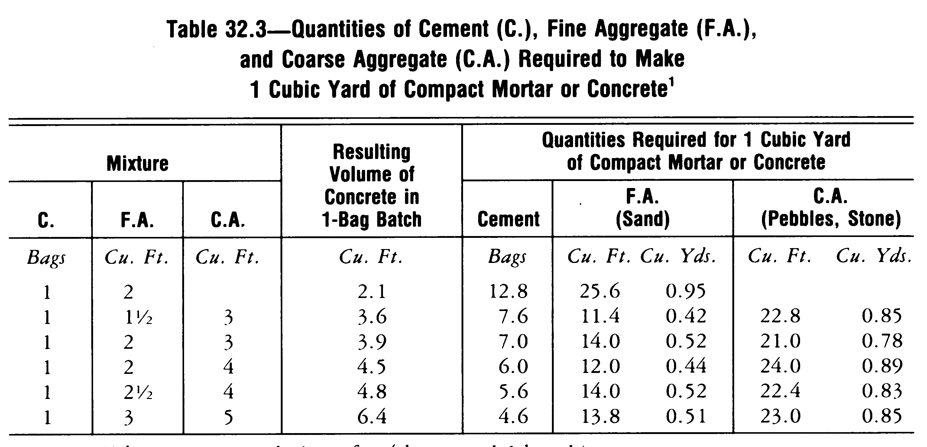

Name ______________________

Concrete Calculations
(2 points each)
- How much concrete (in cubic feet) is required to pour 30 stepping stones as constructed for this lab?

Answer: _______________
- Calculate the amount of concrete (cu. yds.) required to pour a walkway 4" thick, 3' wide and 60' long.

Answer: _______________
- How much cement, sand, and gravel will be required if you mix it yourself for the above project. Use a 1:2:4 mix. (Hint: see table on the handout.) Assume that you purchase the cement in 1cu. foot sacks, sand and gravel are purchased by the cu. yard.
Cement: ______________Sacks

Sand: _______________Yds.

Gravel: _______________Yds.
- How much concrete will you order (cu. yds.) to pour a barn floor 60' by 120'? Assume the slab will be 4" thick and the footings (around the entire slab) will be 18" deep and 12" wide.

Answer: _______________
- If the concrete in the above problem costs $65/cu. yd., how much will the slab cost?

Answer: _______________

Lab Grading:
Criteria (tolerance 1/16") | Possible | Score
Form Size (Width, Length, Square) | 6
Finished Stepping Stones (Finish, Craftsmanship) | 9
Class Participation/Clean Up | 5
Calculations | 10
TOTAL | 30

(blank)

Woodworking – Planter Box
Description: A simple planter box that will hold common 4” plastic pots. Planter can be used for a herb garden or outdoor planter.

Materials:
1” X 6” X 6’ redwood or pine*
5d galvanized box nails
3d galvanized box nails (few)
Wood Glue
Varnish/stain
120 grit Sand Paper
* Project may be cut from 1x12 lumber by ripping to 5” and 4 ¼”.

Tools:
Table Saw
Power Miter Saw
Drill Press
1” forstner bit
Claw Hammer
Steel Tape
Combination square

Directions:
Review the rubric and plan before starting. Determine how to best use your piece of lumber.
- Obtain a piece of redwood that is 1” X 6” X 6’
- Determine the best use of the lumber. Where are the knots? Determine the layout before you begin to cut.
- Crosscut the board at approximately 28” for the bottom/ends.
- Adjust the table saw rip fence so it measures 5” from the fence to the inside of the saw blade
- Rip (cut) the long piece of redwood at 5”.
- From this piece cross cut all the 5” wide pieces (see cutting list – sides, ends).
- Set the table saw to rip at 4 ¼”. Rip your short board (bottom/ends). Save the scrap for the feet.
- Crosscut the 4 ¼” board at 5” (2) and 17”.
- Crosscut the scrap for the feet.
- All of the pieces have now been cut. Put your project together without glue and nails. Does it fit? If so continue.
- Layout the holes in the bottom. Drill 4 holes using a Forstner bit evenly spaced under each pot.
- Nail the ends to the bottom using glue and 5d nails.
- Nail the sides to the bottom and ends using glue and nails. Be sure to properly align the sides (see plan) and insure the ends are square.
- Turn the planter upside down and install the feet as shown the plan. Use 3d nails and glue. Brittle wood may need to be drilled.
- Sand your project down to a smooth finish, DO NOT sand the nails.
- Stain or paint the project for completion

Cutting List:
Quantity | Size |  | Material
2 | 3/4” X 5 ” X 20” | Sides | Redwood
1 | 3/4” X 4 ¼” X 17” | Bottom | Redwood
2 | 3/4” X 4 ¼ ” x 5” | Ends | Redwood
2 | 3/4”X 5 ¾” X 1” | Feet | Redwood

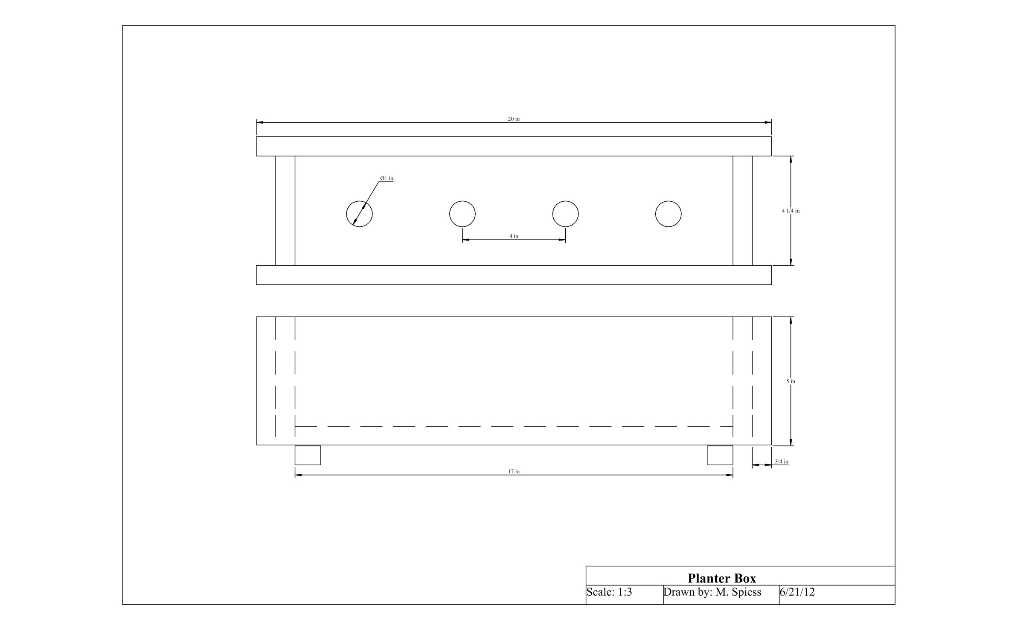

Name: __________________________________

Board Layout (not to scale)
A=Side Piece
B=Side Piece
C=End Piece
D=End Piece
E=Bottom Piece
F=Legs

A
B
E
C
D
F

Grading Rubric:
CRITERIA | POSSIBLE | SCORE
Length | 5
Width | 5
Holes are properly drilled-no chips, slivers, etc. | 5
Holes are lined up straight and evenly spaced | 5
Planter box is square and joints fit well. | 5
Workmanship (sanding, nails, cut quality, etc) | 5
Total | 30

(blank)

Sheet Metal - Tool Box
Name ______________________

Description:
The tool box is a project involving skills in layout, sheet metal construction, wood construction.

Materials:
24-26 ga. Galv. sheet metal
#2 Pine (1” x 6”)
1” hardwood dowel
¾” sheet metal screws
¾” wood screws

Tools:
Snips
Shear
Sheet Metal Brakes
Combination Square
Drill press
1” Forstner Bit

Tinner’s Hammer
Power Screwdriver and bits
Pop Rivet tool
Spot welder
Scribe
Band Saw
Power Miter Saw

Directions:
- Layout the toolbox sides as shown in the drawing and cut out. Take care not to cut on the fold lines.
- Fold the edges of the sides. Crimp tight.
- Break the two middle bends to 90 degrees

- Crosscut the two ends on the miter saw to length.
- Layout the center of the handle hole and the angle cuts.
- Cut the angles on the band saw or using a hand saw
- Bore the hole using drill press.
- Sand the exposed edges (do not sand areas where sheet metal will be joined to wood).

- Fit and attach the sheet metal bottom to the wood ends with sheet metal screws.
- Insert the handle and secure on one end with a wood screw.

- Layout the tray as shown in the drawing and cut out with snips.
- Bend the tray on the finger brake. Carefully consider the order of your bends. Note: Final bends that will hold the tray on the tool box will be made by hand.
- Use the spot welder to fasten corners of the tray.
- Using a tinner’s or ball peen hammer form the final bends of the tray that will hold the tray on the tool box.
- Label your project & tray with a marker and turn in with the grade sheet.

Name ______________________

Grading:
Criteria (Tolerance +/- 1/6") | Possible | Score
Tool Box Length | 4
Tool Box Width | 4
Tool Box Height | 4
Handle (location, fit) | 4
Workmanship (appearance, edges) | 4
Bends (correct, fit, clean) | 4
Tray
Tray Size | 4
Quality of bends | 2
TOTAL | 30/24

Note: Tray may be optional.
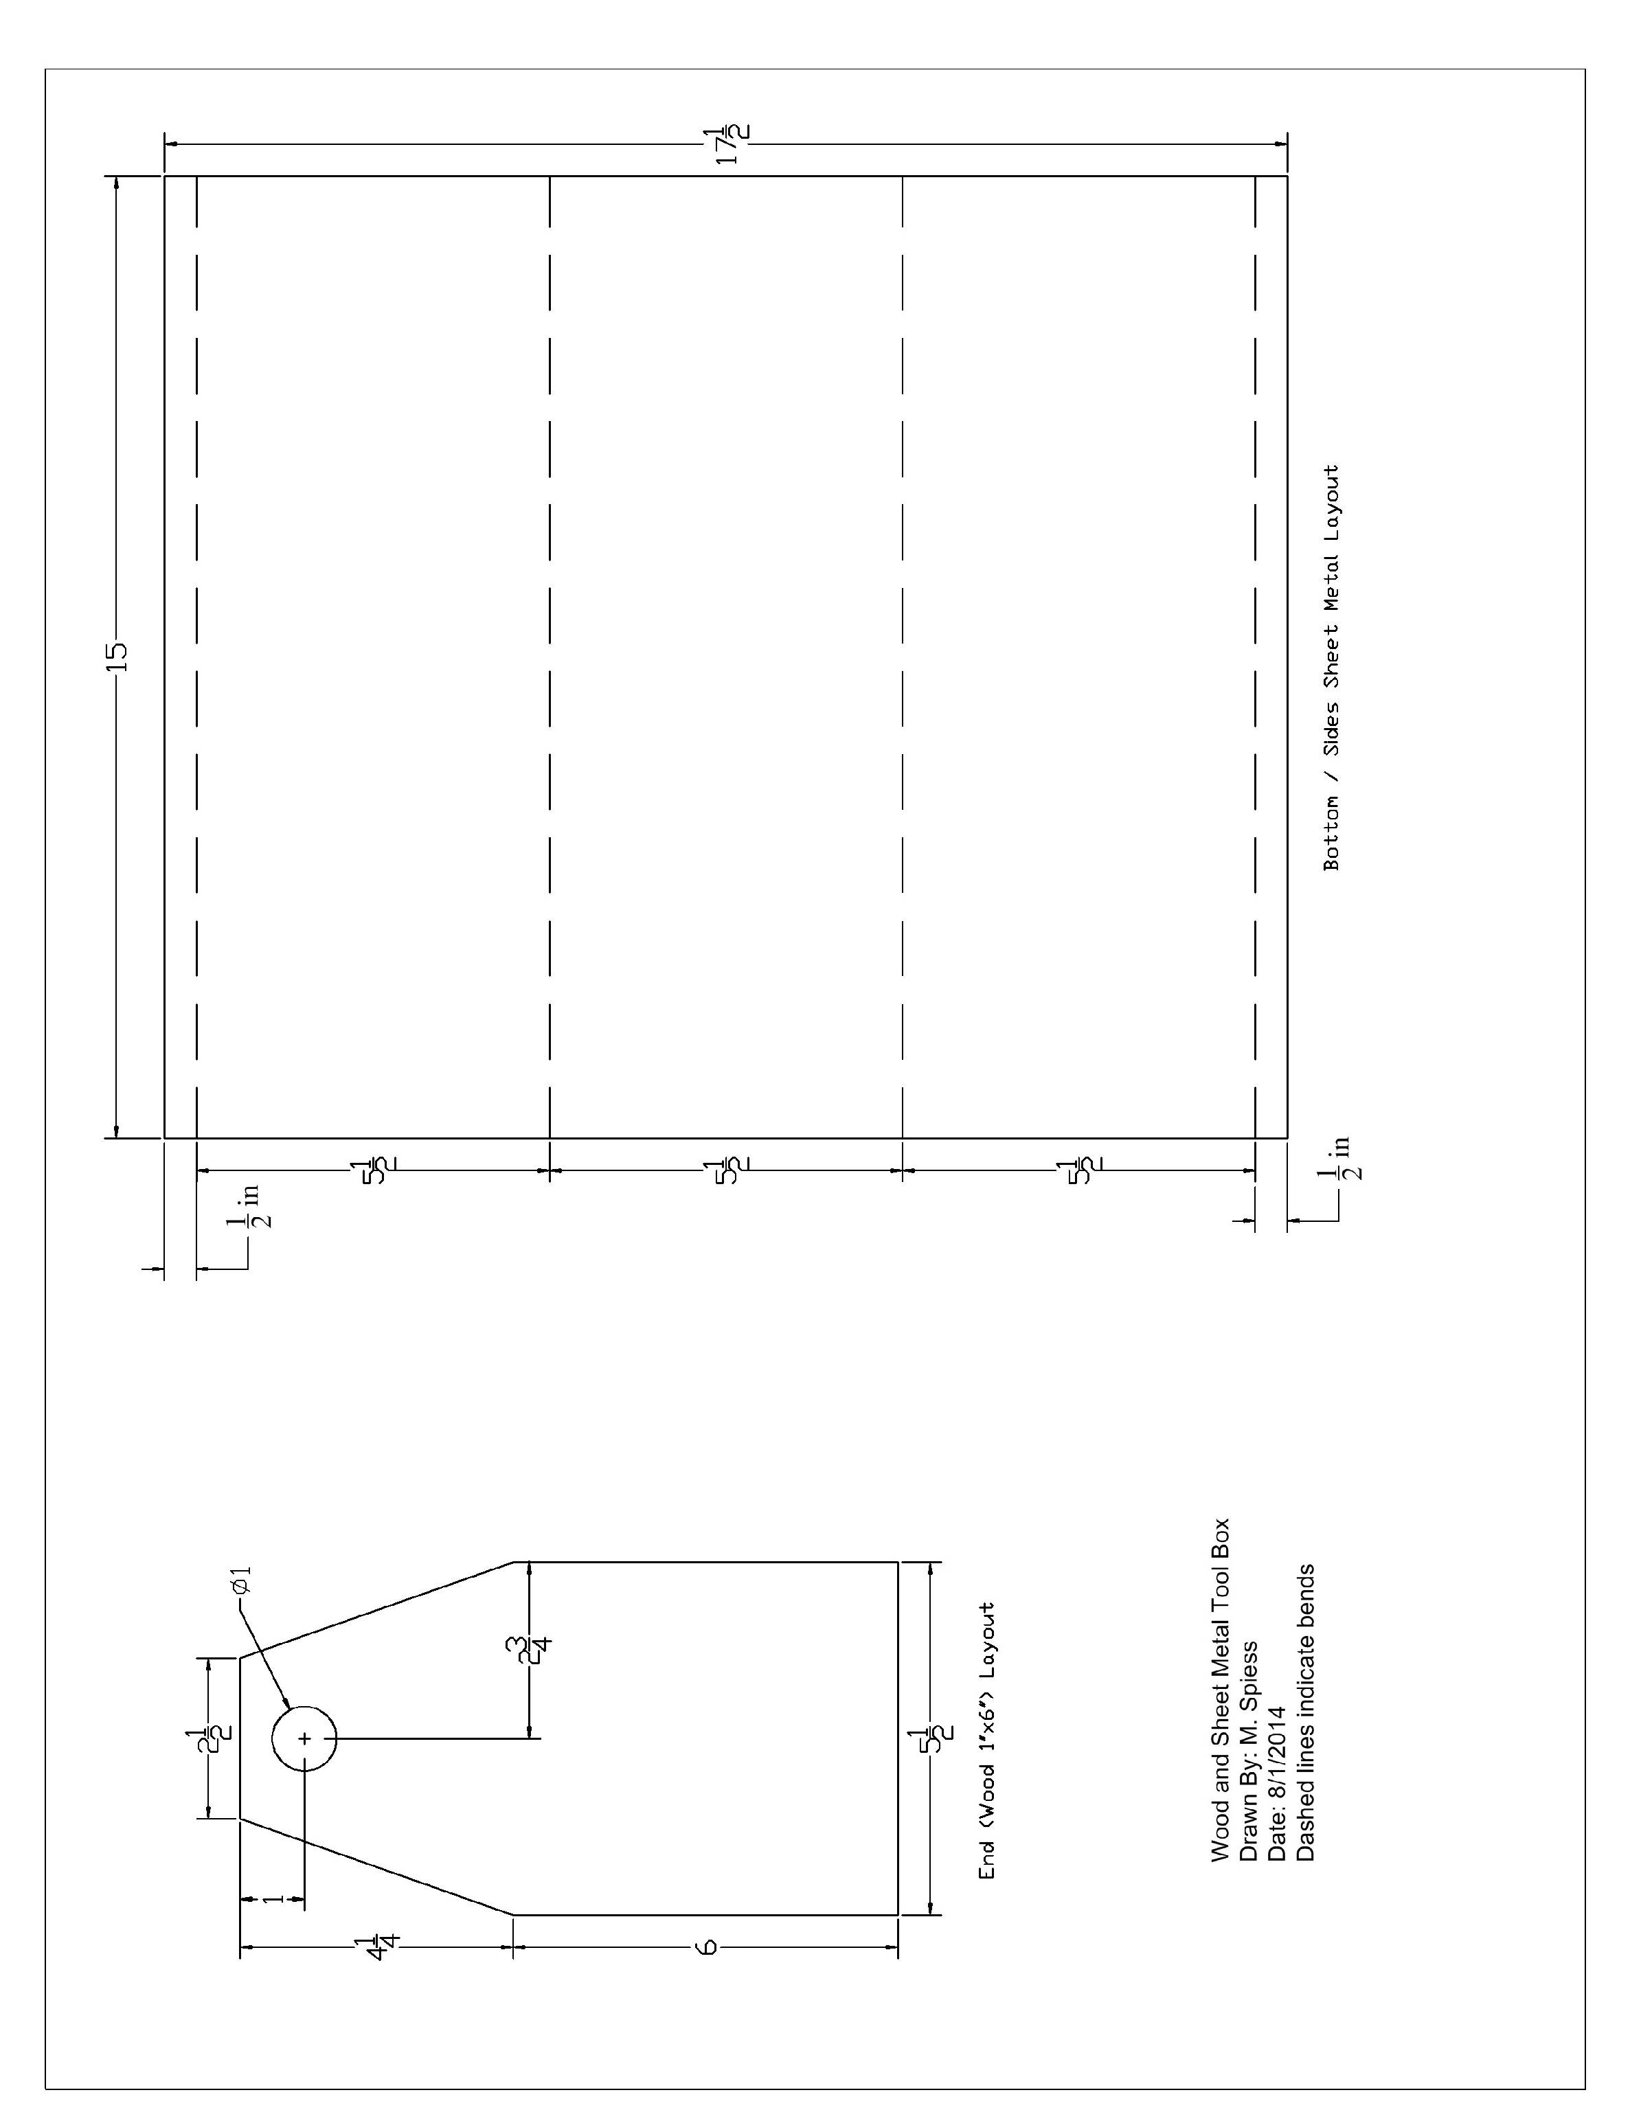
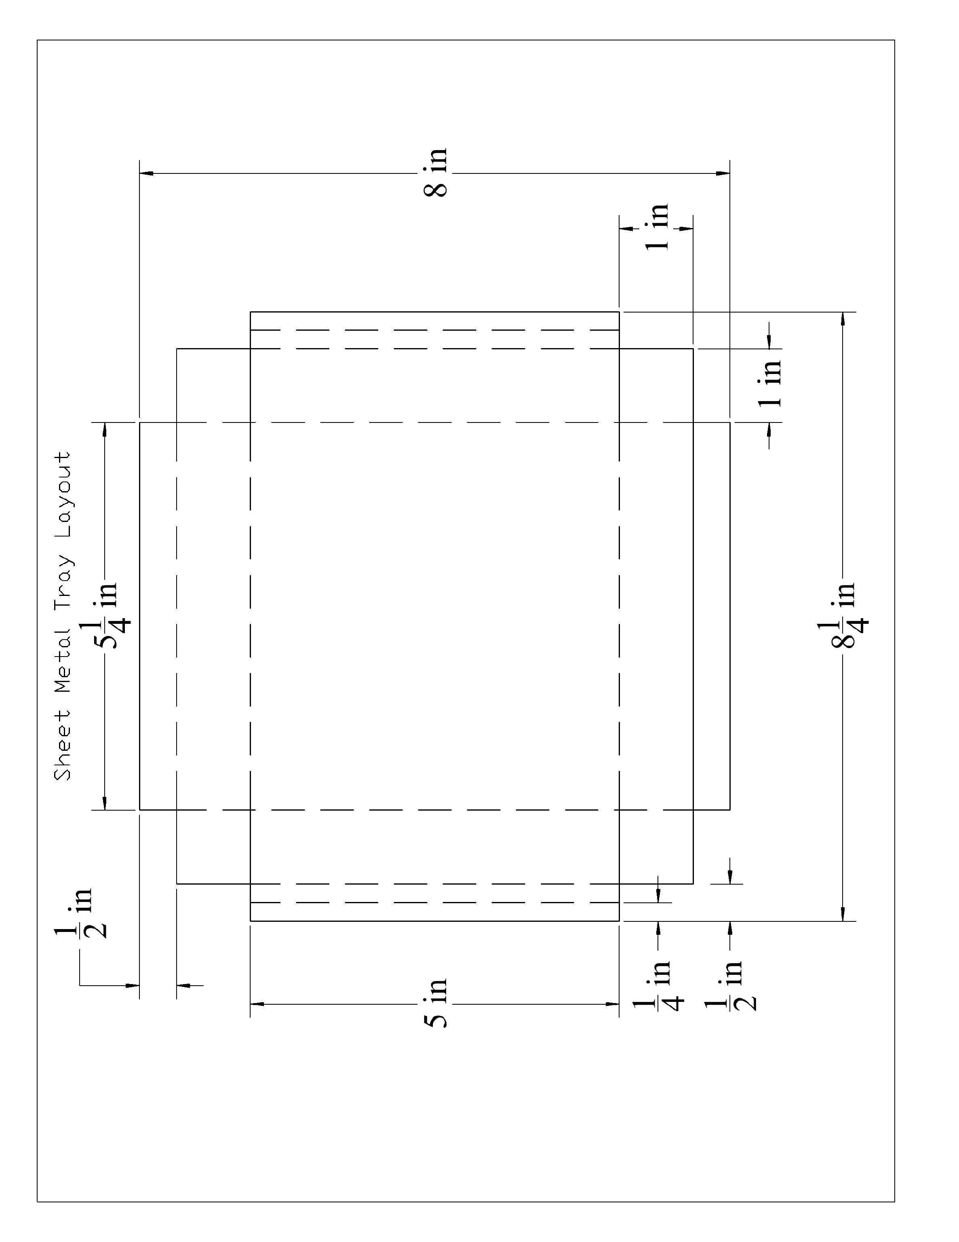

Arc (SMAW) Welding
Name ______________________

Description:
Arc welding is the most common type of industrial welding. In this exercise you will be using the Shielded Metal Arc Welding (SMAW) process sometimes called “stick” welding.
CAUTION: Cover all exposed skin as arc light will cause burning. Always wear safety glasses under the helmet.

Materials:
¼” x 1 ½” x 4” Hot Rolled (HR) steel coupons
1/8” E6103 welding rod

Tools:
AC/DC Arc Welder
Chipping Hammer
Wire brush
Welding Helmet (shade 10)
Hydraulic shear

Directions:
- Review the rubric below. You will turn in two separate projects.
- Measure and cut coupons (4”) using the hydraulic shear.
- The proper rod angle is 10º-20º dragging in the direction of the weld. Rod is held 90º perpendicular to the weld and about 1/8” away from the metal. Use a crescent motion to make the bead 3/8” wide.
- If you are new to arc welding: Using DCRP (DCEP) current setting of approximately 100 Amps. Alternate coupons to avoid over heating.
- Place three beads on a coupon. It is recommended to weld along the edges first then down the middle. Cool the coupon between welds. These welds should demonstrate your ability to weld in a straight line and maintain the proper arc length and rod angle. Complete this project before making the butt weld.
- Butt weld two coupons as shown in the diagram below (weld one side only).
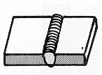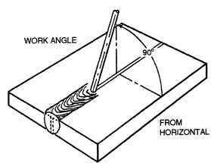

Grading:
Criteria | Possible | Score
Bead quality (speed, heat, straight, etc.) | 10
Butt weld quality (speed, heat, straight, etc) | 10
TOTAL | 20

(blank)

Gas Welding & Cutting
Name ______________________

Description:
Braze welding is a skill that demonstrates control of the welding heat and is commonly used for repairing castings and other materials. Oxy-acetylene cutting is a common cutting technique use in the field and for cutting thick ferrous materials.

Materials:
½” x 4” flat bar stock
2- 1/8” x 2” x 2”
16 ga. HR sheet metal strip
flux coated brazing rod

Tools:
Oxy-acetylene welding outfit
#2 tip
Cutting tip
Welding goggles (shade 5)
Soap stone

Directions:
Review the rubric below. You will turn in three projects for this lab.
Gas Welding:
- Cut two pieces of sheet metal stock 3” long and fusion weld as shown in the diagram below. Hint: Fuse one end then weld from the other end toward the fused end.
Fuse these edges together
Gas Fusion Weld
Gas Cutting:
- Practice making strait and square cuts on some 3/8” or ½” scrap metal.
- Using soapstone and a square mark a cut line ½” from the end of the 4” stock. Make a second line 1” from the first.
- Cut on both lines. Make the cut piece for grading.
Braze Weld:
- Cut two pieces of 1/8” stock and braze weld as shown in the diagram below. Pieces should be assembled at right angles and square.

Braze Weld this joint (one side only)
2”
1”
2”

Gas Welding & Cutting Grading:
Criteria | Possible | Score
Braze Weld quality | 5
Braze Weld Assembly (Square) | 5
Fusion Weld Appearance (uniform width, etc) | 5
Fusion Weld Penetration (complete penetration to underside) | 5
Cut quality and vertical (two edges) | 5
Cut coupon size (1” width and parallel) | 5
TOTAL | 30

Plasma Cutting
Name ______________________

Description:
Plasma cutting is a common process used to cut ferrous and non-ferrous metals.

Materials:
Scrap ¼” steel plate
3” x ¼” flat HR steel bar stock

Tools:
Plasma Cutter
Angle iron guide
Welding clamps
Soap stone

Directions:
- Review the rubric below.
- Practice making strait and square cuts on some ¼” scrap metal.
- Using soapstone and a square mark a cut line ½” from the end of the 4” stock. Make a second line 1” from the first.
- Cut on both lines. Make the cut piece for grading.

Gas Welding & Cutting Grading:
Criteria | Possible | Score
Cut quality (two edges) | 4
Cuts square (two edges) | 4
Cut coupon size (1”) | 2
TOTAL | 10

(blank)

GMAW Welding
Name ______________________

Description:
Arc welding is the most common type of industrial welding. In this exercise you will be using the Gas Metal Arc Welding (GMAW) process sometimes called “MIG” welding.

CAUTION: Cover all exposed skin as arc light will cause burning.

Materials:
¼” x 1 ½” x 4” Hot Rolled (HR) steel coupons

Tools:
GMAW Arc Welder
Wire brush
Welding Helmet (shade 10)
Hydraulic shear

Directions:
- Review the rubric below. You will turn in two separate projects.
- Measure and cut coupons using the hydraulic shear.
- Place three beads on a scarp coupon. It is recommended to weld along the edges first then down the middle. Cool the coupon between welds. Complete this project before making the butt weld.
- Butt weld two coupons as shown in the diagram below (weld one side only).

Grading:
Criteria | Possible | Score
Bead quality (speed, heat, straight, etc.) | 10
Butt weld quality (speed, heat, straight, etc) | 10
TOTAL | 20

(blank)

Cold and Hot Metal - Triangle Dinner Bell
Name ____________________________
Description:
The project is in two parts. The triangle is designed to teach hot bending of steel. The ringer is made by cold bending of steel using a Hosfield bender. Metal is cut with a hack saw and cutoff saw. The resulting project is a functional and decorative dinner bell.

Materials:
1/2" or 3/8” round HR mild steel

Tools:
Hacksaw
Bastard and Smooth (mill) Flat files
Hosfeld Bender
Cutoff Saw
Oxy-Acetylene torch with large welding or heading tip
Soap stone

Part I – Ringer
- Cut a piece of round stock 9” long using the cutoff saw. Dress one end with a file.
- Using the bender, bend an eye in the dressed end leaving the opening slightly larger than the diameter of the rod.
- Trim the ringer to length using the cutoff saw and dress the end. Dress any sharp edges.
- Turn in with the grade sheet
Part II – Triangle
- Cut a piece of round stock 24” long using the hacksaw. Dress the ends with a file.
- Using soapstone mark 8” and 16” (dividing the stock in thirds).
- Place the first 8” in a vice. Using the torch heat at the first mark and bend the stock at a 60º angle. Heat the second mark and finish bending the stock to close the triangle. Leave the ends a ¼” apart as shown in the drawing. The triangle should be flat.
- Let the project cool.
- Dress any rough edges.
- Optionally: Use a scrap of rope and make a hanger using a square knot to make a loop and a bale sling hitch.

Notes:
__________________________________________________________________________________
__________________________________________________________________________________
__________________________________________________________________________________
__________________________________________________________________________________
__________________________________________________________________________________
__________________________________________________________________________________

Name ____________________________

Grading Ringer:
Criteria (tolerance +/- 1/16") | Possible | Score
Length of ringer | 4
Quality of Eye Bend (3/8” gap, centered, round) | 4
General Workmanship (dressed ends) | 4
 | 12

Grading Triangle:
Criteria (tolerance +/- 1/4") | Possible | Score
Dimensions (8” per side) | 4
Triangle lays flat | 4
General Workmanship  (dressed edges, angles, bending, 1/4 “ gap) | 4
Total | 12

Bale Sling Hitch
Make a loop  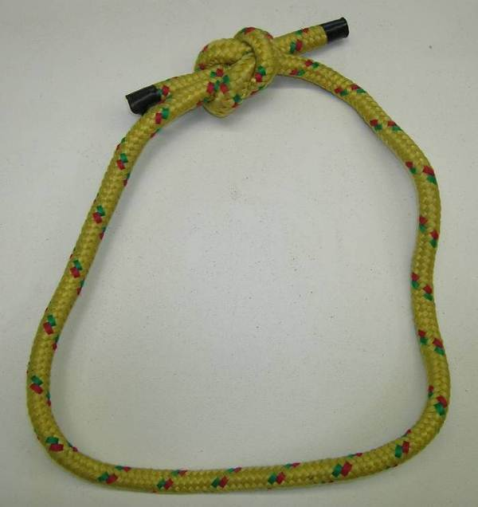 | Slip the loop around the triangle  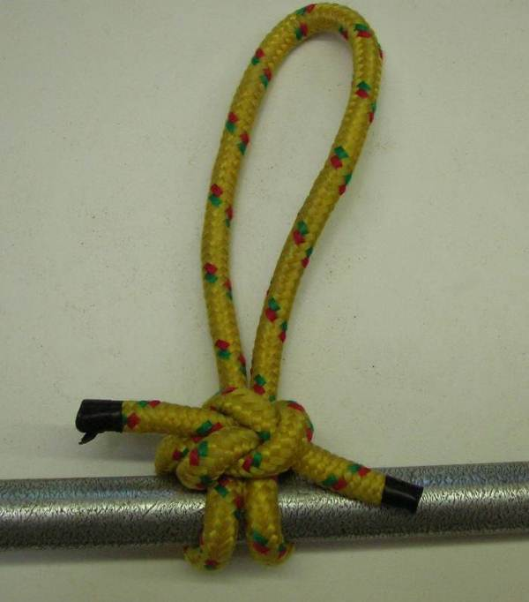

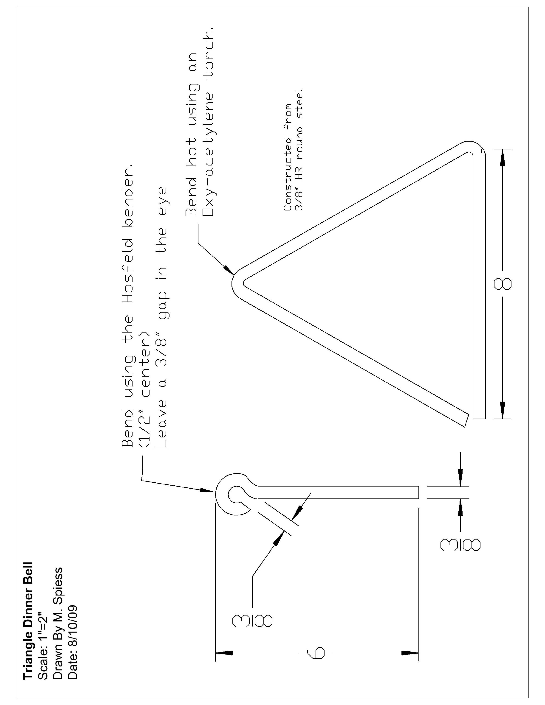
(blank)

Cold Metal – Hose Hanger
Name ____________________________
Description:
A cold metal project that gives students practice sheering, bending, drilling, and fastening steel. The hose hanger can be used for proper storage of a hose in any location after completion. It consists of two pieces that allow it to be attached to a wall and keep the hose off the floor. It can be used for water or air hoses. Sheet metal will be pre-cut on the plasma cutter. See demonstration. The project also uses the hydraulic shear and grinder.

Materials:
1- 6”x 15 1/5”” 16 gauge sheet metal
1- HR Flat Stock 1/4” x 1 ½”x 20”
2- ¼” x ½” NC machine screws
Cutting Oil

Tools:
Scratch awl
Soapstone
Rule
Combination square
Drill Press
Center punch
Hydraulic Sheer
Oxy-acetylene welder

Blacksmith’s Vise
Bastard & Mill Files
Grinder
Sheet metal roll
Locking C Clamps
#7, 13/64, 5/16’’ twist drills

Directions:
- Cut bar to correct length using the hydraulic shear; grind edges to remove sharp edges. Dress with file as needed.
- Layout and drill the four holes on the flat bar. Use a center punch to mark the holes. IMPORTANT: Use a Number 7 drill or 13/64” for all holes.
- Use a ¼” x 20 taper tap to tap the two holes that will hold the sheet metal. Use cutting oil. CAUTION: Do not bend tap as it will break.
- Using the letter stamps, stamp your initials on the underside of the flat stock (between the drilled holes).
- Mark the bends with soapstone. Important: Double check to see that the bends and holes will fit sheet metal BEFORE bending.
- Clamp the flat stock in the vise and bend the two 90º bends first then bend the end (about 30º). Heating the metal in a narrow band will make a sharper corner. Cool between bends.
- Lay out holes in the sheet metal. NOTE: These must match the holes in the flat stock.
- Mark the holes with a center punch and drill holes in sheet metal. These are 5/16”” holes.
- Roll sheet metal bend to correct shape. Note the distance between the ends.
- Assemble the parts with the machine screws.
- Wipe the project clean with a rag. Paint the project with primer.
- At the next lab paint the project with a finish coat.

Cutting List:
Quantity | Size | Material
1 | 6” x 15 1/2” | 16 gauge HR sheet metal
1 | 1 ½” x ¼” x 20” | HR flat steel

Name ____________________________

Hose Hanger Grading Rubric:
CRITERIA | POSSIBLE | SCORE
Bend of sheet metal (12” across ends) | 5
Length of hanger (flat stock) | 5
Bends of flat stock | 5
Hole position (sheet metal centered) | 5
Workmanship (assembly, fit, edges filed, etc) | 5
Paint (no drips, coverage) | 5
TOTAL | 30
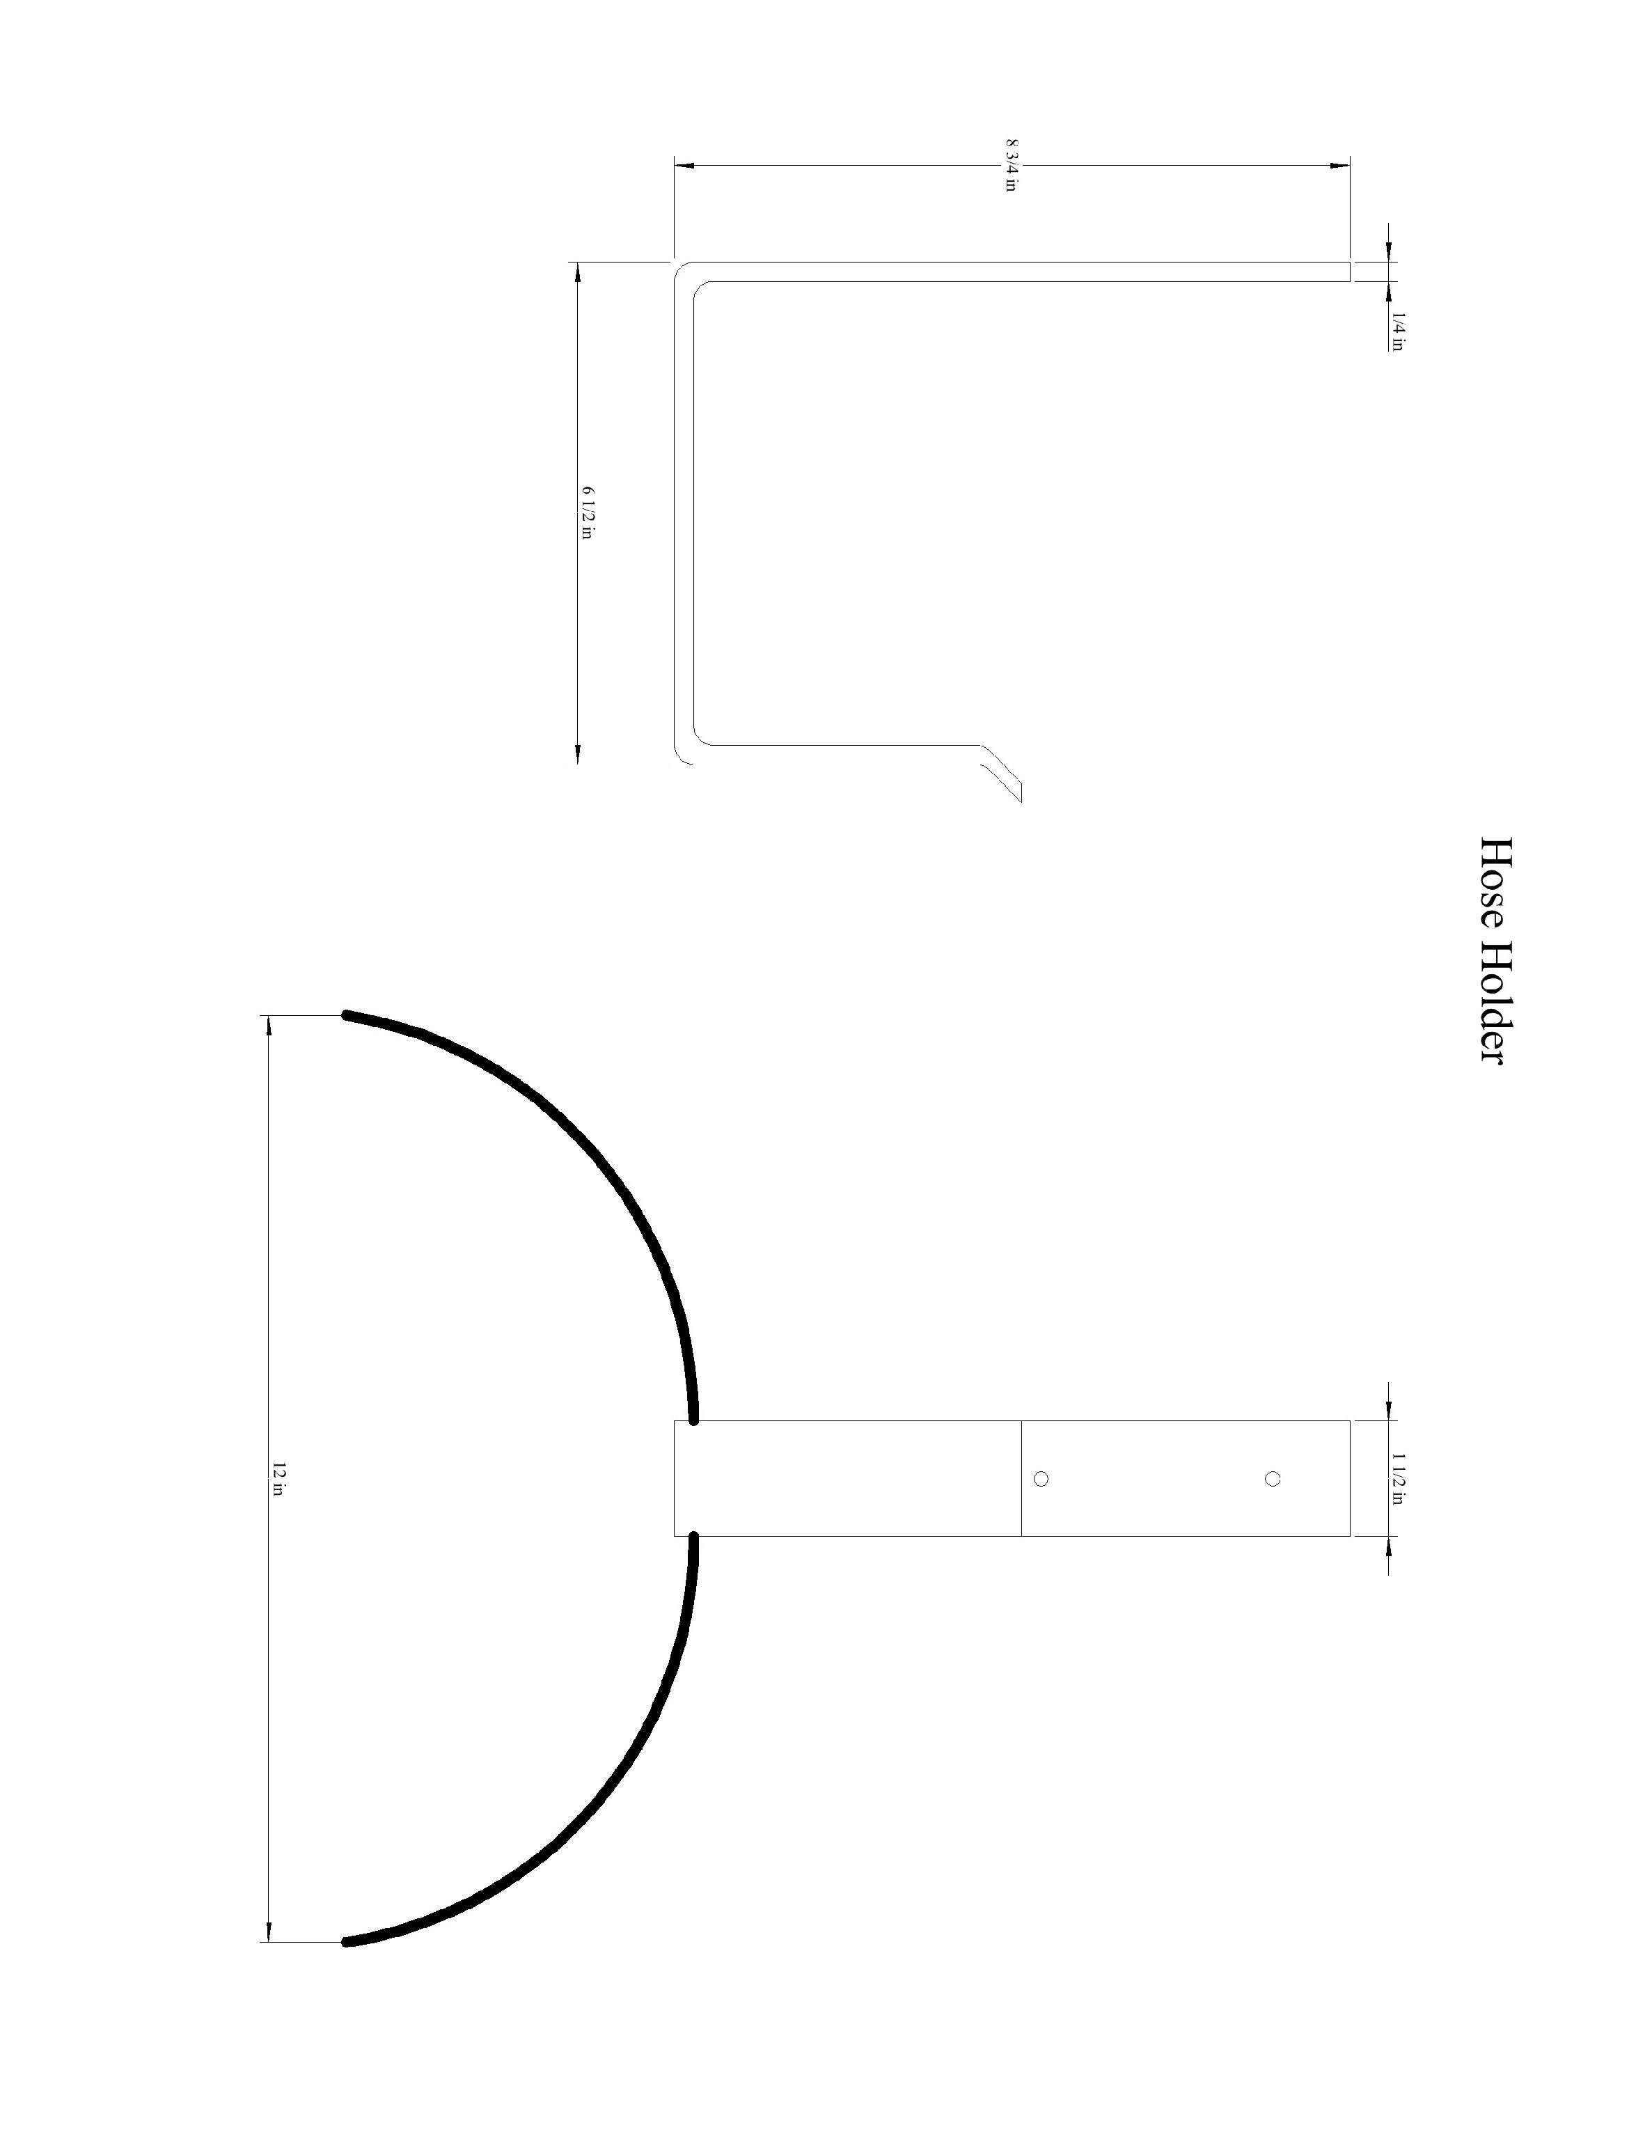
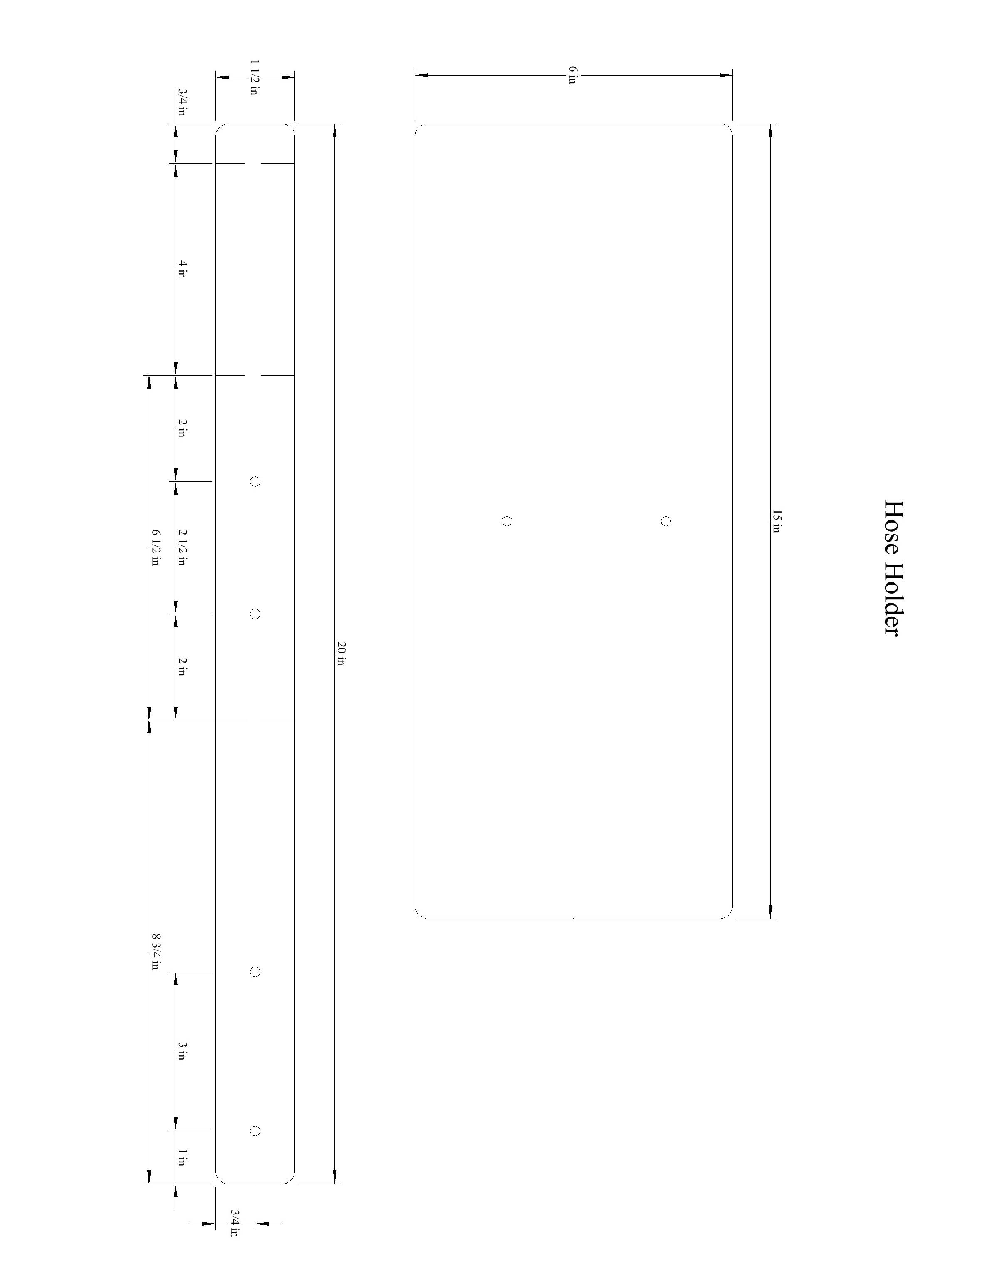
Tap and Drill Chart
(Recommended tap drill to use for 75% depth of thread)
  To Tap This Size Screw Or Bolt: | Use This Drill Bit: | (Closest Fractional:) | Decimal Inches
  0-80 NF | 3/64" | 3/64" | .0469
  1-64 NC | #53 | - | .0595
  1-72 NF | #53 | 1/16" | .0595
  2-56 NC | #50 | - | .0700
  2-64 NF | #50 | - | .0700
  3-48 NC | #47 | 5/64" | .0785
  3-56 NF | #45 | - | .0820
  4-36 NS | #44 | - | .0860
  4-40 NC | #43 | 3/32" | .0890
  4-48 NF | #42 | 3/32" | .0935
  1/8-40 NS | #38 | - | .1015
  5-40 NC | #38 | - | .1015
  5-44 NF | #37 | - | .1040
  6-32 NC | #35 | 7/64" | .1100
  6-36 NS | #34 | - | .1110
  6-40 NF | #33 | - | .1130
  6-48 NS | #31 | - | .1200
  8-32 NC | #29 | - | .1360
  8-36 NF | #29 | 9/64" | .1360
  8-40 NS | #28 | - | .1405
  3/16-24 NS | #26 | - | .1470
  10-24 NC | #25 | 5/32" | .1495
  3/16-32 NS | #22 | - | .1570
  10-32 NF | #21 | 5/32" | .1590
  12-24 NC | #16 | 11/64" | .1770
  12-28 NF | #14 | 3/16" | .1820
  12-32 NEF | #13 | - | .1850
  14-20 NS | #10 | - | .1935
  1/4-20 NC | #7 | 13/64" | .2010
  14-24 NS | #7 | - | .2010
  1/4-24 NS | #4 | - | .2090
  1/4-28 NF | #3 | 7/32" | .2130
  1/4-32 NEF | 7/32" | 7/32" | .2188
  1/4-40 NS | #1 | - | .2280
  To Tap This Size Screw Or Bolt: | Use This Drill Bit: | (Closest Fractional:) | Decimal Inches
  5/16-18 NC | Ltr.F | 17/64" | .2570
  5/16-24 NF | Ltr.L | - | .2720
  5/16-32 NEF | 9/32" | 9/32" | .2812
  3/8-16 NC | 5/16" | 5/16" | .3125
  3/8-16 NC | 5/16" | 5/16" | .3125
  3/8-24 NF | Ltr.Q | 21/64" | .3320
  7/16-14 NC | Ltr.U | 23/64" | .3680
  7/16-20 NF | 25/64" | 25/64" | .3906
  1/2-13 NC | 27/64" | 27/64" | .4219
  1/2-20 NF | 29/64" | 29/64" | .4531
  1/2-24 NS | 29/64" | 29/64" | .4531
  9/16-12 NC | 31/64" | 31/64" | .4844
  9/16-18 NF | 33/64" | 33/64" | .5156
  5/8-11 NC | 17/32" | 17/32" | .5312
  5/8-18 NF | 37/64" | 37/64" | .5781
  11/16-11 NS | 19/32" | 19/32" | .5938
  11/16-16 NS | 5/8" | 5/8" | .6250
  3/4-10 NC | 21/32" | 21/32" | .6562
  3/4-16 NF | 11/16" | 11/16" | .6875
  7/8-9 NC | 49/64" | 49/64" | .7656
  7/8-14 NF | 13/16" | 13/16" | .8125
  7/8-18 NS* | 53/64" | 53/64" | .8281
  1.8 NC | 7/8" | 7/8" | .8750
  1.12 NF | 59/64" | 59/64" | .9219
  1-14 NS | 15/16" | 15/16" | .9375
  1 1/8-7 NC | 63/64" | 63/64" | .9844
  1 1/8-12 NF | 1 3/64" | 1 3/64" | 1.0469
  1 1/4-7 NC | 1 7/64" | 1 7/64" | 1.1094
  1 1/4-12 NF | 1 11/64" | 1 11/64" | 1.1719
  1 3/8-6 NC | 1 7/32" | 1 7/32" | 1.2188
  1 3/8-12 NF | 1 19/64" | 1 19/64" | 1.2969
  1 1/2-6 NC | 1 11/32" | 1 11/32" | 1.3438
  1 1/2"-12 NF | 1 27/64" | 1 27/64" | 1.4219
NC – National (UNC or USS), NF- National Fine (UNF or SAE), NS – National Special, NEF – National Extra Fine
(blank)

Plumbing
Name ______________________

Description:
In this lab you will work with four common plumbing materials: galvanized pipe, copper pipe, PVC, and PEX pipe.

Materials:
8" - 1/2" Galvanized pipe
4" - 1/2" Copper Pipe
1/2" PVC Pipe
1 - 1/2" Copper Male Adapter
2 - 1/2" PVC ST 90º Elbow
1 – ½” PEX x ½” Copper adapter
1 – ½” PEX Plug
12” ½” PEX Pipe
PVC Cement
Flux
Solder
Pipe Joint Compound

Tools:
Steel pipe cutter
Pipe Die
Pipe reamer
Hack Saw
Propane Torch
Flux Brush
Copper pipe brushes or emery cloth
Pipe threading machine
PVC Cutter
PEX Cutter
PEX Cinch Tool

Directions:
Read the directions and review the rubric before beginning the lab.
You may start the project at different points.
IMPORTANT: Only one set of fittings can be provided.
Steel Pipe
- Thread and ream ½” Steel pipe on the threading machine.
- Measure and cut the pipe to 8”.
- Thread and ream the cut end by hand.
Copper Pipe
- Cut a piece of copper pipe 4” long.
- Solder a male adapter on one end and a PEX adapter on the other end.
PEX Pipe
- Cut a 12” piece of PEX pipe.
PVC Pipe
- The finished length of the PCV piece is 10” inches to the outside of the 90º elbow fittings. Determine the length of the PVC pipe. __________________
- Cut the pipe.
- Glue on one elbow. Be sure to seat the pipe completely and twist a ¼ turn. Hold the fitting on for 30 seconds.
- Install the second fitting at 90º to the first. IMPORTANT: The see the diagram below for the direction of the fitting.
- Write your name on the PVC Pipe.
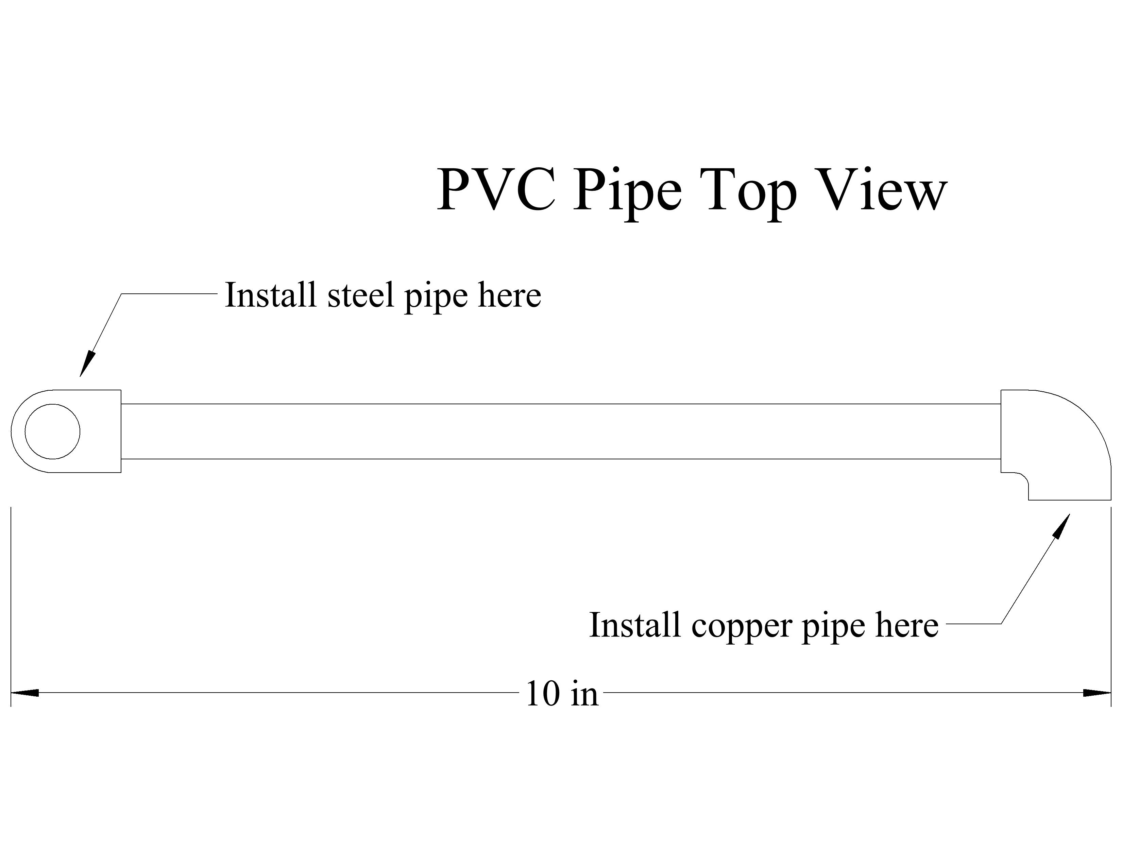
Assembly
- Using pipe joint compound assemble the steel pipe to the PVC Elbow. Snug with a pipe wrench, but do not over tighten.
- Using pipe joint compound assemble the copper pipe to the PVC Elbow. Snug with a pipe wrench, but do not over tighten.
- Place the two cinch rings on the PEX Pipe. Press the PEX pipe onto the adapter and Plug. Cinch the fittings.
Pressure Testing
- Have the project pressure tested and measured (see grade sheet).
Disassembly
- Unscrew the steel pipe and copper pipe from the PVC. Bundle the pieces with masking tape. Turn in for final grading.

Name ______________________

Plumbing Project Grade Sheet
Criteria | Possible | Score
Graded During Class:
Pressure Test (2 per joint, pass/fail) | 10
Disassemble the project, tape parts together and turn in with this sheet
Graded Later:
Galvanized Nipple
Galvanized Pipe Length (+/- 1/8”) | 2
Thread quality (machine thread) | 2
Reaming | 2
Copper Fitting
Copper Pipe Length (+/- 1/8”) | 2
Solder joint quality | 2
PVC
Glue joint quality | 2
PVC Pipe Length (+/- 1/8”) | 2
PEX
PEX Pipe Length (+/- 1/8”) | 2
Assembly/workmanship  (excess glue or solder, damaged pipe, PEX) | 4
TOTAL | 30

Rafter
Name ______________________

Description:
Cut a rafter using a framing (steel) square to layout.

Materials:
1 - 2x4x36" Fir (Rafter is NOT 36” long!)

Tools:
Circular Saw
Crosscut saw
Framing Square or Rafter Square
Sliding “T” bevel

Definitions:
Rise: Change in vertical height of the roof.
Run: Distance from the center of the roof to the edge of the outside of the plate
Span: Distance from outside of one plate to the outside of the other plate (building width)
Pitch: Rise/Span
Slope: Shown in the triangle as rise per foot of run.

Directions:
- Identify the rafter in the drawing and answer the questions.
- Layout the rafter using the framing square.
- Cut the ends with a circular saw.
- Cut the bird’s mouth with a crosscut hand saw.
- Label your rafter with your name and attach this sheet.
Grading:
Criteria (tolerance 1/16") | Possible | Score
Questions:  What is the rise in inches? __________________  What is the run in inches? __________________  What is the span in inches? __________________  What is the pitch? __________________ | 8
Length | 2
End Angles, cut | 2
Bird's moth location, size | 2
Bird's mouth cutting, square, straight, angles | 2
Workmanship (cut quality, wood selection) | 2
TOTAL | 18

2x4 Ridge board
30"
24"
4
12
Bird's Mouth
1 1/2" Deep
48"

Painting
Name ______________________

Description:
Prepare and paint a project using the paint and tools provided. NOTE: This may vary by project. Not all directions may apply.

Materials:
Spackle
Putty knife
Sander or Sanding Blocks
Exterior solid Stain
Drop Cloth or Paper
Latex caulking

Tools:
Putty Knife
Brushes
Roller Covers
Roller
Roller Pan
Cans for soaking brushes
Caulking gun

Directions:
- Prepare your project by sanding as needed. Remove all rough edges.
- Working on a drop cloth or paper, stain/paint the project starting from the top.
- Check for coverage and apply a second coat as necessary.
- Place the painted/stained project on a block of wood with the grade sheet under it.
- Clean brushes when you are done.
- Clean up shop.

Grading:
Criteria | Possible | Score
Surface preparation | 10
Coverage | 5
Workmanship (no drips, no runs, no errors) | 5
TOTAL | 20

(blank)

