Electrical Unit Plan

# Introduction

Electrical wiring is found everywhere so students can easily see the applications in their homes, the school, and elsewhere. When done correctly it is a good skill for homeowners to have. Beyond the basic wiring found in homes, is a whole array of skills dealing with motors and controls. Troubleshooting wiring at any level develops critical thinking skills. Electrical skills are different from many shop skills in that wiring is “rules” based and circuits have many possible variations. The actual wiring skill is not dependent on measurement and can be easily re-worked to correct mistakes. The tools used for wiring projects are simple hand tools and safety is not a big issue. However safety with dealing with live circuits is an important topic as AC electricity presents both electrocution and fire hazards.

# Teacher Preparation

For teachers unfamiliar with electrical wiring, we suggest the resources below be reviewed before teaching in addition to the videos provided with this curriculum. Teachers should practice the provided activities.

## Print Materials

Agricultural Technical Systems and Mechanics, 2nd Edition, 2019

Agricultural Mechanics and Technical Systems, 2017

Agricultural Mechanics: Fundamentals and Applications, 7th edition, 2015

Wiring Simplified. Hartwell et.al.

NFPA 70 NATIONAL ELECTRICAL CODE 2020 NEC

## Web Sites

<https://www.homedepot.com/p/Square-D-Homeline-100-Amp-6-Space-12-Circuit-Indoor-Surface-Mount-Main-Lug-Load-Center-with-Cover-HOM612L100SCP/100190554> (sub panel)

<https://commons.wikimedia.org/wiki/File:3-way_switch_animated.gif>

## Other Videos

Voltage, Current, Resistance: <https://youtu.be/OGa_b26eK2c>

Multi-meter use: <https://youtu.be/r_migcta_Is>

Series/Parallel: <https://youtu.be/Dq6zbNWB0VI>

Ground, Neutral, and Hot Wires: <https://youtu.be/P-W42tk-fWc>

Three Way Switches: <https://youtu.be/_u5ORnhqn8g>

Note: There are many examples of wiring on YouTube. Be cautious as many do not demonstrate correct wiring practice.

# Teacher Notes

* Files are organized by type in folders as described under “Resources”. Files are editable and teachers are encouraged to customize as needed.
* The unit plan is designed in small topics so the instructor can combine to fit into their curriculum.
* Time estimates include classroom instruction and activities. These are estimates and should be used as a guide only. Teaching methods, period scheduling, class size, and the ability to leave an activity setup can impact the instructional time greatly.
* While PowerPoint is useful teachers are to use hands on instruction wherever possible using actual equipment.
* Although not expressly covered in the lessons troubleshooting methods are included in the resources folder. Use of a multi-meter is described. These are good skill and are common in CDEs. It is simple to create stations for electrical troubleshooting with common controls and devices. This is an advanced skill and can be incorporated into an advance class.

# Teaching Methods

* Unlike projects such as woodworking or cold metal wiring projects can be corrected easily. Wiring is “rules” based so emphasis on learning and applying the rules is required.
* Working problems like power consumption and voltage loss will exercise students’ math skills in an applied way.
* Use actual tools for ID rather than PowerPoints when possible.
* Do hands on demos instead of videos when possible.
* Look to develop examples at your school for wiring. For example is EMT used in the shop? Is there a 3 way switch in the classroom. How is the breaker panel wired?
* Test student projects with live current. Note: a visual inspection of the wiring is a good idea. Students particularly like to see it “work” so a project with a switched lamp works well. See tester plan under resources.
* Electrical has many tools and materials. A complete ID for common items is provided. A sub-set of items just for NM Cable (residential) wiring is also provided. Several different methods of tool ID testing are provided. A quiz with pictures and a blank quiz for use with a provided PowerPoint or actual tools laid out with numbers can be used. Actual tools is a preferred method. A review version of the ID is also provided where names are not immediately displayed and this can be used in class for review.

# Required Equipment (minimum)

Class set of:

* Phillips Screwdriver
* Flat screwdriver
* Wire Strippers
* Cable Ripper (NM Cable)
* Steel Tape
* Wiring Boards

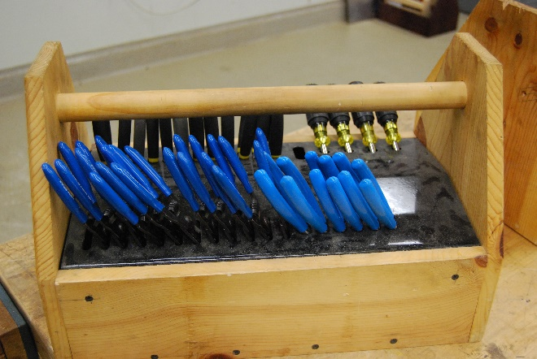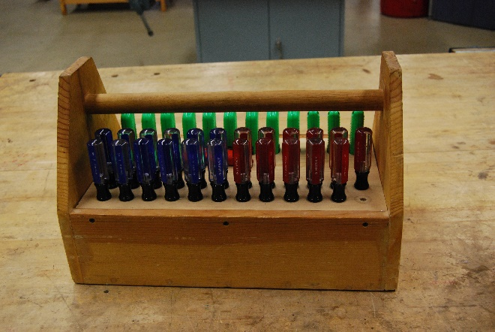

Simple tool cadies for electrical tools (Ripon HS) to organize tools. Cadies are stored when not in use. Inventory is easy if all slots are filled.

# Math

* Solve common equations for power, voltage, and current.
* Compute voltage drop based on resistance and current

# Student Learning Outcomes:

At the completion of the unit the student should be able to:

* Identify common AC devices
* Identify common tools used in electrical wiring
* Demonstrate safe practices when working with AC circuits
* Wire common AC circuits
* Read common electrical plans
* Explain types of electrical power and their applications

# Unit Plan

|  |  |  |  |  |  |  |
| --- | --- | --- | --- | --- | --- | --- |
| Topic | Time (hours) | PPT | Assessment | Activity | Video | Resources |
| 1. Introduction | 2 | x |  | X |  |  |
| 1. Electrical Tool and Materials ID | 2 | x | Quiz |  |  |  |
| 1. Safety Practices | 1 | x | Safety Test |  |  |  |
| 1. Wiring basics | 1 |  |  |  | X |  |
| 1. Circuits | 2 | x | X Quiz | X |  | Project Boards, Tester, Circuits |
| 1. Panels and Branch Circuits | 1 |  |  | X | X |  |
| 1. DC Applications | 1 |  | X Quiz | X |  | Multi-meter |
| 1. Motors | 2 |  |  | X |  |  |
| 1. Electrical Plan Reading | 1 |  | X | X |  |  |
|  | 13 |  | Unit Test |  |  |  |

# Resources:

## PowerPoint

Electrical 01-Introduction.pptx

Electrical 02 ID - Teacher Notes.docx

Electrical 02 ID - Teacher Notes.pdf

Electrical 02-ID Complete Review.pptx

Electrical 02-ID Complete.pptx

Electrical 02-ID NM Cable Review.pptx

Electrical 02-ID NM Cable.pptx

Electrical 03-Electrical Safety Practices.pptx

Electrical 04-Wiring Basics.pptx

Electrical 05.0 Circuit Basics.pptx

Electrical 05.1-Circuit Diagraming.pptx

Electrical 05.2-Circuit Wiring Assignment #1.pptx

Electrical 05.3-Circuit Wiring Assignment #2.pptx

Electrical 05.4-Switches.pptx

Electrical 06-Panels and Branch Circuits.pptx

Electrical 07-DC Applications.pptx

Electrical 08-Electric Motors.pptx

Electrical 09-Reading Electrical Plans.pptx

## Guided Notes

Electrical GN Lesson 01 - Introduction.docx

Electrical GN Lesson 02 - ID.docx

Electrical GN Lesson 03 - Safety.docx

Electrical GN Lesson 04 - Wiring Basics.docx

Electrical GN Lesson 05 .0 - Circuit Basics.docx

Electrical GN Lesson 05 .1 - Circuit Diagraming.docx

Electrical GN Lesson 05 .4 - Switches.docx

Electrical GN Lesson 06 - Panels.docx

Electrical GN Lesson 07 - DC Applications.docx

Electrical GN Lesson 08 - Motors.docx

Electrical GN Lesson 09 - Reading Electrical Plans.docx

## Activities

Electrical 01 Careers Activity.docx

Electrical 05 Circuit Wiring Assignment #1.docx

Electrical 05 Circuit Wiring Assignment #2.docx

Electrical 05 Circuit Wiring Assignment #3.docx

Electrical 05 Wiring Activity Generic.docx

Electrical 05 Wiring Activity Sample.docx

Electrical 06 Panel Wiring Activity.docx

Electrical 07 Trailer Plug Wiring Activity.docx

Electrical 07 Trailer Wiring Activity.docx

Electrical 08 Motor Nameplate Activity.docx

Electrical 09 Plan Reading - Optional Plan.pdf

Electrical 09 Plan Reading Activity.docx

## Assessments

Electrical 02 ID 30 Answer Sheet.docx

Electrical 02 ID - ID Quiz Matching.docx

Electrical 02 ID - ID Quiz.docx

Electrical 02 ID - ID Quiz.pdf

Electrical 02 ID Pictures.docx

Electrical 02-ID NM Cable Quiz.pptx

Electrical 03 Safety Quiz.docx

Electrical 05 Circuit Test.docx

Electrical 07 Vocab and Symbol Matching.docx

Electrical Unit Test.docx

## Videos

## Other Resources

Circuits 1-2.pdf

Circuits 3-6.pdf

Circuits 7-10.pdf

Electrical - NM Cable - Simple.doc

Electrical - NM Cable.doc

Electrical Board - 2013 CDE.doc

Electrical Board and Projects.pdf

Electrical Board.doc

Electrical Project Tester.pdf

Electrical Troubleshooting Activities.docx

Electrical Troubleshooting Stations.docx

Electrical Troubleshooting.docx

Using a Multimeter.docx

## Lesson Outlines

Detailed outlines can be found in the PowerPoint slide decks. To print choose File | Print then select Outline. Some slides also contain notes. These can be viewed with the slide or printed as notes pages.

# Standards and Skills:

## Oregon ANFR:

|  |  |
| --- | --- |
| AGPT01.02.01 | Use hand and power tools commonly required in power, structural, and technical systems |
| AGPT01.02.02 | Demonstrate use of measurement tools. |
| AGPT01.02.03 | Demonstrate use of hand tools and instruments used for service, construction, and fabrication. |
| AGPT01.02.04 | Demonstrate use of power tools and instruments used for service, construction, and fabrication. |
| AGPT01.03.02 | Use the scientific method to guide investigation. |
| AGPT01.03.03 | Apply knowledge of physical science principles to identify the cause of the problem and to brainstorm solutions. |
| AGPT02.01.04 | Service electrical systems. |
| AGPT02.02.02 | Test and service electrical systems. |
| AGPT03.06.01 | Service electrical systems by troubleshooting from schematics. |
| AGPT03.06.02 | Describe features and applications of electrical systems. |
| AGPT03.06.03 | Interpret symbols and wiring diagrams. |
| AGPT03.06.04 | Test and troubleshoot electrical systems and components (e.g., battery, charging, starting, lighting, instrumentation, accessories). |
| AGPT03.06.07 | Describe features and applications of electrical systems. |
| AGPT03.06.08 | Interpret symbols and wiring diagrams. |
| AGPT04.02.01 | Apply structural plans, specifications, and building codes. |
| AGPT04.04.08 | Install electrical wiring and fixtures. |
| AGPT05.01.01 | Execute procedures and techniques for monitoring and controlling electrical systems using basic principles of electricity. |
| AGPT05.01.02 | Show proficiency in use of various meters. |
| AGPT05.01.03 | Discuss importance of and techniques for grounding. |
| AGPT05.01.04 | Show understanding of codes and regulations. |
| AGPT05.01.05 | Discuss various energy sources. |
| AGPT05.02.01 | Design control systems by referencing electrical drawings. |
| AGPT05.02.02 | Develop and read schematic drawings for a control system. |

## Oregon Ag Mechanics CDE:

AGRICULTURAL ELECTRIFICATION and SMALL POWER

1. Electrical Circuits (every year)
   1. Install a single pole, 3-way, switch loop and switch duplex receptacle.
   2. Wire a sub panel with breakers, and 240 outlet. - 2022
2. Electric Motors (even year’s) - 2022
   1. Interpret motor nameplate data.
   2. Identify motors and parts.

## National FFA CDE Skills:

* Use appropriate standards for agricultural applications, including the National Electrical Code (NEC), Electrical Testing Laboratory (ETL), Factory Mutual, Underwriters Laboratory (UL), Canadian Standard Association (CSA) and/or OSHA standards.
* Identify the characteristics of single and three-phase circuits.
* Plan and evaluate proper grounding systems and ground-fault protection.
* Determine volt, amp and ohm relationships (Ohm’s and other application laws).
* Select adequate and appropriate lighting fixtures.
* Select motors based upon type of application.
* Interpret electric motor nameplate data.
* Identify electric motors and motor parts.
* Identify methods of providing electric motor protection.
* Interpret power (horsepower, kilowatt), power factor, torque and other motor selection criteria.
* Identify and describe basic principles of controls including thermostats; humidistat; photoelectric; magnetic relays; programmable controllers; proximity switches and sensors; ultrasonics; timers and other time-delay equipment and pressure, motion, limit, float and sail switches.
* Select controls from supply catalogs/websites.
* Select appropriate wire sizes and protection devices for specific loads and lengths of circuits.
* Use low-voltage electrical control equipment.
* Use electrical test instruments such as VOA (volt-ohm-amp) meter, DMM (digital multimeter) and tachometer.
* Read schematics and sketch wiring circuits.
* Install service entrance for single phase 120/240V service or three-phase power.
* Connect and operate electrical motors to power source.
* Change the direction of electric motor rotation.
* Select and mount an electric motor on a machine.