- Importance of Leveling
  - The determination of elevations is called leveling
  - Measuring relative elevations changes is a comparatively simply process
  - Precise and accurate control of relative elevations are critical to most construction projects
- The Level
  - A level consist of a high-powered telescope
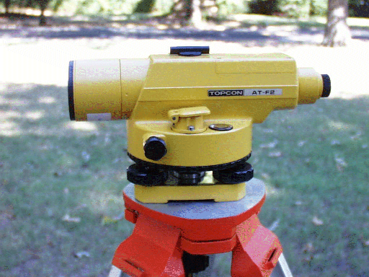
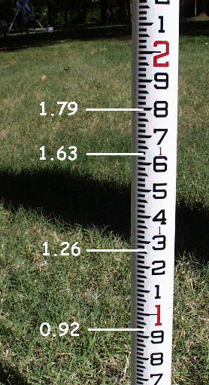
  - The level is attached to a spirit or bubble level that keeps the line of sight of the telescope horizontal
  - Level Instruments

  - Reading the Rod
- Definitions
  - Bench mark (BM) - relatively permanent
point of known elevation
  - Backsight (BS) - a sight taken to the level rod held at a point of known elevation
(either a BM or TP)
  - Height of instrument (HI) - the elevation of the line of sight of the telescope
  - Foresight (FS) - a sight taken on any point to determine its elevation
- Computation of Elevations
  - BS + Elevation = HI
  - HI – FS= Elevation
  - Change in elevation- summation of the backsight and the foresight then subtract
  - The initial backsight (BS) is taken to a point of known elevation
  - The backsight reading is added to the elevation of the known point to compute the height of the instrument (HI)
  - The level may be moved to a temporary point called a turning point (TP)
  - The elevation of a point is the height of the instrument (HI) minus the foresight (FS)

- Common Mistakes
  - Misreading the rod - reading 3.54 instead of 3.45
  - Moving the turning point - use a well–defined TP
  - Field note mistakes - work within your group to check you records
  - Mistakes with extended rod - make sure the leveling rod is fully extended
  - Level rod not vertical
  - Settling of leveling rod
  - Leveling rod not fully extended or incorrect length
  - Level instrument not level
  - Instrument out of adjustment
  - Environment - wind and heat

