Ag Welding Name:

Disc Blade Fire pit

Instructions Date:

**Step I – Gather Materials**

1. 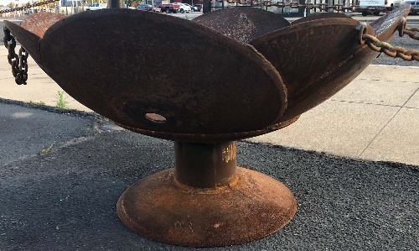You will need 7 disc blades all similar in size.
2. The pedestal is made of either a piece of pipe or square tubing. Length will determine how tall the fire pit will be. Suggest 6-10” long.
3. E7018 electrodes.

**Step II – Material Prep**

1. Disc blades - clean up with a wire cup on an angle grinder.
2. Pedestal riser – cut and de-burr

**Step III – Pedestal Assembly**

1. Place bottom disc on a flat, level surface.

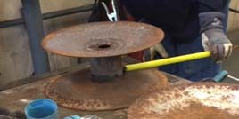

1. Center the pedestal riser on the disc blade, level and tack on 4 points.
2. Place a second disc on a flat, level surface and place the assembly on it (up-side-down), level and tack on 4 points.
3. Weld up.

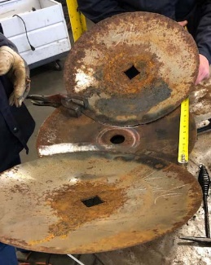**Step IV – Pit Assembly**

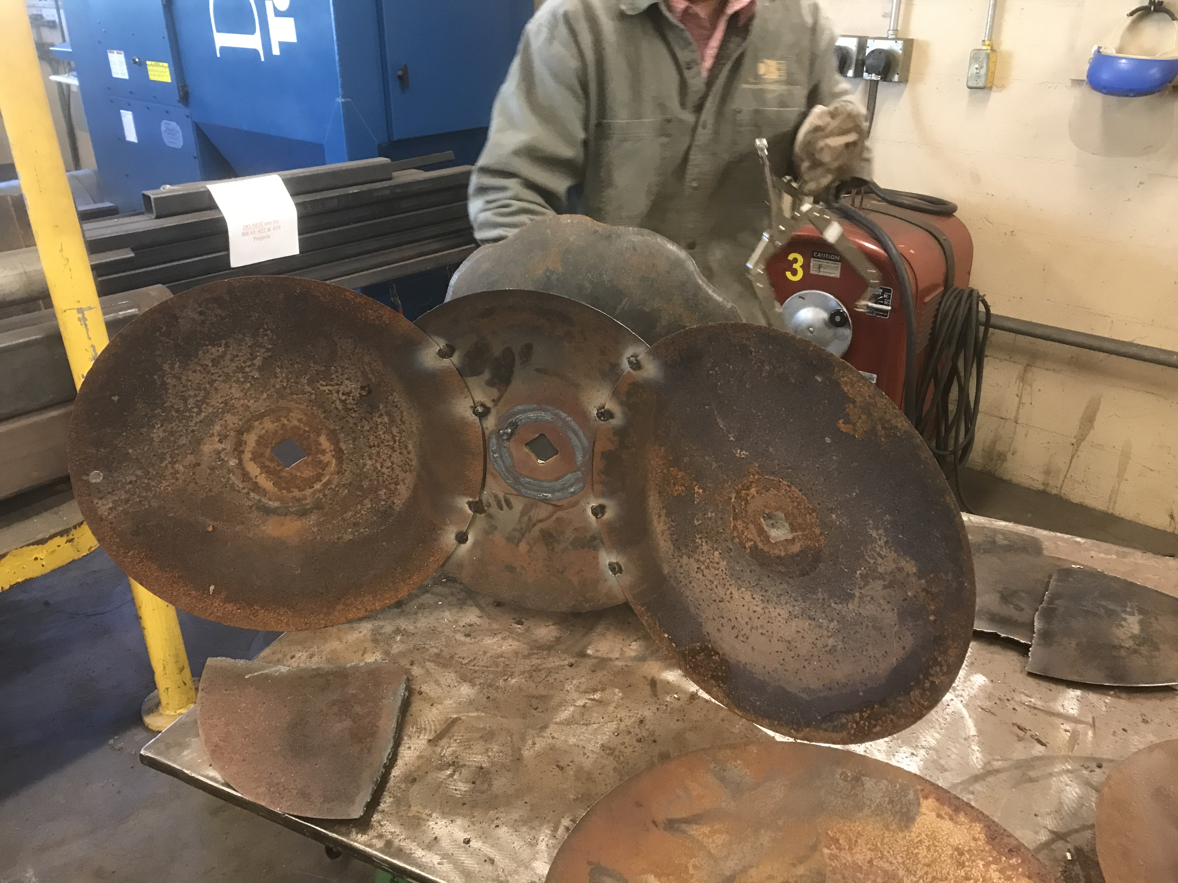

1. Weld a cap over the hole in the center of the pit (If desired).
2. Position 2 disc blades directly across from each other, tack in place. Make sure the disc blades are flat against the upper blade of the pedestal.
3. Use clamps to hold pieces in place while tacking/welding.

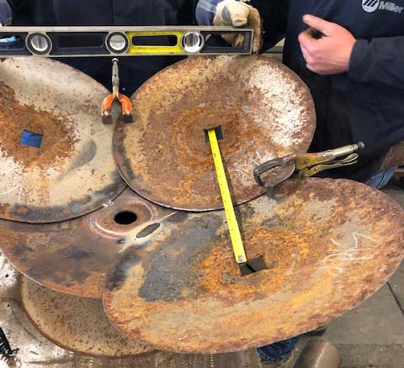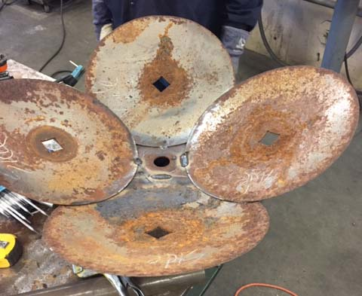

1. Position the next 2 disc blades directly across from each other and perpendicular to the first 2 blades.
2. Measure frequently to be sure the blades are square with each other (north, south, east & west) and clamp securely in place before tacking.
3. 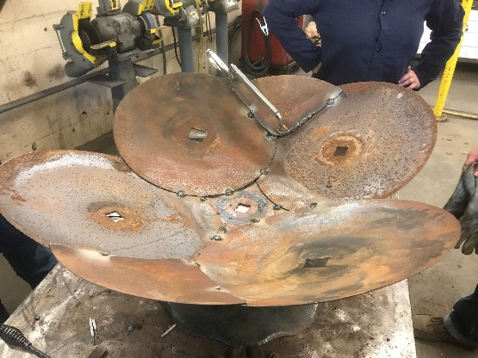Cut the remaining disc blade into 4 equal parts (quarters) with an Oxy-Acetylene torch. Clean off the slag with an angle grinder. Tack into place as shown in the picture.

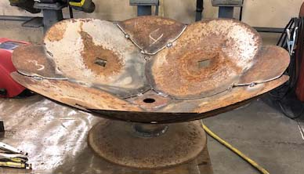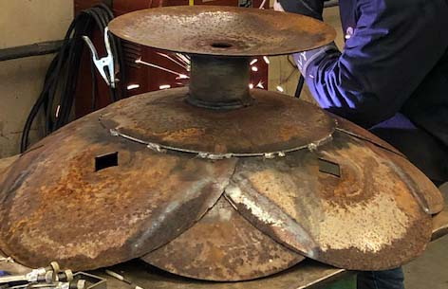

1. Turn the assembly over. Tack to upper blade of the pedestal making sure it remains flat.
2. Weld assembly together. Be careful when welding near the edges of the blades as they are much thinner there and you would be apt to burn through. Don’t weld too long in one place; move around to spread the heat.

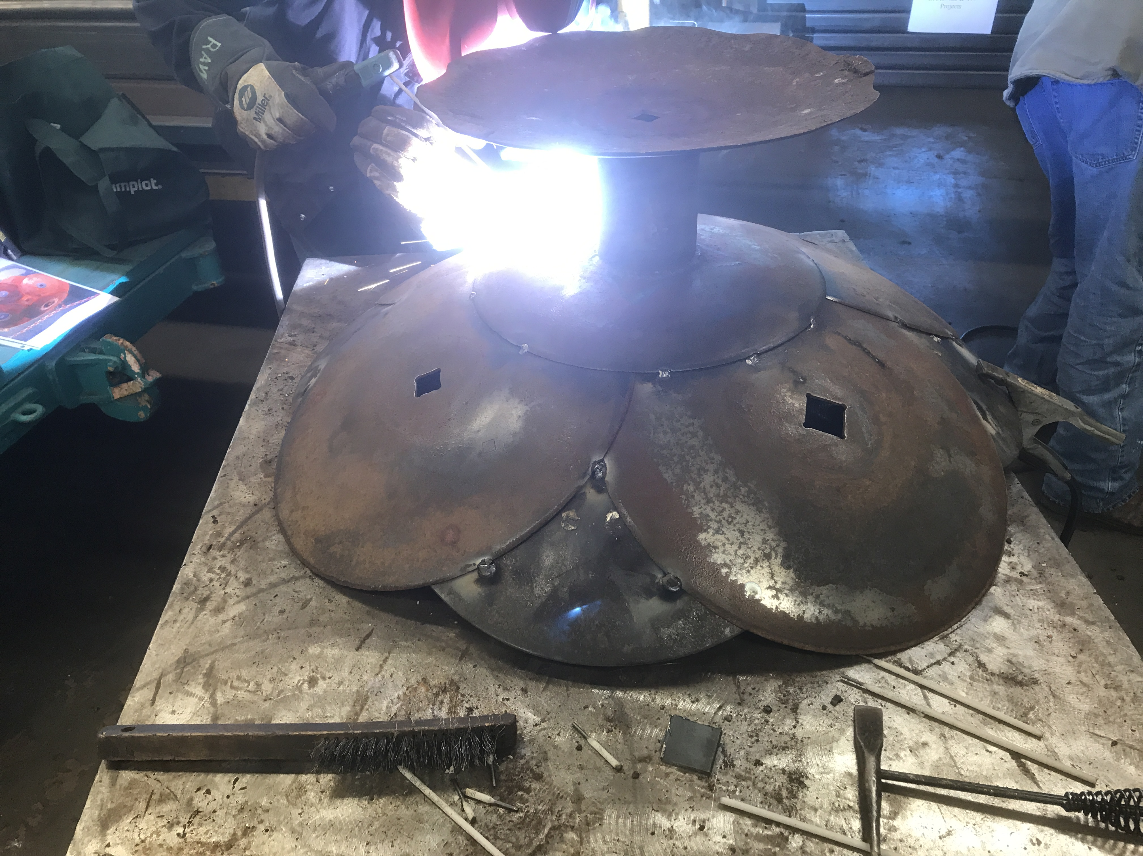

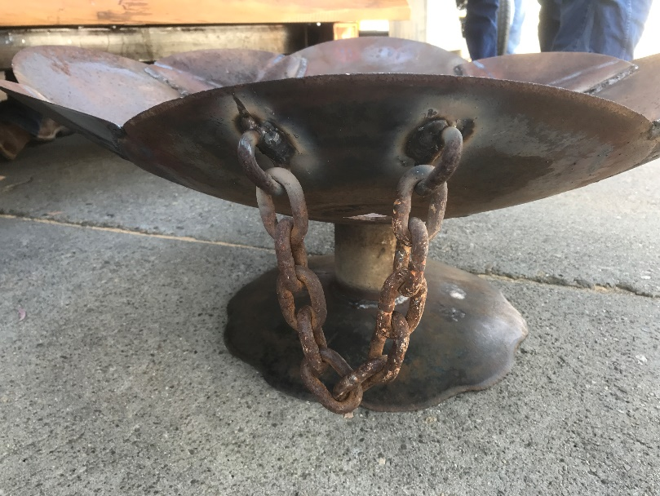

**Step V – Finish**

1. Remove slag with wire wheel/cup, or a wire brush. Clean up as you go.
2. If necessary, use a sanding disk to smooth out rough welds.
3. Add chain handles.