CATA Skills 2017

Metal Project Construction: Intermediate and Advanced: 3 Sessions (Thursday PM, Friday AM & PM)

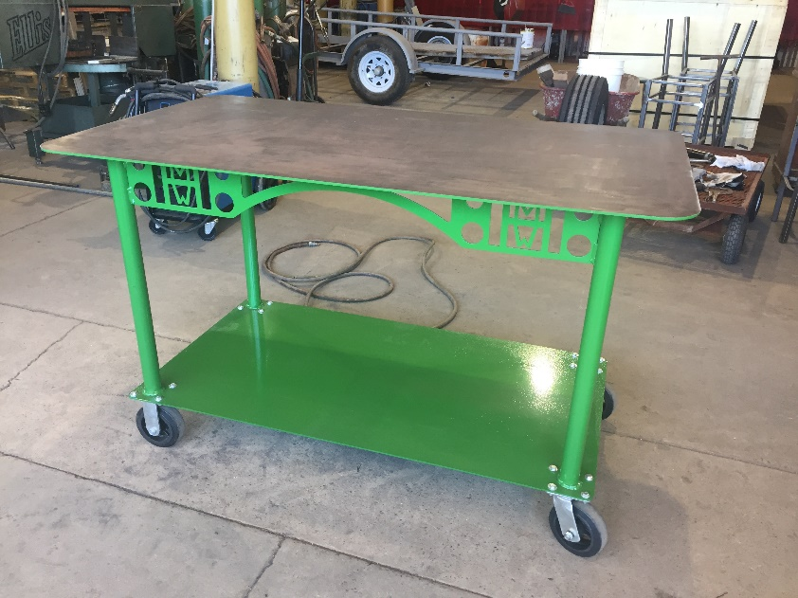

Project: Shop Table –

Description:

1. Top is 60” Long x 34” (fits through a 36” Man Door)
2. Table is 36-1/2” Tall
3. Rides on 6” heavy duty casters (2 swivel; 2 straight)
4. Top is 5/16” Plate (1/4” or 3/8” works well too
5. Legs qre 1-1/2” Sch 40 Black Pipe
6. Shelf and all supports are 3/16” plate

Construction Steps:

1. Clean up the slag (from plasma cutting) on all parts.
2. Start with the table top up-side-down on 2 saw horses (Right). You will assemble the table in this position
3. 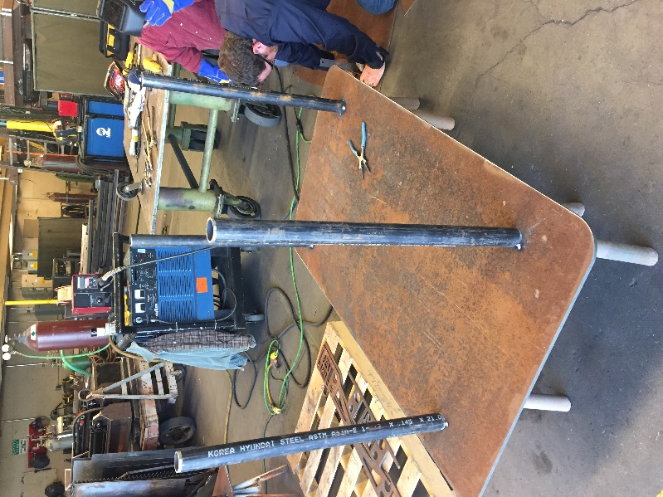Use the jig to locate the position of the legs on the table top (Below).
4. Tack weld each leg in place with 1 tack on the inside or outside. You should still be able to move the legs slightly to square them up once the shelf is installed.
5. Once the 4 legs are tacked in place, slide the shelf over the legs (Below). Use scraps of plate steel to clamp over half of the hole that the leg goes through so it stays flush with the end of the legs.

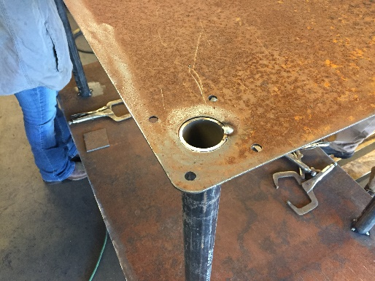

1. 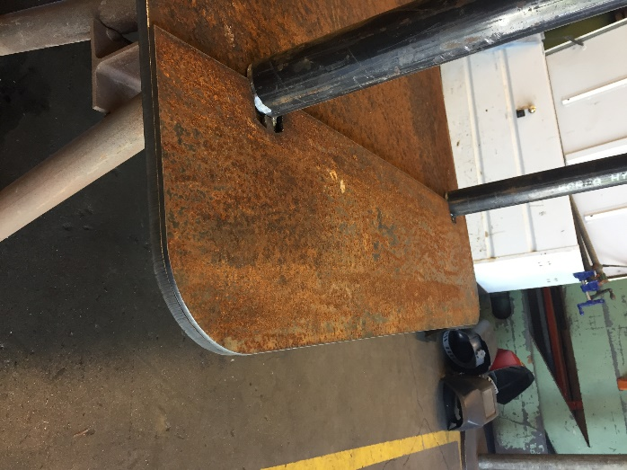Tack weld each leg to the shelf (1 tack per leg).
2. 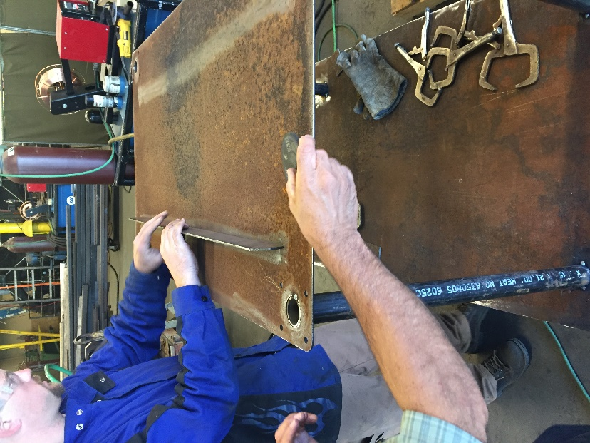Next you will tack in place the shelf supports. Since the shelf is made of 3/16” plate, it will flex when heavy items are stored on it. You will install 2 “stiffeners” as shown. Notice that rust and scale have been sanded away so the tacks and later, the welds will not be affected by porosity.
3. Take the time to measure out where the welds will go (this adds to “quality of workmanship). Tack in place

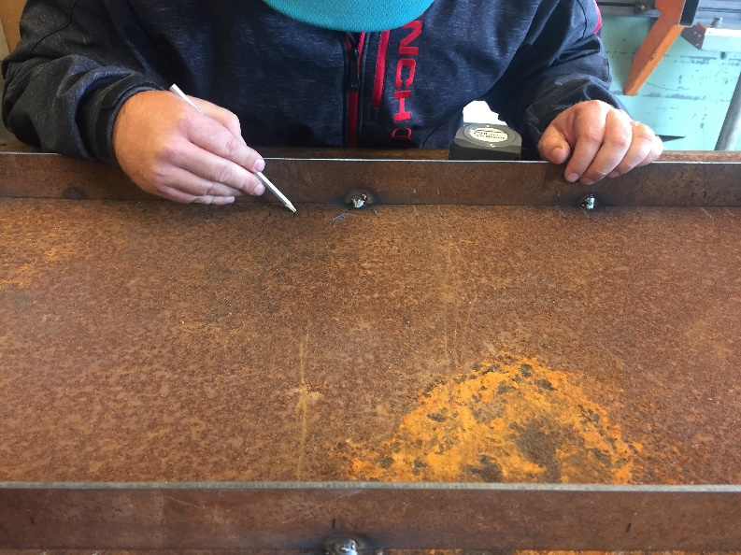

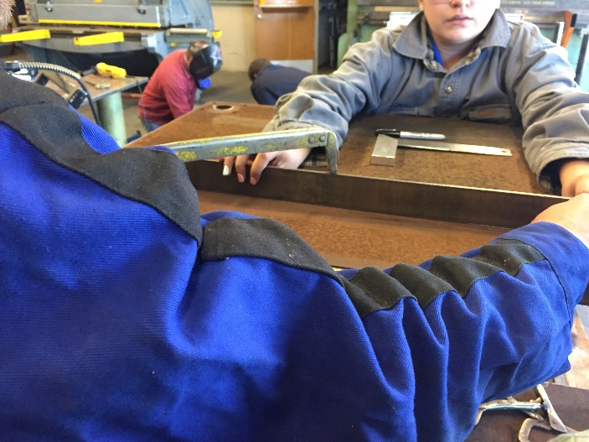

1. Use clamps to make sure the “stiffeners” are flush and that there are no bows in the shelf.
2. Next step will be to square the table legs. You will want to measure your diagonals both from the long edge and also the short edge. Use bar clamps to hold assembly in place while you add tacks.
3. Once square, weld the table legs to the shelf as shown.
4. Weld the legs to the table top.
5. Weld the shelf “stiffeners” in place.
6. Clean up welds and “berries” as you go.

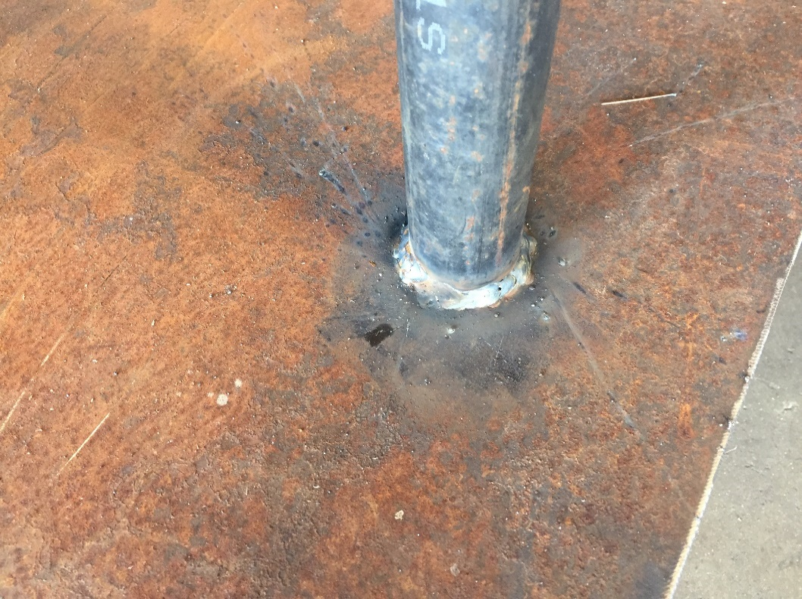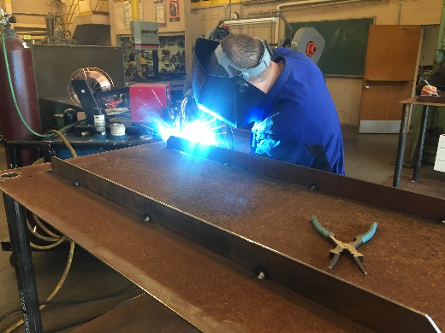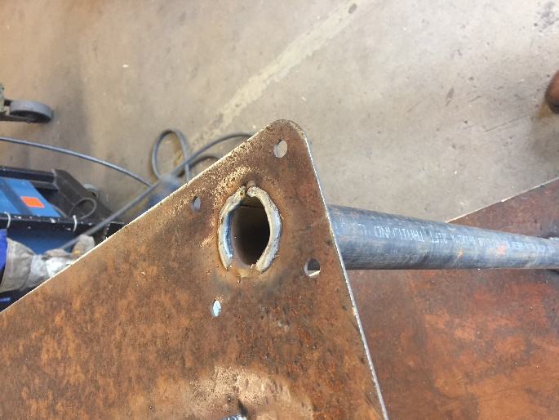

1. 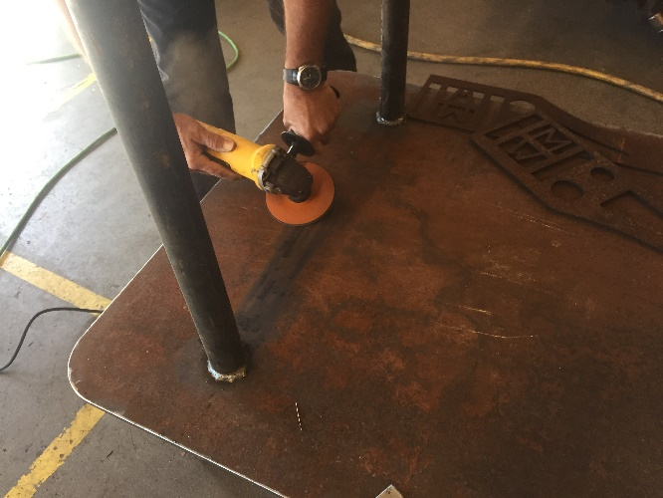Next, sand the area between the table legs as shown.
2. 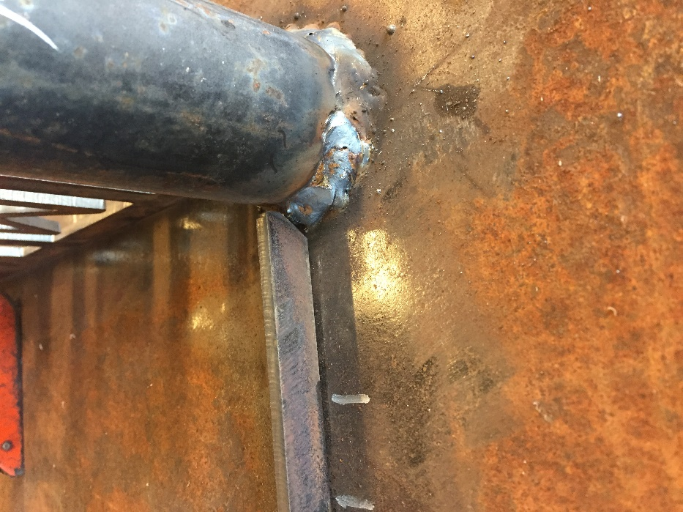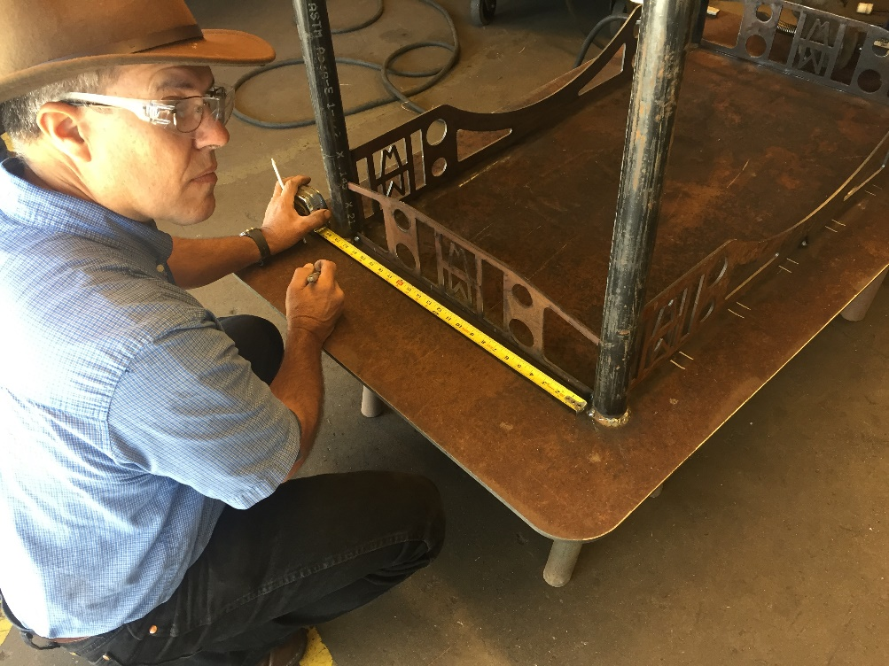Tack the table top supports in place as shown. Take the time to measure where the welds will go.
3. Notch the supports where they meet the welds (leg to table top)
4. Clean up welds and berries as you go.
5. 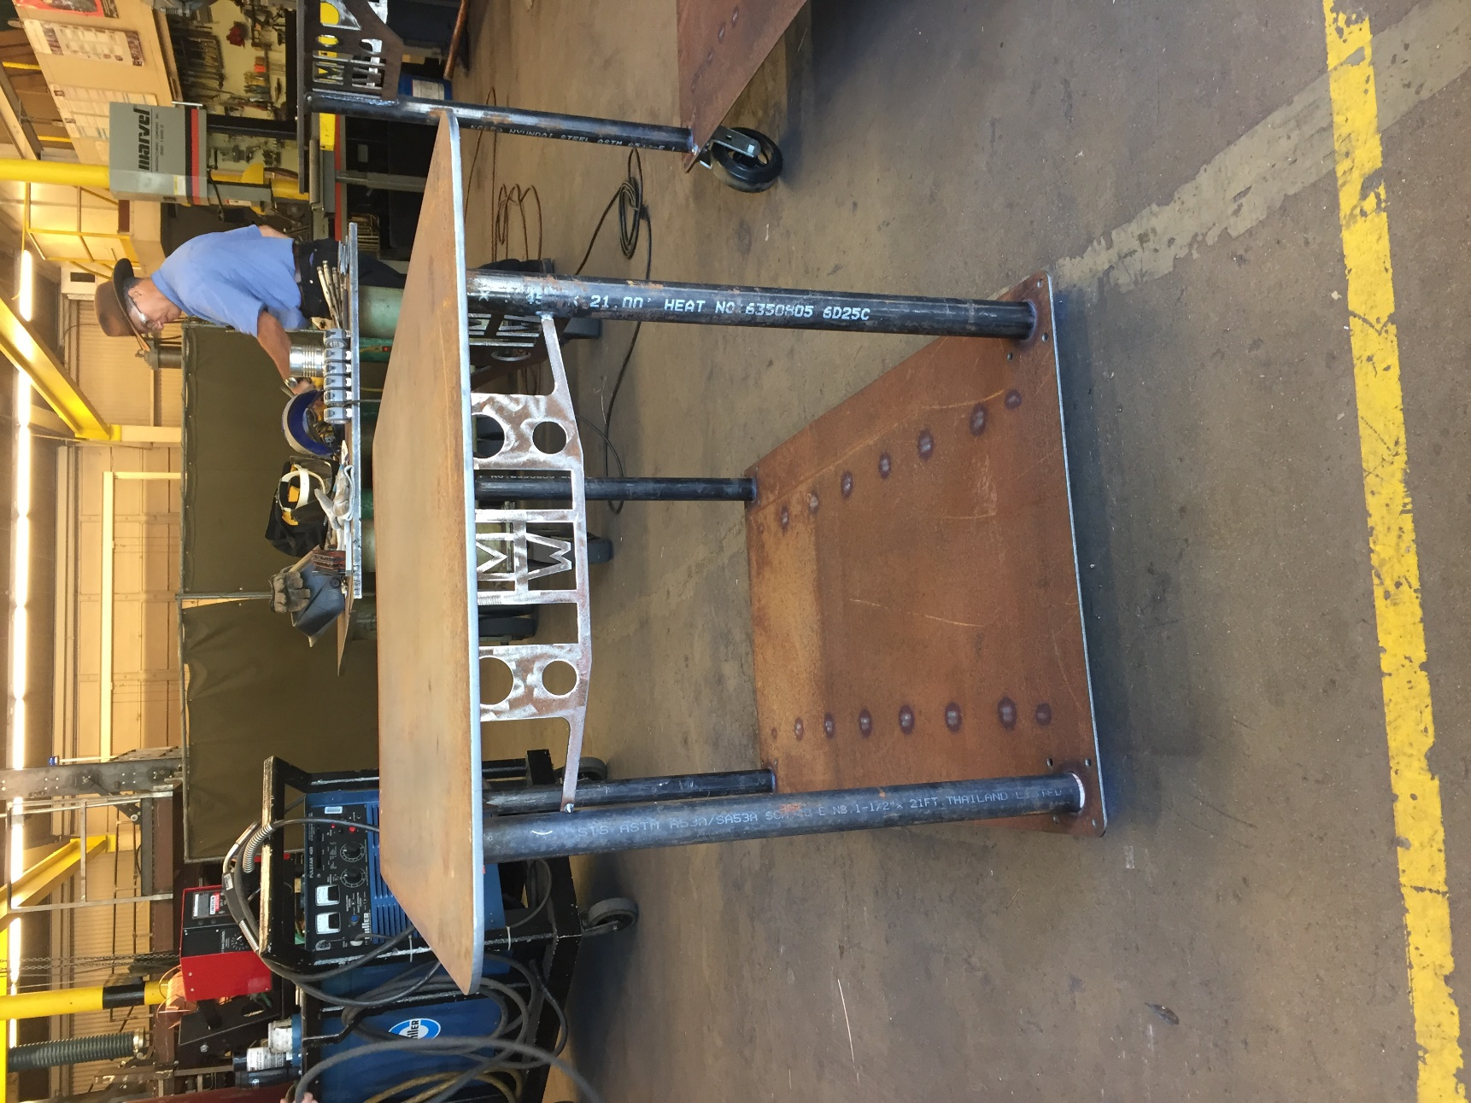Once all welds are complete, flip the table over and weld the legs to the shelf. Your project should now look like this:
6. Temporarily install the casters (2 bolts each one) and do final cleanup with the sander.

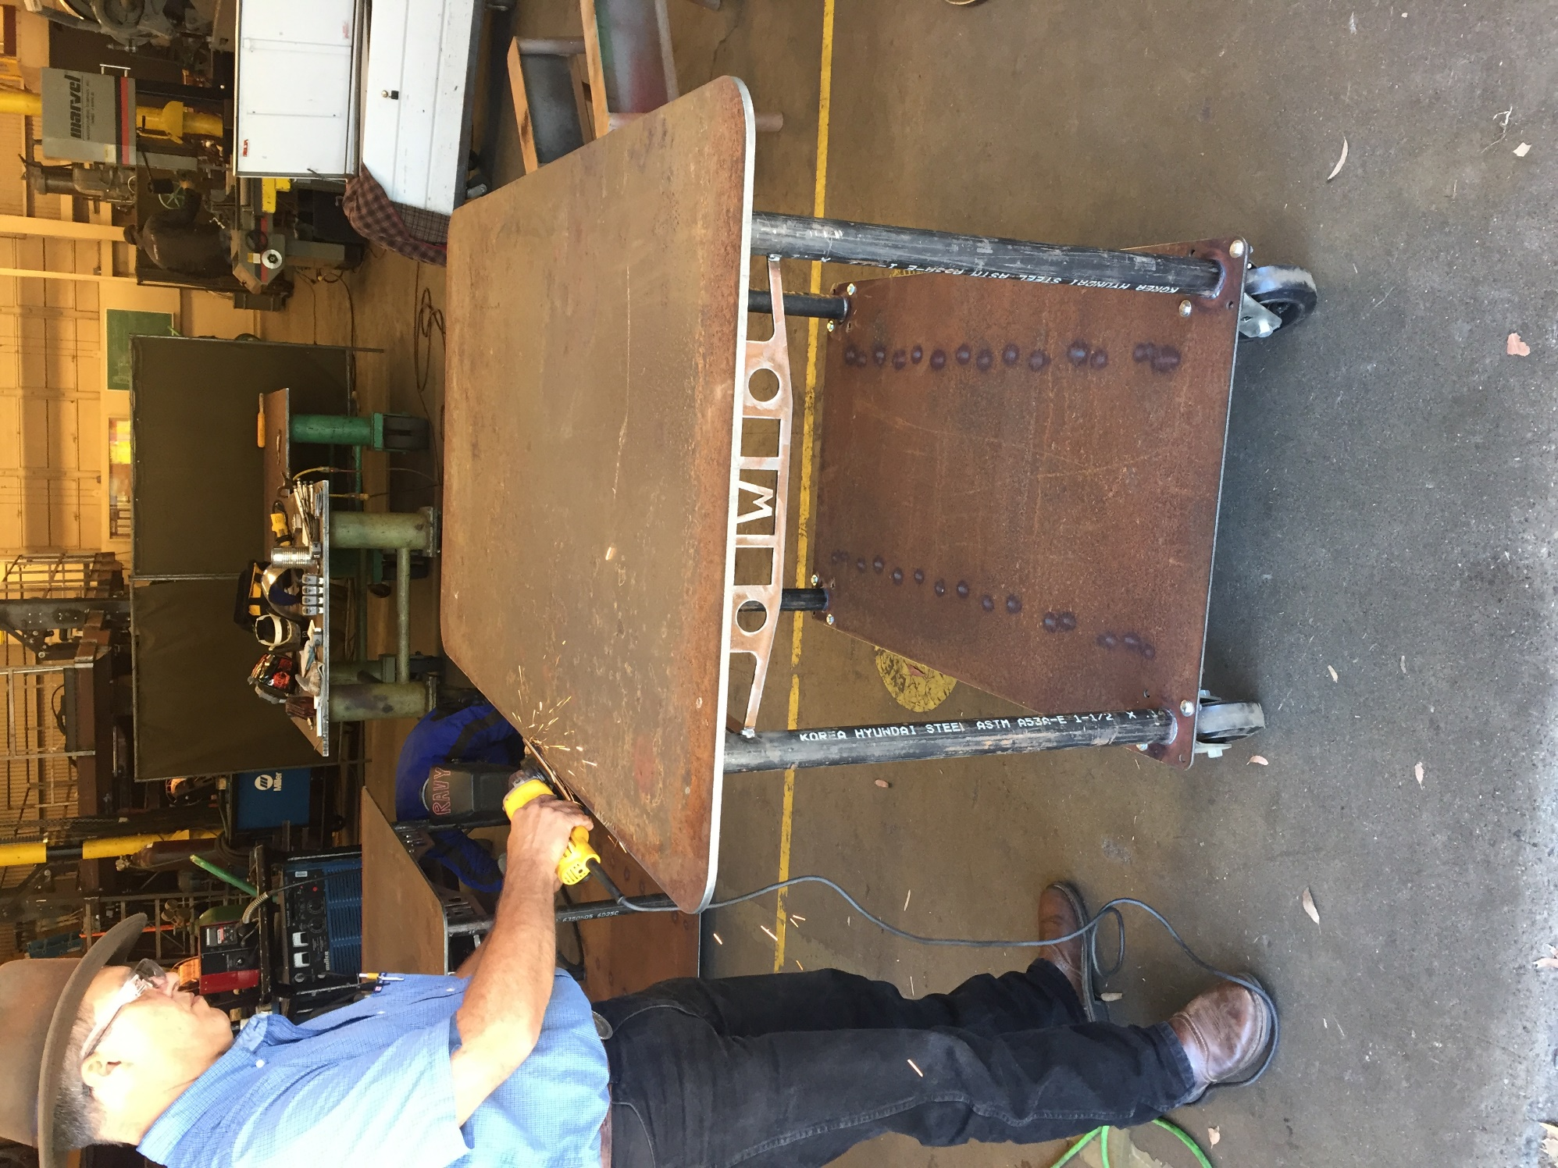

1. Table is ready to sand blast & paint.

Presenters:

Dick Piersma - Hilmar HS ([dpiersma@hilmar.k12.ca.us](mailto:dpiersma@hilmar.k12.ca.us))

Ryan Patterson – Ripon HS (rpatterson@sjcoe.net)

Sam Meredith – Atwater HS ([smeredith@muhsd.org](mailto:smeredith@muhsd.org)) 209-495-6635  Can demonstrate Anytime

Darrell Hirschler – Central HS (dhirschler@centralusd.k12.ca.us)

Morgan Rourke – Hayfork HS (mdrourke@mvusd.us)

Garrett Rowley – Mariposa HS ([growley@mcusd.org](mailto:growley@mcusd.org))

Rich Darrach - Las Plumas HS ([rdarrach@ouhsd.org](mailto:rdarrach@ouhsd.org))

Resources:

<http://www.agedweb.org/>  (click: Ag Mechanics Instructional Resources)