Dinner Bell Triangle & Ringer

Description
This triangle dinner bell project is designed to teach hot metal and/or cold metal bending of steel. This triangle and ringer will be useable as a working item or a decorative item.

Materials
3/8” HR round steel

Tools
Hossfeld bender
Oxy-acetylene torch
Vice
Cut off saw or hydraulic shear
Hack saw
Welding gloves
Grinder
Emery cloth
Bastard & smooth flat files
Soap stone

Directions: Ringer
- Cut a piece of the HR round steel 9” long
- Use hydraulic shear or cut off saw
- File down the one end to a smooth finish using the Bastard & Smooth Flat Files
- Using the Hossfeld bender, bed an eye on the smoothed end, leaving the opening slightly larger than the diameter of the round steel.
- Trim your ringer to length (see plan) using the cut off saw
- File down the trimmed end to a smooth finish using the Bastard & Smooth Flat Files
- Put your name on your project with tape
- Note: If painting the project use emery cloth to clean metal.

Directions: Triangle

Procedure (Hot Bending)
- Cut a piece of HR round steel 24” long using a cut off saw.
- Smooth ends with file.
- Using a soapstone mark 8” and 16”, we are dividing the piece in thirds.
- Place the first 8” in a vice.
- Use a torch to heat the first mark and bend the round steel at 60o angle using a wooden pattern.
- Heat the second mark and finish bending the round steel to close your triangle.
- Leave the ends about a quarter (1/4”) a part.
- The triangle should lay flat.
- Let your project cool before moving it.
- File down any rough edges left by the vise.
- Put your name on your project with tape
- Note: If painting the project use emery cloth to clean metal.
- Turn in project with grade sheet

Procedure (Cold Bending)
- Cut a piece of HR Round Steel 24” long using a cut off saw.
- Smooth ends with file.
- Using a soapstone mark 8” and 16”, *we are dividing the piece in thirds.
- Place the first 8” into the Hossfeld bender and bend at 60º angle
- Place the 16” mark in the Hossfeld bender and bend at 60º angle
- The ends should be about a quarter (1/4”) a part.
- Your triangle should lay flat
- Put your name on your project with tape
- Note: If painting the project use emery cloth to clean metal.
- Turn in project with grade sheet

Photo/Drawing
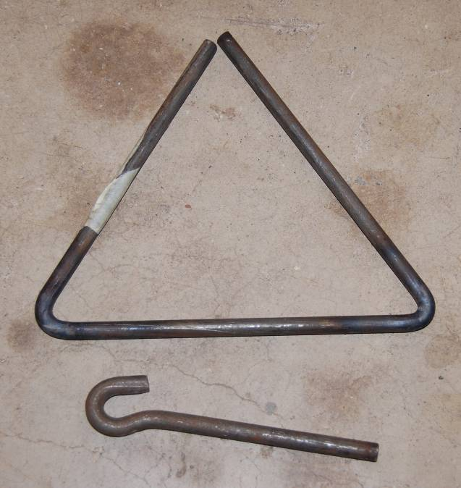

Triangle Worksheet
- What is the degree of the angles you made? _______
- How long is each side of the triangle? ________
- What is a tool we used to cut the metal? _____________
- What was the metal we used? _________
- What is the finished length of the ringer___________

Grading Rubric
Criteria (tolerance +/- 1/16") | Possible | Score
Ringer
Length of ringer | 4
Quality of Eye Bend (3/8” gap, centered, round) | 4
Triangle
Dimensions (8” per side) | 4
Triangle lays flat | 4
General Workmanship  (dressed edges, angles, bending, 1/4 “ gap) | 4
TOTAL | 20

Cold Metal Teacher Notes:

Agricultural Standards Met:
4.0 Technology. Students know how to use contemporary and emerging technological resources in diverse and changing personal, community, and workplace environments:
4.6 Differentiate among, select, and apply appropriate tools and technology.
5.0 Problem Solving and Critical Thinking. Students understand how to create alternative solutions by using critical and creative thinking skills, such as logical reasoning, analytical thinking, and problem-solving techniques:
5.1 Apply appropriate problem-solving strategies and critical thinking skills to work-related issues and tasks.
5.3 Use critical thinking skills to make informed decisions and solve problems.
6.0 Health and Safety. Students understand health and safety policies, procedures, regulations, and practices, including the use of equipment and handling of hazardous materials:
6.1 Know policies, procedures, and regulations regarding health and safety in the workplace, including employers’ and employees’ responsibilities.
6.2 Understand critical elements of health and safety practices related to storing, cleaning, and maintaining tools, equipment, and supplies.
6.4 Maintain safe and healthful working conditions.
6.5 Use tools and machines safely and appropriately.
6.6 Know how to both prevent and respond to accidents in the agricultural industry.
B1.0 Students understand personal and group safety:
B1.1 Practice the rules for personal and group safety while working in an agricultural mechanics environment.
B1.2 Know the relationship between accepted shop management procedures and a safe working environment.
B5.0 Students understand agricultural cold metal processes:
B5.1 Know how to identify common metals, sizes, and shapes.
B5.3 Know layout skills.
B5. 4 Know basic cold metal processes (e.g., shearing, cutting, drilling, threading, bending)
B5.5 Complete a cold metal project, including interpreting a plan, developing a bill of materials, selecting materials, shaping, fastening, and finishing.

Objectives:
By successfully completing this project students will be able to:
- Read a plan to obtain critical dimension
- Measure and layout a project on metal
- Identify by name common types of metal
- Select and properly use hand and power tools used for cold metal projects
- Bend metal using hot and cold processes.

Alternate Tools/Method/Materials:
Project can be done completely with cold bending. Cutting can be done with a hacksaw, cutoff saw, or shear. Cold bending can be done in vise (use a piece of round as a form).

Safety Review
- Hossfeld Bender
- Oxy-Acetylene Torch
- Cut Off Saw
- Grinder
- Hydraulic Shear

Project Time:
Demonstration: | 15-30 minutes
Build: | 1-2 hours

Demonstration Notes
- Review materials (HR round)
- Review tools
- Review plan, have students answer the worksheet questions.
- Review safety and use of each tool
- Measure and cut the metal
- Demo use of files (Tip: Always file on the forward stroke so you don’t dull the file) to dress ends of round stock.
- Demo bending (Ringer) on the Hossfeld bender. Show the setup (dies) for this type of bending.
- Trim the ringer to length and dress ends.
- Stress workmanship.
- Demo oxy heating (triangle) Tips: make a triangle from a scrap of 1” pine with 60º angles on the miter saw. Use this as a bending guide. Heat a small area so the bends will be sharp. If using a cutting tip warn not to press the oxygen lever.
- Remind students of grading rubric

Bill of Materials
Project from: Mike Spiess

