Sheet Metal Tray
Name: ____________
Date: ____________

Description:
Trays or dividers are expensive and hard to find for tool chests. The trays are sturdy, interlocking and can be adjusted to fit any tool chest or drawer. Made from scrap. Teaches beginning sheet metal skills and plan layout.

Materials:
26 ga. galvanized sheet metal

Tools:
Steel tape
Scratch awl
Sheet metal shear
Sheet metal brake

Procedure:
- Adjust the length if needed to fit the tool chest. Adjust the width as desired for the tray width.
- Make corrections to the plan dimensions as needed.
- Shear sheet metal to outside dimensions.
- Mark ½ hem on one side and other two folds on the reverse side.
- Make a loose hem so the tray can interlock with the next tray.
- Turn over and bend the hem side first then the last fold on the opposing side.

Cutting List: (optional)
Quantity | Size | Material
1 | 8 ½” x 14” | 26 ga sheet metal

Notes:
__________________________________________________________________________________________________________________________________________________________________________________________________________________________________________________________________________________________________________________________________________________________________________________________________________________________________________________________________________________________________________________________________________________________________________________________________________________________________________________________________________________________________________________________________________________________________________________________________________________________________________________________________________________

Photo/Drawing:
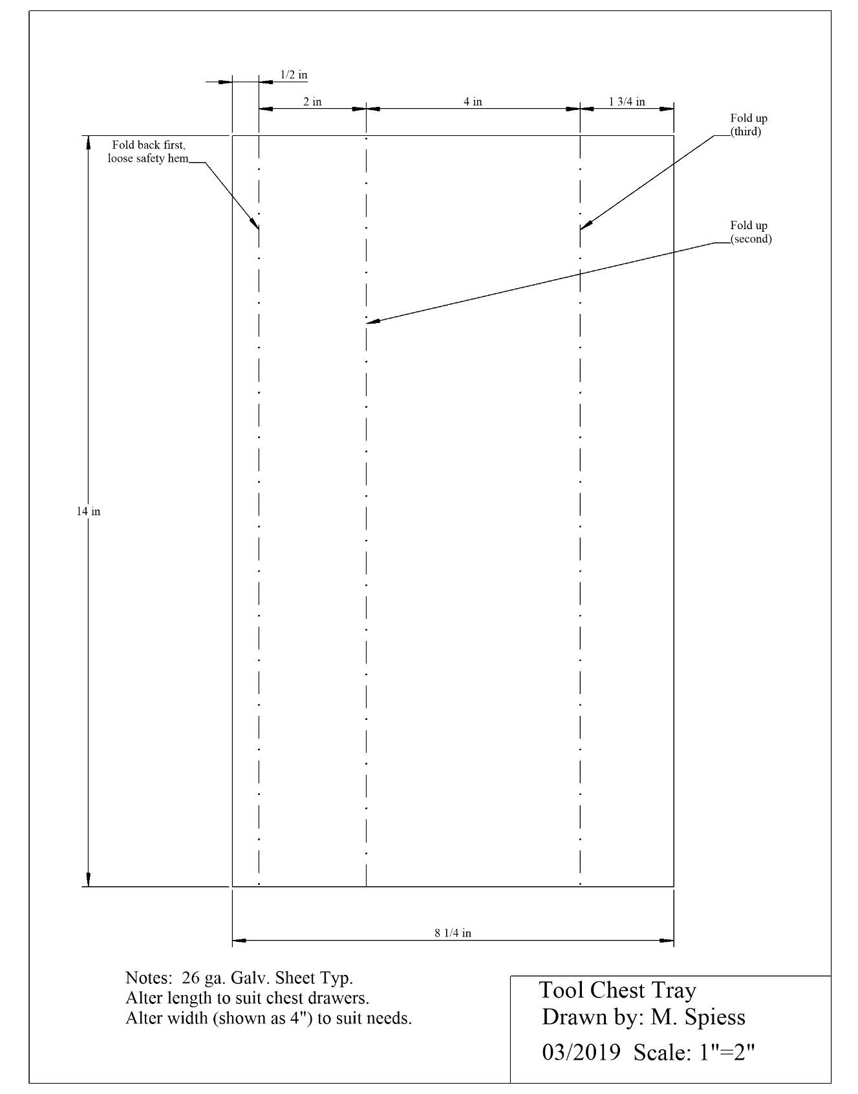
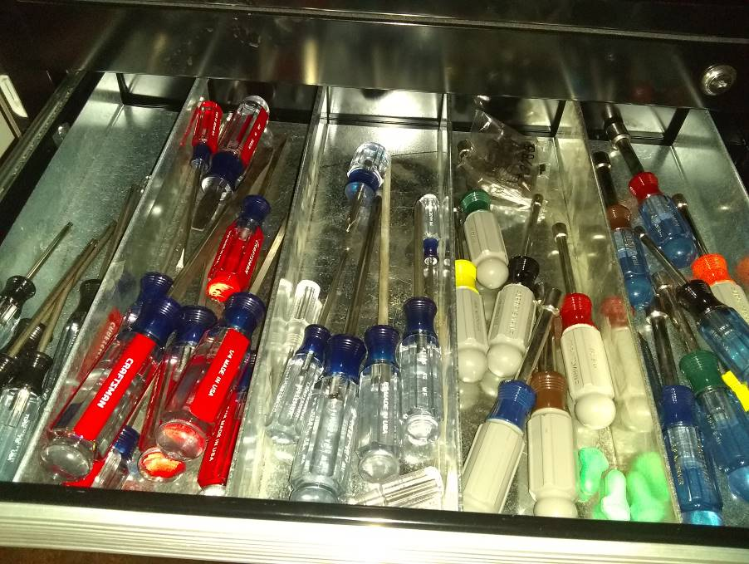
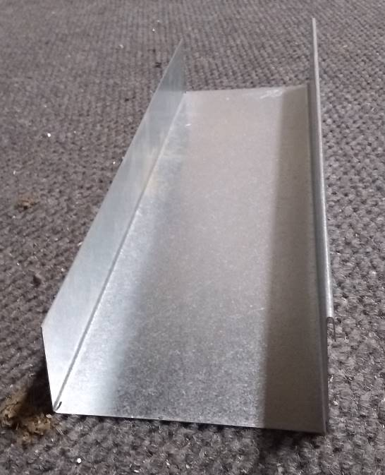

Sheet Metal Box Worksheet
Name: ________________________
Date: ________________________

- What are the dimensions of the tray supposed to be?

- What size the flat piece of sheet metal?

- Which bends are only bent 90-degrees?

- What are the safety considerations when using the foot shear?

- What are the safety issues with a brake?

Grading Rubric:
CRITERIA | POSSIBLE | SCORE
Proper Length (14” or desired length) | 5
Proper width (4” or desired width) | 5
Angle of bends (90 degrees) | 5
Square | 5
Workmanship (no sharp edges, not to scuffed) | 5
Total | 25

Sheet Metal Box Teachers Notes:

Agricultural Standards Met:
6.0 Health and Safety. Students understand health and safety policies, procedures, regulations, and practices, including the use of equipment and handling of hazardous materials:
6.1 Know policies, procedures, and regulations regarding health and safety in the workplace, including employers’ and employees’ responsibilities.
6.2 Understand critical elements of health and safety practices related to storing, cleaning, and maintaining tools, equipment, and supplies.
6.4 Maintain safe and healthful working conditions.
6.5 Use tools and machines safely and appropriately.
6.6 Know how to both prevent and respond to accidents in the agricultural industry.
B1.0 Students understand personal and group safety:
B1.1 Practice the rules for personal and group safety while working in an agricultural mechanics environment.
B1.2 Know the relationship between accepted shop management procedures and a safe working environment.
B5.0 Students understand agricultural cold metal processes.
B5.3 Know layout skills
B5.4 Know basic cold metal processes (e.g., shearing, cutting, drilling, threading, bending.)

Objectives:
By properly completing this project, students will be able to:
- Read a plan and layout dimensions.
- Demonstrate construction techniques for sheet metal

Alternative Tools/Methods/Materials:
- If no shear is available can be cut with snips.
- You can get creative and make short trays with a tab on the end (divider) that will interlock with longer trays.
- These also make excellent dividers in drawers for supplies.

Safety Review:
- Sheet metal (sharp)
- Sheet metal brake
- Shear

Project Time:
Demonstration: | 15 minutes
Build: | 30 minutes (1)

Demonstration Notes
- Use scraps.
- Cut multiple pieces to length first.
- Cut to various widths for desired tray width.
- Layout from sides. Hem on the back (1/2”), then 2 ½” from same edge on front. 1 ¾” from the opposite side.
- Bend hem first and leave loose. Note a more rounded bend can be achieved by adjusting the leaf back.
- Turn over the work and bend then next fold (next to the hem) to 90 degrees.
- Complete the last bend.
- Review the order of the bends.
- Stress the fact that the hem must be folded back.

Bill of Materials:
Plan by: M. Spiess

