Sheet Metal Toolbox
Name: ___________________
Date: ___________________

Description:
15” long sheet metal toolbox with wood ends and a dowel for handle. Useful for tools or supplies. Combines both beginning sheet metal skills and wood working. .

Materials:
26 ga. galvanized sheet metal
1” X 6” #2 common pine
1” diameter hardwood dowel
3d galv. common nails
#6 x 1” pan head screws
Sand paper
Tools:
Combination Square
Rule
Scratch awl
Claw Hammer
Miter Saw
Band Saw
Drill Press
Sheet Metal Brake
Cordless hand drill

Procedure:
Ends
- Measure and mark the length of the end on the 1 x 6wood, then cut the marked piece with the miter saw. Repeat.
- Layout the dowel hole and angles pieces from the plan using the combination square on both ends. Work around any knots.
- Use the drill press to drill out the 1” dowel hole.
- Cut the corners with the band saw.
- Sand the corners smooth.
- Measure and mark 15 1/8” on the wooden dowel
- Cut dowel with miter saw
Sides
- Sheer the sheet metal to size.
- Use the scratch awl to mark the ½” edges (hem) on the sheet metal.
- Flip the sheet metal over and use the scratch awl to measure and mark 6” from each edge as shown in the plan. Scratch straight lines across the sides for the bend locations.
- Use the sheet metal brake to bend and flatten the ½” sides on toward the side. Use the sheet metal brake to bend 90-degree angles along the 6” measurement lines.
Assembly
- Place dowel in the holes of both board pieces, then fit with the sheet metal to the wood checking for fit. Adjust the sheet metal if needed.
- Starting at the bottom and leaving 1/6” of the wood exposed use three nails to fasten the metal to the wood. Nails should be at least 1” from the edge.
- Insure that the ends are square then work your way around the sides and install a nail 1” from the bottom and 2 ½” from the bottom. Install a screw at the edge of the sheet metal hem.
- Adjust the dowel and install a screw from the top of one end to hod the dowel in place. (No glue so the handle can be replaced.)
- Sand the project, rounding exposed edges.

Cutting List:
Quantity | Size | Material
2 | ¾” x 5 ½’ X 10 ½” | #2 pine
1 | 15” X 17 ½” | Sheet Metal

Notes:
________________________________________________________________________________________________________________________________________________________________________________________________________________________________________________________________________________________________________________________________________________________________________________________________________________________________________________________________________________________________________________________________________________________________________________________________________________________________________________________________________________________________________

Photo:
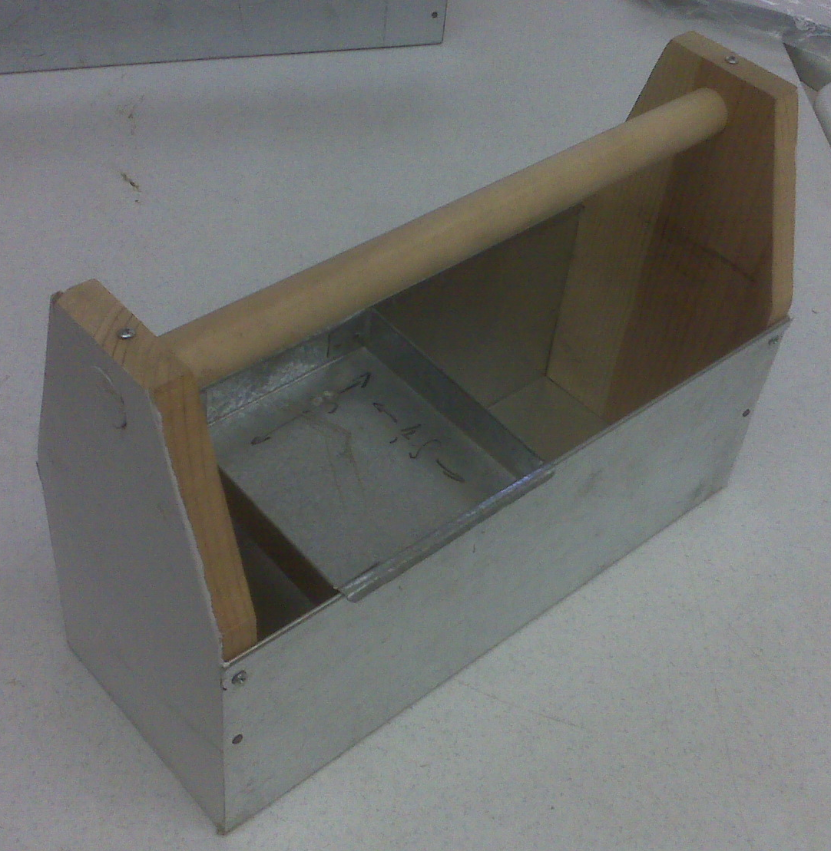

Drawing :
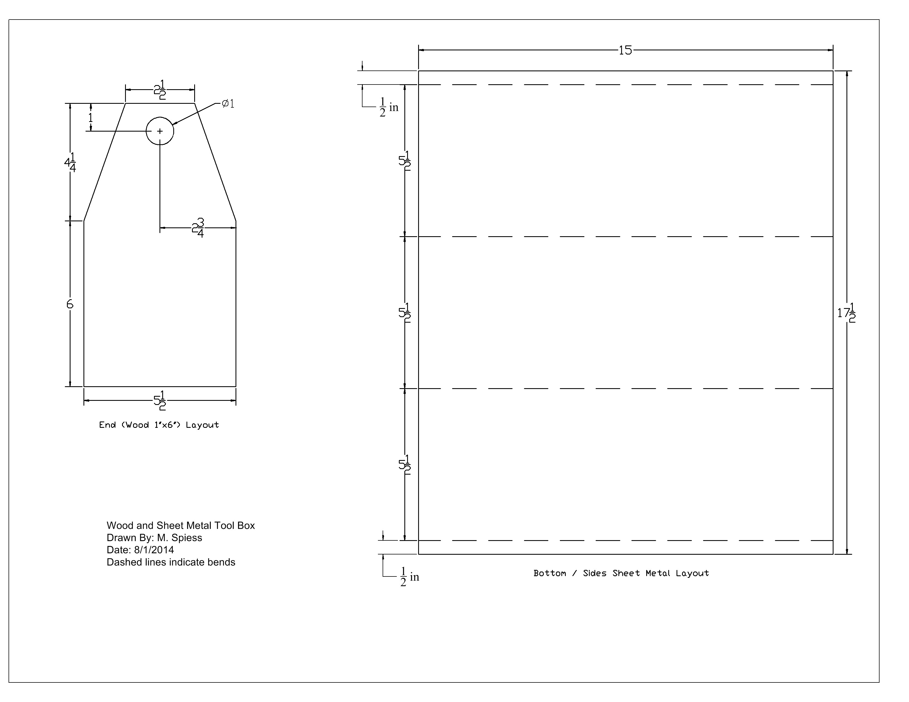
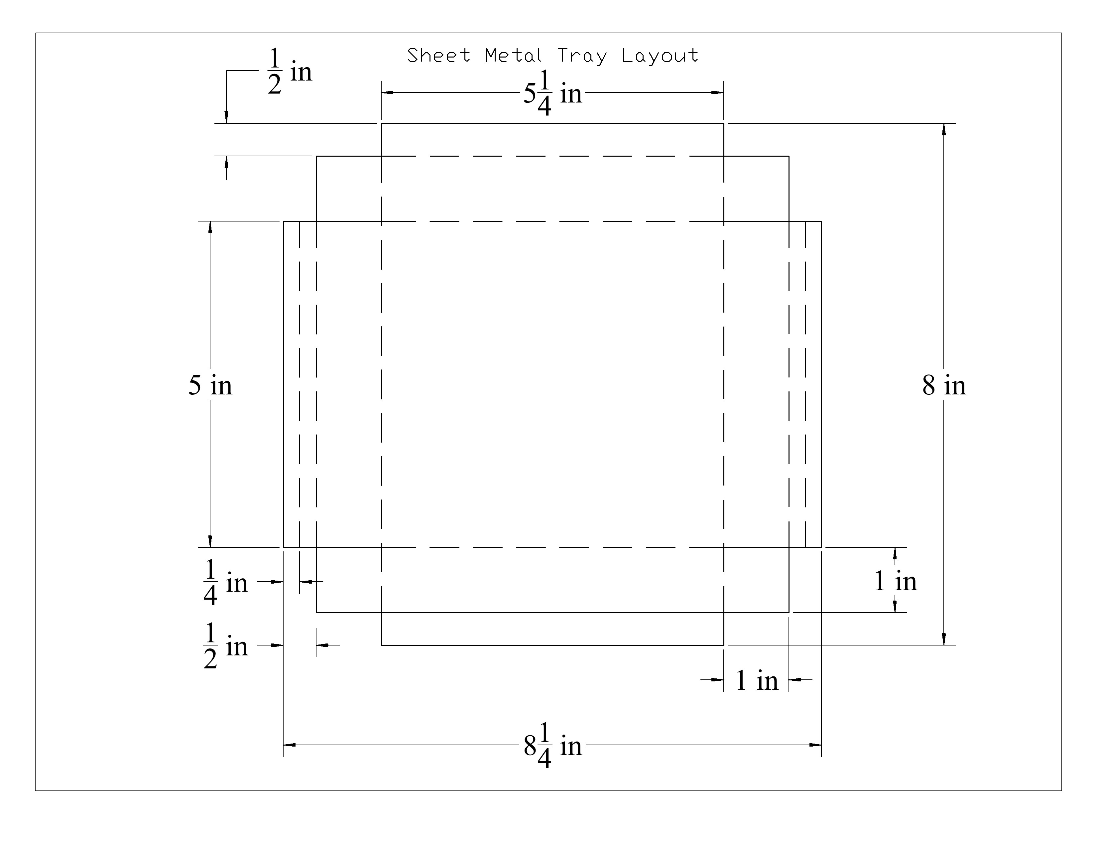

Sheet Metal Toolbox Worksheet
Name: ________________________
Date: ________________________

- What length does the toolbox ends need to be measured and cut at? ______________
- How many screws does the toolbox need? ______________
- How many nails does the toolbox need? ___________________
- Do you bend the hem before or after bending the 90-degree sides? ____________
- What is the first step to connecting the wood portions to the sheet metal?
___________________________________________________________________________
___________________________________________________________________________

Grading Rubric:
CRITERIA | POSSIBLE | SCORE
Height of Ends (10 ½”) | 5
Length of Toolbox (15”) | 5
Angle of Corners Cut | 5
Placement of screws and sheet metal nails | 5
Dowel Fitting | 5
Workmanship (fit, sanded, etc) | 5
Worksheet | 5
TOTAL | 35

Sheet Metal Toolbox Teachers Notes:

Agricultural Standards Met:
6.0 Health and Safety. Students understand health and safety policies, procedures, regulations, and practices, including the use of equipment and handling of hazardous materials:
6.1 Know policies, procedures, and regulations regarding health and safety in the workplace, including employers’ and employees’ responsibilities.
6.2 Understand critical elements of health and safety practices related to storing, cleaning, and maintaining tools, equipment, and supplies.
6.4 Maintain safe and healthful working conditions.
6.5 Use tools and machines safely and appropriately.
6.6 Know how to both prevent and respond to accidents in the agricultural industry.
B1.0 Students understand personal and group safety:
B1.1 Practice the rules for personal and group safety while working in an agricultural mechanics environment.
B1.2 Know the relationship between accepted shop management procedures and a safe working environment.
B2.0 Students understand the principles of basic woodworking.
B5.0 Students understand agricultural cold metal processes.

Objectives:
By properly completing this project, students will be able to:
- Read a plan and layout dimensions on wood and metal.
- Demonstrate construction techniques for wood and metal.

Alternative Tools/Methods/Materials:
- Wood portion can be made with a hand saw and brace.
- Hole can be drilled with a spade bit.
- Ends and handle could be made of sheet metal and spot welded.
- A sheet metal tray can also be built (see plan below). Tray is spot welded.

Safety Review:
- Miter Saw
- Drill Press
- Sheet Metal Brake
- Band Saw

Project Time:
Demonstration: | 40 minutes
Build: | 3 hours

Demonstration Notes
- You may wish to split demonstration into two sections: Layout of wood and metal, cutting and assembly.
- Demo the use of the combination square for the layout.
- When laying out the sheet metal be sure to stress the direction of the bends. The hem is bent on the outside of the box so the sides lay flat to the wood.
- Tip: When aligning the sides to the ends it is a not touch to have about 1/16” of the wood “revealed” or sticking out to make it less likely to catch the edge of the sheet metal. For this reason the handle should be 1/8” longer than the sheet metal.
- Use caution when cutting the dowel on the miter saw as it will roll if not held tight against the fence.
- Stress installing the handle before assembly. It is hard to push the handle all the way through on end.
- Tip: Installing the handle with the grain vertical for strength.
- Tip: Use a nail (ex. 6d duplex) to punch through the metal before installing the screws.
- Tip: Fit all the pieces before fastening.
- Tip: Stress start nailing on the bottom middle then work your way to the sides fitting as you go.
- Tip: Demonstrate nailing by looking down the edge of the project so the nail will be driven straight into the wood. If the nail comes out the side use a nail set to drive it out and then using the same hole and a different angle replace the nail.

Bill of Materials: Sheet Metal Toolbox
Project from: M. Spiess
Plan by: Shelby West
Tray plan. See photo.

