Tool Box Project
Name: ________________________
Date: ________________________

Description:
This project consists of building a tool tote that is useful in the shop or garden. General skills used to build this project include drawing, measuring, laying out the project and cutting the materials. Cutting the angles of this project offers additional challenges. Nails and glue are used to fasten different parts together. Finishing is another important skill used in this project.

Materials:
5d finish nails
Sand Paper
1" x 12" #3 Pine
1” x 8” #3 Pine
1” hardwood dowel
Wood Glue
Paint or Stain
Wood Dough

Tools:
Table Saw
Power Miter Saw
Band saw
Claw Hammer
Nail set
Drill Press
1” Forstner Bit
Combination square
Steel Tape

Procedure:
- Cross cut the 1 x 12 to 11 ½” (2).
- Layout the ends on these two pieces.
- Cut the angles on the band saw.
- Drill the holes for the handle using the drill press and Forstner bit.
- Round the top of the end by the handle hole with sandpaper or a stationary disc sander. You can rough cut with the band saw.
- Set the table saw to a78 degree bevel.. Trim the edge of a 1 x 8 to this angle. Rip a piece of 1 x 8 to 7” (narrow side) for the bottom.
- Rip a piece of 1 x 8 Rip lumber to 6 ½” width for the sides.
- Cross-cut the sides and bottom to length.
- Cut the dowel to length. Hint: cut 1/16” long to insure a good fit.
- “Dry fit” all the parts to be sure you have a good fit.
- Install the dowel.
- Assemble the ends to the bottom with nails and glue.
- Assemble the sides to the bottom/ends with glue and nails. Use the sides to square the ends to the bottom. Double check square with the combination square.
- Counter sink all nails.
- Sand and fill the nail holes.
- Sand and finish.
- Use a short screw or nail to secure the handle.

Cutting List:
2 | 3/4"x 10 x 12” | End | #3Pine
2 | 3/4"x 6 ½” x 23" * | Side | #3Pine
1 | 3/4"x 7 1/2"x 21 1/2" * | Bottom | #3Pine
1 | 1"x23" | Handle | Hardwood dowel
* Tapered width.

Notes:
____________________________________________________________________________________________________________________________________________________________________________________________________________________________________________________________________________________________________________________________________________________________________________________________________________________________________________________________________________________________________________________________________________________________________________________________________________________________________________________________________________________________________________________________________________________________________________________________________________________________________________________________________________________________________________________________________________________________________________________________________________________________________________________________________________________________________________________________________________________________________________________________________________________________________________________________________________________________________________________________________________________________________________________________________________________________________________________________________________________________________________________________________________________________________________________________________________________________________________________________________________________________________________________________________________________________________________________________________________________________________________________________________________________________________________________________________________________________________________________________________________________________________________________________________________________________________________________________________________________________________________________________________________________________________________________________________________________________________________________________________________________________________________________________________________________________________________________________________________

Photo/Drawing:
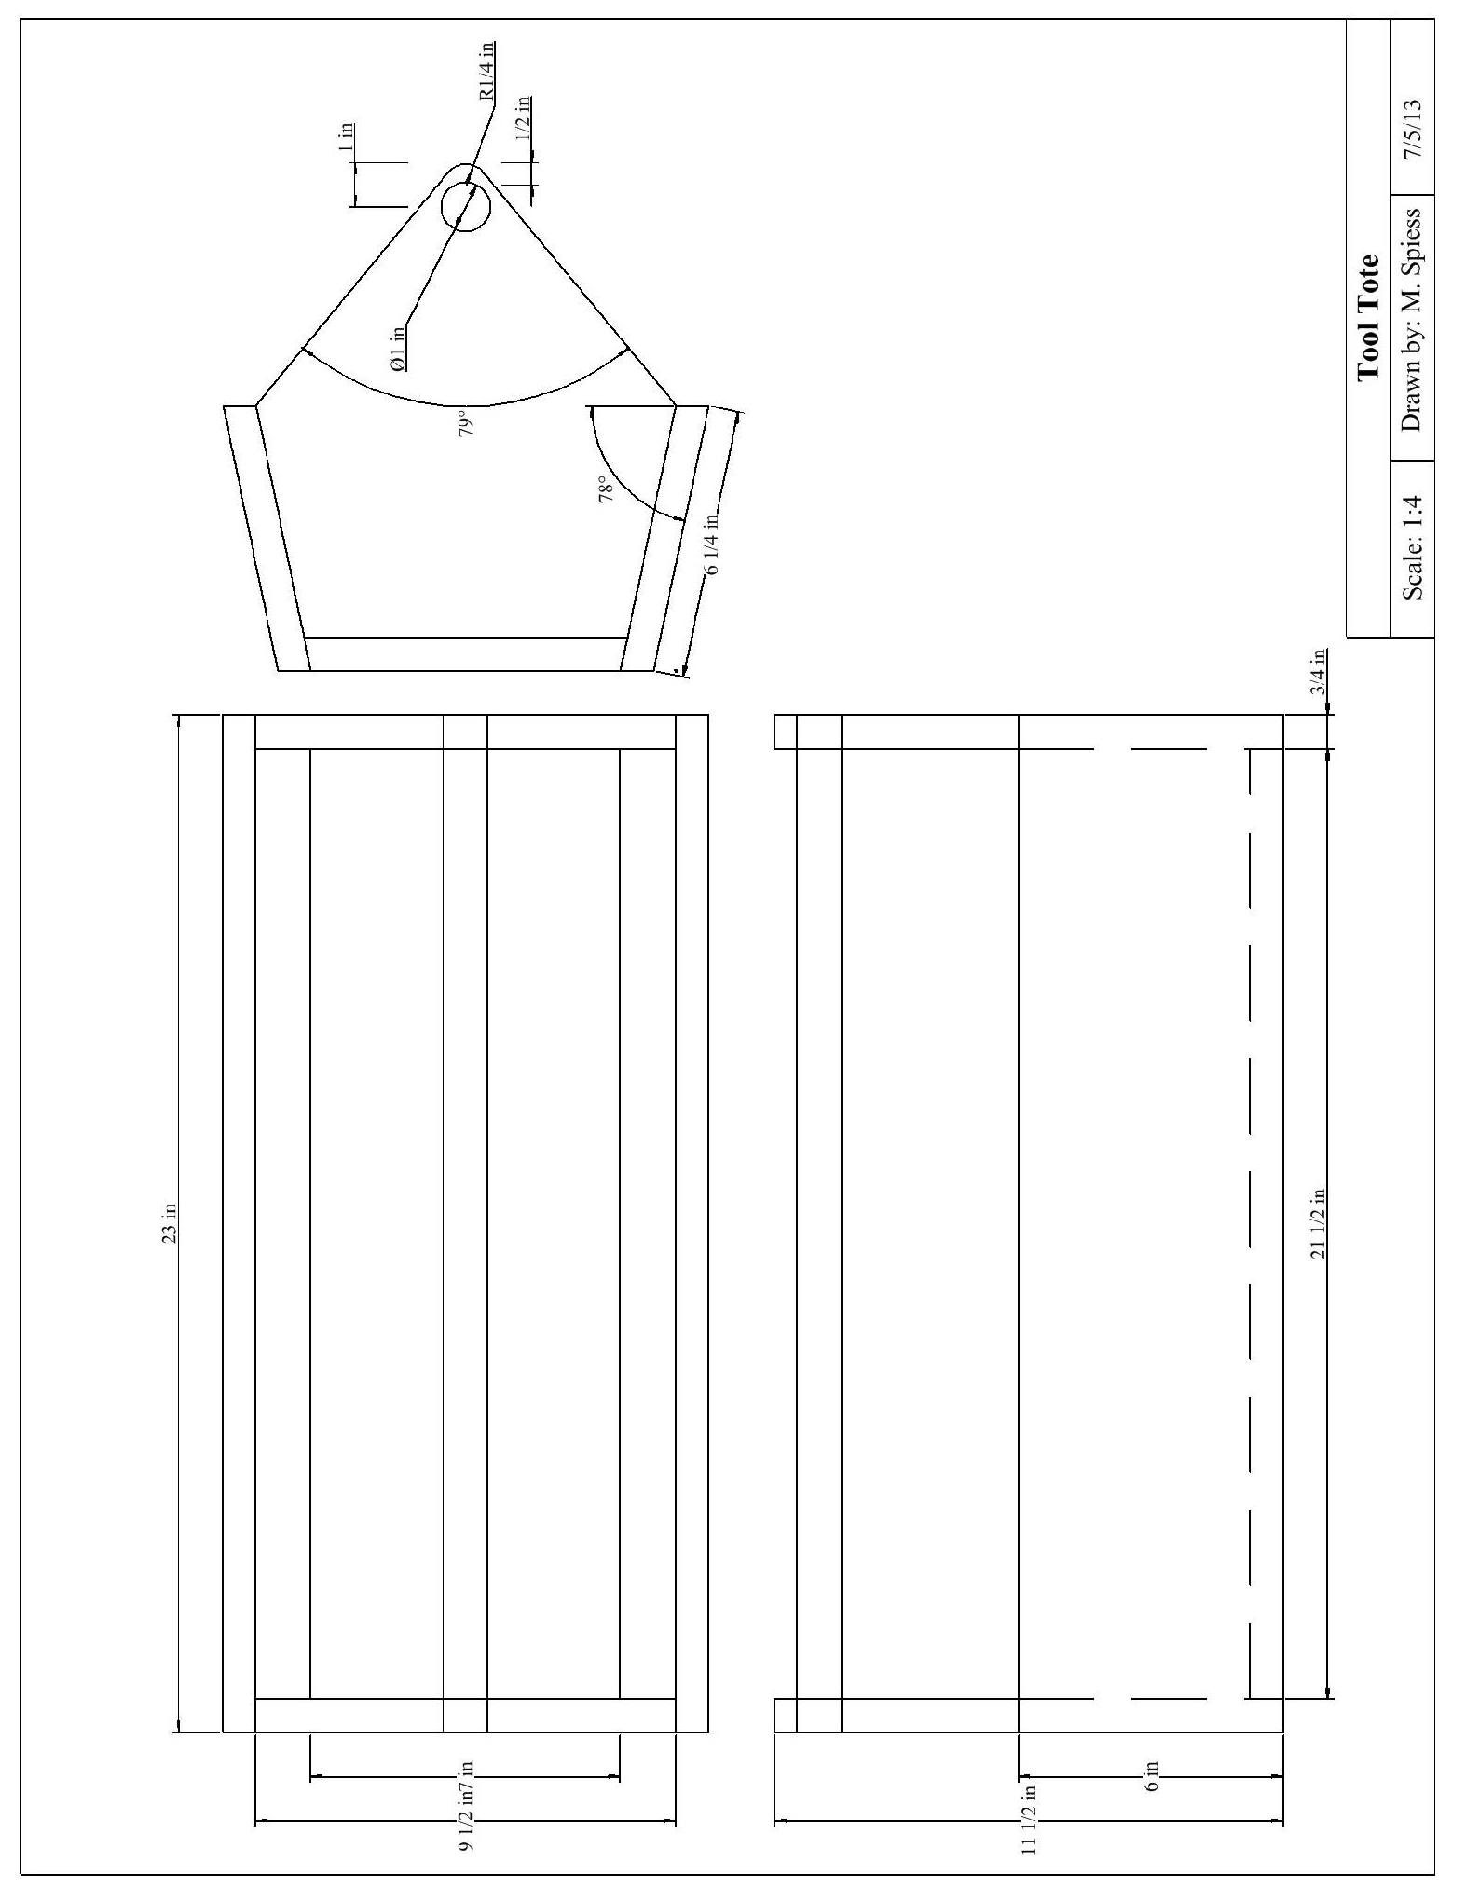

Pre-Building Worksheet
Name: ________________________
Date: ________________________

- Why is wood selection important for this project?

- What nails specifically are used for this project?

- What tool is used to layout the ends of the tool box?

- What type of bit is used to drill the holes for the handle?

- What safety precautions must be observed when using the power miter saw?

Grading Rubric:
CRITERIA | POSSIBLE | SCORE
Length | 5
End height | 5
Handle location | 5
Screws and nails are counter-sunk | 5
Workmanship (fit, cuts, sanding) | 5
TOTAL | 25

Teachers Notes:

Agricultural Standards Met:
6.0 Health and Safety. Students understand health and safety policies, procedures, regulations, and practices, including the use of equipment and handling of hazardous materials:
6.1 Know policies, procedures, and regulations regarding health and safety in the workplace, including employers’ and employees’ responsibilities.
6.2 Understand critical elements of health and safety practices related to storing, cleaning, and maintaining tools, equipment, and supplies.
6.4 Maintain safe and healthful working conditions.
6.5 Use tools and machines safely and appropriately.
6.6 Know how to both prevent and respond to accidents in the agricultural industry.
B1.0 Students understand personal and group safety:
B1.1 Practice the rules for personal and group safety while working in an agricultural mechanics environment.
B1.2 Know the relationship between accepted shop management procedures and a safe working environment.
B2.0 Students understand the principles of basic woodworking:
B2.1 Know how to identify common wood products, lumber types, and sizes.
B2.3 Know how to identify, select, and implement basic fastening systems.
B2.4 Complete a woodworking project, including interpreting a plan, developing a bill of materials and cutting list, selecting materials, shaping, joining, and finishing

Objectives:
By properly completing this project, students will be able to:
- Read a plan and implement layout dimensions.
- Fasten all components together using nails and screws.
- Select kinds, grades, and quantity of lumber for a given task.
- Demonstrate proper use of common woodworking power tools.

Alternative Tools/Methods/Materials:
This project could be built with some wood screws to practice that skill. Use #6 x 1 ½” (or 1 5/8” course drywall screws). The angles on the ends can be cut on the power miter saw. Be cautious of hand placement. The angles on the sides and bottom can be made with a Jack Plane instead of the table saw. A jointer can also be used, but DO NOT joint short pieces. Set the angle of the fences and joint full length pieces.
The handle can be made from ¾” EMT. Cut with a hack saw, de-burr with a file and fasten with a sheet metal screw. Use a spade bit as close as possible to the O.D. of the EMT.

Safety Review:
- Safety Glasses
- Table Saw Safety
- Miter Saw Safety
- Drill Press Safety
- Band Saw Safety

Project Time:
Demonstration: | 20-30 minutes
Build: | 2-3 hours

Demonstration Notes:
- Identify all the tools and materials you will be using. It is good to reinforce this even if it is not your first wood project.
- Talk about wood selection. Lumber has knots so place them where where they will be on an exposed edge or in the handle hole.
- Demonstrate ripping the angles with the table saw. Start with a 1 x 8 and just barly trim the edge to the angle. The set the fence to cut the proper with on the second. REMEMBER: The bottom is trapezoidal and the sides are parallelograms. You may wish to rip these parts as a class.
- Cut a 3’ piece of each width. Talk about where knots might fall and plan accordingly.
- Demonstrate how to cut the square pieces using the power miter saw. Explain that they must mark and cut, mark and cut because of the saw kerf.
- Using the combination square to layout the ends.
- Demonstrate the use of the band saw and drill press to complete the ends. On the drill press explain the need to place a scrap under the work to prevent splitting.
- Demonstrate a “dry” fit of the parts to insure everything fits OK.
- Assemble in the order of the directions. Key here is to place the handle in the ends first (hard to install later). Show how the grain runs in the handle. It should be installed with the grain vertical for strength. Handle can be held in place with a #6 x ¾” screw or a brad. Pre-drill for the screw so the dowel will not split.
- A solder flux brush works well to spread glue. You don’t need much! Have a damp rag handy to wipe of excess.
- Demonstrate countersinking the nails just below the surface so they are not sanded.
- Fill the nail holes with wood dough. Let dry overnight.
- Paint or stain. Suggest using gloves for stain.

Bill of Materials:
Project and plan by Mike Spiess.
Alternate Plan with 1” x6” lumber
