Stepping Stone
Name: ________________________
Date: ________________________

Description:
Students will create their own stepping stone by creating a wooden form then mixing, pouring, and finishing concrete. Stepping-stones are often used in landscaping. Concrete mixing and finishing is a common skill of construction.

Materials:
Concrete Mix
Builders Paper or roofing felt
Decorative materials (tile, glass beads, stones)
Form release agent (diesel fuel, diesel/motor oil 1:1, or commercial form release agent)

Form:
1 x 2 x 12’ lumber (makes 2 forms)
6d duplex nails

Tools:
Wheel Barrow / Shovel (square nose) or bucket and masonry trowel
Float (can be homemade)
Edger
Steel Trowel
Claw Hammer
Hand Saw
Combination square

Procedure:
- Make form.
  - Cut 2 pieces of wood at 12 inches each
  - Cut 2 pieces of wood at 16 inches each or simply use scrap cut in half
  - Nail 4 pieces together (see drawing) with duplex nails. Form should be square.
- Place the form on builder’s paper.
- Apply release agent to form (helps to spray the paper as well)
- Place stones on builders paper in chosen design (remembering that stones may be moved in pouring process).
- Mix concrete carefully measuring water as directed.
- Poor concrete carefully so as not to disturb your stone pattern. You may wish to use a masonry trowel to place the concrete.
- Use a 2x4 scrap to screed the form and tamp the concrete. Float to tamp down aggregate and smooth surface. Float as little as possible to smooth the surface. Tap the form gently with a hammer to settle the concrete. Over working will bring moisture to the surface and slow setting.
- When the shine is just gone, edge with the edger and trowel smooth with the steel trowel.
- CLEAN UP TOOLS! Place steel tools on edge to dry (so they don’t rust).
- Let sit overnight then remove the form. Clean the surface with the stones.

Photo/Drawing:
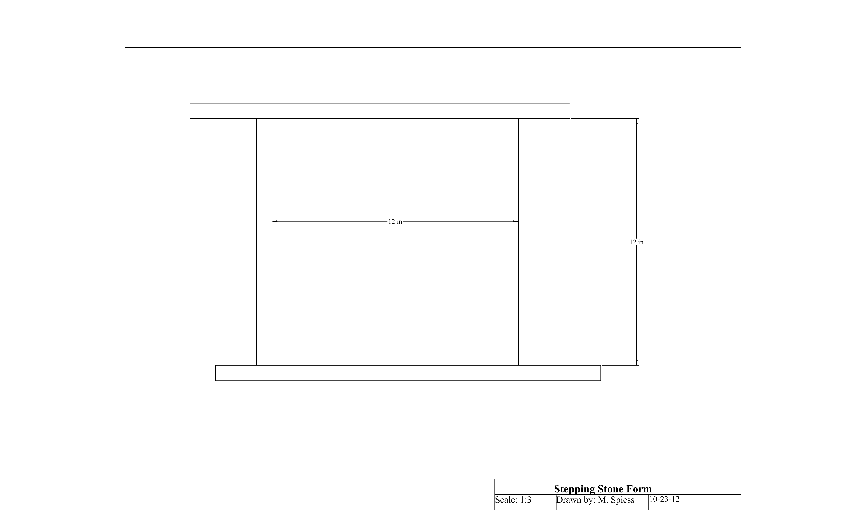

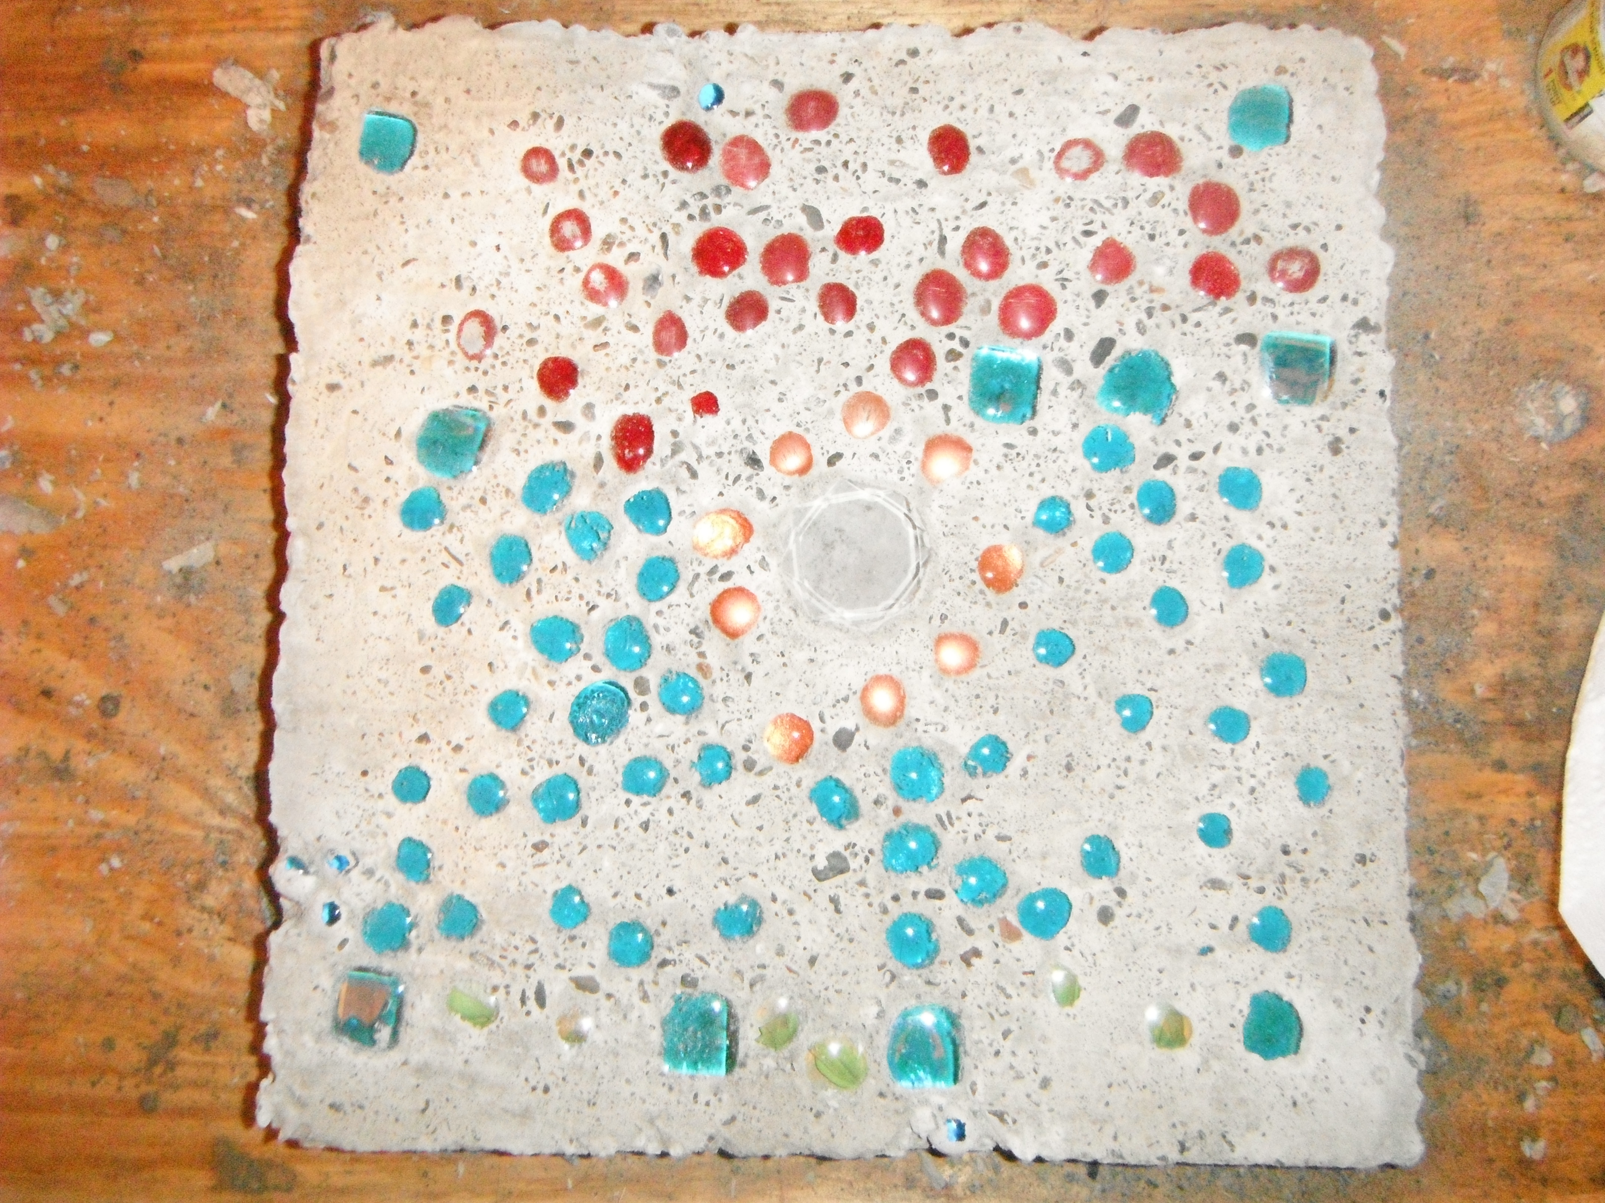

Stepping Stone Worksheet
Name: ________________________
Date: ________________________

- What are the materials needed to create a stepping stone?

- List all safety concerns with working with wood, concrete, and in groups with shop materials.

- What determines the strength on concrete?

- How to calculate cubic yards of concrete?

- Why should concrete be reinforced?

- What does it mean to cure concrete?

- What are the benefits of concrete over wood or metal?

- What unit is concrete sold in?

- What is the formula for cubic yards ?

- You are pouring a pad for a sidewalk, since there is a lot of shift because of weather you need to pour 6 sections that are 4” x 4’ x 5’. How many cubic yards do you need for the whole job?

Grading Rubric:
CRITERIA | POSSIBLE | SCORE
Stepping stone is square | 6
Stepping stone is correct size | 6
Concrete mixed correctly ( Concrete has no cracks and has hardened ) | 6
Personalization of stepping stone | 6
Workmanship | 6
Total | 30

Stepping Stone Teachers Notes:
The concrete stepping stone can be done in a class without a shop. Mix and pour concrete outside. Tell students ahead of time, that if they would like any special decorations, to bring in their own decorative materials.
Great way to start a unit: Take students out to driveway and sidewalk. ---- Ask them to look at the driveway and the sidewalks in front of the school. How thick do you think each one is? Is the driveway thicker than the sidewalk? Why do you think that is? Also may include decorative buildings with concrete walls that are made by a similar process as what students will do. Stepping stones can be set on sand to make a patio.

Worksheet Answers
- The precise proportions of cement, water and gravel determine the strength on concrete.
- To calculate cubic yards by multiplying length X width Depth of the concrete form. Inches must be converted to feet. 4 inches equals 1/3 foot.
- Concrete should be reinforced to strengthen the concrete to hold weight.
- Curing concrete is the drying of the concrete in s slow process to keep the concrete from cracking.
- It does not warp, sturdy, durable, and water resistant.
- Cubic Yards
- Formula for cubic yards T’xW’xL’
- 1.48 cu/yds

Agricultural Standards Met:
6.4 Maintain safe and healthful working conditions.
B1.1 Practice the rules for personal and group safety while working in an agricultural mechanic environment.
B6.1 Understand how to accurately calculate volume, materials needed, and project costs for a concrete or masonry project.

Objectives:
By properly completing this project, students will be able to:
- Calculate volume, materials needed, and project costs for concrete.
- Work with concrete including form building and finishing.

Alternative Tools/Methods/Materials:
Skill saw or miter saw instead of hand saw --- more dangerous for students to use in a non shop setting and often times there is only one or two available allowing some students to have less work to do.
Mixing concrete instead of redi-mix bag. This will teach students about the components of concrete as well as the ratios of mixing the part. The table below shows common mixes and yields.
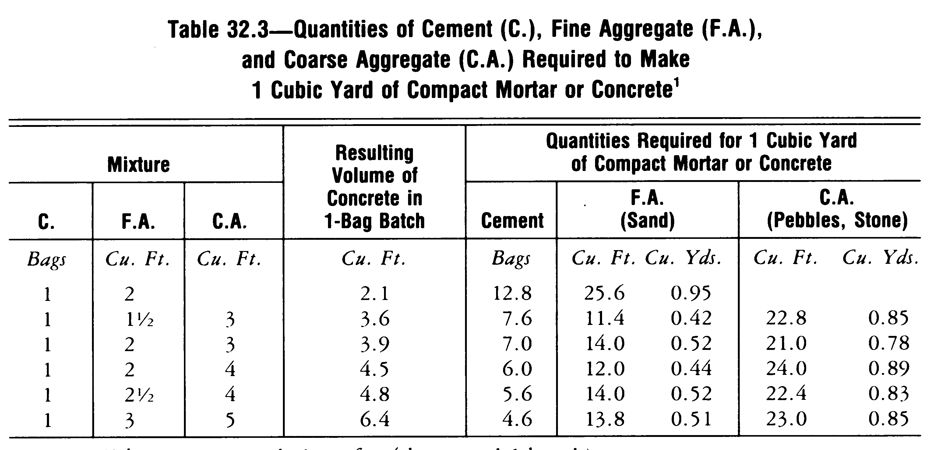
If mixing from scratch use 3/8” (pea gravel) for aggregate.
Plastic buckets can be used instead of a wheelbarrow and shovel for mixing. Use a masonry trowel to mix. This allows for less space and students may pair up in teams instead of groups to mix concrete it also allows the process to be completed indoors in a classroom easier.
Concrete die may be used to add color to the concrete.
Form lumber can be cut easily form 2 x 6 lumber by ripping on a table saw. The advantage of this is that green 2 x 6 will nail easier (less splitting) and the edges are not rounded by the surfacing process.

Safety Review:
- Safety glasses
- Shop environment in classroom ---- careful with saws
- Avoid breathing and skin contact. Use of gloves ( optional)-if concrete gets on hands wash concrete off of hands quickly do not go to next class with concrete on hands ---- use garden hose outside do not wash concrete down sink !

Project Time:
Demonstration: | 30 minutes
Build: | 2 hours + set time

Demonstration Notes
- Cover terms such as concrete, cement, sand, gravel, screed, floating, and troweling.
- Review tools. Floats and trowels are different, but look similar.
- http://www.Quickrete.com is a good resource.
- Worksheet to be given before students start building project and discuss with students answers to the worksheet.
- Demonstrate and have students build form. Note that the length of the long pieces of the form doesn’t really matter. The trade they just “run wild”. Hint: Place the long pieces of the form together and mark 12” in the middle on both using a square. Put the 12” pieces on the OUTSIDE of the marks. By not nailing on the end (see drawing) you lessen the chances of splitting the lumber.
- Talk about concrete again, demonstrate mixing concrete, and have students complete the concrete portion.
- Use concrete accelerator to speed up setting. Available at many home improvement stores or a local redimix company.
- Stress that concrete must be completely mixed. If mixing from cement, sand, gravel. Wet sand will reduce the amount of water needed.
- Have students work in groups or pairs to mix concrete.
- MEASURE water. It is easy to mix too wet or dry. Note: For each 80 lb. bag of QUIKRETE® Concrete Mix to be mixed, add approximately 6 pints of water. MEASURE; this is not much.
- Recommend that you allow extra time for the concrete to set if you intend to finish with a steel trowel.

Bill of Materials:
Project from: Cassie Nichols

