Step Stool
Name: ________________________

Description:
This project provides students the opportunity to work on wood working skills. It requires the use on several common power wood working tools. Angle cuts provide practice in layout, tool setup and cutting.

Materials:
1”x 8” #3 common pine
5d finish nails
6 x 1 5/8” course drywall screws
Wood glue
Sand Paper

Tools:
Compound Miter Saw
Jig Saw
Drill Press
Table Saw
1” Forstner Bit
Combination square
Sliding T Bevel
Steel Tape
Claw Hammer
Nail Set
Hand Plane
Power Screwdriver
#6 Counter sink

Directions:
- Review the plan. Select your lumber and determine the best layout.
- Cut the step from the stock.
- Layout the center of the holes for the slot. Drill on the drill press.
- Use a square to connect the two holes with cut lines. (Cut the slot after the step is assembled to the legs.)
- Use a plane to chamfer the top edges of the step. About a ¼ inch.
- Set the compound miter saw to the desired angle (a bevel) and cut the legs.
- Layout the center of the hole for the leg notch and drill on the drill press.
- Layout the leg notch and cut with the jig saw.
- Rip a scrap of 1” x 8” for the braces. Cut the angle of brace to match the legs.
- Dry fit the legs and the braces.
- Use the counter sink to make screw holes in the legs for the braces. 4 holes in each leg. Holes should be parallel with the bevel.
- Use the plane to chamfer the long edges of the legs (about 1/8”).
- Assemble the legs and braces with glue and screws. Hint: Assemble upside down on a flat surface and have a helper hold the pieces.
- Assemble the top with finish nails and glue. Set the nails.
- Carefully cut out the slot in the step using the lines previously marked with the jig saw.
- Sand with a sanding block. Hint: a ¾” dowel wrapped with sandpaper will help in sanding the slot.
- There are a number of options for finish.
  - Stain: After sanding stain the project. Use matching putty to fill the holes in the top.
  - Paint: Fill holes with spackle. Sand smooth. Paint with a semi-gloss paint.
- Write your name on the bottom of the step.

Notes:
__________________________________________________________________________________
__________________________________________________________________________________
__________________________________________________________________________________
__________________________________________________________________________________
__________________________________________________________________________________
__________________________________________________________________________________

Photo:
(Note this example is missing the slot in the step.)
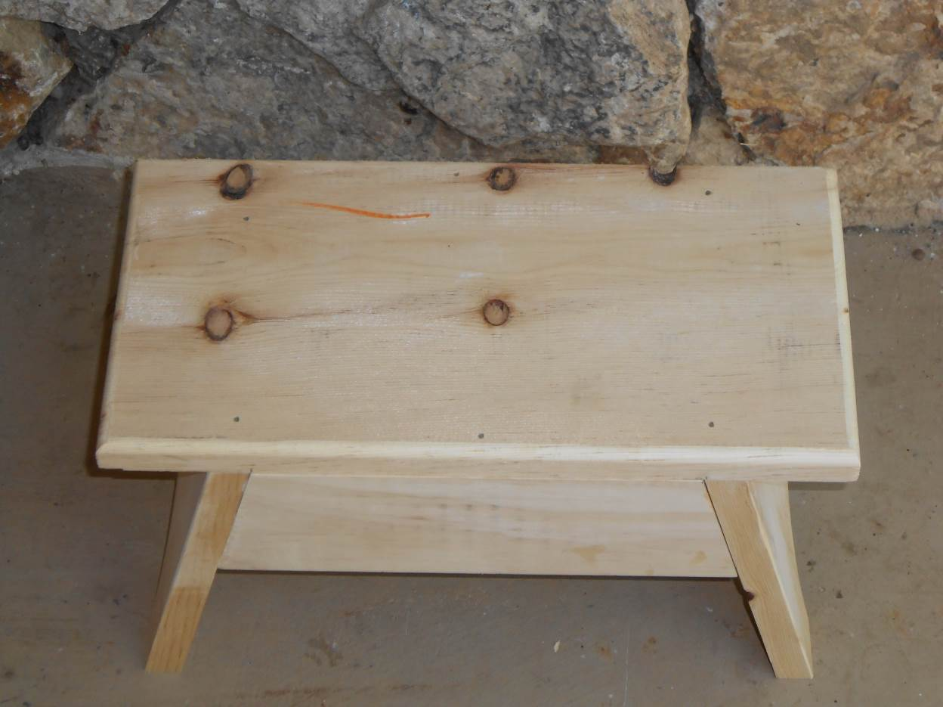

Drawing:

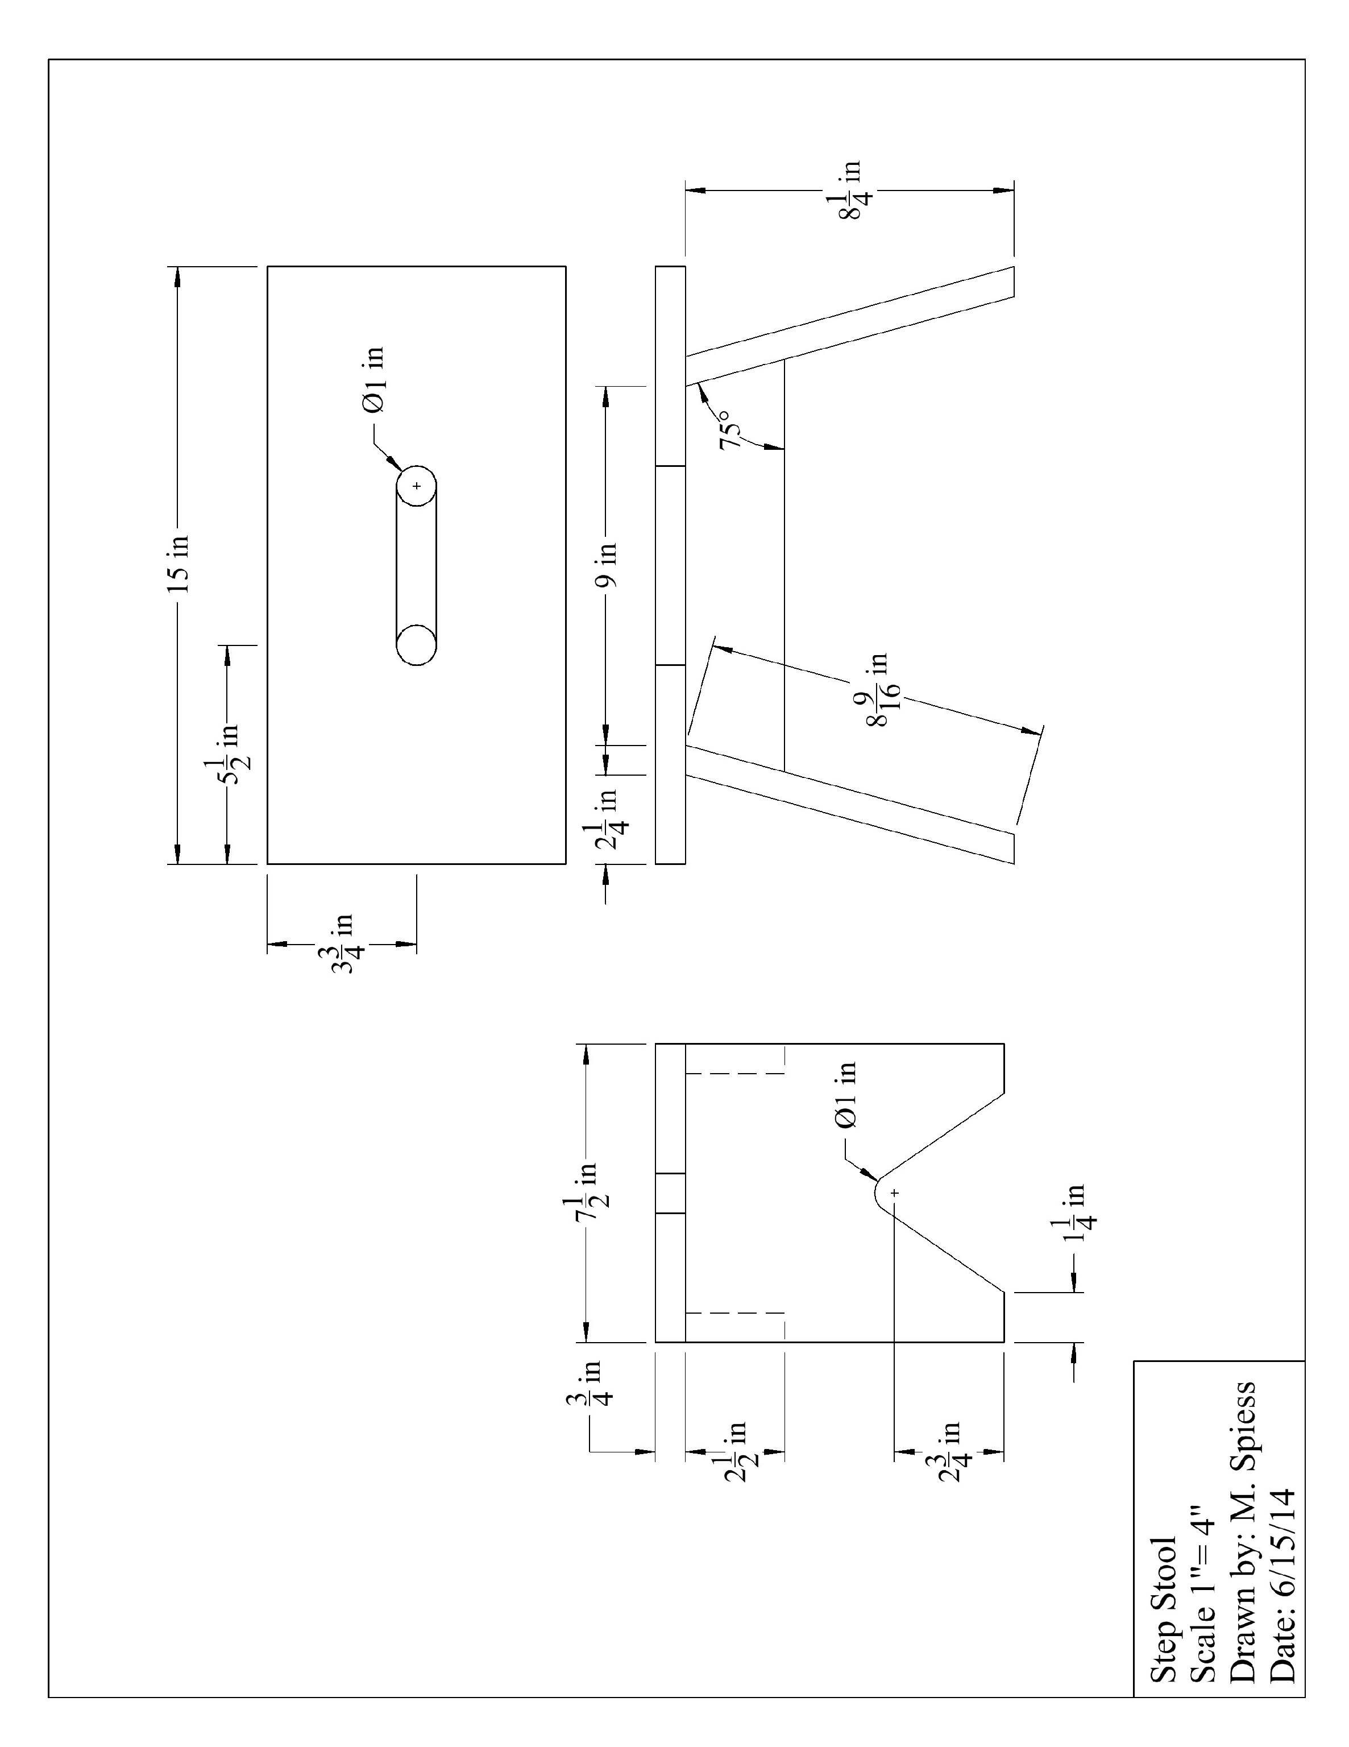

Step Stool Student Worksheet:
Name: ________________________
Complete this worksheet prior to starting the project.
- What angle is used to set the miter saw when cutting the legs? __________
- What type of fasteners are used to secure the step of the stool? ______________________
- What type of fasteners are used to secure the braces of the stool? ______________________
- How long will you cut the leg? __________________
- The brace is 9” long. Do you measure this on the long side or short side? Long / Short

Grading Rubric:
Criteria (tolerance +/- 1/16") | Possible | Score
Stool width | 5
Stool height | 5
Correct use of fasteners | 5
Stool square and does not rock | 5
General Workmanship  (sanding, edges, excess marks, scaring of wood) | 5
TOTAL | 25

Small Tool and Supply ToteStep Stool Teaching Notes:

Agricultural Standards Met:
4.0 Technology. Students know how to use contemporary and emerging technological resources in diverse and changing personal, community, and workplace environments:
4.6 Differentiate among, select, and apply appropriate tools and technology.
5.0 Problem Solving and Critical Thinking. Students understand how to create alternative solutions by using critical and creative thinking skills, such as logical reasoning, analytical thinking, and problem-solving techniques:
5.1 Apply appropriate problem-solving strategies and critical thinking skills to work-related issues and tasks.
5.3 Use critical thinking skills to make informed decisions and solve problems.
6.0 Health and Safety. Students understand health and safety policies, procedures, regulations, and practices, including the use of equipment and handling of hazardous materials:
6.1 Know policies, procedures, and regulations regarding health and safety in the workplace, including employers’ and employees’ responsibilities.
6.2 Understand critical elements of health and safety practices related to storing, cleaning, and maintaining tools, equipment, and supplies.
6.4 Maintain safe and healthful working conditions.
6.5 Use tools and machines safely and appropriately.
6.6 Know how to both prevent and respond to accidents in the agricultural industry.
B1.0 Students understand personal and group safety:
B1.1 Practice the rules for personal and group safety while working in an agricultural mechanics environment.
B1.2 Know the relationship between accepted shop management procedures and a safe working environment.
B2.0 Students understand the principles of basic woodworking:
B2.1 Know how to identify common wood products, lumber types, and sizes
B2.3 Know how to identify, select, and implement basic fastening systems.
B2.4 Complete a woodworking project, including interpreting a plan, developing a bill of materials, and cutting list, selecting materials, shaping, joining and finishing.

Objectives:
By successfully completing this project students will be able to:
- Read a plan to obtain critical dimensions
- Measure and layout a project on wood using common layout tools
- Identify by name common wood working tools
- Demonstrate how to setup and cut bevels and miters on a compound miter saw.

Alternate Tools/Materials:
This project can be made with hand tools. Angle can be determined with a steel square or protractor. Cutting the brace angle with an adjustable miter box. The leg angle can be cut in a homemade miter box with a 15 degree angle cut in it.
A table saw can also be used to cut the bevel cut in the leg if a compound miter saw is not available.
A band saw can be used to cut the leg notch.
The table saw can be avoided by pre-sawing scraps to width or using 1” x 3” stock. 1” x 4” stock can also be used.
Slot and top can be routed using a 3/8” ¼ round bit.

Safety Review:
- Use of all power tools
- Demonstrate how to clamp wood when cutting with the jig saw.

Project Time:
Demonstration: | 15-30 minutes
Build: | 3 hours

Demonstration Notes:
- Begin by reviewing materials and tools used for the project.
- Review the plan and show how the plan describes the project.
- Explain why lumber selection is critical (avoid knots).
- Explain how to determine saw angle (90-75=15)
- Demonstrate proper use of compound miter saw and review safety precautions.
- Explain the legs are parallelogram shaped and the brace is a trapezoid shape. THIS IS A COMMON MISTAKE!!!
- Show how to cut the brace by measuring the short side.
- Explain why cutting the slot last is easier (no need to clamp).
- Remind students of workmanship. Final projects should be sanded and free of any excess glue.

Bill of Materials

