Small Tool and Supply Tote
Name: ________________________

Description:
This project provides students the opportunity to work on wood working skills. They also get to practice layout skills and using a compass to make round edges.

Materials:
1” x 12” board – #3 common pine
¼” plywood – grade CC sanded
6x1 ½” FH wood screws
5d finishing nails
3d box nails
Wood glue
¾” Sch 40 PVC Pipe
Pipe caps
PVC pipe glue

Tools:
Table Saw
Band Saw
Miter Saw
Combination square
Drill press
1 1/8” Forstner Drill Bit
Steel Tape
Compass
Sand Paper
Claw Hammer
Power drill with screw driver bit

Directions:
- Review the drawing. Determine dimensions of all pieces of wood needed.
- Using the Miter Saw cut a piece of 1 x 12” 36” long. Determine how you will cut out the pieces. Hint: avoid knots.
- Rip a 3” piece and a 5” piece using the table saw.
- Cut the ripped pieces to length.
- Rip the plywood to 6 ½”. From the strip cut the bottom piece (15 ½”).
- On your two 5” x 8 ½” pieces and mark where the whole for the handle will be. The center of the hole should be 2 ½” in from the sides and 1 ¼” in from the top.
- Using a compass draw the curve for the top of your 5” x 8 ½” boards. Use the same mark that you made for the center of the handle hole as a starting point and make curves 1 ¼” from that mark.
- From the bottom of your 5” x 8 ½” boards measure 3” up and make marks on both sides.
- Draw lines, using a ruler, from the marks you just made that connect with the curve made previously. This will be line that you will cut to make the tops curve.
- Cut out the lines you just created using a band saw for both pieces.
- Cut the holes for the handle using a drill press and Forstner drill bit.
- Dry fit all the pieces to insure a good fit.
- Assemble your four pieces together as shown in the diagram using wood glue, 1- ½” wood screws, and 2 5d finishing nails on each connection.
- Secure your piece of plywood to the bottom of the tote using glue several 3d box nails on each side.
- Sand down all pieces of wood so that they are smooth.
- Cut out a 16 ½” piece of ¾” PVC pipe and put through your holes to form your handle.
- Glue pipe caps on either end of your pipe to keep pipe from coming off.
- To secure your pipe and keep it from twisting around, put a nail or screw in the top of the piece of wood that’s long enough to go through your pipe too.
- Mark your initials on the bottom of tote and leave to dry.

Notes:
__________________________________________________________________________________
__________________________________________________________________________________
__________________________________________________________________________________
__________________________________________________________________________________
__________________________________________________________________________________
__________________________________________________________________________________
__________________________________________________________________________________
__________________________________________________________________________________
__________________________________________________________________________________
__________________________________________________________________________________
__________________________________________________________________________________
__________________________________________________________________________________
__________________________________________________________________________________
__________________________________________________________________________________
__________________________________________________________________________________
__________________________________________________________________________________
__________________________________________________________________________________
__________________________________________________________________________________
__________________________________________________________________________________
__________________________________________________________________________________

Photo/Drawing:

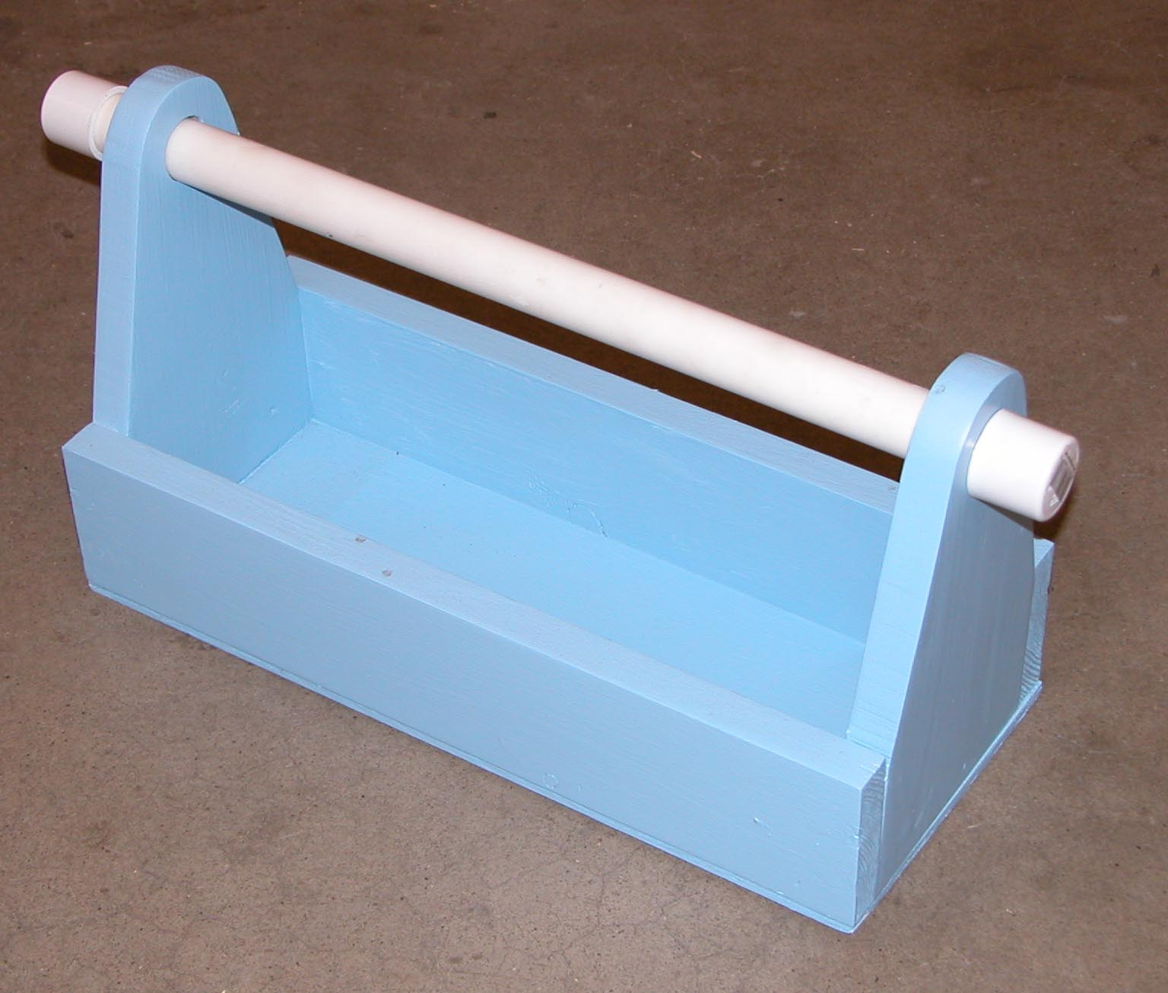

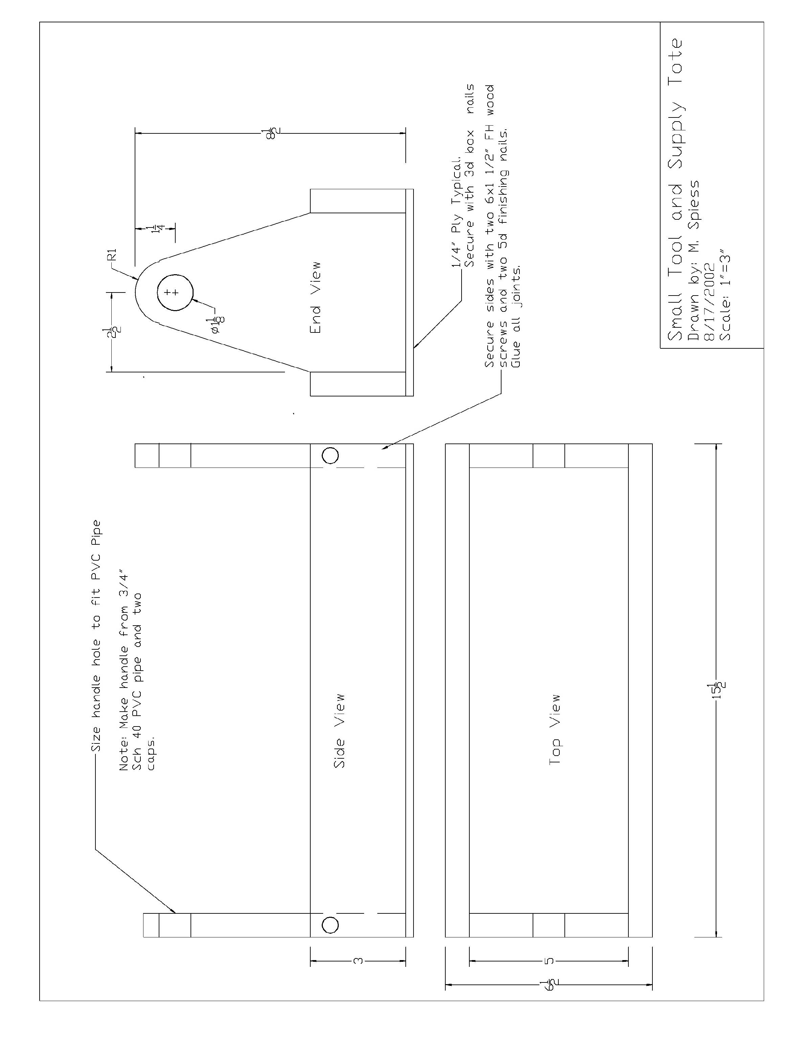

Small Tool and Supply Tote Student Worksheet:
Name: ________________________
Complete this worksheet prior to starting the project.
- What are the dimensions of the project? __________________________________________
- How far is the center of the holes for the handle from the top of the board? _____________
- What kind of bit is used to create the holes for the handle? ___________________________
- What tool is used to cut
- How do you make the edges round? _____________________________________________ ___________________________________________________________________________
- What size PVC pipe is used for the handle? ________________________________________
- How much total wood is used in the project? ______________________________________
- What can you use this project for? _______________________________________________ ______________________________________________________________________________________________________________________________________________________
- Why do we use glue to secure the box together if we are already using fasteners? ________ ______________________________________________________________________________________________________________________________________________________

Grading Rubric:
Criteria (tolerance +/- 1/16") | Possible | Score
Dimensions | 5
Top sides rounded | 5
Fasteners | 5
Handle (holes in right place, doesn’t spin) | 5
General Workmanship  (scale, edges, excess marks, scaring of wood) | 5
TOTAL | 25

Small Tool and Supply ToteSmall Tool and Supply Tote Teaching Notes:

Agricultural Standards Met:
4.0 Technology. Students know how to use contemporary and emerging technological resources in diverse and changing personal, community, and workplace environments:
4.6 Differentiate among, select, and apply appropriate tools and technology.
5.0 Problem Solving and Critical Thinking. Students understand how to create alternative solutions by using critical and creative thinking skills, such as logical reasoning, analytical thinking, and problem-solving techniques:
5.1 Apply appropriate problem-solving strategies and critical thinking skills to work-related issues and tasks.
5.3 Use critical thinking skills to make informed decisions and solve problems.
6.0 Health and Safety. Students understand health and safety policies, procedures, regulations, and practices, including the use of equipment and handling of hazardous materials:
6.1 Know policies, procedures, and regulations regarding health and safety in the workplace, including employers’ and employees’ responsibilities.
6.2 Understand critical elements of health and safety practices related to storing, cleaning, and maintaining tools, equipment, and supplies.
6.4 Maintain safe and healthful working conditions.
6.5 Use tools and machines safely and appropriately.
6.6 Know how to both prevent and respond to accidents in the agricultural industry.
B1.0 Students understand personal and group safety:
B1.1 Practice the rules for personal and group safety while working in an agricultural mechanics environment.
B1.2 Know the relationship between accepted shop management procedures and a safe working environment.
B2.0 Students understand the principles of basic woodworking:
B2.1 Know how to identify common wood products, lumber types, and sizes
B2.2 Know how to calculate board feet, lumber volume, and square feet.
B2.3 Know how to identify, select, and implement basic fastening systems.
B2.4 Complete a woodworking project, including interpreting a plan, developing a bill of materials, and cutting list, selecting materials, shaping, joining and finishing.

Objectives:
By successfully completing this project students will be able to:
- Read a plan to obtain critical dimensions
- Measure and layout a project on wood using common layout tools
- Identify by name common wood working tools
- Select and properly used hand and power tools used for wood working

Alternate Tools/Materials:
The handle can be made with a hardwood dowel. A jig saw can be used to cut the end (clamp the board before cutting). Course drywall screws work well instead of FH wood screws. Screws can be omitted if this skill is not desired.

Safety Review:
- Use of all saws.
- Use of the drill press.
- PVC Glue

Project Time:
Demonstration: | 15-30 minutes
Build: | 3 hours

Demonstration Notes:
- Begin by reviewing materials and tools used for the project.
- Review the plan and show how the plan describes the project.
- You may wish to rip some or all the pieces from longer lumber as a class or ahead to avoid a bottleneck at the table saw. NOTE: It is safer to rip longer lumber than short pieces. Full sheets of plywood are hard to handle.
- Demonstrate proper use of miter saw and review safety precautions.
- Demonstrate proper use of table saw and review safety precautions.
- Demonstrate how to layout the handle holes.
- Demonstrate how to make curves using compass and connecting to other mark.
- Demonstrate proper used of band saw and review safety precautions. Remind students that the blade is small and easily breakable so they should never back the blade out of the cut while still running. Use a narrow blade to cut the curve. A stationary disc sander is nice to have to clean up the curve.
- Demonstrate how to cut a hole using a drill press.
- Demonstrate how to properly glue PVC. While this is not a plumbing lesson learning to apply glue properly is a valuable skill. (Apply glue to both parts, assemble with a ½ twist, hold for 20 sec.)
- Remind students of workmanship. Final projects should be sanded and free of any excess glue.

Bill of Materials

