Sheet Metal Tray
Name: ____________
Date: ____________

Description:
11” long sheet metal box, useful for nut and bolt storage. Teaches beginning sheet metal skills and plan layout.

Materials:
26 ga. galvanized sheet metal

Tools:
Steel tape
Scratch awl
Sheet metal brake
Spot welder

Procedure:
- Measure out piece A and B
- Measure the 1/2 “ hems on the needed edges
- On piece A measure from the ends 4 ¾” into the center.
- On the 4 ¾” mark make two 45 degree angle marks that go in no more than ½”
- Have it checked by instructor before cutting
- Use the sheet metal brake to bend the ½” hems 180 degrees on pieces B and the with hems on piece A
- On the 11” long hems only bend the hems 90-degrees using the sheet metal brake
- Use the brake to make a 90-degree angle along the 4 ¾” inch measurements
- Take the two remaining B pieces and spot weld them to piece A

Cutting List: (optional)
Quantity | Size | Material
1 | 5 x 18 | 26 ga sheet metal
2 | 4 ½ x 9 | 26 ga sheet metal

Notes:
______________________________________________________________________________________________________________________________________________________________________________________________________________________________________________________________________________________________________________________________________________________________________________________________________________________________________________________________________________________________________________________________

Photo/Drawing:

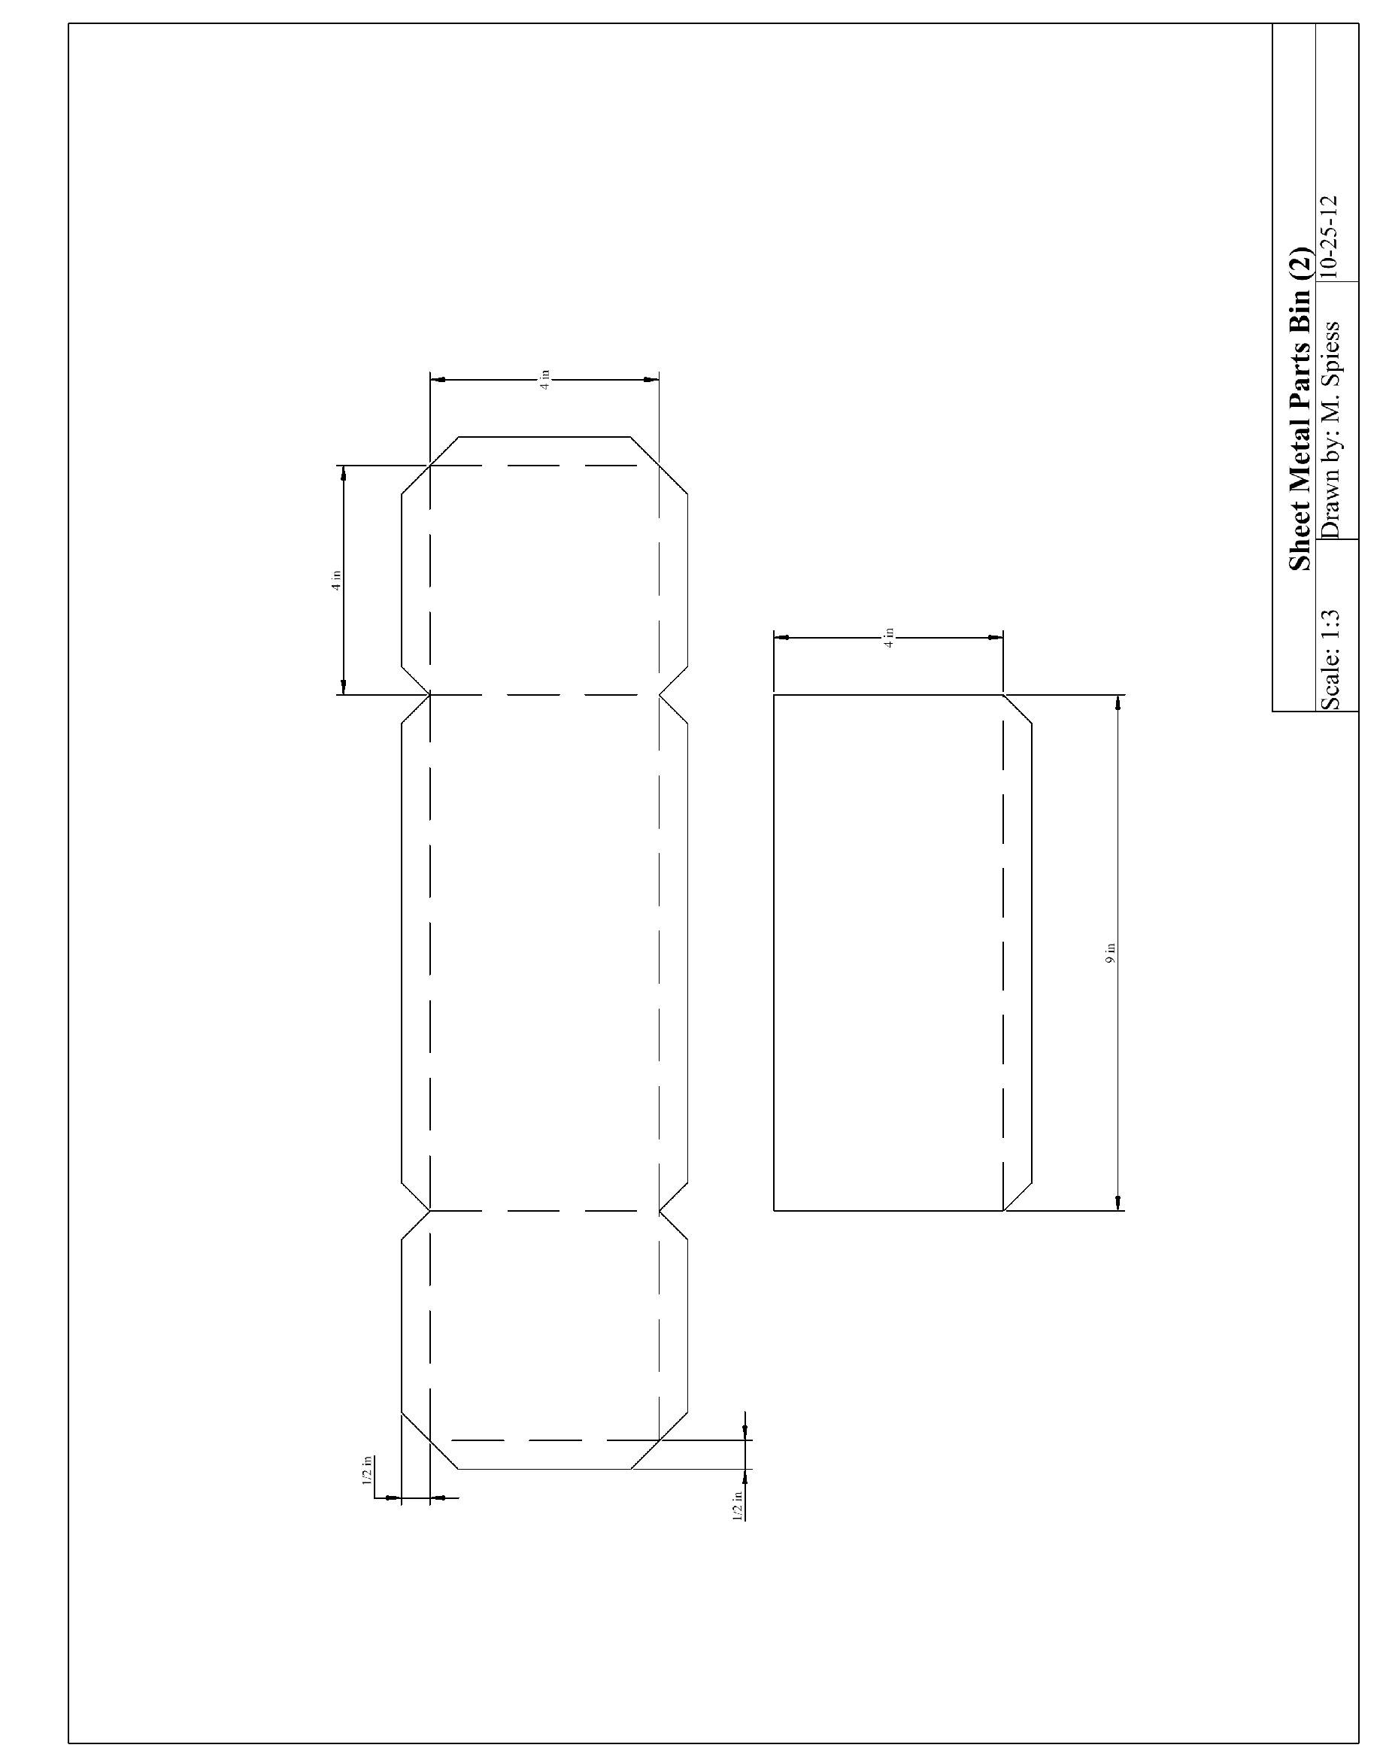
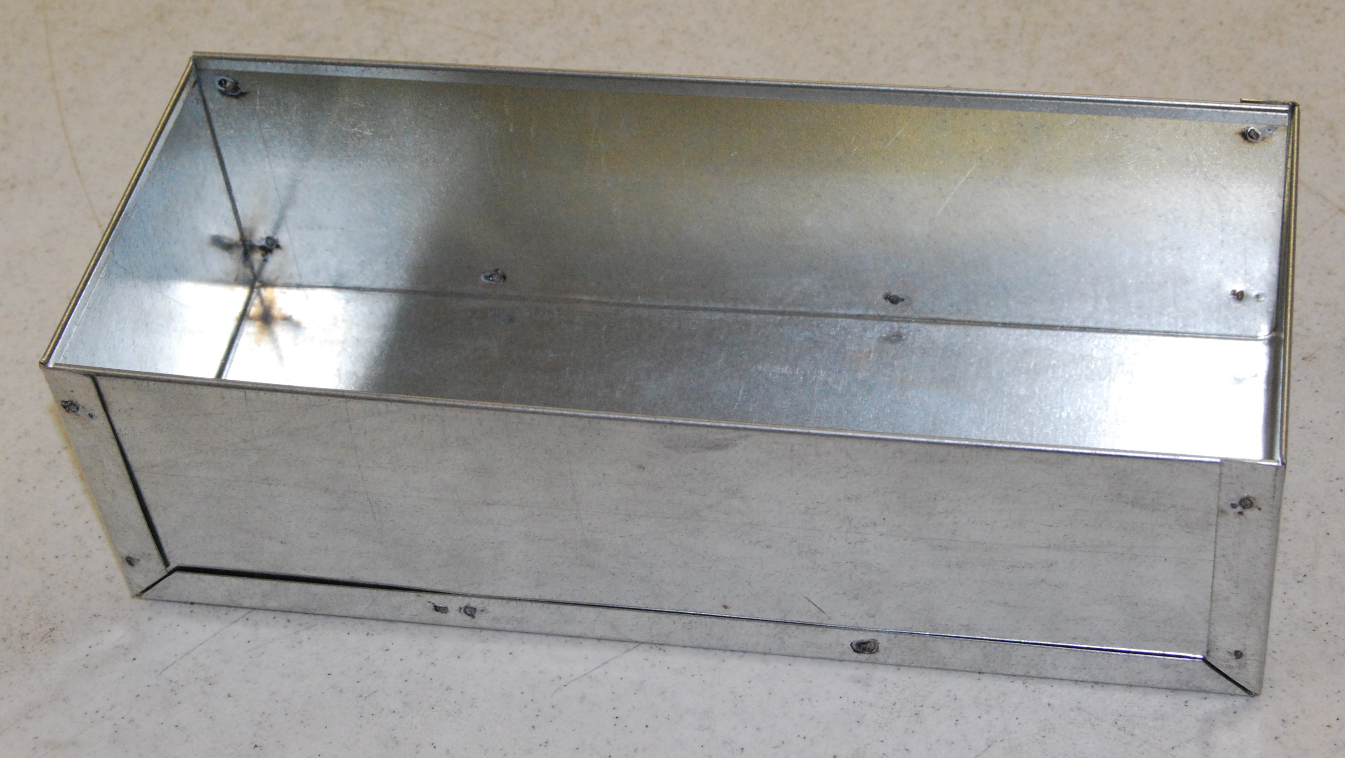

Sheet Metal Box Worksheet
Name: ________________________
Date: ________________________

- What are the dimensions of the box supposed to be?

- When do you make the first cut?

- Which bends are only bent 90-degrees?

- Why do we not bend and flatten all of the bends?

- What are the safety issues with a brake?

Grading Rubric:
CRITERIA | POSSIBLE | SCORE
Proper Length (11”) | 6
Proper with (5”) | 6
Angle of bends | 6
Square | 6
Workmanship (no sharp edges, not to scuffed) | 6
Total | 30

Sheet Metal Box Teachers Notes:

Agricultural Standards Met:
6.0 Health and Safety. Students understand health and safety policies, procedures, regulations, and practices, including the use of equipment and handling of hazardous materials:
6.1 Know policies, procedures, and regulations regarding health and safety in the workplace, including employers’ and employees’ responsibilities.
6.2 Understand critical elements of health and safety practices related to storing, cleaning, and maintaining tools, equipment, and supplies.
6.4 Maintain safe and healthful working conditions.
6.5 Use tools and machines safely and appropriately.
6.6 Know how to both prevent and respond to accidents in the agricultural industry.
B1.0 Students understand personal and group safety:
B1.1 Practice the rules for personal and group safety while working in an agricultural mechanics environment.
B1.2 Know the relationship between accepted shop management procedures and a safe working environment.
B5.0 Students understand agricultural cold metal processes.
B5.3 Know layout skills
B5.4 Know basic cold metal processes (e.g., shearing, cutting, drilling, threading, bending.)

Objectives:
By properly completing this project, students will be able to:
- Read a plan and layout dimensions.
- Demonstrate construction techniques for sheet metal
- Demonstrate use of spot welder

Alternative Tools/Methods/Materials:
- Instead of a spot welder joints and be soldered. Self-tapping sheet metal screws or rivets can also be used to assemble. A combination of these fasteners can be used to teach the use of different fasteners.
- An alternate plan below requires the use of a box (pan) brake, but uses one piece construction.
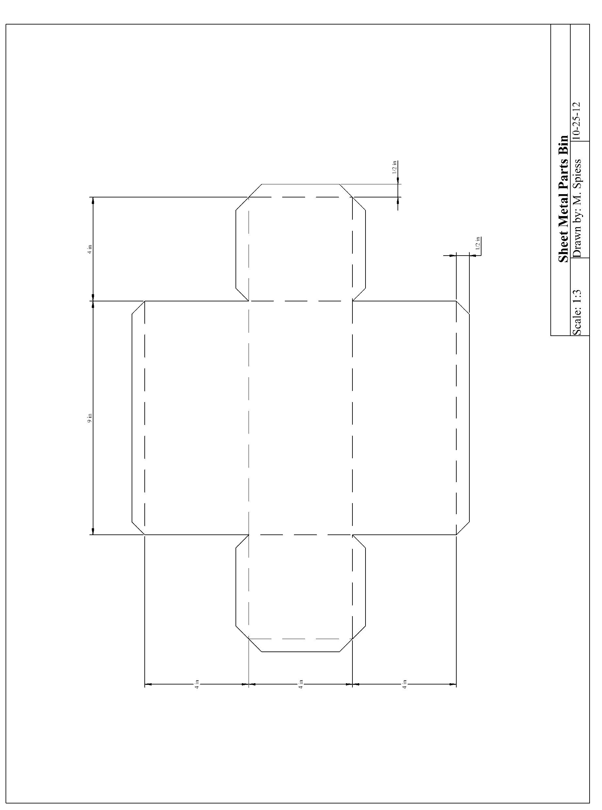

Safety Review:
- Snips
- Sheet metal brake
- Spot welder

Project Time:
Demonstration: | 40 minutes
Build: | 4 hours

Demonstration Notes
- 36” metal can be sheared at 5”. From this strip cut (or shear) 1 18” piece and 2-9” pieces.
- The project can be laid out on these pieces then cut out with snips.
- Demonstrate the use of a combination square for layout. This is a critical layout skill. See: http://www.agedweb.org/TeacherResources/Use%20of%20the%20Combination%20Square%20for%20Layout.pdf for a tutorial.
- Demonstrate how to cut out the corners and angles
- Review the order of the bends.
- Stress the fact that the hems must be folded inwards
- Demonstrate how to use the spot welder

Bill of Materials:

Plan by: Miguel Manzo

