Saw Guide and Rafter Square
Name: ________________________

Description:
The project is a tool for guiding a circular saw as well as a functional square and rafter layout tool. Useful cold metal skills are used to construct the project.

Materials:
1 ½” x 3/16” Aluminum Flat Stock
1” x 1” x 1/8” Aluminum Angle
3/8 x 8-32 Brass Machine Screws
1/8” x ½” Al Pop Rivet
Cutting Oil

Tools:
Hack Saw
Combination square
Scribe or Scratch Awl
Pop Rivet Tool
8-32 Tap
Tap Handle
Center Punch
Ball Peen Hammer
#29 twist Drill
1/8” twist drill
Drill Press
Locking Pliers
Machinist’s Vise
Bastard and Mill Files
Numbered Punches

Directions:
- Review the drawing. Determine the location of the rivets and screws and note on the drawing.
- IMPORTANT: Use wood scraps to hold the aluminum in vise to avoid scaring of the soft metal.
- *Dress the cut end of the angle stock using a file. Hint: scribe a line then cut on the edge of the line. Cut the angle stock to length using a hacksaw. Dress the ends to be smooth and square.
- Mark the angle stock exactly at 6” using a square and a scribe. Use this mark as a guide for aligning the “tongue” of the saw guide. The 6” dimension is critical.
- *Dress the cut end of the flat stock using a file. Hint: scribe a line then cut on the edge of the line. Cut the flat stock for the “tongue” of the square to length using a hacksaw. Dress the ends to be smooth and square.
- Layout the hole pattern on the tongue. Mark the drilling locations with a center punch.
- Drill the four holes using the 1/8” drill and a drill press.
- Using a scribe and a square mark the tongue every 1” up to 7”. Beginning at 2” mark the scale 2,4,6,8,10, and 12 using the number punches.
- Using the locking pliers clamp the tongue to the fence. Use the 6” mark on the fence and the 1” mark on the tongue for alignment. Use a good combination square to square your assembly. Drill one rivet hole.
- Install a pop rivet. If the rivet is loose, tighten with a few light blows of a ball peen hammer.
- Re-check the square of the project and reset the locking pliers to allow drilling of the other three holes. Check for square one last time before drilling. Drill 1/8” holes into the fence.
- Install the second pop rivet.
- Ream the two screw holes with the #29 bit using the drill press or carefully with a hand drill. Carefully tap the two screw holes using a few drops of cutting oil. CAUTION: The taps are small and easily broken.
- Install the two brass screws. CAUTION: Do not over torque and break the screws.
- Check the entire project for sharp edges and use a file to remove them.
- Using the letter stamps, stamp your initials in the underside of the project.

Notes:
__________________________________________________________________________________
__________________________________________________________________________________
__________________________________________________________________________________
__________________________________________________________________________________
__________________________________________________________________________________
__________________________________________________________________________________
__________________________________________________________________________________

Drawing/Photo:
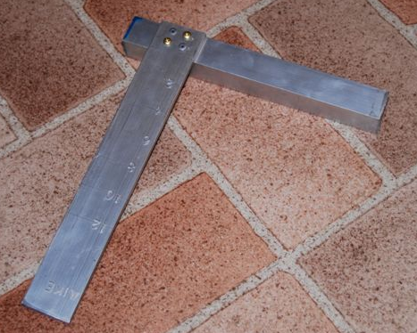

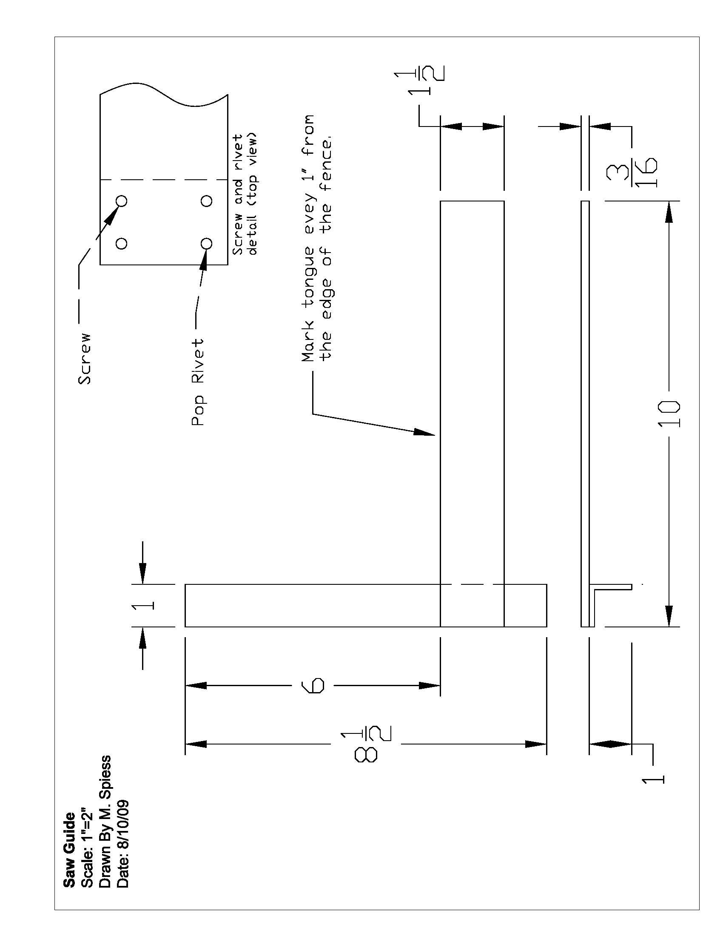

Saw Guide and Rafter Square Student Worksheet:
Name: ________________________
Complete this worksheet prior to starting the project.
- How long is the “tongue” piece cut from the flat stock? ____________________
- How long is the “fence” part cut from the angle stock? _________________
- Layout below the dimensions for the screw locations below:

- Draw the location of the scale lines on the drawing above and show the dimensions.
- How is the aluminum protected from scaring in the machinist’s vice?
_____________________________________________________________________
- What size machine screws are used? __________________
- What size drill is used for the screw tap (see tap chart)? ______________________
- What tool is used to mark hole locations for drilling? _________________________

Grading Rubric:
Criteria (tolerance +/- 1/16") | Possible | Score
Dimensions (fence and tongue) | 4
Tongue location (6”) | 4
Project square | 4
Screw and Pop Rivet (location and installation) | 4
General Workmanship  (scale, edges, excess marks, scaring of metal) | 4
TOTAL | 20

Saw Guide and Rafter Square Teaching Notes:

Agricultural Standards Met:
4.0 Technology. Students know how to use contemporary and emerging technological resources in diverse and changing personal, community, and workplace environments:
4.6 Differentiate among, select, and apply appropriate tools and technology.
5.0 Problem Solving and Critical Thinking. Students understand how to create alternative solutions by using critical and creative thinking skills, such as logical reasoning, analytical thinking, and problem-solving techniques:
5.1 Apply appropriate problem-solving strategies and critical thinking skills to work-related issues and tasks.
5.3 Use critical thinking skills to make informed decisions and solve problems.
6.0 Health and Safety. Students understand health and safety policies, procedures, regulations, and practices, including the use of equipment and handling of hazardous materials:
6.1 Know policies, procedures, and regulations regarding health and safety in the workplace, including employers’ and employees’ responsibilities.
6.2 Understand critical elements of health and safety practices related to storing, cleaning, and maintaining tools, equipment, and supplies.
6.4 Maintain safe and healthful working conditions.
6.5 Use tools and machines safely and appropriately.
6.6 Know how to both prevent and respond to accidents in the agricultural industry.
B1.0 Students understand personal and group safety:
B1.1 Practice the rules for personal and group safety while working in an agricultural mechanics environment.
B1.2 Know the relationship between accepted shop management procedures and a safe working environment.
B1.3 Know how to safely secure loads on a variety of vehicles.
B5.0 Students understand agricultural cold metal processes:
B5.1 Know how to identify common metals, sizes, and shapes.
B5.3 Know layout skills.
B5.4 Know basic cold metal processes (e.g., shearing, cutting, drilling, threading, bending.).
B5.5 Complete a cold metal project, including interpreting a plan, developing a bill of

Objectives:
By successfully completing this project students will be able to:
- Read a plan to obtain critical dimensions
- Measure and layout a project on metal
- Identify by name common cold metal tools
- Select and properly used hand and power tools used for cold metal work
- Determine proper drill sizes for threads
- Cut threads in metal using a tap

Alternate Tools:
A hydraulic shear could be used to cut the metal, but dressing the ends will take longer. A drill press is not needed, but insures that the holes are square. It is possible to build this project without a shop. You will need some sort of benches or sawhorses and clamps to hold the work. A hand drill used carefully can be used to drill the holes.

Safety Review:
- Use of the drill press.

Project Time:
Demonstration: | 15-30 minutes
Build: | 3 hours

Demonstration Notes:
(Tips, methods to stage the project)
- Begin by reviewing materials and tools used for the project.
- Review the plan and show how the plan describes the project.
- Review a thread chart and show how drill sizes are determined.
- Demonstrate the proper use of a file.
- Demonstrate how to mark the aluminum with a combination square and scribe.
- Demonstrate cutting to the line with a hacksaw. Show how to place the work in a vise using the protective wood block and place the cutting line close to the vise so it will not move.
- Demonstrate how to layout the drill holes (see worksheet) using a combination square and center punch. Center punch on an anvil or vise anvil (not on the bench). Since aluminum is soft only moderate pressure is required to mark with the center punch.
- Demonstrate how to mark the scale (see worksheet) with a combination square. Show how to use number stamps on anvil.
- Review drill press safety as you demonstrate drilling. If the drill press vise doesn’t have shoulders then place a scrap piece of wood in the bottom of the vise to protect the vise when drilling the flat stock. Remind students that the drill is small and easily broken if work is not secured.
- When drilling the clamped assembly use the vise to clamp the vertical part of the angle and demonstrate keeping the hole locations near but clear of the vise and the locking pliers clear of the drill press handle.
- Demonstrate tapping. Taps are small and can easily be broken even if small handles are used. Use a few drops of oil. Show how far to tap to make complete threads. NOTE: Incomplete threads will lead to breaking the brass screw when installing.
- Remind students of workmanship. Final project should be clean and free of sharp edges.
- Demonstrate how the tool is used to cut and layout a rafter.

Standard Tap & Drill Sizes
American Std. and Unified Form Threads
Tap Drill Size is approximately 75% Thread
Thread | Drill |  | Thread | Drill |  | Thread | Drill
0-80 | 3/64 |  | 1/4-20 | 7 |  | 1-12 | 59/64
1-64 | 53 |  | 1/4-28 | 3 |  | 1 1/8-7 | 63/64
1-72 | 53 |  | 5/16-18 | F |  | 1 1/8-12 | 1-3/64
2-56 | 50* |  | 5/16-24 | I |  | 1 1/4-7 | 1-7/64
2-64 | 50 |  | 3/8-16 | 5/16 |  | 1 1/4-12 | 1-11/64
3-48 | 47* |  | 3/8-24 | Q |  | 1 3/8 -6 | 1-7/32
3-56. | 45* |  | 7/16-14 | U |  | 1 3/8-12 | 1-19/64
4-40 | 43 |  | 7/16-20 | 25/64* |  | 1 1/2 -6 | 1-11/32
4-48 | 42 |  | 1/2-13 | 27/64 |  | 1 1/2-12 | 1-27/64
5-40 | 38* |  | 1/2-20 | 29/64 |  | 1 3/4 -5 | 1-9/16
5-44 | 37 |  | 9/16-12 | 31/64 |  | 2" - 4 1/2 | 1-25/32
6-32 | 36 |  | 9/16-18 | 33/64 |  | 2 1/4-4 1/2 | 2-1/32
6-40 | 33 |  | 5/8-11 | 17/32 |  | 2 1/2 - 4 | 2-1/4
8-32 | 29 |  | 5/8-18 | 37/64 |  | 2 3/4 - 4 | 2-1/2
8-36 | 29 |  | 3/4-10 | 21/32 |  | 3" - 4 | 2-3/4
10-24 | 25 |  | 3/4-16 | 11/16 |  | 3 1/4-4 | 3 "
10-32 | 21 |  | 7/8-9 | 49/64 |  | 3 1/2-4 | 3-1/4
12-24 | 16* |  | 7/8-14 | 13/16 |  | 3 3/4-4 | 3-1/2
12-28 | 14* |  | 1" -8 | 7/8 |  | 4" - 4 | 3-3/4
 |  |  | 1" -14 | 15/16

Bill of Materials
(Excel, update with local prices)

