Wood Work Bench

Original plans from EAA.

Description:
This sturdy work bench is simple to build. The bench is made entirely from dimensional lumber and with only simple cuts and butt joints. Cut list is for a 2’ x 4’ x 34” high bench. This size will use ½” sheet of MDF or Plywood per bench. Some other size options are:
- 2’x8’ – use as a miter saw bench. Consider using 2”x6” lumber for the long top supports.
- 4’x4’ – Use the same plan but cut cross members to 45”
Other modifications can include : Adding drawers, install an duplex receptacle in an electrical box connected to an extension cord (add a hook so cord can be stored). Adding a piece of 1 x 2 across the end to hang clamps from. Install a wood working vice (may want to adjust top framing). Install lumber supports for use with a miter saw (install with carriage bolts and wing nuts to allow for removal).

Skills Required:
Students must have the ability to read an assembly plan, properly measure, and operate a table saw, miter saw, and hand saw.

Materials:
- 2 x4 Douglas fir (kiln dried lumber will make a smoother finish
- ¾” MDF or plywood
- 2 ½” construction (deck) screws (a pound will be enough). Torx or square drive recommended.
- 1 5/8” course thread drywall screws
- 1 ½” Truss head wood screws. (Lath screws)
- Waterproof wood glue
- Paint (optional)
- 2” castors. Larger castors can be used. Recommend two locking swivel castors and 2 fixed castors.
Tools Required:
- Miter saw
- Circular Saw or table saw
- Impact driver with bits.
- Wood Clamps (2)

Bill of Materials:
Complete the bill of materials below for this project. Use the completed bill of materials for your record book budget by entering the name of the project and the total amount as an expense
Size | Description | Units | Qty/Project | Cost/Unit | Order | Amount

Project Price:
Enter the expected price you will receive for the project in your record book budget (income).

Estimated Construction Time:
__5___ hours.

Directions:
- Cut 2”x4” lumber to length on the miter saw.
- Cut top and shelf from the MDF. Note: cut top 2” wide, shelf will be slightly narrower due to the saw kerf. This is OK.
- To make the table flat and square, you build it from the top down. To construct the top frame, connect the 2-by- 4s with wood glue and 2 ½”-inch screws. Flip the frame over so you use the truest side and cover it with the 3/4-inch medium density fiberboard (MDF). Tip: Use the square top to square the frame. Attach with 1 5/8” drywall screws. If you are going to have your tabletop be a piece that you can drill into and generally abuse, do not use glue to attach it, just screws so it can be replaced. Countersink the holes.
- Turn the top frame over and attach the four legs with wood glue and 2 ½ inch screws. Hint: Use the clamps to hold the leg square when installing screws. Make sure everything is as square as possible and then fasten the 17.5-inch leg doublers on the outside of each leg with glue and 2.5-inch screws. Clamps are helpful here as well to insure the doublers are aligned. Suggest screwing from the inside to hide screws.
- Build the lower 2-by-4 shelf frame, again using wood glue and 3-inch screws.
- With the table upside down, put the shelf frame on the table legs with the glue and 2.5-inch screws and add the remaining 8.5-inch leg doublers. Screw from the inside.
- Check the fit of the shelf and trim as needed. Glue the shelf. Center on 2”x4” (cut slightly less than 24”). Attach with 1 5/8” drywall screws.
- Attach castors with truss head or similar wood screws.
- If using green lumber let the bench dry.
- Sand rough edges.
- Paint if desired. Note: Concrete paint is tough!

Cut List (for a 2’ x 4’ work bench)
Part | Quantity | Material | Size
Top Frame | 2 | Doug Fir | 2”x4”x48”
Top Frame | 5 | Doug Fir | 2”x4”x21”
Top | 1 | MDF (or Plywood) | 24” x 48”
Legs | 4 | Doug Fir | 2”x4”x31”
Doubler (top) | 4 | Doug Fir | 2”x4”x17 ½”
Doubler (bottom) | 4 | Doug Fir | 2”x4”x 6 ¼” (
Shelf Frame | 2 | Doug Fir | 2”x4”x45”
Shelf Frame | 2 | Doug Fir | 2”x4”x21”
Shelf | 1 | MDF (or Plywood) | 24”x38”

Notes:
- Top and shelf can be cut from ½” of a 4’x8’ sheet. Make the top exactly 24” wide. Shelf can be slightly narrower to accommodate the saw kerf.

Photo/Drawing:
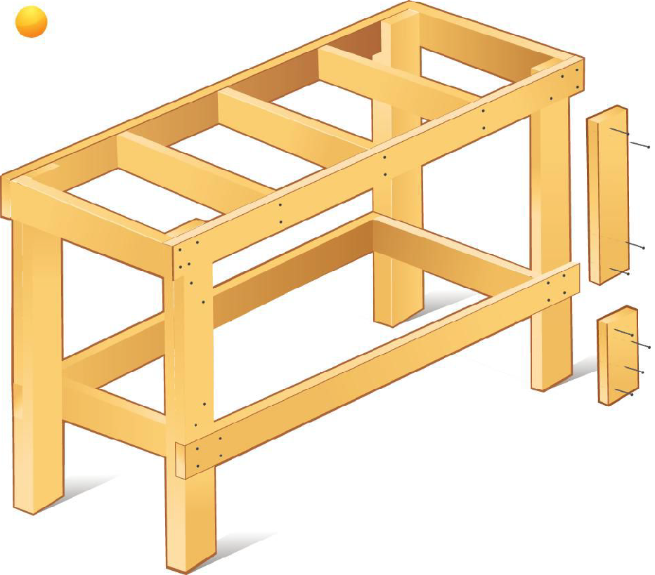
(From EAA Plan)

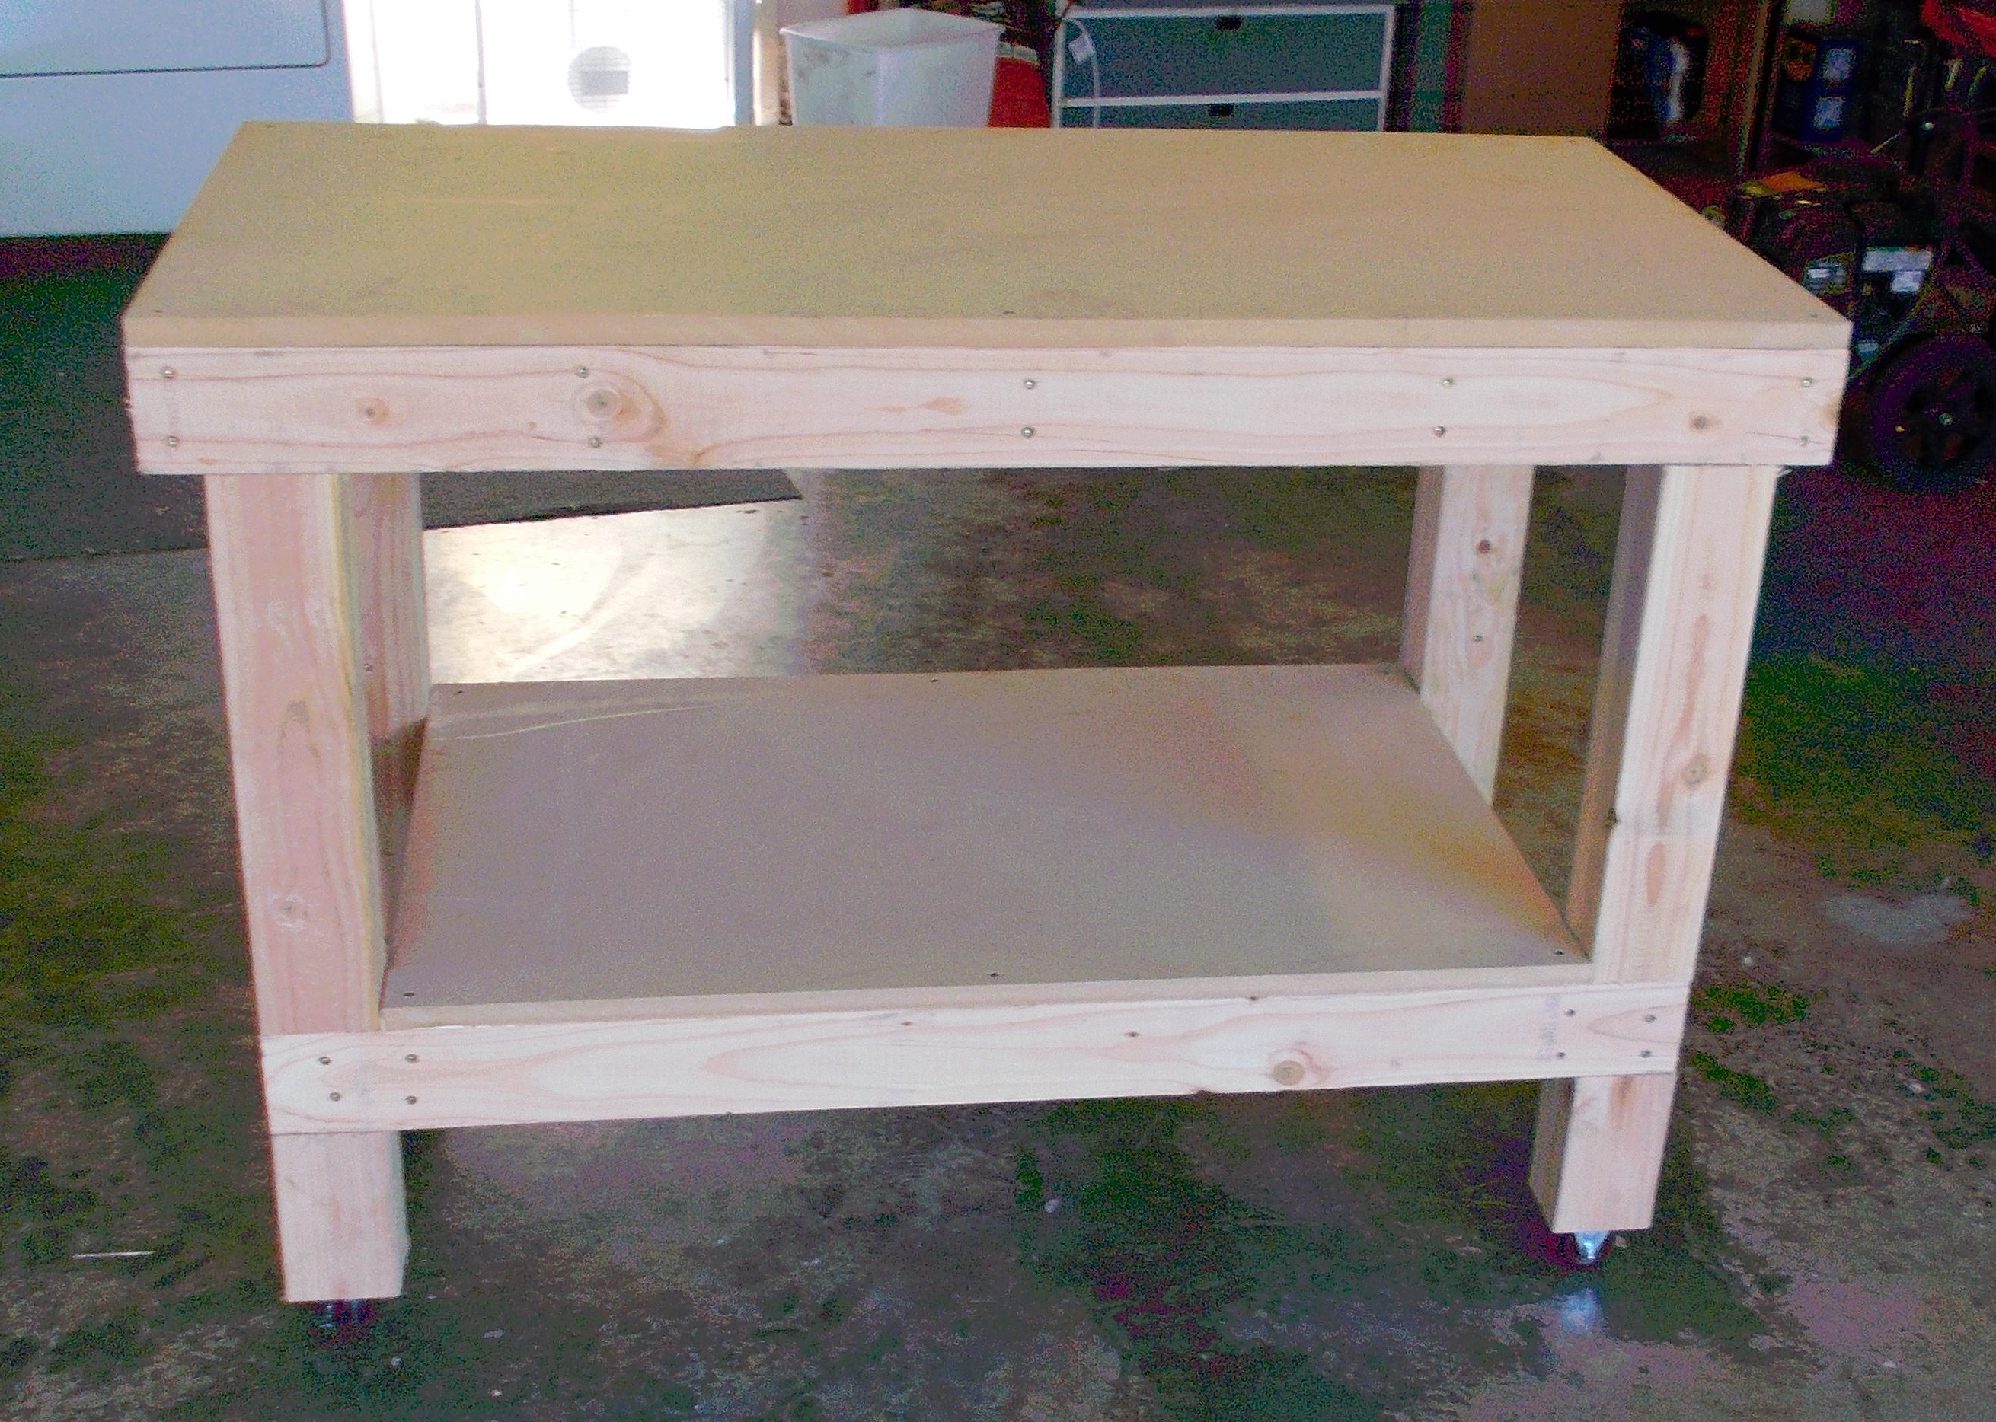
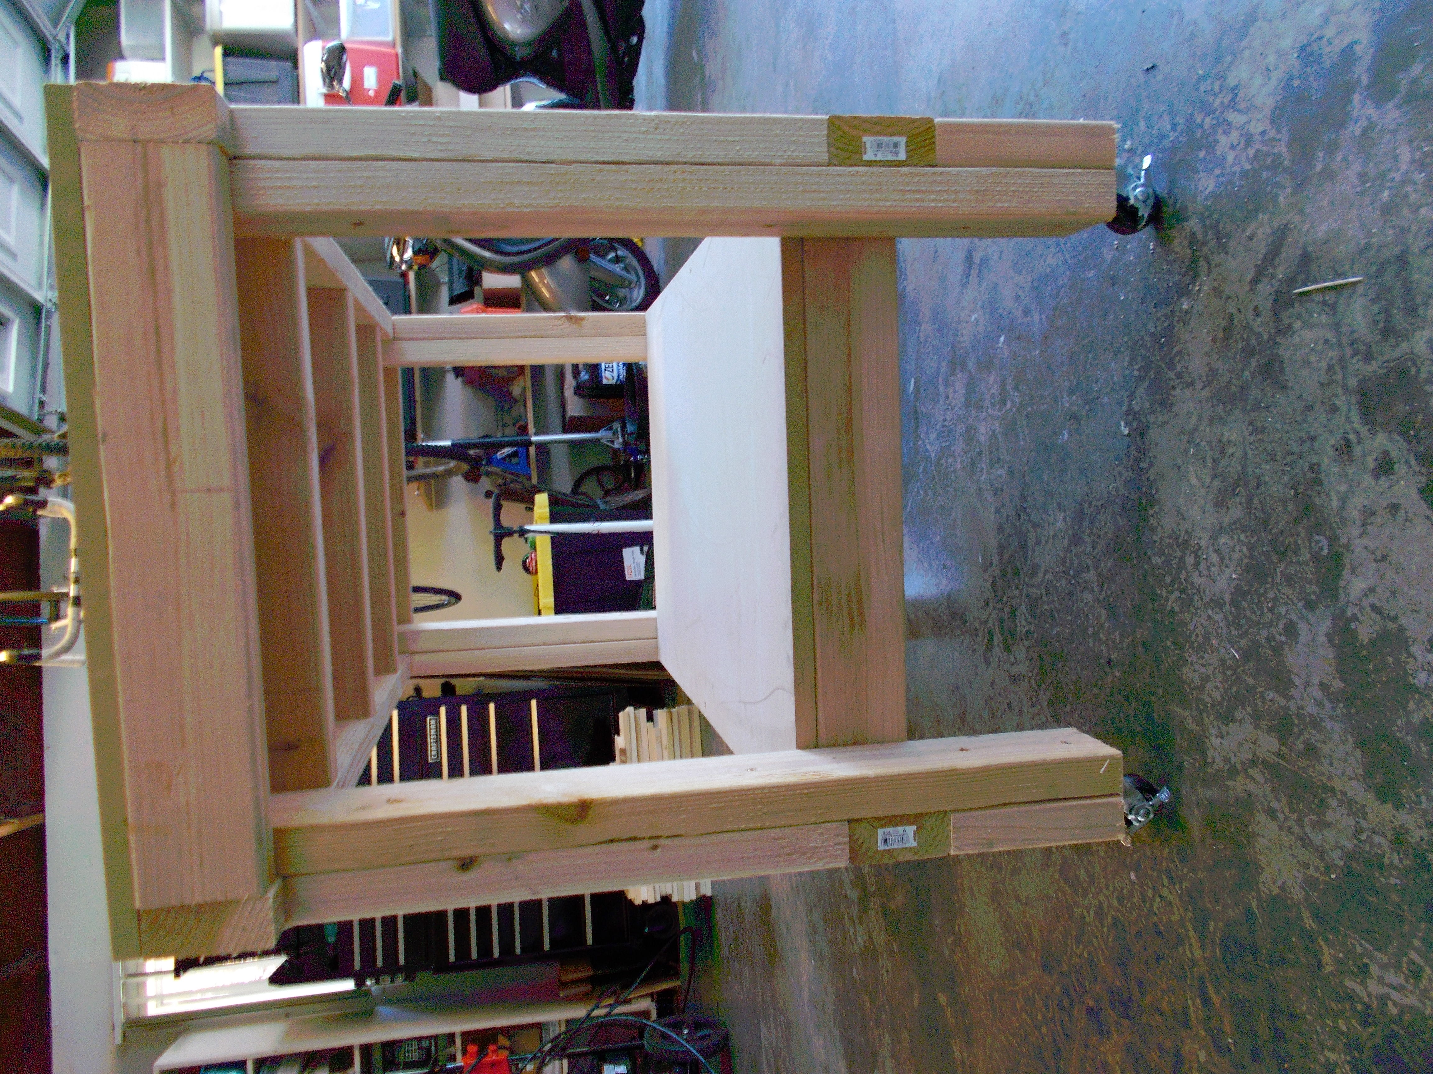

Construction Log:
Complete the log below making an entry every day you work on the project. Transfer the logged hours to your record book journal for this SAE enterprise.
Date | Tasks Completed | Skills Used/Learned | Hours

Actual Price Received:
Enter the actual price you received for the project in your record book journal as income. $_________

Project Portfolio:
Complete a portfolio for the project that includes:
- A description of the project and the skills you learned building the project. Include the hours spent on the project and the income (if sold). Use the construction log to complete this narrative. Write in complete sentences.
- The Bill of Materials
- The project plan
- 2-8 photos documenting the project at various stages of construction.

