Rraised Bed

## Description:

A 3’ x 9’ raised bed for gardening. Bed size is easily changed with different material lengths and beds can be stacked to make a taller bed. Notch joints make an extremely strong frame.

## Skills Required:

Students must have the ability to read an assembly plan, properly measure, and operate a circular saw and jig saw.

## Materials:

* 2” x 12” x 12’ rough sawn redwood or pressure treated* lumber
* 4” deck screws
* ½” hardware cloth.
* Small fence staples

* Some people object to PT wood because of concern about the chemicals used to treat the lumber.

Tools Required:

* Circular saw
* Jig Saw
* Portable Drill/driver
* Steel tape
* Snips
* Hammer

## Bill of Materials:

Complete the bill of materials below for this project. Use the completed bill of materials for your record book budget by entering the name of the project and the total amount as an expense

|  |  |  |  |  |  |  |
| --- | --- | --- | --- | --- | --- | --- |
| Size | Description | Units | Qty/Project | Cost/Unit | Order | Amount |
|  |  |  |  |  |  |  |
|  |  |  |  |  |  |  |
|  |  |  |  |  |  |  |
|  |  |  |  |  |  |  |
|  |  |  |  |  |  |  |

## Project Price:

Enter the expected price you will receive for the project in your record book budget (income).

## Estimated Construction Time:

__1___ hours.

## Directions:

1. Cut the lumber to 9’ and 3’ pieces.
2. Determine the center of the board width and make a notch in each end as shown in the drawing. Begin the notch with the circular saw and finish with the jig saw (or hand saw). Notch should be ½ the width x the thickness of the lumber.
3. Assemble the notched pieces using 4 screws at each corner.
4. Square the frame with the bottom up.
5. Cut the hardware cloth to length (9’) and staple to the bottom of the frame.
6. Turn the frame over and install on a level pad. Note: You may wish to plumb a pipe riser into the frame before adding soil. Riser may be pressurized (a simple hose bib) or connected to an automatic valve for timed watering. To do this install the riser in a location that will be the end of the bed. Cut the hardware cloth enough to allow the riser to pass. Attach the riser with a pipe clamp to the inside of the frame with a 1” screw.

## Photo/Drawing:

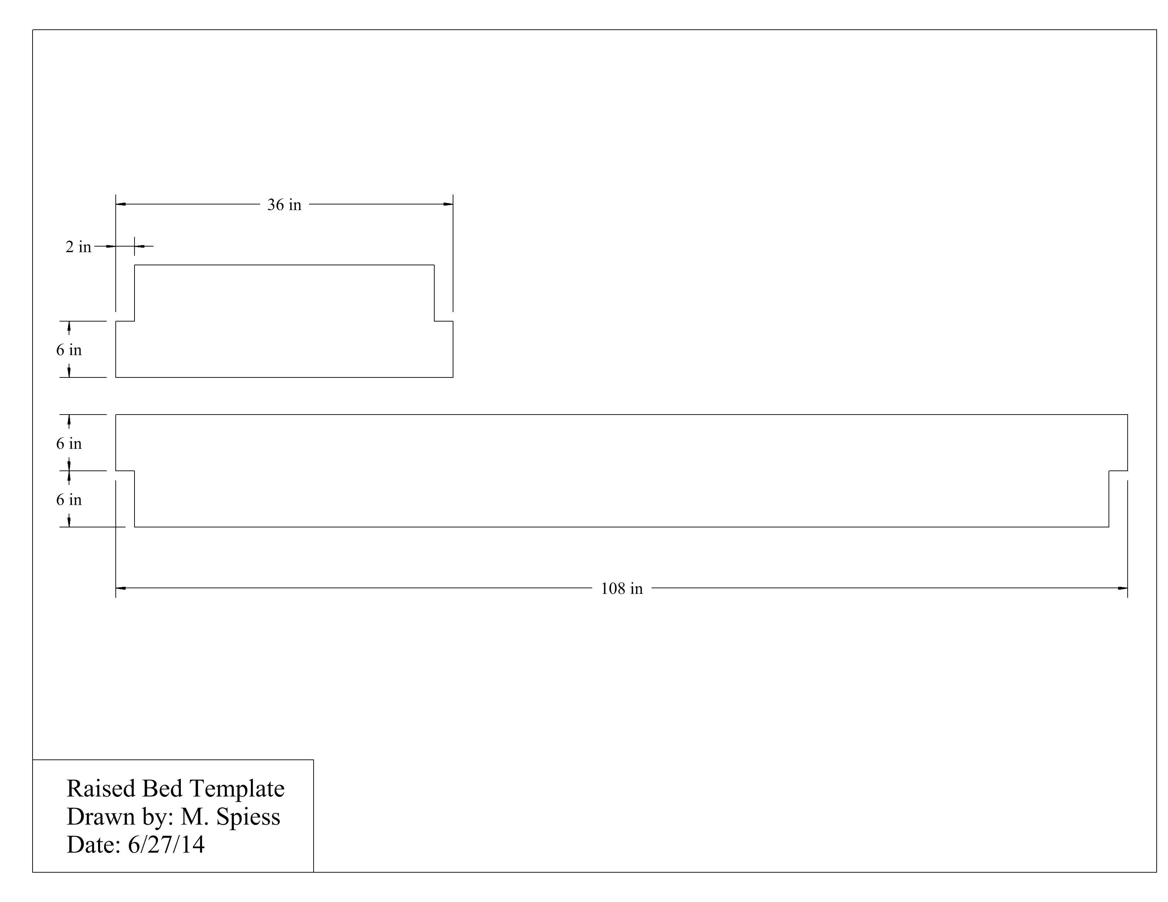

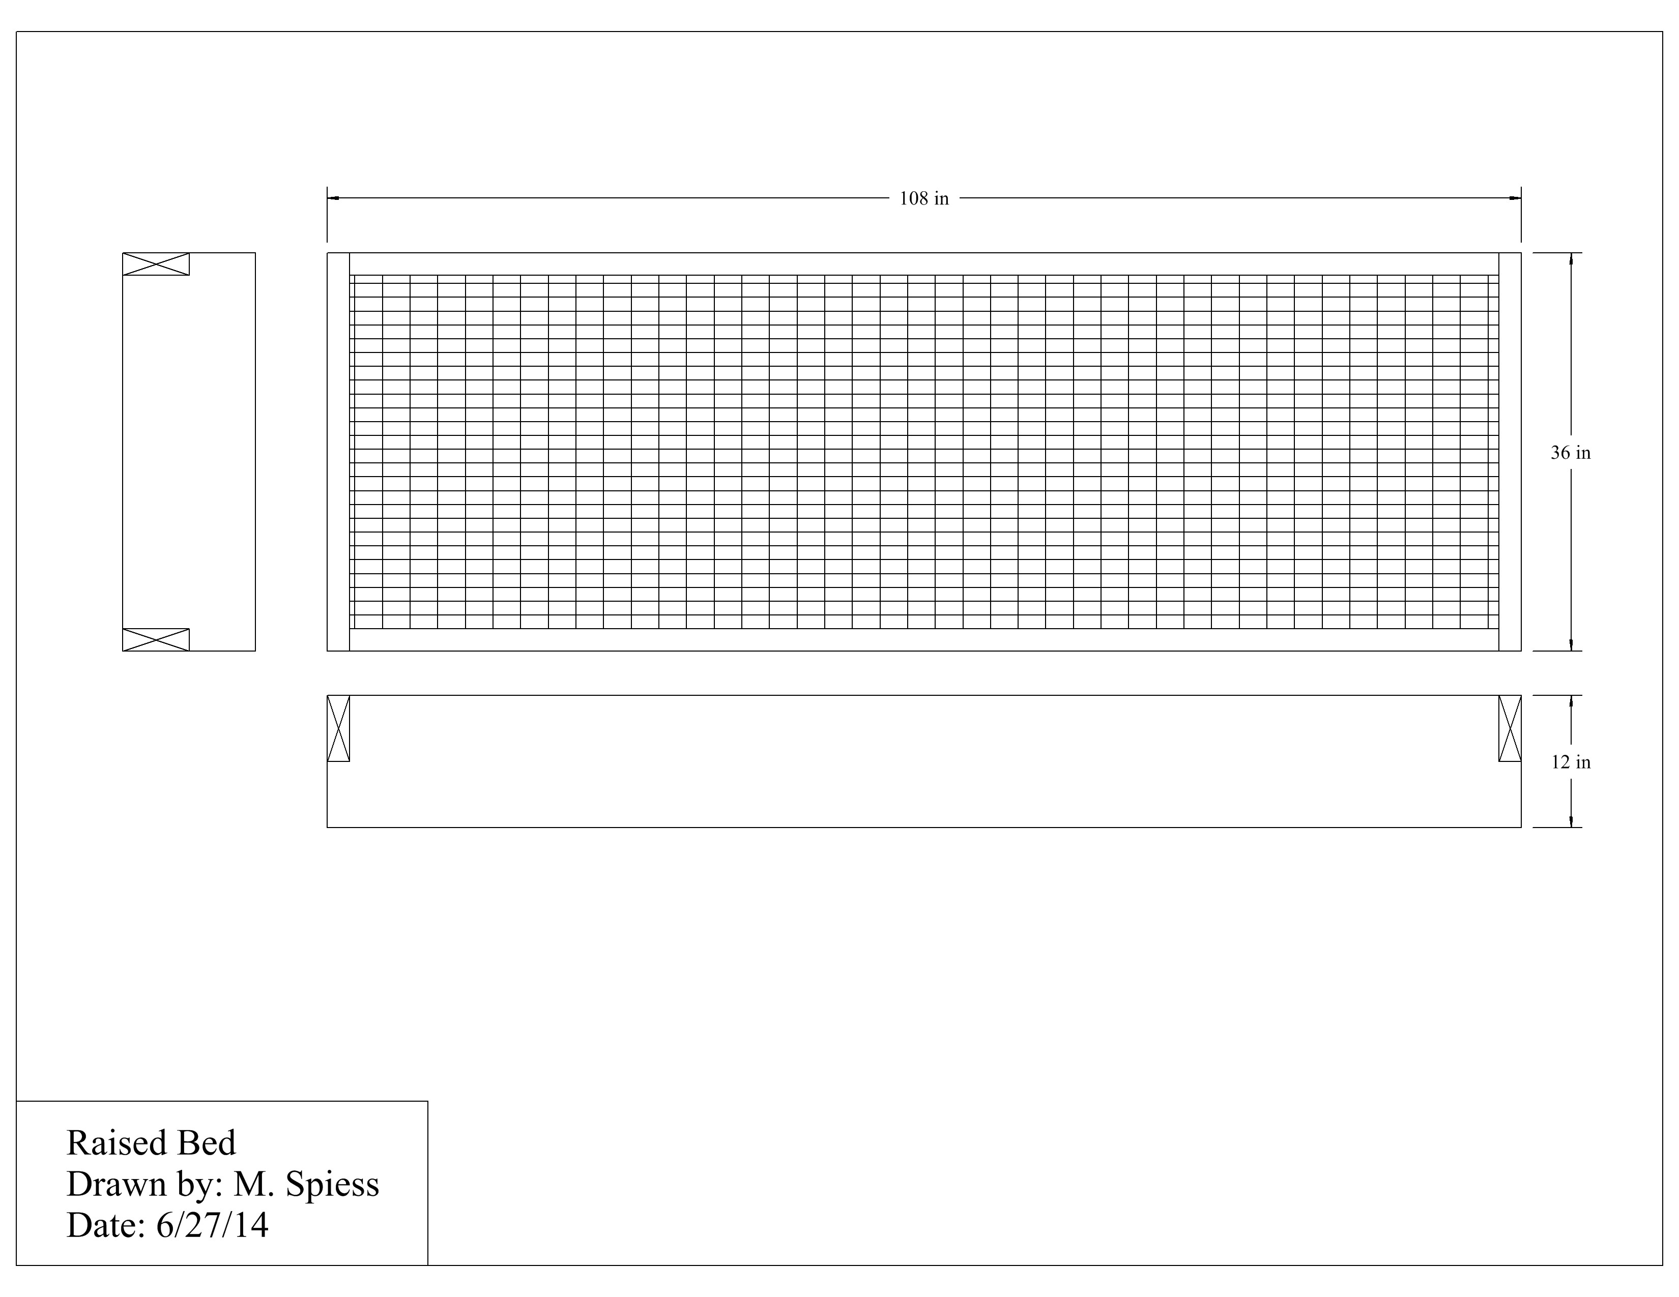

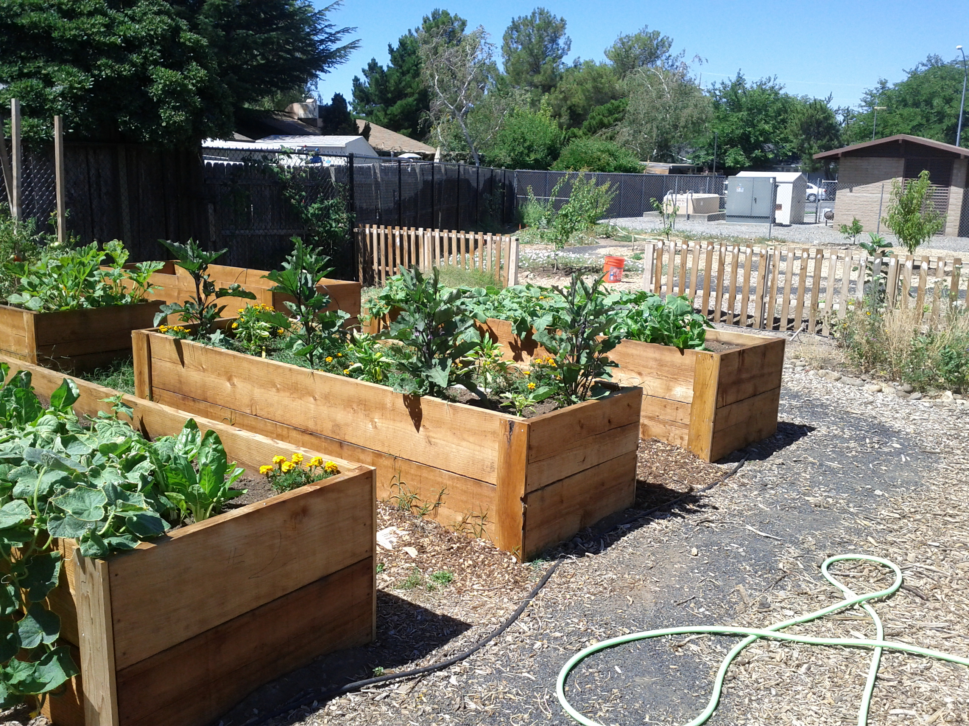

Example of a two high raised bed. 1 x 6 cedar fencing was used as a cleat to connect the beds a the corners.

## Construction Log:

Complete the log below making an entry every day you work on the project. Transfer the logged hours to your record book journal for this SAE enterprise.

|  |  |  |  |
| --- | --- | --- | --- |
| **Date** | **Tasks Completed** | **Skills Used/Learned** | **Hours** |
|  |  |  |  |
|  |  |  |  |
|  |  |  |  |
|  |  |  |  |
|  |  |  |  |
|  |  |  |  |
|  |  |  |  |
|  |  |  |  |
|  |  |  |  |
|  |  |  |  |
|  |  |  |  |
|  |  |  |  |
|  |  |  |  |
|  |  |  |  |
|  |  |  |  |
|  |  |  |  |
|  |  |  |  |
|  |  |  |  |
|  |  |  |  |

## Actual Price Received:

Enter the actual price you received for the project in your record book journal as income. $_________

## Project Portfolio:

Complete a portfolio for the project that includes:

* A description of the project and the skills you learned building the project. Include the hours spent on the project and the income (if sold). Use the construction log to complete this narrative. Write in complete sentences.
* The Bill of Materials
* The project plan
* 2-8 photos documenting the project at various stages of construction.