Garden Tool Rack

Description:
A great project built from scraps laying around the shop. Rack is customized for the types of tools that need to be stored. Good gift to take home. Designed to fasten to wall studs. The project can be built with a jig (also a good skill) to insure fingers are evenly spaced and alighned.

Skills Required:
Cold metal, GMAW welding, and layout skills are used to construct this project.

Materials:
Materials are variable depending on availability.
- Flat bar for the back. ¼”x2” or ¼”x3”.
- ½” round for fingers or 1”x1”x1/8” angle.
Tools Required:
- Welder
- Shear or cut-off saw
- Drill press
- Welding clamps

Bill of Materials:
Complete the bill of materials below for this project. Use the completed bill of materials for your record book budget by entering the name of the project and the total amount as an expense
Size | Description | Units | Qty/Project | Cost/Unit | Order | Amount

Project Price:
Enter the expected price you will receive for the project in your record book budget (income). $_______

Estimated Construction Time:
_____ hours.

Directions:
- Design the project. Consider the location and stud spacing when determining the back plate length. Consider the handle width of what you want to hang when determining the spacing between the finger pairs. Consider the width of what you want to hang (ex. Broom, Shovel, Hoe) when determining the spacing between the finger pairs.
- Cut the back plate.
- Cut the fingers.
- Using clamps tack the fingers in place. Hint: If you are using angle stock it can be clamped to both sides of a a scrap of square tubing.
- Drill holes in the back plate customized to the stud spacing and position. Note: This could be done in place with a portable drill is hole location is unknown.

Photo/Drawing:

Rack for folding chairs
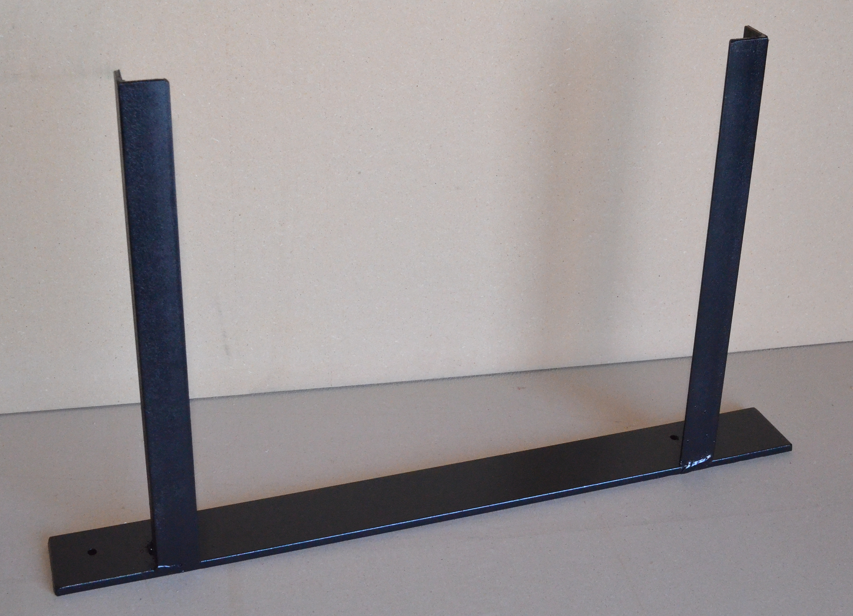

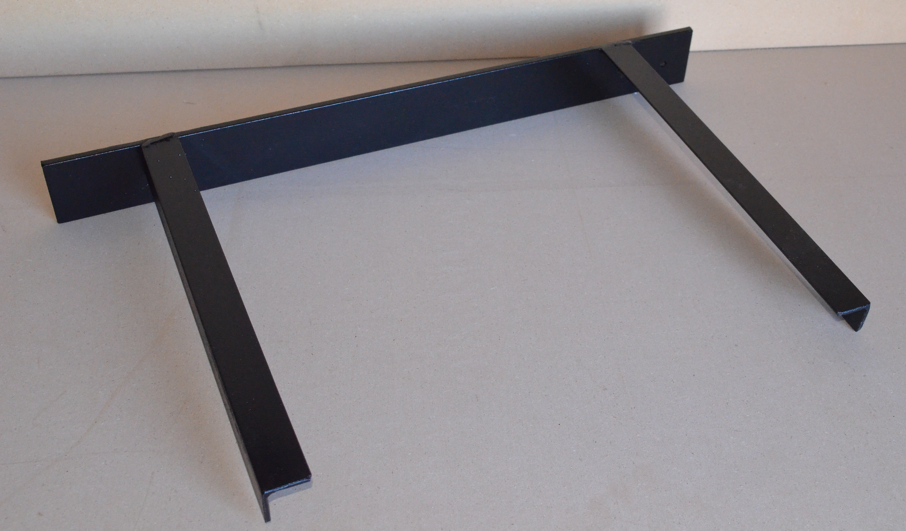

Rack for garden tools
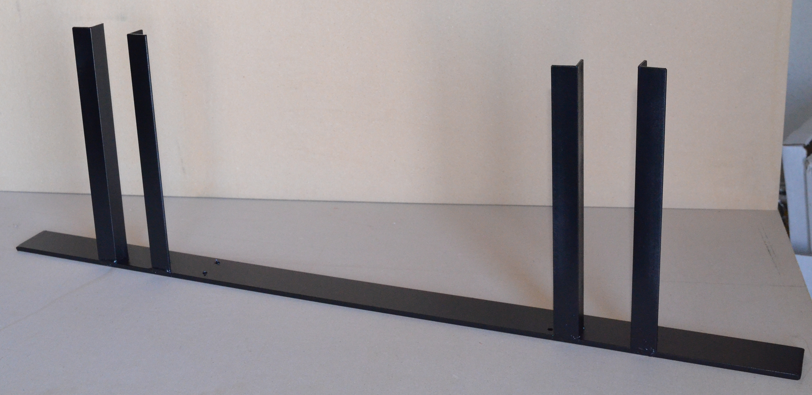

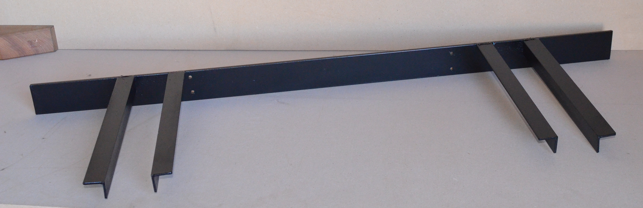

Rack for garden tools
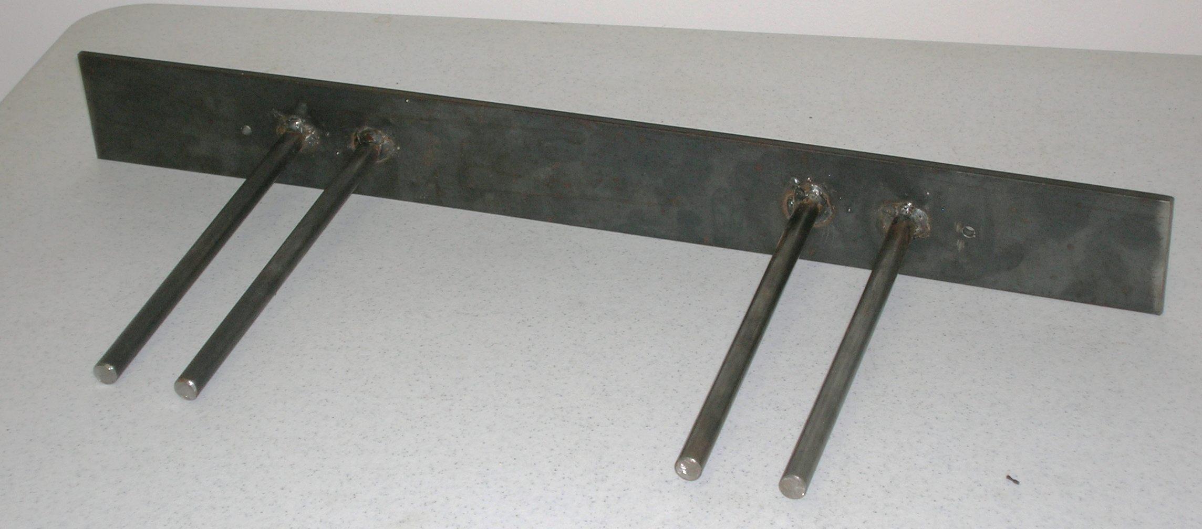

Construction Log:
Complete the log below making an entry every day you work on the project. Transfer the logged hours to your record book journal for this SAE enterprise.
Date | Tasks Completed | Skills Used/Learned | Hours

Actual Price Received:
Enter the actual price you received for the project in your record book journal as income. $_________

Project Portfolio:
Complete a portfolio for the project that includes:
- A description of the project and the skills you learned building the project. Include the hours spent on the project and the income (if sold). Use the construction log to complete this narrative. Write in complete sentences.
- The Bill of Materials
- The project plan
- 2-8 photos documenting the project at various stages of construction.

