Round Fire Pit

## This project was created by J. Myers at California State University, Chico in the fall of 2014. Plan from Hilmar High School.

## Description:

## This is a round fire pit used for outdoor fires for at a home, cabin, camping, or where ever you may want to use it. The fire pit has ventilation for limited smoking, and it is very easy to transport.

## Skills Required:

Students will need basic/moderate metal working skills. Students will also need to know the proper procedures for Plasma/Oxy-Acetylene cutting and GMAW welding. Proper safety practices is also required.

## Materials:

* 1 ¼” pipe
* 24” Disc Harrow Blade.
* 6” flat bar.Tools Required:
* Grinders
* Plasma/Oxy-Acetylene Cutting
* Welder
* Miter Saw
* Metal Shears

## Bill of Materials:

Complete the bill of materials below for this project. Use the completed bill of materials for your record book budget by entering the name of the project and the total amount as an expense

|  |  |  |  |  |  |  |
| --- | --- | --- | --- | --- | --- | --- |
| Size | Description | Units | Qty/Project | Cost/Unit | Order | Amount |
|  |  |  |  |  |  |  |
|  |  |  |  |  |  |  |
|  |  |  |  |  |  |  |
|  |  |  |  |  |  |  |
|  |  |  |  |  |  |  |

## Project Price:

Enter the expected price you will receive for the project in your record book budget (income). $_______

## Estimated Construction Time:

4 hours.

## Directions:

1. Select your blade
2. Cut three legs from the 1 ¼” pipe to 6 ½” long
3. Cut one end of the pipe to a 31⁰ angle and the other side to an 18⁰ angle.
4. Using a jig if provided tack the legs into place.
5. Take the blade and the legs out of the jig and place them on the floor to see if it sits level.
6. If the BBQ stand level than weld the legs all the way out.
7. Fabricate the rim piece out of the 6"X1/8" strip. Determine circumference of the disk blade and cut to length. Optionally you may cut a notch (shown below) on ½ of the rim. Using a roll bend the rim to fit the disk blade.
8. Fit the rim to the blade. If it fits then weld the ends together, then skip weld to the disk blade.
9. Clean up the BBQ and welds
10. Paint with High temp paint if preferred.

## Photo/Drawing:

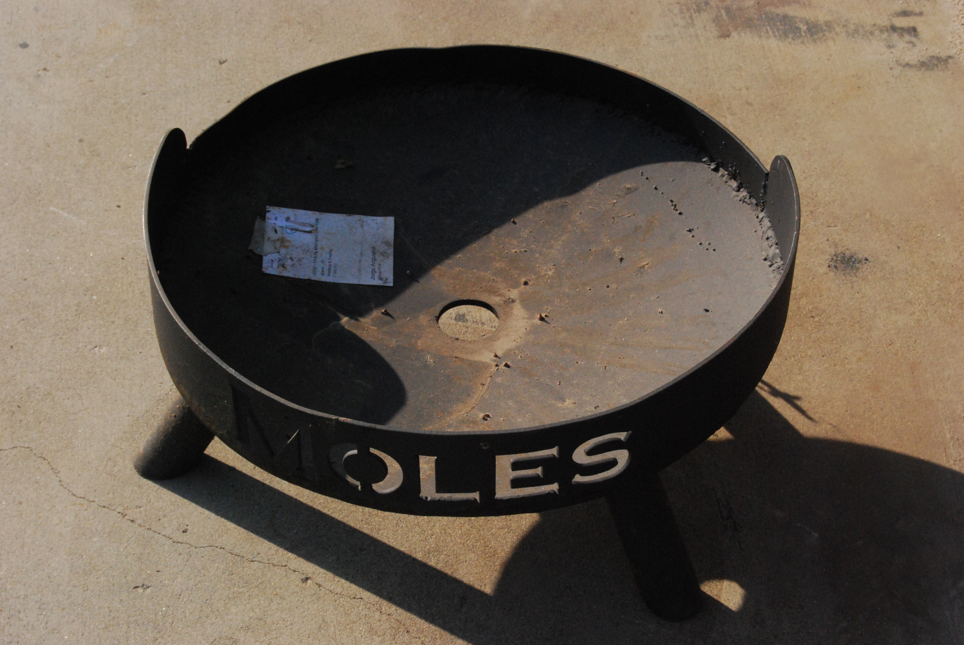

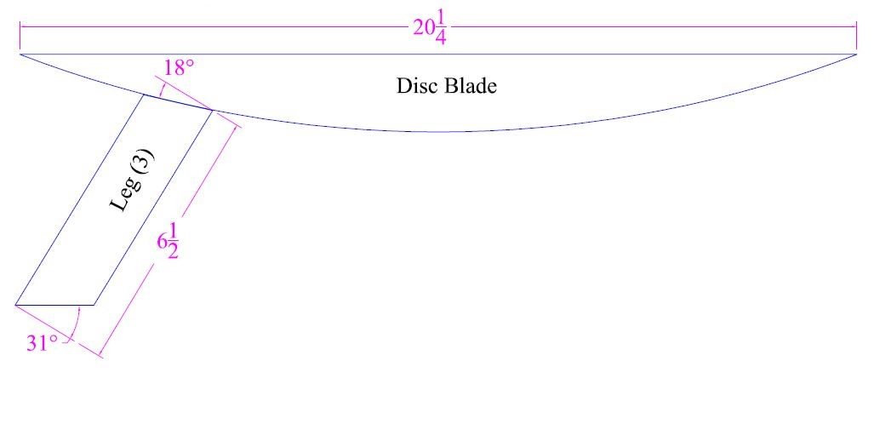

## Construction Log:

Complete the log below making an entry every day you work on the project. Transfer the logged hours to your record book journal for this SAE enterprise.

|  |  |  |  |
| --- | --- | --- | --- |
| **Date** | **Tasks Completed** | **Skills Used/Learned** | **Hours** |
|  |  |  |  |
|  |  |  |  |
|  |  |  |  |
|  |  |  |  |
|  |  |  |  |
|  |  |  |  |
|  |  |  |  |
|  |  |  |  |
|  |  |  |  |
|  |  |  |  |
|  |  |  |  |
|  |  |  |  |
|  |  |  |  |
|  |  |  |  |
|  |  |  |  |
|  |  |  |  |
|  |  |  |  |
|  |  |  |  |
|  |  |  |  |

## Actual Price Received:

Enter the actual price you received for the project in your record book journal as income. $_________

## Project Portfolio:

Complete a portfolio for the project that includes:

* A description of the project and the skills you learned building the project. Include the hours spent on the project and the income (if sold). Use the construction log to complete this narrative. Write in complete sentences.
* The Bill of Materials
* The project plan
* 2-8 photos documenting the project at various stages of construction.