**Geometric Fire Pit**

## This project was created by H. Clement at California State University, Chico in the fall of 2014.

## Description:

A geometric fire pit is a versatile piece that can double as a grill and, when not in use, a wood-topped table. This fire pit can be constructed with the use of two different metals depending on preference. There is a choice of corten or carbon steel. It can be used with cut seasoned wood or charcoal. There is a small slit at the bottom to increase airflow while retaining ambers, coal, and/or wood particles. This project requires that all steps of the project will be completed while demonstrating proper safety procedures.

## Skills Required:

Students must be able to properly and safely use a plasma cutter, MIG welder, and grinder. Students will also need the basic knowledge of reading a proper layout, measuring materials, and abide by the proper safety rules.

## Materials:

* HR Steel Plate 3/16”x 4’ x 8’  
  (1/4” plate may also be used)Tools Required:
* Plasma cutting torch
* GMAW Welder
* Hand Grinder
* Tape Measure
* Soapstone
* Straight Edge

## Bill of Materials:

Complete the bill of materials below for this project. Use the completed bill of materials for your record book budget by entering the name of the project and the total amount as an expense

|  |  |  |  |  |  |  |
| --- | --- | --- | --- | --- | --- | --- |
| Size | Description | Units | Qty/Project | Cost/Unit | Order | Amount |
|  |  |  |  |  |  |  |
|  |  |  |  |  |  |  |
|  |  |  |  |  |  |  |
|  |  |  |  |  |  |  |
|  |  |  |  |  |  |  |

## Project Price:

Enter the expected price you will receive for the project in your record book budget (income). $_______

## Estimated Construction Time:

10 hours.

## Directions:

1. If available, upload all CAD cutout templates to Plasma Cam computer. If a plasma cam is unavailable; follow the attached layout and cut out individual pieces using a plasma cutting torch
2. Cut out all pieces of fire pit edges (2 triangular side pieces, 2 trapezoidal, and 4 base pieces – refer to diagram for measurements)
3. Measure and ensure all pieces are correctly sized and grind any rough edges
4. Start assembling by tack welding base pieces to the 2 trapezoidal pieces
5. Then fit triangle side pieces to the already assembled pieces
6. All pieces should be assembled with tack welds
7. Check all components to see if they are flush and straight
8. Weld all pieces for strength.

## Photo/Drawing:

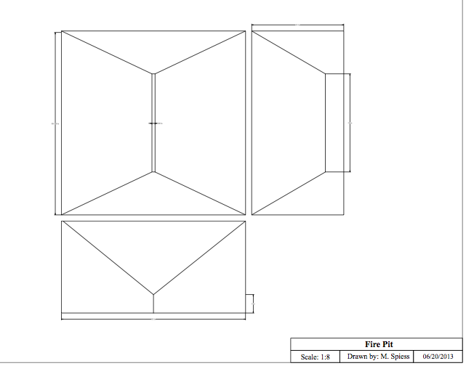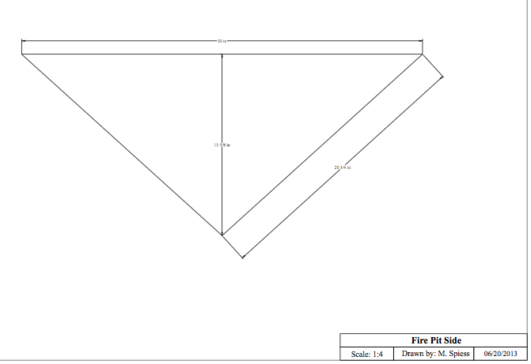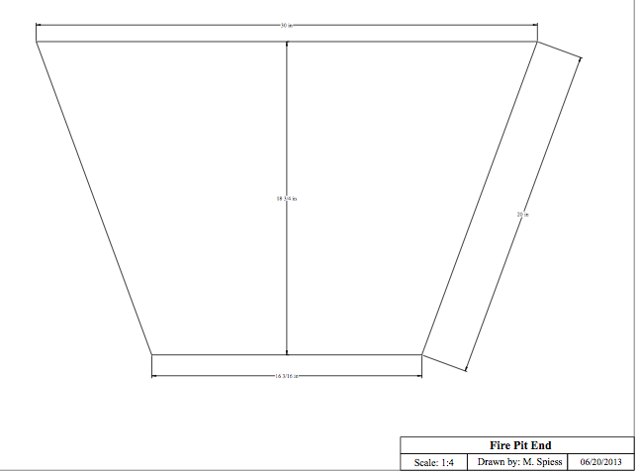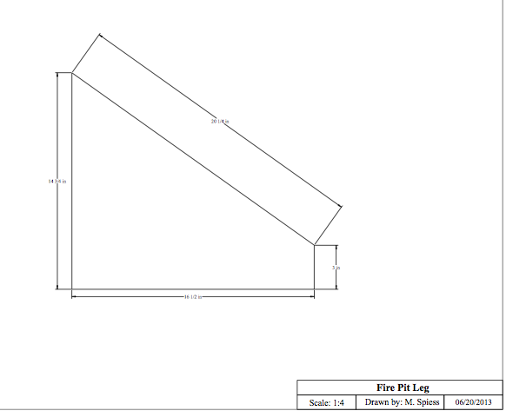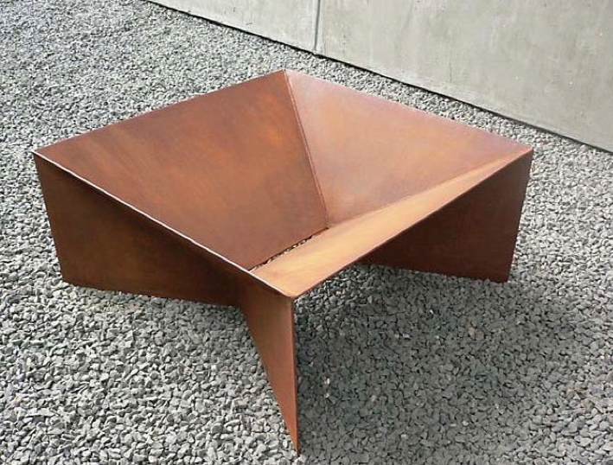

## Construction Log:

Complete the log below making an entry every day you work on the project. Transfer the logged hours to your record book journal for this SAE enterprise.

|  |  |  |  |
| --- | --- | --- | --- |
| **Date** | **Tasks Completed** | **Skills Used/Learned** | **Hours** |
|  |  |  |  |
|  |  |  |  |
|  |  |  |  |
|  |  |  |  |
|  |  |  |  |
|  |  |  |  |
|  |  |  |  |
|  |  |  |  |
|  |  |  |  |
|  |  |  |  |
|  |  |  |  |
|  |  |  |  |
|  |  |  |  |
|  |  |  |  |
|  |  |  |  |
|  |  |  |  |
|  |  |  |  |
|  |  |  |  |
|  |  |  |  |

## Actual Price Received:

Enter the actual price you received for the project in your record book journal as income. $_________

## Project Portfolio:

Complete a portfolio for the project that includes:

* A description of the project and the skills you learned building the project. Include the hours spent on the project and the income (if sold). Use the construction log to complete this narrative. Write in complete sentences.
* The Bill of Materials
* The project plan
* 2-8 photos documenting the project at various stages of construction.

**Layout:**

**(not drawn to scale)**