Feed Scoop
Name: ________________________
Date: ________________________

Description:
Students will accurately measure, cut, and bend sheet metal into a feed scoop shape. Then they will properly measure and cut wood into the shape specified in the layout. Shortly afterwards they will then cut and attach the handle and the bent sheet metal to the wood that was previously cut. Once all materials are combined students will have successfully created a feed scoop

Materials:
1X4 #3 pine
½” EMT Pipe
26 Gauge Galvanized Sheet Metal
7 x 5/16” Carriage Bolt
3d Galvanized Box Nails
5/16 x 1 ½” Fender Washer
5/16 x Flat Washer
5/16” Nut

Tools:
Band Saw (3/8” blade or smaller)
Drill Press
Open End Wrench
Duck Bill Snips
Sheet metal brake
Dividers
Compass
Sheet metal Shear
Scribe
Combination Square
Carpenter Square
Miter Saw
3/4” Forstner Bit
5/16” Drill Bit
Claw Hammer
Roll

Procedure:

Wood Back
- Measure 7” on the 1 x 4 piece of wood and cut with the table saw
- Set compass to appropriate setting and draw the half circle on the 1 x 4
- Cut the half circle out with a band saw
- Use the plan and a combination square mark the center of the hole
- Use the wood drill press and a ¾” Forstner bit to drill a hole half way into the wood where you marked the center of the hole
- Use the 5/16” Drill Bit to drill completely through in the center of the hole created by the Forstner Bit.
- Sand any rough edges.
- Place washers on the side where the drill bit went through
- Put the Carriage Bolt through the 6” EMT, the wood, and then the washer. Fasten with a nut on the inside of the scoop

Sheet Metal Scoop
- Sheer a piece sheet metal 12” x 13” using Sheet Metal Brake
- Using the combination square and scribe, apply layout to sheet metal
- Use the combination square to locate center point and mark
- Use the dividers to scribe the arc
- Check your scribed lines
- Cut out the project using snips
- Using the sheet metal brake bend the ½” sides all the way over on both sides. (WATCH OUT FOR THE TABS)
- Ease and cut corners on the tabs
- Using a Smooth Mill File, file any sharp edges
- Roll through roller as needed to fit wood
- Place steel scoop on wood back and start nailing in nails starting from the center and working towards the sides with the tabs. (Approximately 9 nails). Proceed to nail in the tabs

Notes:
____________________________________________________________________________________________________________________________________________________________________________________________________________________________________________________________________________________________________________________________________________________________________________________________________________________________________________________________________________________________________________________________________________________________________________________________________________________________________________________________________________________________________________________________________________________________________________________________________________________________________________________________________________________________________________________________________________________________________________________________________________________________________________________________

Photo/Drawing:
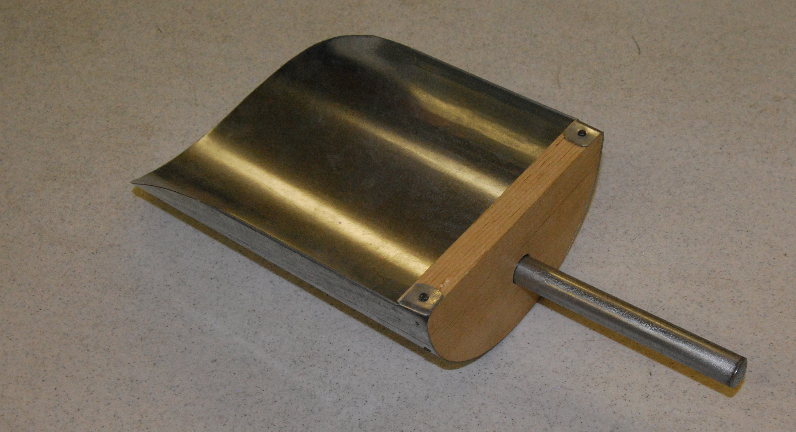
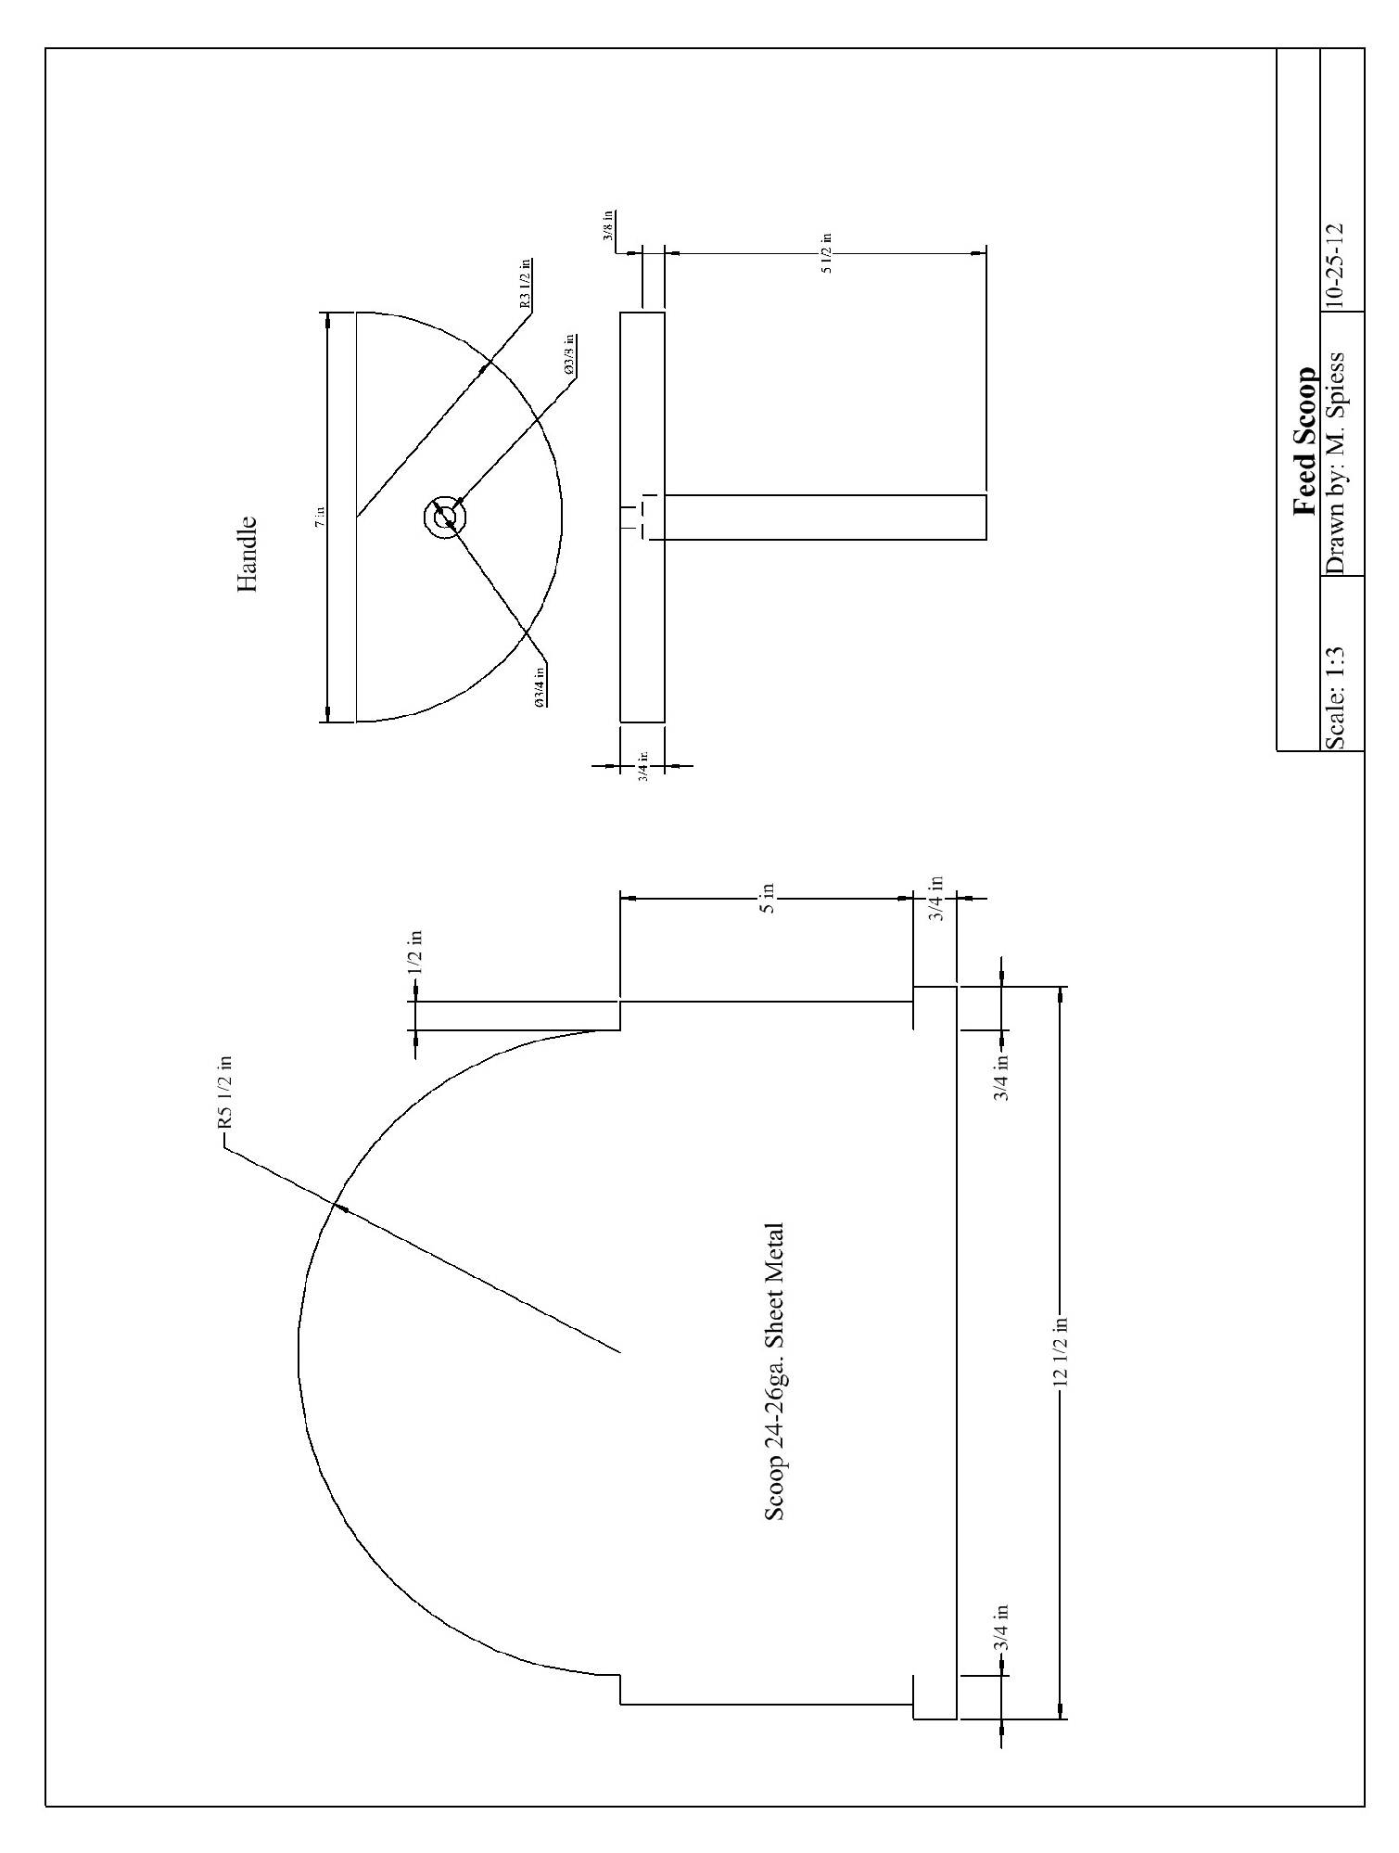

Feed Scoop Worksheet
Name: ________________________
Date: ________________________

- The radius of the half circle on the scoop is __________
- The radius of the half circle of the wood back of the scoop is ________
- Use a ____________ to make the metal scoop round to fit onto the wood back.
- A _____________ is used to make the half circle lines on the sheet metal.
- The length of the handle should be _________ and is cut to that length using a ____________ and ___________

Grading Rubric:
CRITERIA | POSSIBLE | SCORE
Length/Width | 5
Tabs/Edges | 5
Angles | 5
Metal Fitting to Wood | 5
Handle installation and placement | 5
Worksheet | 5
 | 30

Feed Scoop Teachers Notes:

Agricultural Standards Met:
Specific applications of Geometry standards (grades eight through twelve):
8.0 Students know, derive, and solve problems involving the perimeter, circumference, area, volume, lateral area, and surface area of common geometric figures.
11.0 Students determine how changes in dimensions affect the perimeter, area, and volume of common geometric figures and solids.
4.0 Technology Students know how to use contemporary and emerging technological resources in diverse and changing personal, community, and workplace environments:
4.6 Differentiate among, select, and apply appropriate tools and technology.
5.0 Problem Solving and Critical Thinking Students understand how to create alternative solutions by using critical and creative thinking skills, such as logical reasoning, analytical thinking, and problem-solving techniques:
5.1 Apply appropriate problem-solving strategies and critical thinking skills to work-related issues and tasks.
5.3 Use critical thinking skills to make informed decisions and solve problems.
6.0 Health and Safety Students understand health and safety policies, procedures, regulations, and practices, including the use of equipment and handling of hazardous materials:
6.2 Understand critical elements of health and safety practices related to storing, cleaning, and maintaining tools, equipment, and supplies.
6.4 Maintain safe and healthful working conditions.
6.5 Use tools and machines safely and appropriately.
B1.0 Students understand personal and group safety:
B1.1 Practice the rules for personal and group safety while working in an agricultural mechanics environment.
B1.2 Know the relationship between accepted shop management procedures and a safe working environment.

B2.0 Students understand the principles of basic woodworking:
B2.1 Know how to identify common wood products, lumber types, and sizes.
B2.3 Know how to identify, select, and implement basic fastening systems.
B2.4 Complete a woodworking project, including interpreting a plan, developing a bill of materials and cutting list, selecting materials, shaping, joining, and finishing
B5.0 Students understand agricultural cold metal processes:
B5.1 Know how to identify common metals, sizes, and shapes.
B5.2 Know basic tool-fitting skills.
B5.3 Know layout skills.
B5.4 Know basic cold metal processes (e.g., shearing, cutting, drilling, threading, bending.).
B5.5 Complete a cold metal project, including interpreting a plan, developing a bill of materials, selecting materials, shaping, fastening, and finishing.

Objectives:
By properly completing this project, students will be able to:
- Demonstrate knowledge of reading and implementing a layout
- Know tool & material terminology, identification, and usages
- Cut wood and sheet metal
- Bend sheet metal

Alternative Tools/Methods/Materials:
- Hand Drill to drill holes. A spade bit works better, but depth control is harder.
- Use a pipe as a form to bend scoop (to replace Roll)
- Use a wooden dowel (1”) for the handle. Glue and screw in place.
- Larger EMT can also be used for a stronger handle.
- The handle can be attached without the counter sunk hole. Consider using a fender washer on both sides.

Safety Review:
- Use of Drill Press
- Use of Sheet metal Shear
- Use of Sheet Metal Brake
- Safety Glasses

Project Time:
Demonstration: | 40 minutes
Build: | 1 1/2 hours

Demonstration Notes
- The key to this project is the layout of both sheet metal and wood. Demonstrate using the combination square and dividers.
- Over roll the scoop slightly so it will “hug” the wood.
- Trim the tabs so edges don’t stick out.
- Start nailing the metal on the wood with the scoop upside-down. (Be sure metal is centered.) HINT: Leave a 1/16” of the wood edge exposed so the sheet metal edge is not sticking out.
- Be careful when hammering in nails, so that your nail that you hammer into the tab doesn’t interfere with the nails used on the side
- Use sand paper to smooth out any rough edges to give the finished product a more professional look
- Remove protruding nails with a nail set.

Bill of Materials:
Project By: Lindsay Swickard

