Rafter
Name: ________________________
Date: ________________________

Description
Cut a rafter using appropriate construction tools and learn to use a framing square to layout a common rafter angle and length.

Materials:
2x4x Fir (36”)

Tools:
Sliding T-bevel (optional)
Hand crosscut saw
Framing (carpenter’s) square
Rafter Square (optional)
Saw Horse
Circular Saw

Definitions:
Rise: Change in vertical height of the roof.
Run: Distance from the center of the roof to the edge of the outside of the plate
Span: Distance from outside of one plate to the outside of the other plate (building width)
Pitch: Rise/Span
Slope: Shown in the triangle as rise per foot of run.
Plate: The top board on a wall.
Plumb cut: An angle that is plumb (up and down).
Ridge Board: The perpendicular framing member that ties the rafters together at the paek of the roof.

Directions:
- Identify the rafter in the drawing and answer the questions.
- Layout the rafter using the framing square. Key concepts are:
  - The rafter is longer than 30” (the slant distance).
  - The rafter length must be trimmed ¾” to allow for the ridge board.
  - The bird’s mouth must be located on the bottom of the rafter (angles in the proper direction)
  - Sliding “T” bevel may be used to repeat angles
- Cut the ends with a circular saw.
- Begin the cuts for the bird’s mouth with the circular saw and complete with the crosscut hand saw.
- Label your rafter with your name and turn in with your worksheet.

Drawing/Photo:
2x4 Ridge board
30"
24"
4
12
Bird's Mouth
1 1/2" Deep
48"

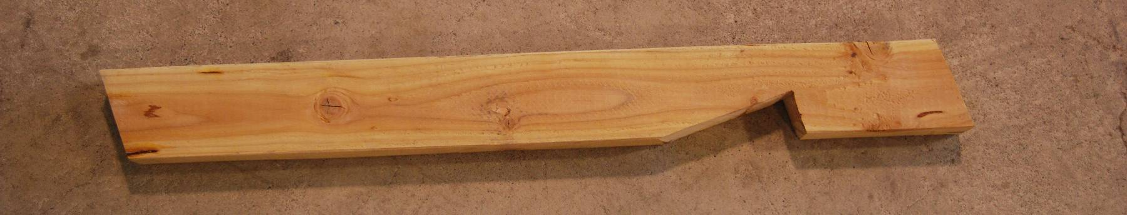

Rafter Project Student Worksheet
Name____________________________
- What is the rise in inches? _________________
- What is the run in inches? __________________
- What is the span in inches? _________________
- What is the pitch? _______________
- How deep should the bird’s Mouth be? ___________

Rubric:
Criteria (tolerance 1/16”) | Possible | Score
Length | 5
End Angles, cut | 5
Bird’s mouth location, size | 5
Bird’s mouth cutting, square, straight, angles | 5
Workmanship (cut quality, wood selection) | 5
Total: | 25

Agricultural Standards Met:
4.0 Technology. Students know how to use contemporary and emerging technological resources in diverse and changing personal, community, and workplace environments:
4.6 Differentiate among, select, and apply appropriate tools and technology.
5.0 Problem Solving and Critical Thinking. Students understand how to create alternative solutions by using critical and creative thinking skills, such as logical reasoning, analytical thinking, and problem-solving techniques:
5.1 Apply appropriate problem-solving strategies and critical thinking skills to work-related issues and tasks.
5.3 Use critical thinking skills to make informed decisions and solve problems.
6.0 Health and Safety. Students understand health and safety policies, procedures, regulations, and practices, including the use of equipment and handling of hazardous materials:
6.1 Know policies, procedures, and regulations regarding health and safety in the workplace, including employers’ and employees’ responsibilities.
6.2 Understand critical elements of health and safety practices related to storing, cleaning, and maintaining tools, equipment, and supplies.
6.4 Maintain safe and healthful working conditions.
6.5 Use tools and machines safely and appropriately.
6.6 Know how to both prevent and respond to accidents in the agricultural industry.
B1.0 Students understand personal and group safety:
B1.1 Practice the rules for personal and group safety while working in an agricultural mechanics environment.
B1.2 Know the relationship between accepted shop management procedures and a safe working environment.
B2.0 Students understand the principles of basic woodworking:
B2.1 Know how to identify common wood products, lumber types, and sizes.
B2.4 Complete a woodworking project, including interpreting a plan, developing a bill of materials and cutting list, selecting materials, shaping, joining, and finishing.

Objectives:
By successfully completing this project students will be able to:
- Read the plan and obtain critical dimensions
- Indentify common wood working tools
- Determine the proper angles of the bird mouth

Alternative Tools/Methods/Materials:
Rafter squares may be used, but length must be determined with a framing square or rafter table.

Safety Review:
- Use of the circular saw

Project Time:
Demonstration: | 20-30 minutes
Build Time: | 1 hour

Demonstration Notes:
- Point out the key terms used in describing a rafter.
- Introduce the framing square and the concept of rise/run on the square.
- Show the selection of lumber (avoid knots at key locations like the bird’s mouth.
- Layout the first angle at the end of the board.
- Use the square to mark the length (< 30”!) and location of bird’s mouth. Note: 4/12 = 2/6.
- Set the sliding “T” bevel to the angle and use it to mark the angle of the end of the rafter.
- Show how to determine which side of the rafter the bird’s mouth will fall by orienting the plumb cuts.
- Mark the bird’s mouth using the sliding “T” bevel. Use the square to make a 90º line 1 ½” deep. Tip: The tongue of the square is 1 ½” wide.
- Measure ¾” in from the top of the rafter using the square (90º to plumb cut) and mark a parallel cut line to allow for a 2x ridge board.
- Review safety with the circular saw.
- Cut the end with a circular saw.
- Cut the bird’s mouth 2nd so you hold the board. How the guard back to keep it from catching. Cut on the inside of the line and just so the cuts touch.
- Make the other end cut with the circular saw.
- Complete the bird’s mouth cut with the hand saw.
- Smooth any rough edges.

Bill of Materials:
Project from: Mike Spiess

