Push Stick
Name: ________________________
Date: _________________________

Description:
A push stick is a device made of wood which has a notch on the end. A push stick is used to push or guide stock on a table of a power tool. The use of a band saw and drill press will be taught.

Materials:
1” x 4” #3 Common Pine
Heavy paper (or file folder)
150 grit sandpaper

Tools:
Combination square
Scissors
Band saw
Drill press
¼” twist drill

Procedure:
- Obtain a piece of 1 x 4 #3 common pine which approximately 12 long.”
- Using a combination square rule layout 1” grids on some heavy paper.
- Sketch the outline of a push stick as shown in the plan.
- Cut out this outline and use as a template.
- Using the template, mark out the push stick on the lumber. Avoid knots.
- Bore a ¼” hole in the handle using a drill press.
- Cut out the push stick using a band saw.
- Sand and finish the push stick.
- Turn in the finished push stick, your template, and the work sheet for grading.

Notes:
__________________________________________________________________________________________________________________________________________________________________________________________________________________________________________________________________________________________________________________________________________________________________________________________________________________________________________________________________________________________________________________________________________________________________________________________________________________________________________________________________________________________________________________________________________________________________________________________________________________________________________________________________________________

Photo/Drawing:

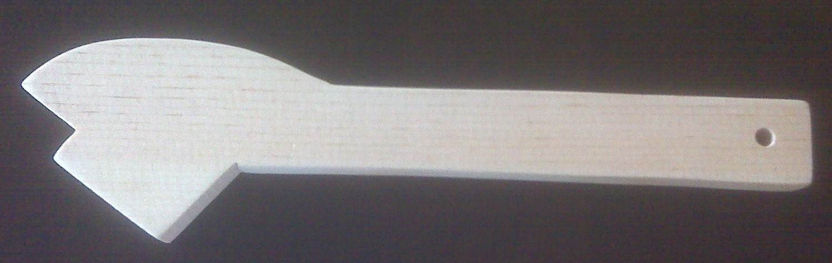

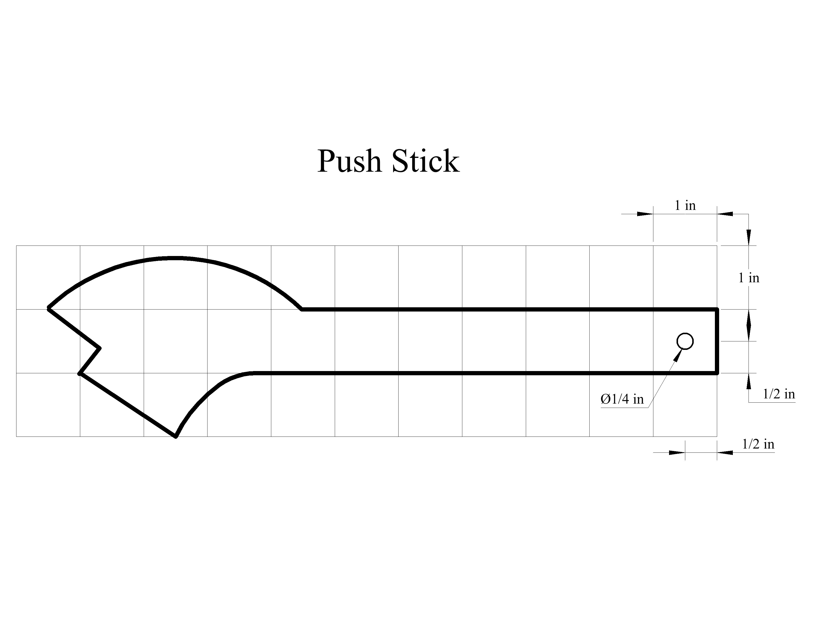

Push Stick Student Worksheet:
Name:___________________________

Directions: Complete this worksheet prior to starting the project.
- What is overall length of the push stick? ___________________________
- What is width of the handle? ___________________________
- What distance should the band saw guard be set above the wood? ___________
- How is the push stick used with a table saw?
___________________________________________________________________________
___________________________________________________________________________
- When should a push stick used with a table saw?
___________________________________________________________________________
___________________________________________________________________________

Grading Rubric:
CRITERIA | POSSIBLE | SCORE
Template | 5
Correct length of push stick | 5
Correct size/placement of hole in handle | 5
Correct shape | 5
Overall neatness, including sanding, cutout | 5
Worksheet | 10
TOTAL | 35

Push Stick - Teachers Notes:
This is a great beginning project to get students confortable with power tools. They can decorate the stick and use it in class to build other projects.

Agricultural Standards Met:
6.0 Health and Safety
Students understand health and safety policies, procedures, regulations, and practices, including the use of equipment and handling of hazardous materials:
6.1 Know policies, procedures, and regulations regarding health and safety in the workplace, including employers’ and employees’ responsibilities.
6.2 Understand critical elements of health and safety practices related to storing, cleaning, and maintaining tools, equipment, and supplies.
6.4 Maintain safe and healthful working conditions.
6.5 Use tools and machines safely and appropriately.
6.6 Know how to both prevent and respond to accidents in the agricultural industry.
11.0 Demonstration and Application
Students demonstrate and apply the concepts contained in the foundation and pathway standards.
B1.0 Students understand personal and group safety:
B1.1 Practice the rules for personal and group safety while working in an agricultural mechanics environment.
B1.2 Know the relationship between accepted shop management procedures and a safe working environment.
B2.0 Students understand the principles of basic woodworking:
B2.1 Know how to identify common wood products, lumber types, and sizes.
B2.2 Know how to calculate board feet, lumber volume, and square feet.
B2.4 Complete a woodworking project, including interpreting a plan, developing a bill of materials and cutting list, selecting materials, shaping, joining, and finishing.

Objectives:
By properly completing this project, students will be able to:
- Layout dimensions for a project from a template.
- Know how to use a band saw
- Know how to use a drill press

Alternative Tools/Methods/Materials:
A portable drill may be used instead of a drill press. A coping saw, jig saw or compass saw can be used instead of a band saw. If the different saws are used, then students would have the chance to learn how to properly use them.

Safety Review:
- Band saw
- Drill press

Project Time:
Demonstration: | 15-20 minutes
Build: | 3-4 hours

Demonstration Notes:
- Demonstrate how the push stick is used.
- Cut lumber into 1 x 4 x 12”+ pieces.
- Have a few push sticks already cut out for examples.
- Scissors and rulers need to be out for the students to use.
- Have plenty of paper. Recycled file folders work well.
- If possible, use an overhead projector for the layout demonstration.
- Show how to properly sketch the push stick, including the hole in the handle.
- Show how to select lumber and work around knots.
- Demonstrate how to properly mark out the project on the lumber.
- Hint: Use a scratch awl to poke through the template and mark the hole for drilling.
- Review drill press safety. Demonstrate how to properly bore a hole using the drill press.
- Tell students to drill the hole in the handle before cutting out the push stick.
- Review band saw safety. Demonstrate how to cut out the push stick with a band saw.
- Inform students to cut off excess lumber using the band saw after marking out the push stick.
- Advise students when using the band saw to cut the radius by segmenting.
- Mention that the overall neatness of their push stick is very important. Tell them to take their time and do a good job!!

Bill of Materials:
Note: This is a great project to make from scraps.
Project from: Ray V. Herren, Agricultural Mechanics Fundamentals & Applications 5th Edition, Thomson Delmar Learning, 2006
Plan by: Amy Bohlken

