Woodworking- Clay Pot Hanger
Name: _________________________
Date: _________________________

Description:
A useful small project that demonstrates layout skills using a grid. Hanger holds a 6” clay pot. .

Materials:
2”x 4” redwood or cedar
120 grit sandpaper

Tools:
Combination or Try Square
Band saw (1/4” blade desirable)
Drill Press (3/8” and 1/8” twist drills)

Procedure:
- Review the plan.
- Create a template using the plan as a guide.
  - Create a 1” grid as shown on the plan.
  - Use the ruler from the square to draw the straight lines.
  - Sketch in the curved lines.
  - Cut out your template.
- Test the template it on the 6” clay pot. Adjust as needed.
- Transfer your template to a scrap of 2” x 4” redwood. Use a scratch awl or nail to locate the 3/8” hole center.
- Drill the 3/8” hole. The cut remaining lines with the band saw.
- Locate and mark the two 1/8” holes (for the mounting screws) and drill.
- Test the completed project on your pot. Sand as need to for a good fit.
- Sand all edges and surfaces smooth.
- Turn in the project with the template.

Notes:
_________________________________________________________________________________________________________________________________________________________________________________________________________________________________________________________________________________________________________________________________________________________________________________________________________________________________________________________________________________________________________________________________________________________________________________________________________________________________________________________________________________________________________________________________________________________________________________________________________________________________________________________________________________________________________________________________________________________________________________________________________________________________________________________________________________________________________________________________________________

Photo/Drawing: 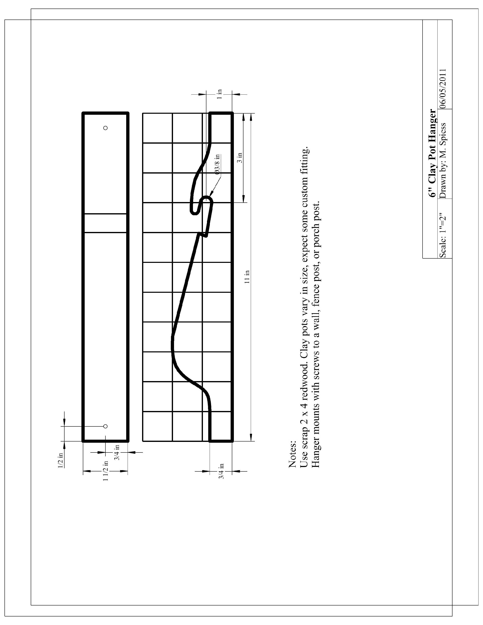
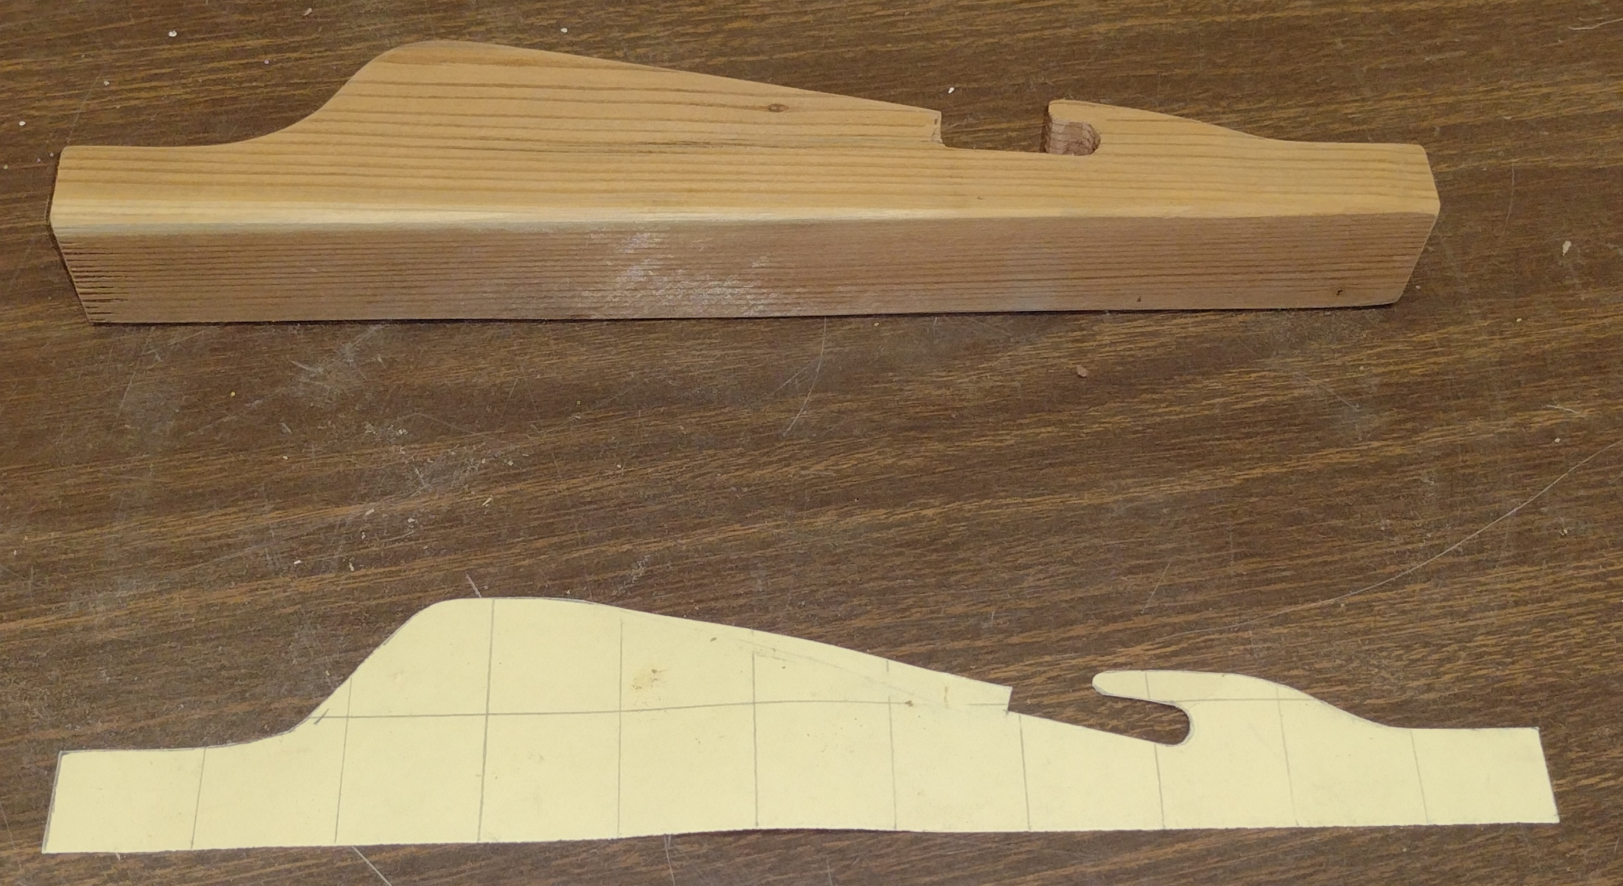

Wood Working: Pot Hanger Worksheet
Name: ________________________
Date: ________________________

- What size drill bits are needed? ____________ and _______________
- What type of wood are you using? _______________________
- How big are the grid lines? ______________
- What size blade is used on the band saw? __________
- Why is the blade size important on the band saw?
_________________________________________________________________________
_________________________________________________________________________

Grading Rubric:
CRITERIA | POSSIBLE | SCORE
Quality of the template | 5
Proper length | 5
Placement of the mounting holes | 5
Quality of the band saw cuts | 5
Overall quality (finishing) | 5
Worksheet | 5
Total | 30

Woodworking Boot Jack Project Teachers Notes:

Agricultural Standards Met:
6.0 Health and Safety. Students understand health and safety policies, procedures, regulations, and practices, including the use of equipment and handling of hazardous materials:
6.1 Know policies, procedures, and regulations regarding health and safety in the workplace, including employers’ and employees’ responsibilities.
6.2 Understand critical elements of health and safety practices related to storing, cleaning, and maintaining tools, equipment, and supplies.
6.4 Maintain safe and healthful working conditions.
6.5 Use tools and machines safely and appropriately.
6.6 Know how to both prevent and respond to accidents in the agricultural industry.
B1.0 Students understand personal and group safety:
B1.1 Practice the rules for personal and group safety while working in an agricultural mechanics environment.
B1.2 Know the relationship between accepted shop management procedures and a safe working environment.
4.0 Technology
Students know how to use contemporary and emerging technological resources in diverse and changing personal, community, and workplace environments:
4.1 Understand past, present, and future technological advances as they relate to a chosen pathway.
4.6 Differentiate among, select, and apply appropriate tools and technology.
7.0 Responsibility and Flexibility
Students know the behaviors associated with the demonstration of responsibility and flexibility in personal, workplace, and community settings:
7.1 Understand the qualities and behaviors that constitute a positive and professional work demeanor.
7.2 Understand the importance of accountability and responsibility in fulfilling personal, community, and workplace roles.
7.3 Understand the need to adapt to varied roles and responsibilities.
7.4 Understand that individual actions can affect the larger community.
7.5 Understand the importance of time management to fulfill responsibilities.
7.6 Know how to apply high-quality craftsmanship to a product or presentation and continually refine and perfect it.
B2.0 Students understand the principles of basic woodworking:
B2.1 Know how to identify common wood products, lumber types, and sizes.
B2.2 Know how to calculate board feet, lumber volume, and square feet.
B2.3 Know how to identify, select, and implement basic fastening systems.
B2.4 Complete a woodworking project, including interpreting a plan, developing a bill of materials and cutting list, selecting materials, shaping, joining, and finishing.

Objectives:
By properly completing this project, students will be able to:
- Identify and learn the proper use of the woodworking tools for the project
- Measure and mark wood for cutting and/or drilling
- Cut, assemble, and finish the wood project properly

Alternative Tools/Methods/Materials:
Project can be adapted to different sized pots. Multiple hangers can be placed on a single board to hold multiple pots. A jig saw can be used to cut out the project (clamp board to something solid).

Safety Review:
- Drill Press
- Band saw safety

Project Time:
Demonstration: | 20 minutes
Build: | 1 hour

Demonstration Notes
- Be sure to review safety with the power tools as you demonstrate.
- Talk about selecting lumber so knots are not a problem. Solid knots are OK in the middle of the project.
- Demonstrate the use of the grid for this type of layout. Using an overhead projector with a 1”grid transparency helps.
- Use a combination or try square to layout the 3/8” hole. Old file folders work well for the template.
- Describe the cutting radii of various widths of band saw blades (see below). A 1/4” works well for the project. Don’t force material through the band saw.
Blade Width | 1/8" | 3/16" | 1/4" | 3/8" | 1/2" | 3/4" | 1"
Min. Radius | 3/16" | 5/16" | 5/8" | 1 1/2" | 2 1/2" | 5 1/2" | 7"

Bill of Materials:
Project from: Mike Spiess

