Plumbing - 2
Name: ________________________
Date: ________________________

Description:
In this lab students will work with three common plumping materials: galvanized pipe, copper pipe, and plastic pipe. They will utilize measuring, cutting, and various pipe skills.

Materials:
7" - 1/2" Galvanized pipe
6" - 1/2" Copper Pipe
1 - 1/2 Copper Cap
1 - 1/2" Copper Male Adapter
10"-1/2" PVC Pipe
2 - 1/2" PVC ST 90º Elbow
PVC Cement
Flux
Solder
Pipe Joint Compound

Tools:
Steel pipe cutter
Pipe Die
Pipe reamer
Hack Saw
Propane Torch
Flux Brush
Copper pipe brushes or emery cloth
Pipe threading machine

Directions:
Read the directions before beginning the project. Dimensions are from the outside of the fittings. Note the completed project should lay flat. Give some thought as how you will assemble the project.
- Determine the correct length of 3/4" galvanized pipe to fit the diagram. Measurement is from the end of the pipe to the OUTSIDE of the PVC fitting. Assemble the pipe and fitting. Cut a _______" Galvanized Pipe nipple. Thread one end with the power threader, ream, and cut to length. Thread the other end by hand and ream. Assemble with the provided fitting using pipe sealant.
- Cut a piece of 1/2" copper pipe __________" long to fit the diagram below using a hack saw. Measurement is from the OUTSIDE of the cap to the OUTSIDE of the PVC fitting. Length should be adjusted for the copper fittings and the depth the fitting will screw into the PVC Ell. Assemble the copper pipe and fittings. Solder the joint. Screw into the PVC Ell using pipe sealant after the fittings have cooled.
- Cut a piece of 3/4" PVC pipe _________" long to fit the diagram below. Dimensions are from the OUTSIDE of the fittings. Glue the joints.
- Have your project pressure test checked. Have your pipe length graded. Disassemble the project and tape together. Label with your name for final grading.

Notes:
____________________________________________________________________________________
____________________________________________________________________________________
____________________________________________________________________________________
____________________________________________________________________________________
____________________________________________________________________________________
9"
(To end of pipe)
Galvanized
Copper
7"
PVC Pipe
10"
(To outside of Ell's)
Not to Scale
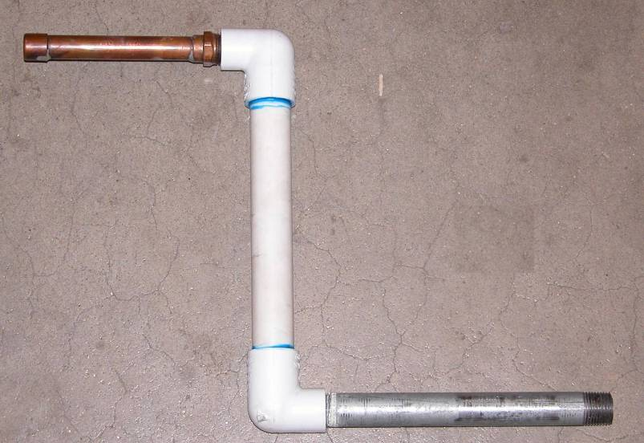

Plumbing Project Student Worksheet:
Name: ________________________
Date: ________________________

Complete this worksheet prior to starting the project.
- What is the size and type of PVC pipe we are using:_____________________________
- What is the size and type of Copper pipe we are using:___________________________
- What is the size of Galvanized pipe we are using:________________
- List all of the fittings that are required to complete this project: ___________________________________________________________________________
___________________________________________________________________________
___________________________________________________________________________
___________________________________________________________________________
___________________________________________________________________________
- Explain why primer is not used for this specific project:
___________________________________________________________________________
___________________________________________________________________________

Grading Rubric:
Criteria | Possible | Score
Graded During Class:
Galvanized Pipe Length (+/- 1/8”) | 2
Copper Pipe Length (+/- 1/8”) | 2
PVC Pipe Length (+/- 1/8”) | 2
Pressure Test (2 per joint, pass/fail) | 10
Graded Later:
Galvanized Thread quality (machine thread) | 2
Galvanized Reaming | 2
Copper Solder joint quality | 2
Cut square and deburred | 2
PVC Glue joint quality | 2
Assembly/workmanship  (excess glue or solder, damaged pipe) | 4
TOTAL | 30

Plumbing Project Teacher Notes:

Agriculture Standards Met:
4.0 Technology. Students know how to use contemporary and emerging technological resources in diverse and changing personal, community, and workplace environments:
4.6 Differentiate among, select, and apply appropriate tools and technology.
5.0 Problem Solving and Critical Thinking. Students understand how to create alternative solutions by using critical and creative thinking skills, such as logical reasoning, analytical thinking, and problem-solving techniques:
5.1 Apply appropriate problem-solving strategies and critical thinking skills to work-related issues and tasks.
5.3 Use critical thinking skills to make informed decisions and solve problems.
6.0 Health and Safety. Students understand health and safety policies, procedures, regulations, and practices, including the use of equipment and handling of hazardous materials:
6.1 Know policies, procedures, and regulations regarding health and safety in the workplace, including employers’ and employees’ responsibilities.
6.2 Understand critical elements of health and safety practices related to storing, cleaning, and maintaining tools, equipment, and supplies.
6.4 Maintain safe and healthful working conditions.
6.5 Use tools and machines safely and appropriately.
6.6 Know how to both prevent and respond to accidents in the agricultural industry.
7.0 Responsibility and Flexibility: Students know the behaviors associated with the demonstration of responsibility and flexibility in personal, workplace, and community settings:
7.6 Know how to apply high-quality craftsmanship to a product or presentation and continually refine and perfect it.
B1.0 Students understand personal and group safety:
B1.1 Practice the rules for personal and group safety while working in an agricultural mechanics environment.
B1.2 Know the relationship between accepted shop management procedures and a safe working environment.
B1.3 Know how to safely secure loads on a variety of vehicles.
B4.0 Students understand plumbing system practices commonly used in agriculture:
B4.1 Know basic plumbing fitting skills with a variety of materials, such as copper, PVC (polyvinyl chloride), steel, polyethylene, and ABS (acrylonitrile butadiene styrene).
B4.3 Know how various plumbing and irrigation systems are used in agriculture.
B4.4 Complete a plumbing project, including interpreting a plan, developing a bill of materials and cutting list, selecting materials, joining, and testing.

Objectives:
By successfully completing this project students will be able to:
- Read a plan to obtain critical dimension
- Measure and layout a plumbing project using various types of pipe and fittings
- Identify by name common pipe and fitting types
- Select and properly use hand and power tools used for plumbing work

Alternate Tools/Methods/Materials:
A pipe threading machine can by used as an alternate tool for the pipe threader, reamer, cutter and no need for a pipe vice. Primer is not needed because we are using pipe that is smaller than 1 inch, but you can use primer to teach its use. It is possible to build this project without a shop, but a portable pipe vise is required.

Safety Review:
- Soldering (heat)
- PCV Glue (Fumes and fire hazard)
- Galvanized Pipe threads are often sharp.

Project Time:
Demonstration: | 30 minutes
Build: | 2 hours

Demonstration Notes:
(Tips, methods to stage the project)
- Begin by reviewing materials and tools used for the project
- Review the plan and show how the plan describes the project
- Review names of fittings while demonstration is in process
- Demonstrate how to calculate the pipe length by measuring the fittings. Note: Table in text describes how far a threaded fitting will go into a fitting. 1/2” pipe will go ½” into the fitting.
- Review the process of cutting and fitting:
  - PVC (cut and glue). Show how to make the ell’s lay flat by pressing on the table of floor. Newspaper can be used to keep glue off tables.
  - Copper. Dry fit first. Show how to clean WELL with brushes or emery cloth. Clean the outside of the pipe and inside of the fitting only. Coat with flux. Assemble. Heat from opposite side and use about ¼” of solder.
  - Galvanized steel pipe. Show cutting, reaming, and threading. Hint: Thread until the pipe is just to the end of the die cutters.
- Assembled project should lay flat.
- Pressure test at 30 PSI at least 10 minutes after gluing the PVC pipe.

Bill of Materials
(Excel, update with local prices)
Project from: Mike Spiess

