Paper Towel Holder Project
Name: ________________________
Date: ________________________

Description:
Construction of the towel holder utilizes scrap lumber to make a useful project. Workmanship is a key part of the project. In Building this project you will use common woodworking tools and learn to identify common woods.

Materials:
Waterproof wood glue
Mineral oil or stain
Sand paper (120 grit, open coat)
1” dowel
½” Dowel
Scarp hardwood or cutting board (3/4”x8”x8”)
Painting gloves

Tools:
Compass
½” & 1” Forstner Bits
Drill Press
Power Miter Saw or Hand Saw
Band Saw or Jig Saw
Router with 3/8” ¼ round bit.
Palm Sander
Flux brush (for glue)

Procedure:
- Draw a 7 ½” diameter circle on your wood.
- Cut the circle with the band saw or jig saw.
- Sand the edge to make it smooth.
- Route the edge to round (top only)
- Located the two holes and drill (1/2” deep).
- Sand the surface.
- Cut the two dowels and lightly sand, round the top edges. Important: If using a power miter saw to cut the dowels they must be securely held to avoid spinning.
- Glue dowels in place and let dry.
- Apply mineral oil or stain to finish.

Notes:
_______________________________________________________________________________________________________________________________________________________________________________________________________________________________________________________________
__________________________________________________________________________________________________________________________________________________________________________

Photo:
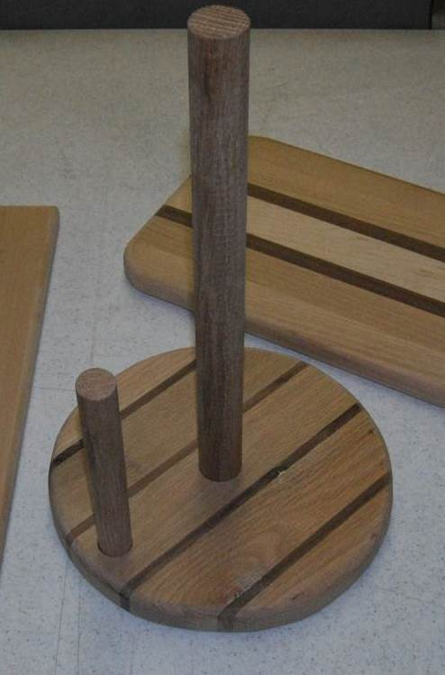

Drawing:
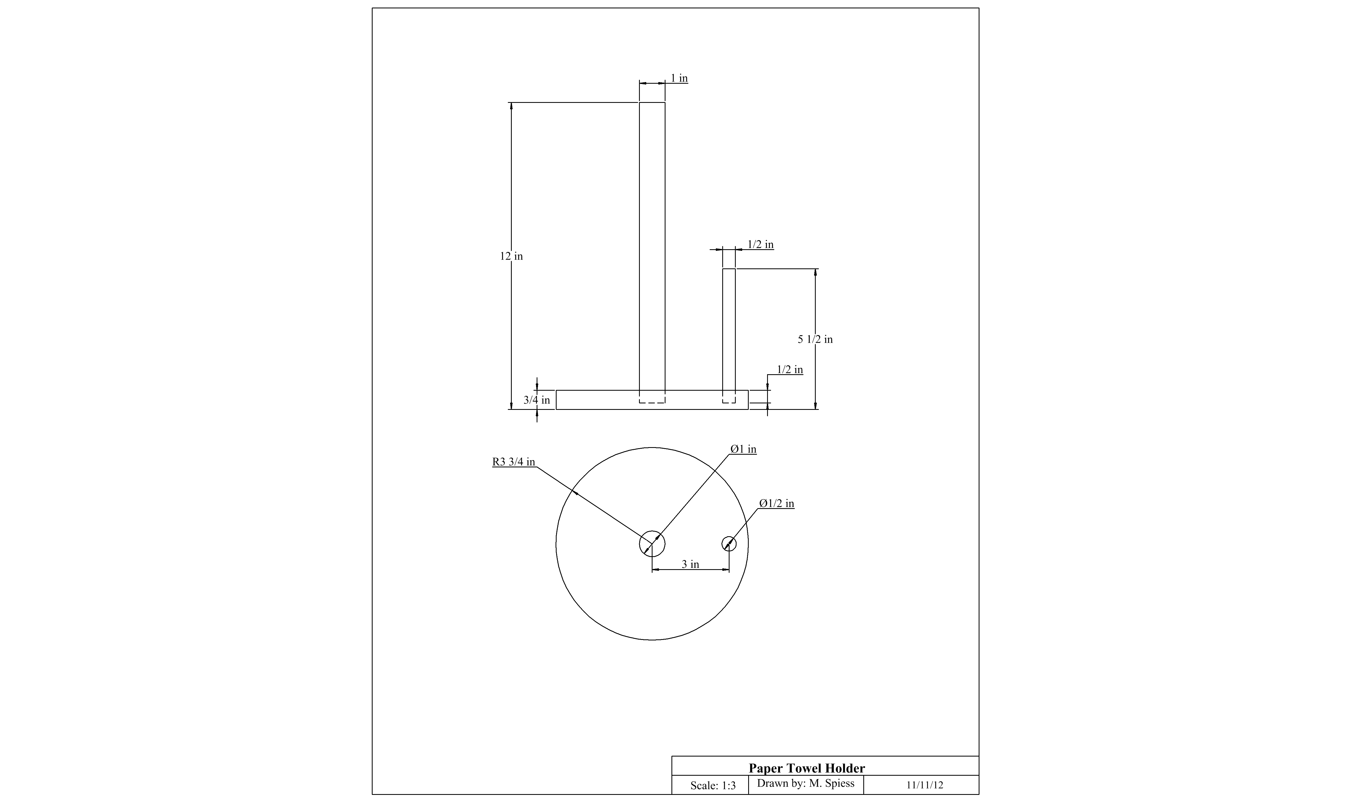

Paper Towel Holder Worksheet
Name: ________________________
Date: ________________________

- Why is wood selection important for this project?

- What types (species) of wood are you using?

- What is the purpose of the finish?

- How deep are the holes drilled?

- What type of bit was used to drill the holes and why this type?

Grading Rubric:
CRITERIA | POSSIBLE | SCORE
Wood selection (avoid knots, etc) | 10
Finish (surface, edges) | 10
Workmanship (sanding) | 10
TOTAL | 30

Teachers Notes:

Agricultural Standards Met:
6.0 Health and Safety. Students understand health and safety policies, procedures, regulations, and practices, including the use of equipment and handling of hazardous materials:
6.1 Know policies, procedures, and regulations regarding health and safety in the workplace, including employers’ and employees’ responsibilities.
6.2 Understand critical elements of health and safety practices related to storing, cleaning, and maintaining tools, equipment, and supplies.
6.4 Maintain safe and healthful working conditions.
6.5 Use tools and machines safely and appropriately.
6.6 Know how to both prevent and respond to accidents in the agricultural industry.
B1.0 Students understand personal and group safety:
B1.1 Practice the rules for personal and group safety while working in an agricultural mechanics environment.
B1.2 Know the relationship between accepted shop management procedures and a safe working environment.

B2.0 Students understand the principles of basic woodworking:
B2.1 Know how to identify common wood products, lumber types, and sizes.
B2.3 Know how to identify, select, and implement basic fastening systems.
B2.4 Complete a woodworking project, including interpreting a plan, developing a bill of materials and cutting list, selecting materials, shaping, joining, and finishing

Objectives:
By properly completing this project, students will be able to:
- Use various power tools saw to work wood.
- Layout a project

Alternative Tools/Methods/Materials:
- Softwoods such a fir may be used, but the project will not be very durable. As shown in the photo a laminated base is nice (see cutting board project)
- Base can be square if you want to avoid cutting the circle.
- Edges can be beveled with a sander or sanding block to avoid the router.
- Edges can be smoothed using a stationary disk sander.

Safety Review:
- Safety Glasses
- Band saw/Jig Saw (blade thickness)
- Router (proper clamping)
- Sander (dust)

Project Time:
Demonstration: | 15-25 minutes
Build: | 1-2 hours

Demonstration Notes:
- Review the plan and determine how long to cut dowels.
- Show how to use a compass or divider to mark the circle.
- Cutout the circle on the band saw.
- Find the center (should be marked by the compass) and use a nail to clearly mark. Locate the ½” hole center and clearly mark with a nail.
- Set the stop on the drill press to drill only ½” deep. NOTE: If you have 2 drill presses you can set up both drill sizes. Note that the shoulder on a forstner bit is usually about a ½” and can be used as a gauge.
- Sand edges and surface.
- CLAMP the project to a table or sawhorse and route about ½” or the circumference. Reclamp to expose the other ½ and complete routing.
- Finish sand.
- Cut the dowels and sand.
- Assemble with glue, let dry
- Finish (use gloves)

Bill of Materials:
Plan by Mike Spiess

