PVC Pipe Cord Reel
Name: __________________
Date: __________________

Description:
This project is a reel made of PVC pipe. It can be used for extension cords, hoses, or ropes. This project helps students learn, plan, and apply basic plumbing skills as well as produce a project that can be useful in the shop and everyday life.

Materials:
-1/2” Schedule 40 PVC Pipe
-1/2” SSS PVC Tee
-1/2” S PVC Cap
- PVC Pipe Cement
-PVC Primer

Tools:
-Hack Saw
-Steel Tape
-Marker/Pencil
-Cleanup Rags

Procedure:
- Obtain the necessary tools and PVC materials that are needed to construct this project.
- 4- ½” PVC Pipe
- 4-1/2” PVC Pipe Tee Fittings
- 4-1/2” PVC Pipe Ends
- To determine the length of each pipe by subtracting the fitting length from the overall dimensions. Using a steel tape, measure the PVC pipe and mark the lengths using a marker or pencil. Record results on worksheet.
- Place the PVC pipe on a saw horse. Being careful of cutting your hands or others, use a hacksaw to cut through the PVC pipe on the pre-measured lines.
- Use your cleanup/shop rag to remove all the burs from the cut edges of the PVC pipe that has been cut.
- In order to check your layout and cutting accuracy, layout the PVC pipe and fittings on a flat surface (do not out them together).
- Assemble the Tees and caps on the sides of the reel.
  - Prime the pipe, and place a small amount of PVC cement on the inside of each fitting and on the end of the pipe.
  - Press the pipe and fitting completely together, giving the pipe a ½ twist. Place the project on a flat surface, and press project flat to ensure that the tees are all aligned.
  - Hold until cement is set.
  - Wipe off excess cement.
- Assemble the sides.
  - Glue in the two cross pieces into on side as described above.
  - Check to see that the cross pieces will align with the unglued side.
  - Prime and glue both tees and both ends.
  - Quickly assemble both fittings; hold until set.

Notes:
_________________________________________________________________________________________________________________________________________________________________________________________________________________________________________________________________________________________________________________________________________________________________________________________________________________________________________________________________________________________________________________________________________________________________________________________________________________________________________________________________________________________________________________________________________________________________________________________________________________________________________________________________________________________________________________________________________________________________________________________________________________________________________________________________________________________________________________________________________________________________________________________________________________________________________________________________________________________________________________________________________________________________________________________________________________________________________________________________________________________________________________________________________________________________________________________________________________________________________________________________________________________________________________________________________________________________________________________________________________________________________________________

Photo/Drawing:
Assembled Project:
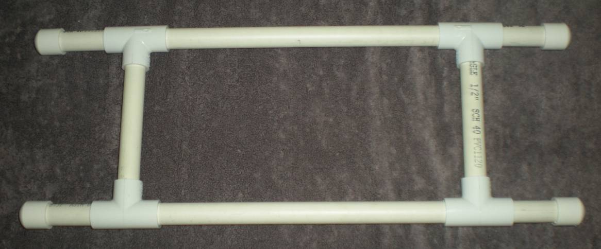

Layout:

21”
8 ½ ”
13 ½ ”

PVC Pipe Cord Reel Worksheet:
Name: _____________________
Date: _____________________
This worksheet is to be completed, and attached to your completed project.

- What are the tools are required to complete this project?
___________________________________________________________________________
- How many feet of pipe will you need to complete this project? _______________________
- What size and type of pipe is used for this project? _______________________
- Draw a sketch of the project and label the dimensions of each pipe.

- What are two safety precautions you should take when building this project?
_____________________________________________________________________
_____________________________________________________________________

Grading Rubric:
CRITERIA (+/- 1/8”) | POSSIBLE | SCORE
Width | 5
Length | 5
Distance (Between Tees) | 5
Assembly (Project is Flat and Square) | 5
Workmanship (no excess pipe cement) | 5
Total | 25

PVC Cord Reel Teachers Notes/Tips:
Each Student will need 4’ of PVC pipe to complete his/her project. It is up to the discretion of the teacher whether or not to (a) give each student a premeasured amount of pipe, or (b) give them the dimensions and allow them to figure out the proper amount.
All parts to this project can be bought at any local hardware store. Fittings are commonly available in “contractor packs” at stores like Home Depot.
Project can be painted with spray paint to give it a finished look.
Use two cable ties to attach the plug end of an extension cord (leave a few feet free so the reel doesn’t hang form a wall)

Agricultural Standards Met:
5.0 Problem Solving and Critical Thinking: Students understand how to create alternative solutions by using critical and creative thinking skills, such as logical reasoning, analytical thinking, and problem-solving techniques:
5.1 Apply appropriate problem-solving strategies and critical thinking skills to work-related issues and tasks.
5.2 Understand the systematic problem-solving models that incorporate input, process, outcome, and feedback components.
5.3 Use critical thinking skills to make informed decisions and solve problems
6.0 Health and Safety. Students understand health and safety policies, procedures, regulations, and practices, including the use of equipment and handling of hazardous materials:
6.1 Know policies, procedures, and regulations regarding health and safety in the workplace, including employers’ and employees’ responsibilities.
6.2 Understand critical elements of health and safety practices related to storing, cleaning, and maintaining tools, equipment, and supplies.
6.4 Maintain safe and healthful working conditions.
6.5 Use tools and machines safely and appropriately.
6.6 Know how to both prevent and respond to accidents in the agricultural industry.
B1.0 Students understand personal and group safety:
B1.1 Practice the rules for personal and group safety while working in an agricultural mechanics environment.
B1.2 Know the relationship between accepted shop management procedures and a safe working environment.
B4.0 Students understand plumbing system practices commonly used in agriculture:
B4.1 Know basic plumbing fitting skills with a variety of materials, such as copper, PVC (polyvinyl chloride), steel, polyethylene, and ABS (acrylonitrile butadiene styrene).

Objectives:
By properly completing this project, students will be able to:
- Select and Correctly use shop tools in a safe manner
- Adequately measure, cut, layout, and assemble a PVC Pipe Cord Reel project
- Read a plan, obtain dimensions, and create a project accordingly.

Alternative Tools/Methods/Materials:
- A PVC Pipe cutter can be used in place of a hack saw
- Any size pipe (to about 1” in size) can be used instead of schedule 40 PVC.
- By changing the tools (PVC pipe cutter vs. hack saw), we can give students the opportunity to use more plumbing specific tools.

Safety Review:
- Use of Glue

Project Time:
Demonstration: | 15-20 minutes
Build: | 90 minutes

Demonstration Notes
- Review the materials and tools needed to complete this project.
- Discuss the role of primer and different types of glue. See: http://www.herchem.com/specs/pipecement.pdf
- Discuss different types of PVC pipe (schedule vs. class designations)
- Make sure each student has a copy of the project layout and plan
- Demonstrate how to properly measure the PVC dimensions
- Explain the purpose for priming the PVS and fittings. NOTE: Priming is not commonly done on pipe smaller than 1”. However using primer for the project gives students experience using primer.
- Layout the project first to give the students a visual BEFORE assembling

Bill of Materials:
Project adapted from the web by Missy Mae Ruble

