Oxy-Fuel Cutting Name:
Skill Assignment Date:

Description:
This project will help you evaluate your Oxy-Fuel cutting skills. Knowledge of project layout and the ability to follow directions will be tested as well.

Materials:
5/16” Plate Steel, 3-½” x 6”
Soapstone or other marking device
¼” Flat Washer

Tools:
Oxy-Fuel Cutting set-up
Combination square
Scribe or Scratch Awl
Compass or Dividers
Center Punch & Cold Chisel
Ball Peen Hammer
Chipping Hammer
Locking Pliers
Numbered Punches

Directions:
- Introduction
  - Review the drawing. Determine one of the long edges to be your “working edge” and note it on the plate.
- Layout Cut Lines
  - Mark and layout all of the cut lines making sure you measure from the “working Edge” when possible.
  - Use the center punch to mark the spot for the center of the 3” diameter round cut on the right end of the plate. This would be 1-½” from the top (working) edge, and 1-½” from the right edge. Use a compass or dividers to mark the radius of this circle.
  - When laying out the oval, use the center punch to mark the centers of the ends. A ¼” flat washer can be used to trace the ends.
- Making your Cuts
  - Straight Cut – Start this cut at the left edge of the plate and cut from left to right (or, if you are right handed, cut from right to left by turning the plate 180°). To cut the round part, cut part of the way around, stop, reposition the metal by turning it clockwise, and then continue cutting. Do this as many times as needed to complete the cut.
  - Oval and Square Cuts – Pierce a hole on the inside of the line and move to the line to make your cut.
  - Bevel Cut – Position yourself so that you are cutting directly away from your body. Start on the left edge and cut from left to right (or right to left if you are left-handed)
  - Initials – Draw your initials following the directions given. Pierce the steel and cut the outline of your initials. You may have to leave some cuts incomplete so that the centers of letters like O and D will not fall out.
- Finishing Up
  - Chip slag from the bottom of your cuts.
  - Using the number stamps, stamp your ID # in the spot indicated on the project diagram.
Notes:

Drawing/Photo:
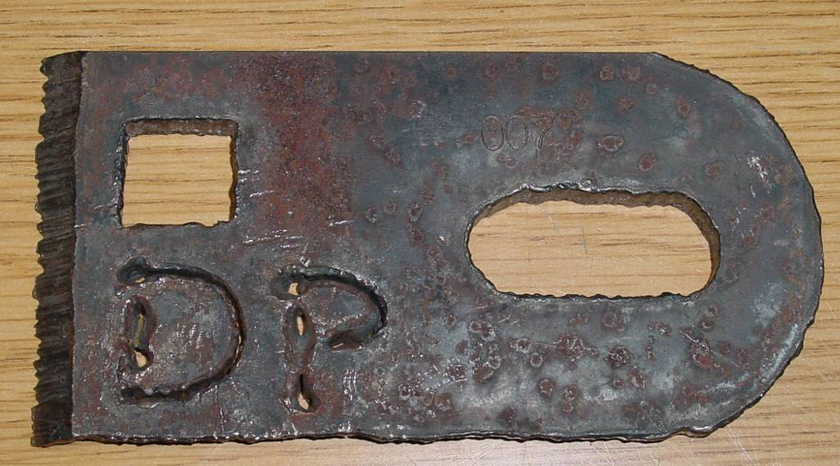
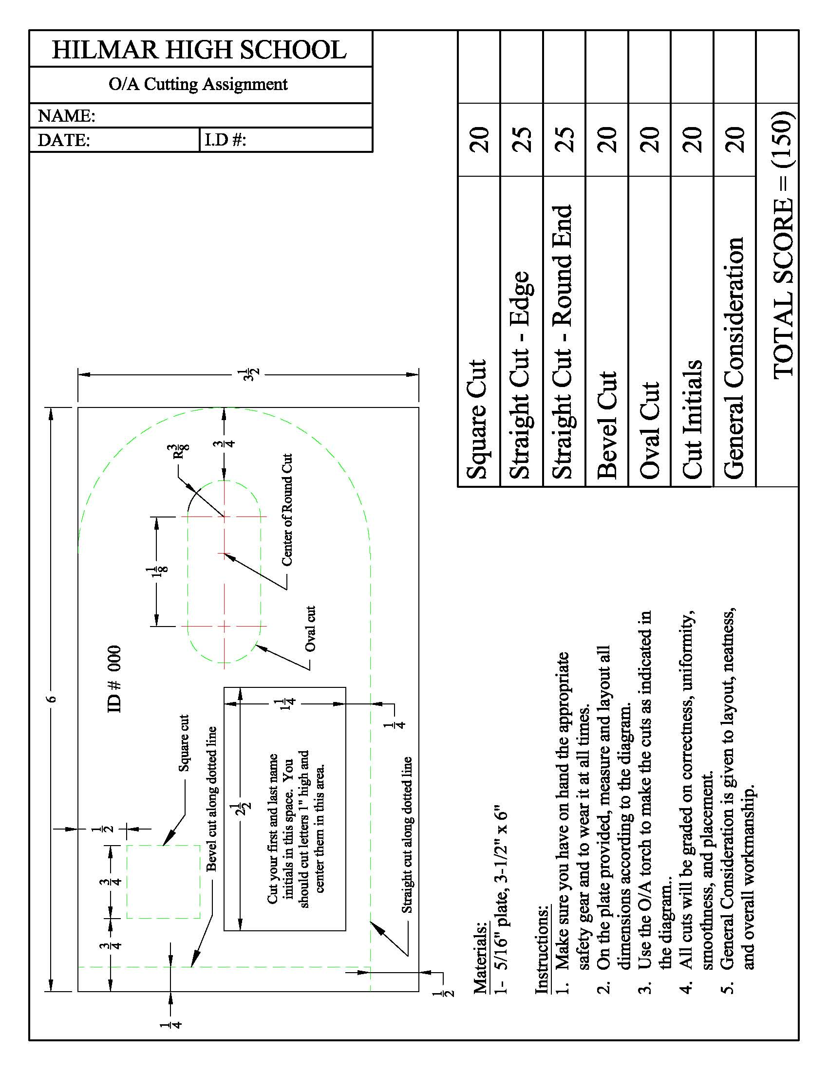
Oxy-Fuel Cutting Name:
Student Worksheet Date:

Complete this worksheet prior to starting the project.
- How wide is the oval slot supposed to be?
- What will the overall dimensions of the plate be once all of the cuts are made?
- What three cutting procedures are used in this assignment?

- What Safety equipment will be used to complete this assignment?

- What tool(s) is used to mark the center of the 3” diameter circle?

Grading Rubric:
Criteria | Possible | Score
Square Cut | 20
Straight Cut – Edge | 25
Straight Cut – Round End | 25
Bevel Cut | 20
Oval Cut | 20
Cut Initials | 20
General Consideration  (Accuracy, Position of Cuts, Follow Instructions, Neatness) | 20
TOTAL | 150

Oxy-Fuel Cutting, Skill Assignment - Teaching Notes:

Agricultural Standards Met:
4.0 Technology
Students know how to use contemporary and emerging technological resources in diverse and changing personal, community, and workplace environments:
4.6 Differentiate among, select, and apply appropriate tools and technology.
5.0 Problem Solving and Critical Thinking
Students understand how to create alternative solutions by using critical and creative thinking skills, such as logical reasoning, analytical thinking, and problem-solving techniques:
5.1 Apply appropriate problem-solving strategies and critical thinking skills to work-related issues and tasks.
5.3 Use critical thinking skills to make informed decisions and solve problems.

6.0 Health and Safety.
Students understand health and safety policies, procedures, regulations, and practices, including the use of equipment and handling of hazardous materials:
6.2 Understand critical elements of health and safety practices related to storing, cleaning, and maintaining tools, equipment, and supplies.
6.4 Maintain safe and healthful working conditions.
6.5 Use tools and machines safely and appropriately.
6.6 Know how to both prevent and respond to accidents in the agricultural industry.

B1.0 Students understand personal and group safety:
B1.1 Practice the rules for personal and group safety while working in an agricultural mechanics environment.
B1.2 Know the relationship between accepted shop management procedures and a safe working environment.

B5.0 Students understand agricultural cold metal processes:
B5.1Know how to identify common metals, sizes, and shapes.
B5.3 Know layout skills.
B5.4 Know basic cold metal processes (e.g., shearing, cutting, drilling, threading, bending.).

B7.0 Students understand oxy-fuel cutting and welding:
B7.1 Understand the role of heat and oxidation in the cutting process.
B7.2 Know how to properly set up, adjust, shut down, and maintain an oxy-fuel system.
B7.3 Know how to flame-cut metal with an oxy-fuel cutting torch.

Objectives:
By successfully completing this project students will be able to:
- Read a plan to obtain critical information and dimensions.
- Measure and layout a project on metal.
- Safely set-up, operate, and shut-down the Oxy-Fuel Cutting set up.
- Safely demonstrate how to flame cut mild steel with an 80% degree of accuracy.

Alternate Tools:
- Use a piece of pipe or something that measures 3” in diameter to trace the line used to mark the round end. This way you don’t have to use a compass or dividers.
- Depending on the number of Oxy-Fuel set-ups you have, you could set up rotations where students could be working on different parts of the project at a time. You could break it down like this:
  - Bevel Cut
  - Oval Cut
  - Straight Cut
  - Round End Cut
  - Initials
Divide class into 5 groups and have each group work on one of the above parts. As one group gets to cut, the others can work on layout and then trade off.
- Could use ¼” or 3/16” plate steel instead of 5/16” It is easier for the students to work with thicker metal and it’s easier to see mistakes in the cutting procedure with thicker metal.
- Try to secure scrap metal from a local metal shop to cut costs.

Safety Review:
Use of the Oxy-Fuel Cutting Set-up.
Safety Equipment for Oxy-Fuel Cutting.

Project Time:
Demonstration: | 15-30 minutes
Student Completion: | 3 hours

Demonstration Notes:
(Tips, methods to stage the project)
For the Instructor:
- Begin by reviewing materials and tools used for the project.
- Do the project yourself to see where the pitfalls may be and where the bottlenecks are that will hold up the students.

With the Students:
- Review the plan and show how the plan describes the project.
- Demonstrate and/or explain the layout procedures you wish the students to follow.
- Demonstrate how to use the layout tools (compass, divider, center punch, etc.).
- Demonstrate how to layout the center marks for the oval cut and the round end cut (see worksheet).
- Review safety rules for the Oxy-Fuel Cutting process.
- Demonstrate the set-up, operation, and shut-down of the Oxy-Fuel set-up.
- Demonstrate how to use number stamps on anvil to identify their project.
- Remind students of workmanship. Final project should be clean and free of sharp edges.

Bill of Materials
(Excel, update with local prices)

