Meat Hook
Name: ________________________
Description: This project allows students to use hot and cold metal working skills and wood working skills to construct a meat hook. Hot metal working skills are also useful for making repairs and decorative work.

Materials:
1/4” round cold rolled steel 20” long
3/4” wooden dowel 4” long
Epoxy
Wood Stain
Sand Paper
Emery Cloth

Tools:
Safety Glasses
Blacksmith or Ball Peen Hammer
Vise
Anvil
Steel Tape
Hacksaw
Metal pipe – 1” to 1-1/2” Diameter (6” long)
Bastard File
Oxy-Acetylene torch
Drill Press and ¼” drill
Miter Saw
Scratch Awl
Welding Gloves

Directions:
- Read ALL directions before beginning
- Obtain 1 piece ¼” cold rolled steel 20” inches long
- Heat the tip of the steel to red hot. Shape on anvil with the hammer. “Draw” out the point. The point should be approximately 2” long.
- Use a file to do the final shaping of the point (sharp).
Get approval from teacher before continuing to the next step!!!
- Set up the bending station by placing the pipe in a vise so that the pipe extends past the side of the vise 1-2”.
- Using the oxy-acetylene torch heat about 3” of the tip. Set heated steel on metal pipe with the tip facing right (right handed hook). Starting at the 3” mark tap the red hot metal around the pipe. You may have to heat it more than once. You should end up with a hook the is a ½ or slightly less of a circle (see photo).
- Heat a ½” section at the beginning of your hook. To make a right handed hook lay the on the anvil with the hook to the left and bend it at the heated section down to 90 degrees. To make a left handed hook lay the on the anvil with the hook to the right and bend it at the heated section down to 90 degrees.
- After the metal is cool, clean with emery cloth and optionally paint the high temperature paint (BBQ).
- Using the miter saw, cut the dowel 4” long. Find the center of your dowel on the flat end and make a mark.
- Use drill press to make a hole that is 2” deep with the drill bit.
- Sand dowel until smooth. You may wish to taper the handle.
- Stain or paint the handle if desired. At minimum, seal with linseed oil.
- Epoxy the handle and rod together ensuring that the handle is set and let dry

Notes:
__________________________________________________________________________________
__________________________________________________________________________________
__________________________________________________________________________________
__________________________________________________________________________________
__________________________________________________________________________________
__________________________________________________________________________________

Drawing/Photo:
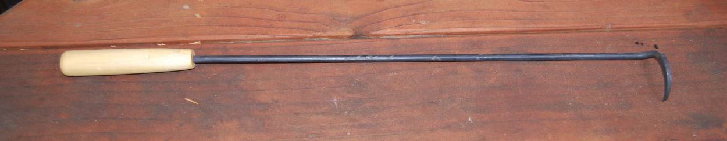
Finished project
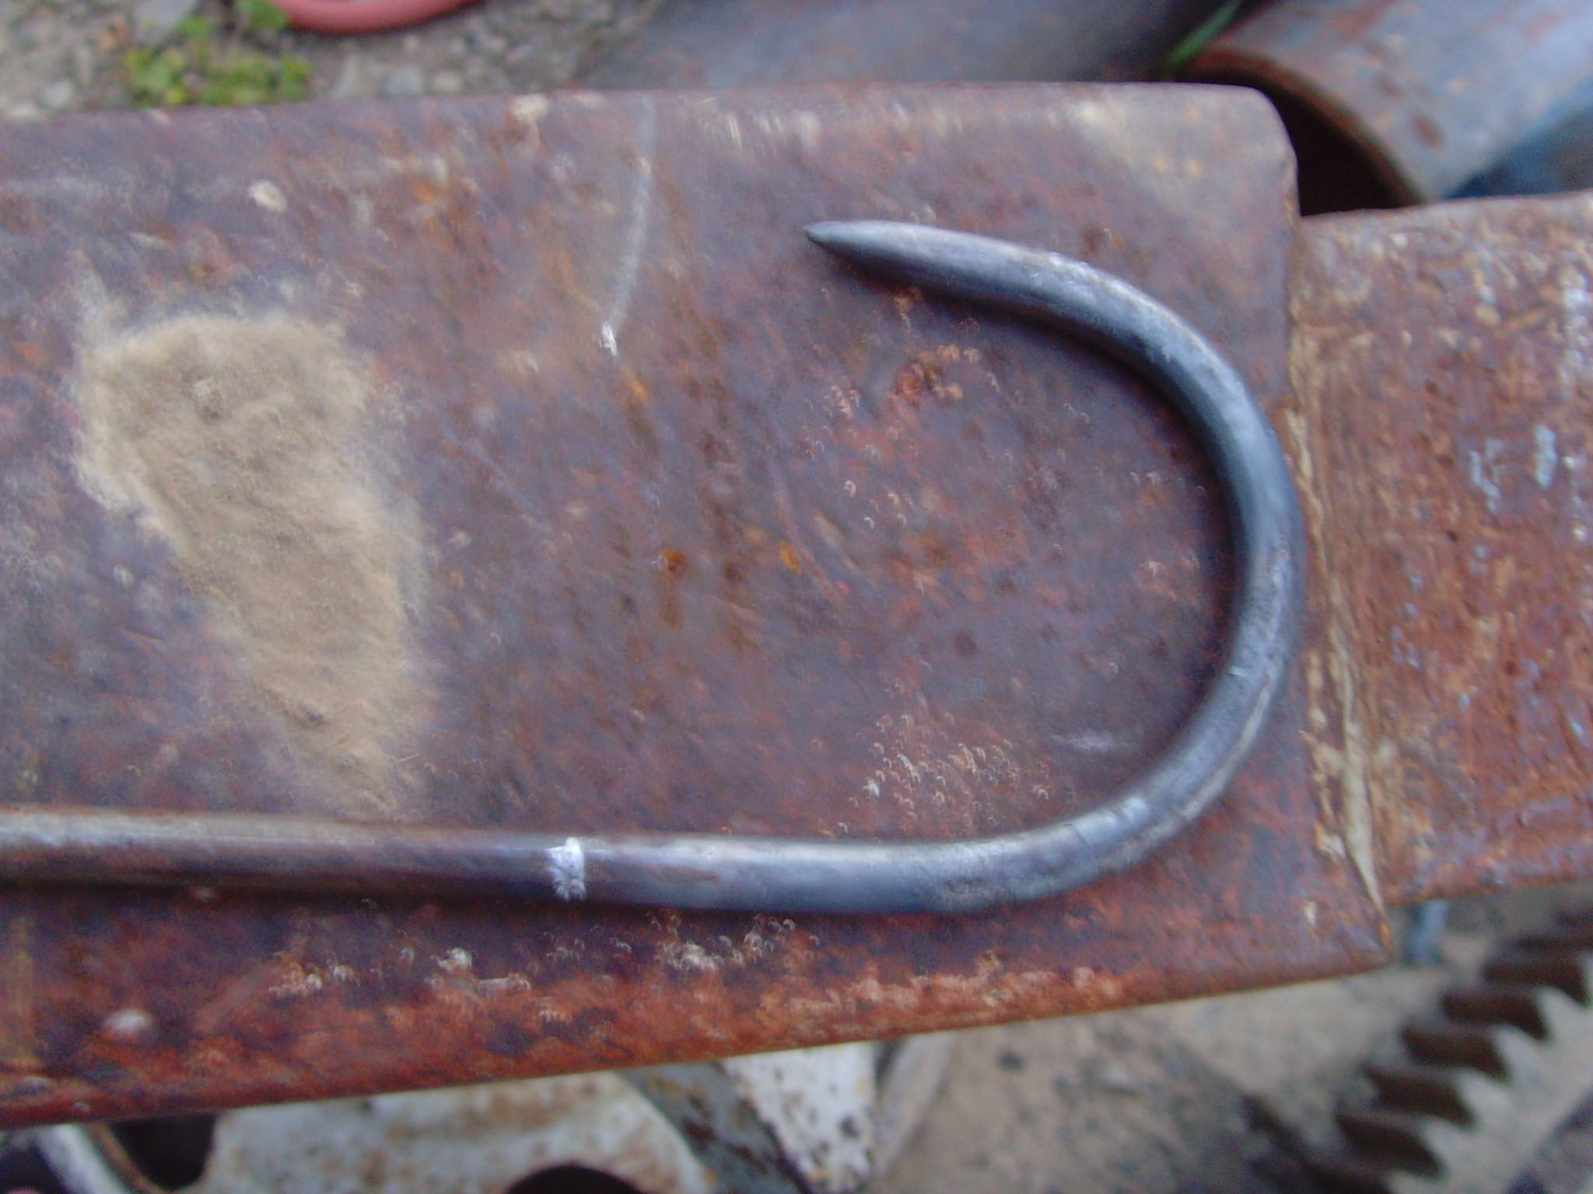
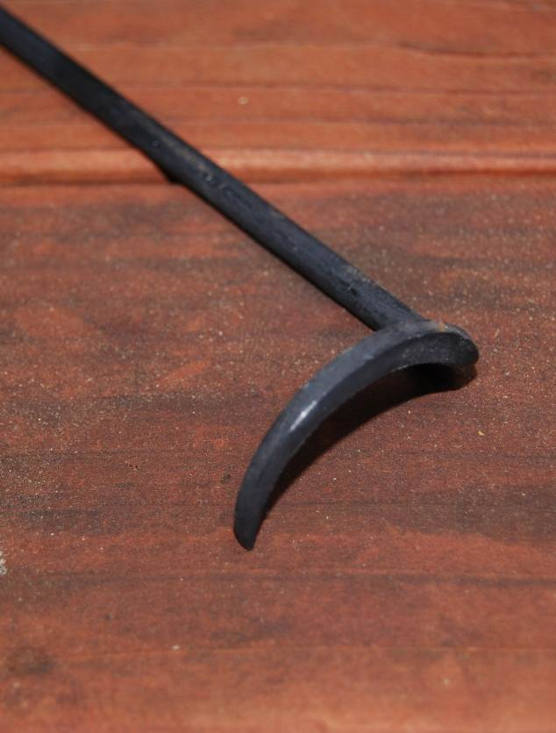

Hook Detail (Variations)

Meat Hook Student Worksheet:
Name: ________________________
Complete this worksheet prior to starting the project.
1) Read ALL directions before beginning. T F
2) Obtain 1 piece ¼” cold rolled steel how many inches long?
- Place steel rod into the vise sideways. Begin filing using a __________ motion with your file. Shape end of the rod into a point.

4) Make 2 marks, one _______” and the other “ from the point you have made.

- Should you hold the torch in one spot while heating the metal? YES NO

- What type of hammer will you use to form the angle of your hook?

- Wait until the hook is cool to the touch and begin heating an area ____________of the rod.

- What type of saw will you use to cut your dowel?

- How long is your dowel?

- Use drill press to make a hole that is ______ inches deep. Sand dowel until smooth.

- List three safety precautions to exhibit when using the drill press and the oxyacetylene torch.

Grading Rubric:
Criteria | Possible | Score
Measurements to plan | 10
Point (clean/square) | 10
Angel of hook | 10
Handle (Properly attached and sanded) | 10
Overall Craftsmanship | 10
TOTAL | 50

Meat Hook Teaching Notes:

Agricultural Standards Met:
B1.0 Students understand personal and group safety:
B1.1 Practice the rules for personal and group safety while working in an agricultural mechanics environment.
B1.2 Know the relationship between accepted shop management procedures and a safe working environment.
B5.0 Students understand agricultural cold metal processes:
B5.1 Know how to identify common metals, sizes, and shapes.
B5.2 Know basic tool-fitting skills.
B5.3 Know layout skills.
B5.4 Know basic cold metal processes (e.g., shearing, cutting, drilling, threading, bending).
B5.5 Complete a cold metal project, including interpreting a plan, developing a bill of materials, selecting materials, shaping, fastening, and finishing.
4.0 Technology
Students know how to use contemporary and emerging technological resources in diverse and changing personal, community, and workplace environments:
4.1 Understand past, present, and future technological advances as they relate to a chosen pathway.
4.6 Differentiate among, select, and apply appropriate tools and technology.
5.0 Problem Solving and Critical Thinking
Students understand how to create alternative solutions by using critical and creative thinking skills, such as logical reasoning, analytical thinking, and problem-solving techniques:
5.1 Apply appropriate problem-solving strategies and critical thinking skills to work-related issues and tasks.
5.3 Use critical thinking skills to make informed decisions and solve problems.
6.0 Health and Safety
Students understand health and safety policies, procedures, regulations, and practices, including the use of equipment and handling of hazardous materials:
6.2 Understand critical elements of health and safety practices related to storing, cleaning, and maintaining tools, equipment, and supplies.
6.4 Maintain safe and healthful working conditions.
6.5 Use tools and machines safely and appropriately.
6.6 Know how to both prevent and respond to accidents in the agricultural industry.
7.0 Responsibility and Flexibility
Students know the behaviors associated with the demonstration of responsibility and flexibility in personal, workplace, and community settings:
7.1 Understand the qualities and behaviors that constitute a positive and professional work demeanor.
7.2 Understand the importance of accountability and responsibility in fulfilling personal, community, and workplace roles.
7.3 Understand the need to adapt to varied roles and responsibilities.
7.4 Understand that individual actions can affect the larger community.
7.5 Understand the importance of time management to fulfill responsibilities.
7.6 Know how to apply high-quality craftsmanship to a product or presentation and continually refine and perfect it.

Objectives:
By successfully completing this project students will be able to:
- Read a plan to obtain critical dimensions
- Measure and layout a project on metal
- Identify by name common cold and hot metal tools
- Select and properly used hand and power tools used for cold metal work
- Determine proper drill sizes for drilling holes

Alternate Tools/Materials:
Instead of using a metal pipe to form the hook an anvil can be used as an alternative. Metal can also be bent with out using a heat. NOTE: Stainless steel and larger diameter of metal rod can be used to insure a nice stable meat hook. Length can be altered to suit your needs. A file handle can also be used for the handle.

Safety Review:
- Use of the drill press.
- Use of oxy acetylene torch
- Hot Metal

Project Time:
Demonstration: | 15-20 minutes
Build: | 1 – 2 hours

Demonstration Notes:
- Begin by reviewing materials and tools used for the project.
- Review the plan and show how the plan describes the project.
- Demonstrate how to use a hacksaw.
- Demonstrate the proper use of a file.
- Demonstrate how to mark the steel with a scribe or soap stone.
- Demonstrate using the oxy-acetylene torch to heat the steel at the area specified in the handout. Make sure to constantly move the torch back and forth and rotate the steel while heating.
- Exhibit forming the hook around the metal pipe. Use a blacksmiths or machinists hammer and mold the hook starting an inch from the point that has been filed and work the metal toward the 3 “ mark.
- Demonstrate heating metal in a vise with the newly formed hook lined up on the 3 “ mark. After metal is heated use hammer to bend hook to a 90 degree angle. Remind students that the way the hook is bent will determine if it is to be used for a right or left handed individual.
- Demonstrate how to find the center of the dowel.
- Review drill press safety as you demonstrate drilling. If the drill press vise doesn’t have shoulders use a jig to hold the dowel in place. Remind students that the drill is small and easily broken if work is not secured.
- When drilling the clamped assembly use the vice to clamp the vertical part of the angle and demonstrate keeping the location of the hole near but clear of the vise and the locking pliers clear of the drill press handle.
- Demonstrate how to properly sand dowel. Show students that the edges of the top and bottom of the dowel should be rounded and smooth.
- Exhibit the amount of epoxy that should be used to attach the dowel. Remind students to allow the epoxy to dry completely.
- Demonstrate how to apply stain and shellac to the finished project. Use emery cloth if desired to clean the metal. Metal can be painted with hi-temp paint.
- NOTE: A hole can be drilled through the end of the handle to be used with a hook or string to allow project to be hung on a nail.

Bill of Materials
(Excel, update with local prices)
Plan developed by Jamie Carter

