Hose Hanger – Cold Metal Work
Name: _______________________
Date: ________________________

Description:
A cold metal project that gives students practice sheering, bending, drilling, and fastening steel. The hose hanger can be used for proper storage of a hose in any location after completion. It consists of two pieces that allow it to be attached to a wall and keep the hose off the floor. It can be used for water or air hoses.

Materials:
1- 6”x 15” 16 gauge sheet metal
1- HR Flat Stock 1/4” x 1 ½”x 20”
2- Pop rivets 3/16” x ½”

Tools:
Scratch awl
Soapstone
Rule
Combination square
Drill Press
Center punch
Hydraulic Sheer
Oxy-acetylene welder
Pop Rivet Tool
Bastard & Mill Files
Snips
Grinder
Sheet metal roll
Locking C Clamps
Cordless power drill
3/16’’ twist drill

Procedure:
- Cut bar to correct length; grind edges to remove sharp edges. Dress with file as needed.
- Layout and drill the four holes on the flat bar. Use a center punch to mark the holes.
- Mark the bends with soapstone.
- Heat metal for bends start with smallest bend (note the hotter the metal the easier to bend and the sharper the corner). Cool between bends.
- Lay out sheet metal.
- Use the sheer to cut the sheet metal (note 16 gauge is thick and may require help to cut)
- Use snips to clip sharp corners and use file smooth sharp edges.
- Layout and drill holes in sheet metal.
- Roll sheet metal bend to correct shape. Note the distance between the ends.
- Clamp together with locking clamps (the tighter the better!)
- Use cordless drill to clean out the drill holes for the pop rivets
- Rivet the pieces together. Rivets go in from the top.
- Sand and paint, use primer to ensure a good paint finish

Cutting List:
Quantity | Size | Material
1 | 6” x 15” | 16 gauge HR sheet metal
1 | 1 ½” x ¼” x 20” | HR flat steel

Notes:
__________________________________________________________________________________________________________________________________________________________________________________________________________________________________________________________________________________________________________________________________________________________________________________________________________________________________________________________________________________________________________________________________________________________________________________________________________________________________________________________________________________________________________________________________________________________________________________________________________________________________________________________________________________
__________________________________________________________________________________________________________________________________________________________________________________________________________________________________________________________________________________________________________________________________________________________________________________________________________________________________________________________________________________________________________________________________________________________________________________________________________________________________________________________________________________________________________________________________________________________________________________________________________________________________________________________________________________

Photo/Drawing:
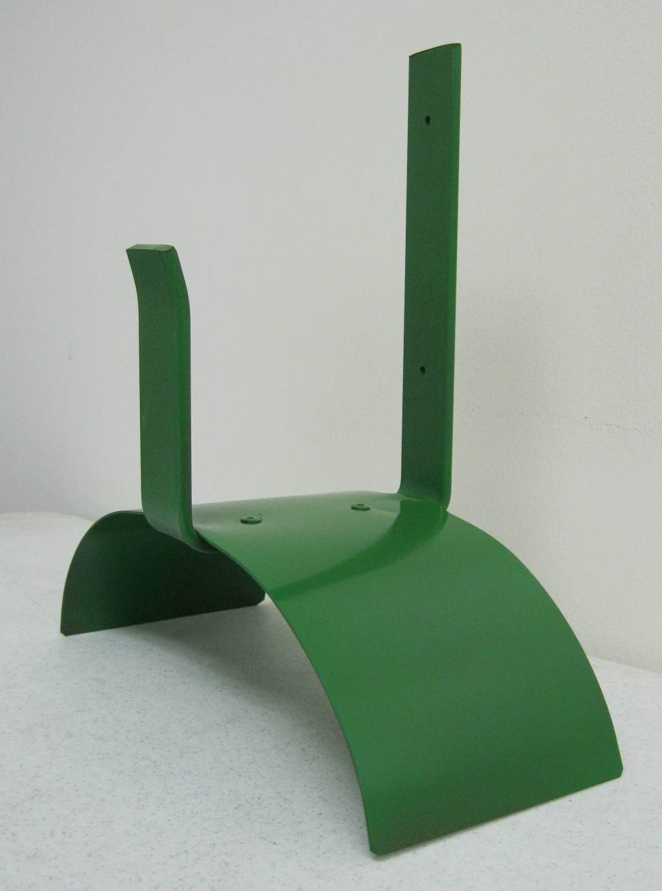
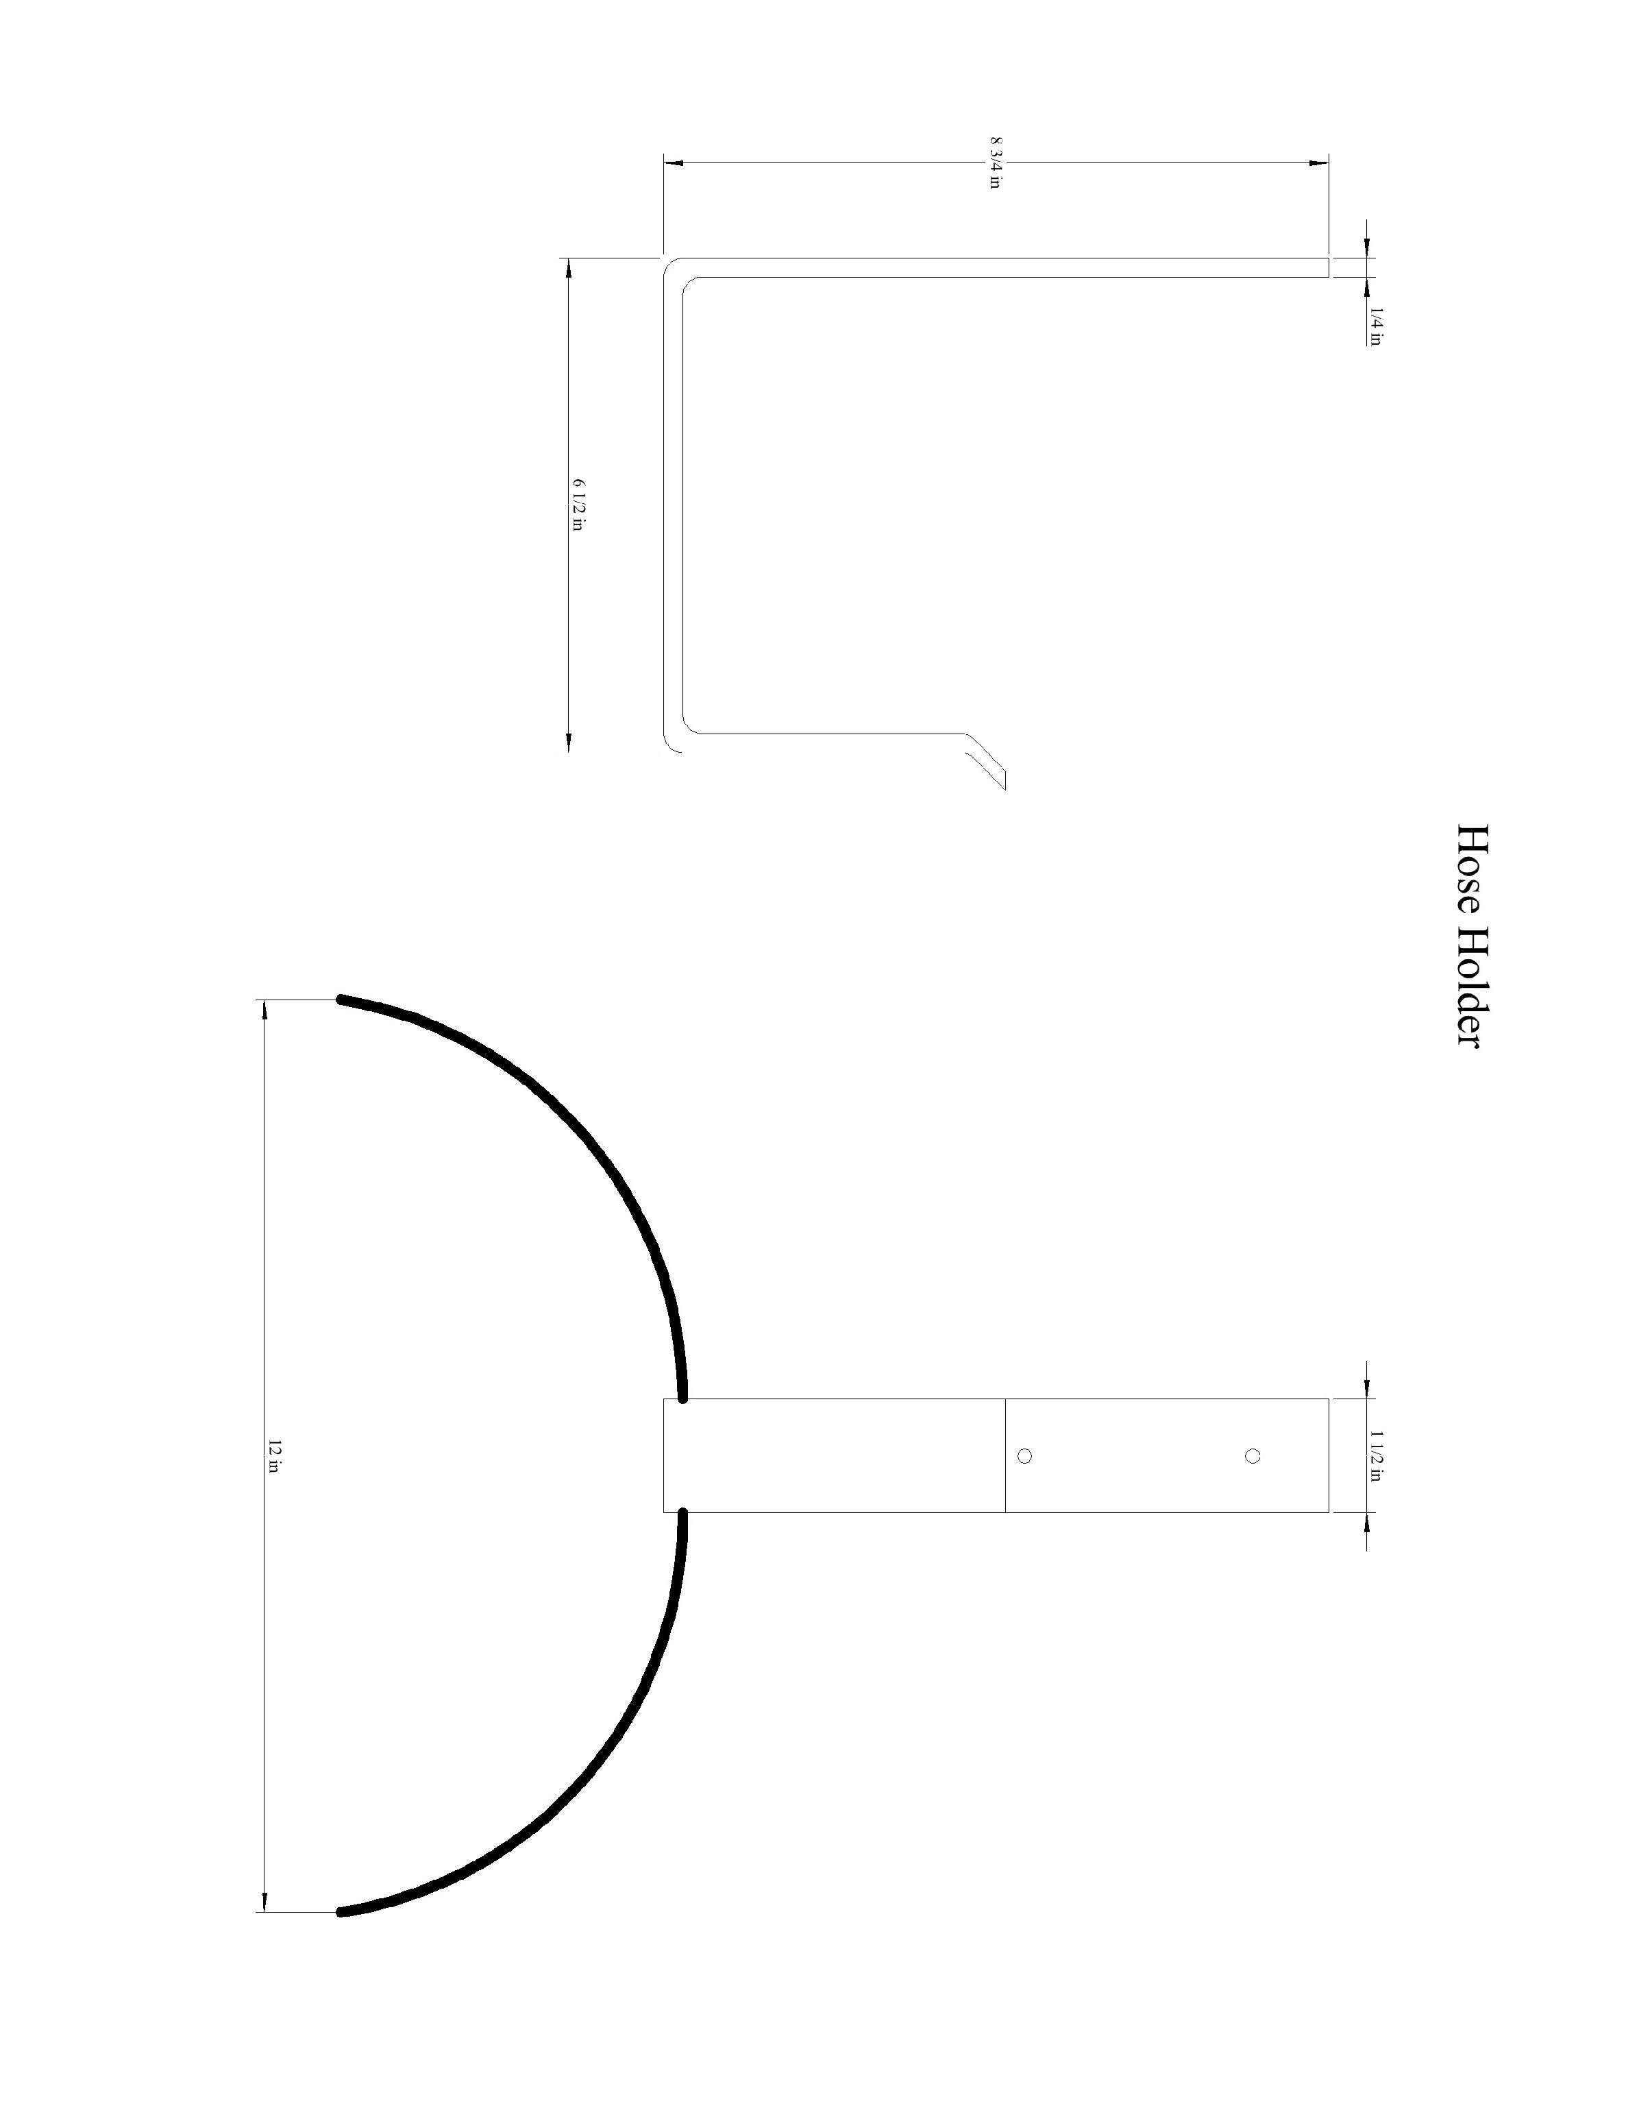

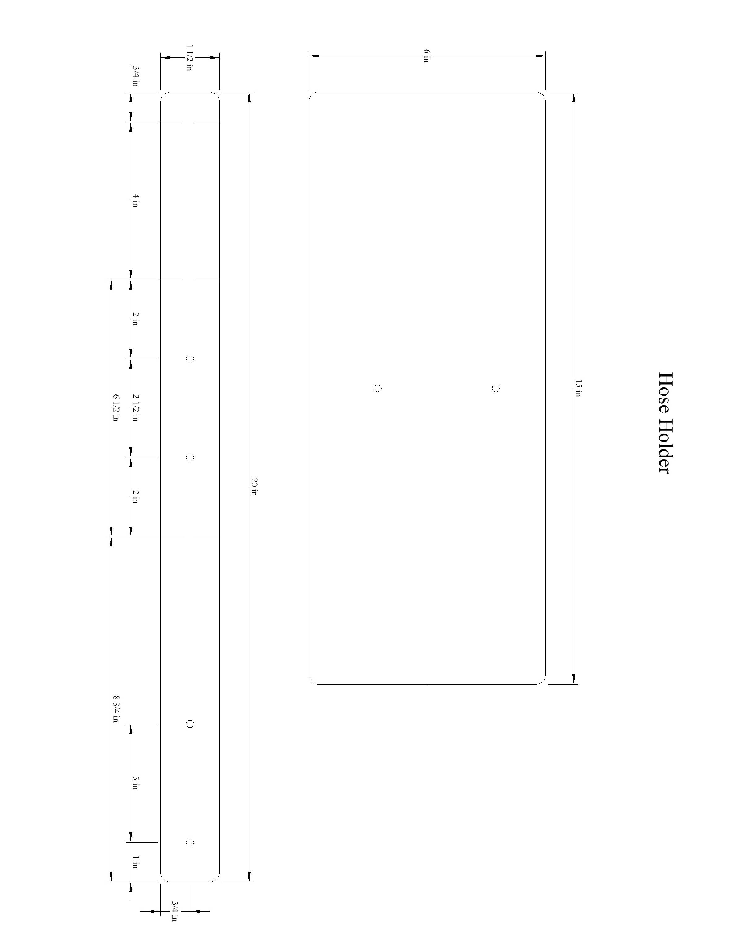

Hose Hanger Worksheet
Name: ________________________
Date: ________________________

- Which piece requires thicker metal in this project?

- Are you required to wear safety glasses during a cold metal project?

- How will the pieces be joined?

- What safety procedures should be followed when using the drill press?

- What degree are the angles you bend in this project?

Grading Rubric:
CRITERIA | POSSIBLE | SCORE
Size of sheet metal | 5
Bend of sheet metal | 5
Length of hanger (flat stock) | 5
90 ° angles | 5
Hole position | 5
Workmanship (assembly, edges, etc) | 5
Worksheet | 5
TOTAL | 35

Hose Hanger Teachers Notes:

Agricultural Standards Met:
5.0 Students understand how to create alternative solutions by using critical and creative thinking skills, such as logical reasoning, analytical thinking, and problem-solving techniques:
5.1 Apply appropriate problem-solving strategies and critical thinking skills to work-related issues and tasks.
5.3 Use critical thinking skills to make informed decisions and solve problems.
6.0 Health and Safety. Students understand health and safety policies, procedures, regulations, and practices, including the use of equipment and handling of hazardous materials:
6.1 Know policies, procedures, and regulations regarding health and safety in the workplace, including employers’ and employees’ responsibilities.
6.2 Understand critical elements of health and safety practices related to storing, cleaning, and maintaining tools, equipment, and supplies.
6.4 Maintain safe and healthful working conditions.
6.5 Use tools and machines safely and appropriately.
6.6 Know how to both prevent and respond to accidents in the agricultural industry.
B1.0 Students understand personal and group safety:
B1.1 Practice the rules for personal and group safety while working in an agricultural mechanics environment.
B1.2 Know the relationship between accepted shop management procedures and a safe working environment.
B5.0 Students understand agricultural cold metal processes
B5.3 Know layout skills.
B5.4 Know basic cold metal processes (e.g., shearing, cutting, drilling, threading, bending.).
B5.5 Complete a cold metal project, including interpreting a plan, developing a bill of materials, selecting materials, shaping, fastening, and finishing.

Objectives:
By properly completing this project, students will be able to:
- Read a plan to and layout dimensions.
- Bend sheet metal to desired dimensions
- Rivet sheet metal together effectively
- Use drill press to precisely drill holes
- Perform cold and hot metal processes

Alternative Tools/Methods/Materials:
- Thinner sheet metal can allow students to cut out pieces with snips
- Instead of riveting the pieces together you could braze or GMAW weld the pieces so they there is no fastener in view. Machine screws and nuts could also be used or the flat stock could be tapped and no nut used (adds threading skills to the project).
- Instead of using a roll to form the sheet metal it can be simply bent carefully over a 2” pipe mandrel mounted in a vise. Could also use a metal brake to form the sheet metal.
- Cut the sheet metal with a Beverly sheer of you don’t have a stationary sheer.
- The flat stock can be cut many ways with hack saw, plasma cutter, cut off saw

Safety Review:
- Working with hot metal. Leave plenty of room around the heating of the metal for safety
- Grinder
- Oxy-Acetylene Torch

Project Time:
Demonstration: | 30 minutes
Build: | 1.5 hours

Demonstration Notes
- Key point: Drill holes before bending.
- Dress edges before bending.
- Use soapstone to mark bending locations so the torch will not burn off the mark.
- Heat a narrow area to make a tight bend.
- Be sure to keep water nearby when bending the metal, you don’t want to be walking around with red hot metal.
- Use a tape to measure the distance (12” cord length) on the sheet metal to achieve the proper curve.
- Clamp the sheet metal then use the portable drill to “ream” the holes before placing the pop rivets.
- Insert the pop rivets from the top. The clamps help hold the two pieces of metal tight.
- Note: If pop rivets are installed loose, simply drill out with portable drill and try again.

Bill of Materials:
Project adapted from: C. Weston
Plan by: Ben Aguirre

