Octagon Shaped Flower Pot
Name: __________________
Date: __________________

Description:
The Octagon Flower Project is a more advanced project. It requires layout and fitting skills. Advanced setup of the table saw is required.

Materials:
1x 12 x 8’ Redwood Fencing Board
#6 x 1¼” deck screws
#6 x ½” galv. Flat head screws
2” galvanized mending plates
Course sand paper (80 grit)

Tools:
Table Saw
Miter Saw
Drill and screwdriver bit

Procedure:
- Cut a board 50 inches long for the walls.
- Tilt the table saw blade to 22.5 degrees and rip the board to the 4 1/5”. Reverse the boards and bevel the other edge.
- Cross-cut the boards to 12” using the power miter saw. These are your walls.
- Bend 8 straps to 135º (a 45º bend up) in a vise or on a brake.
- Assemble the walls with the straps on the outside 2” down from the top. Note: straps can be painted black for a better look prior to installation. Use ½” flat head wood screws.
- Cut a board 4” wide by 11 long. This “cleat” will help support the bottom. On larger pots with 2 piece bottoms it will hold the bottom together.
- Cut a board 11” by 11” long. This is the bottom.
- Set the walls on the bottom and install the cleat across the bottom pieces (90º to the grain) with glue and wood screws.
- Mark the corners of the pot on the bottom and cut the 45º angles on the miter saw.
- Assemble the bottom to the walls using wood glue and screws.
- Options: Add 1” swivel castors to the bottom. Add some 1” cleats to the bottom to act as legs. Drain holes (1/2”) may be added to the bottom.
- Sand as needed

Notes:
___________________________________________________________________________________________________________________________________________________________________________________________________________________________________________________________________________________________________________________________________________________________________________________________________________________________________________________________________________________________________________________________________________________________________________________________________________________

Photo/Drawing:

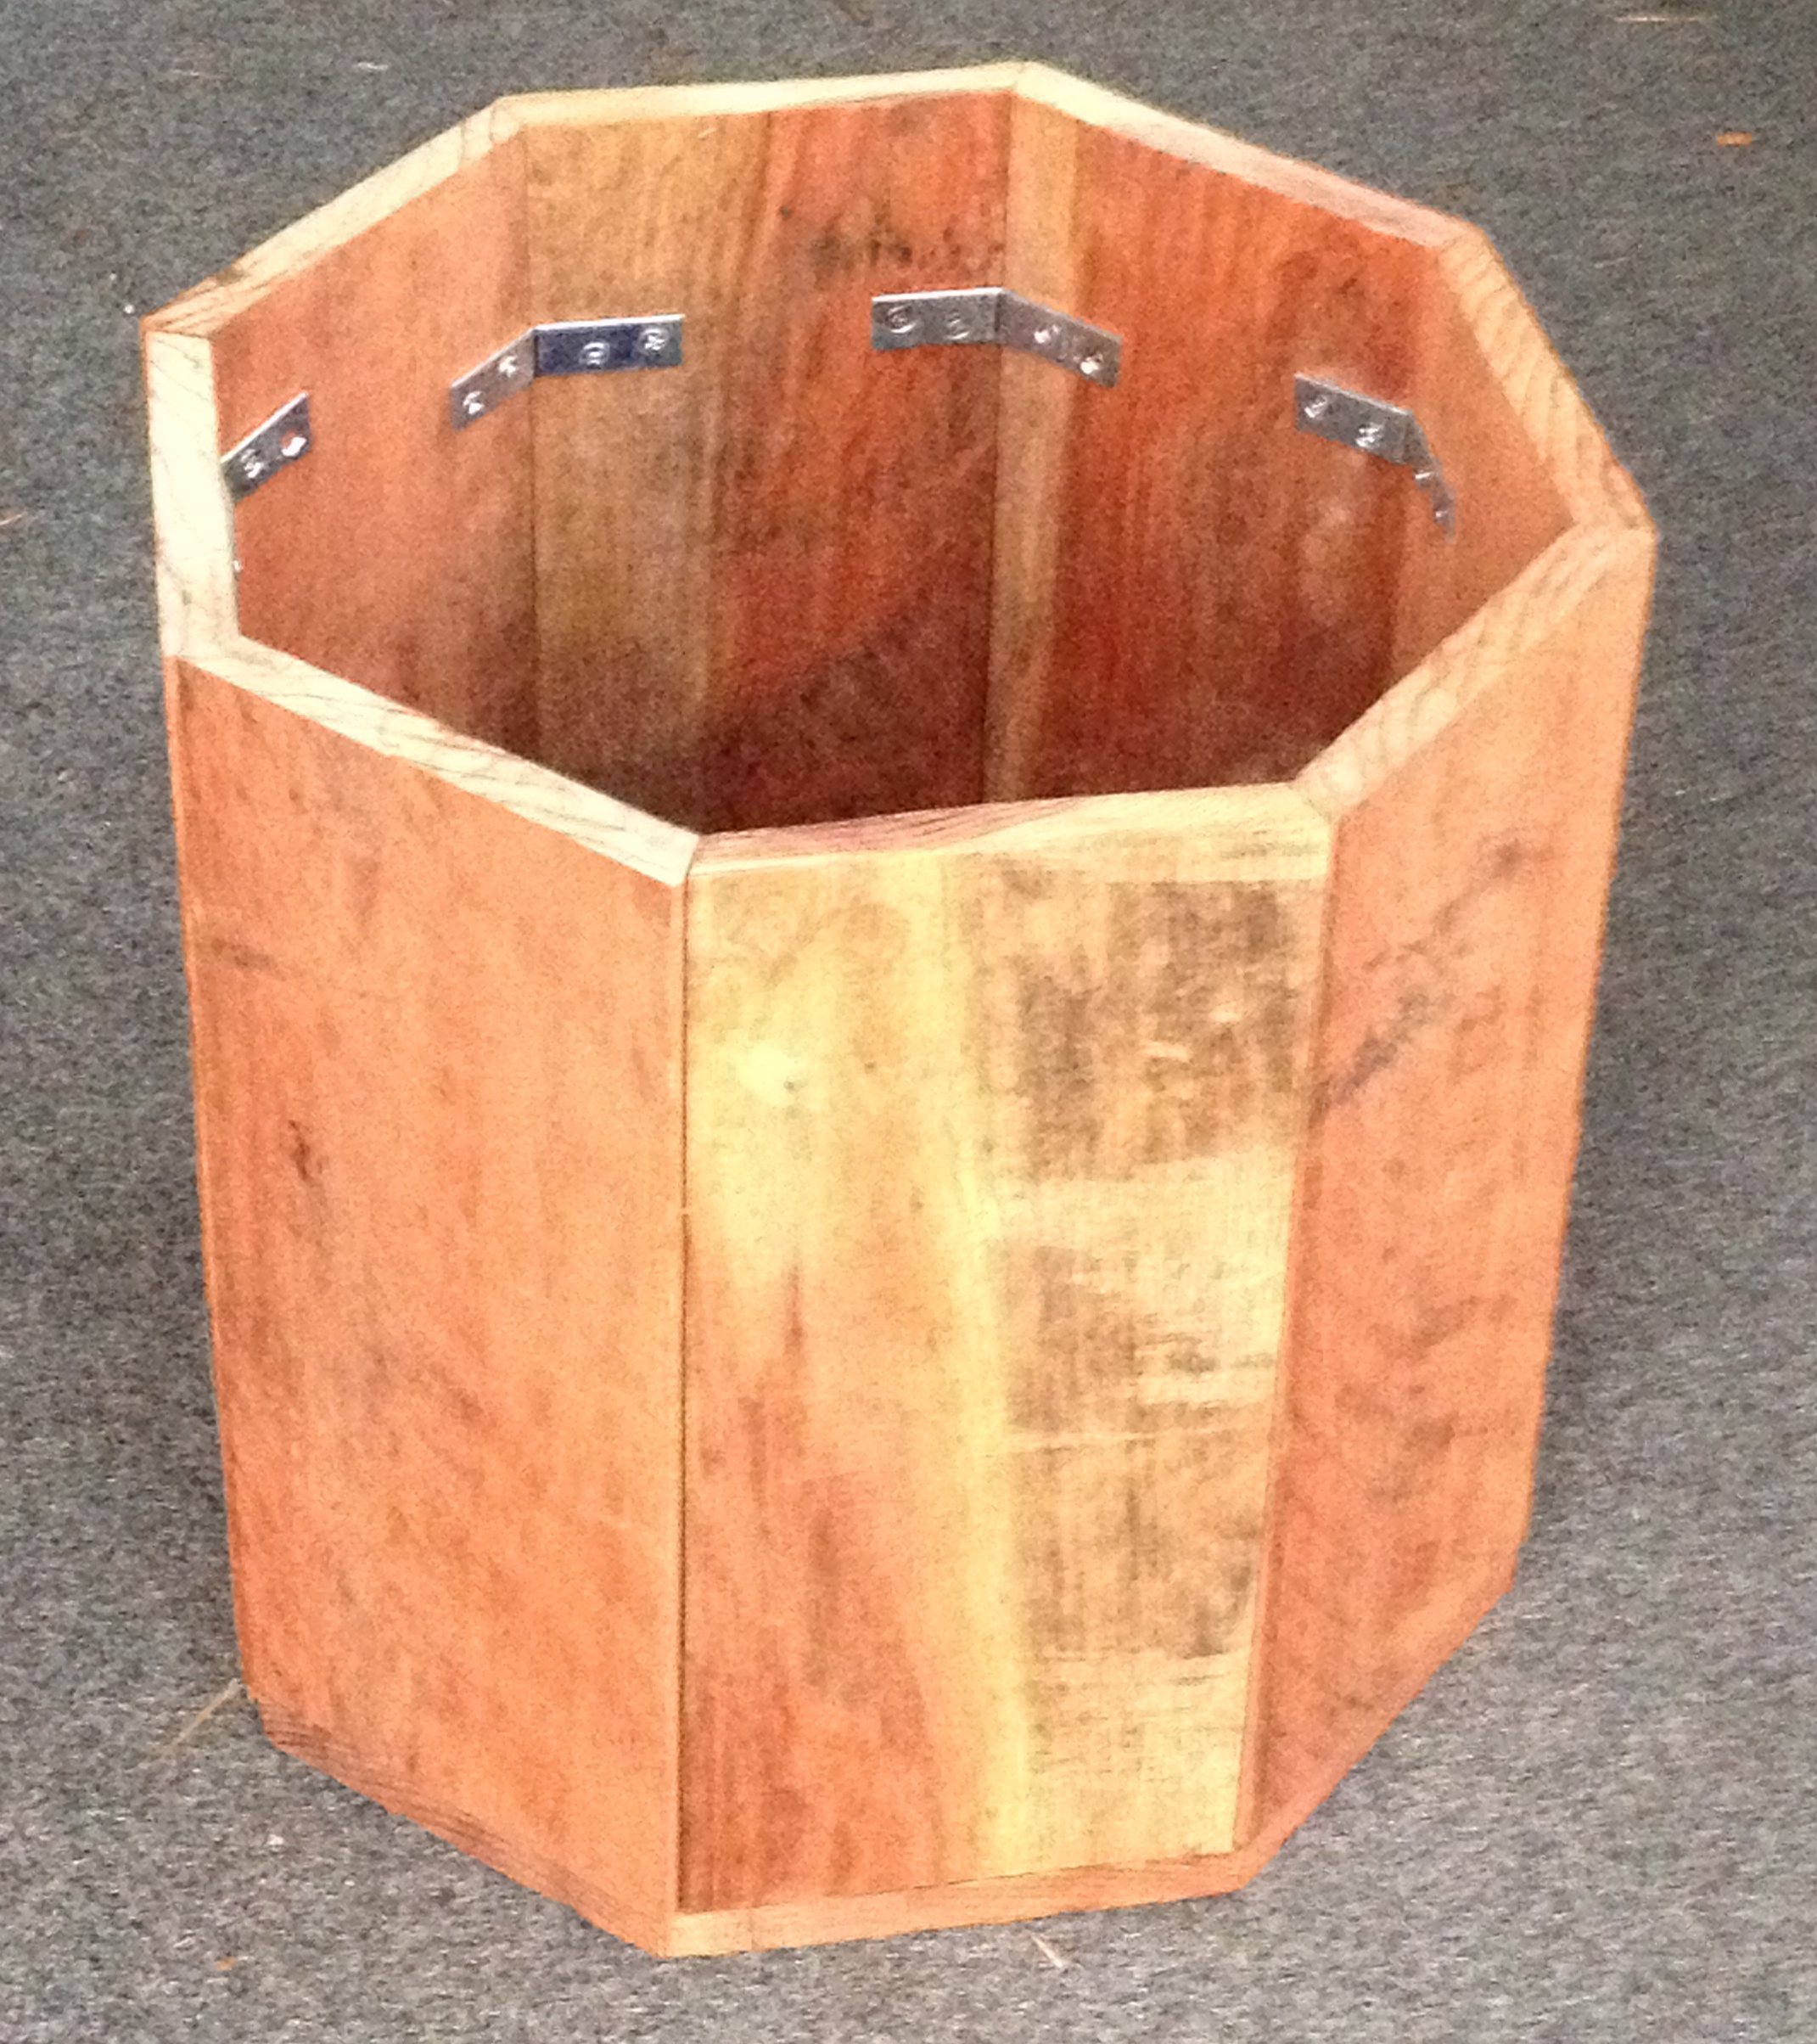
Note: Mending straps are shown on the inside in this example.
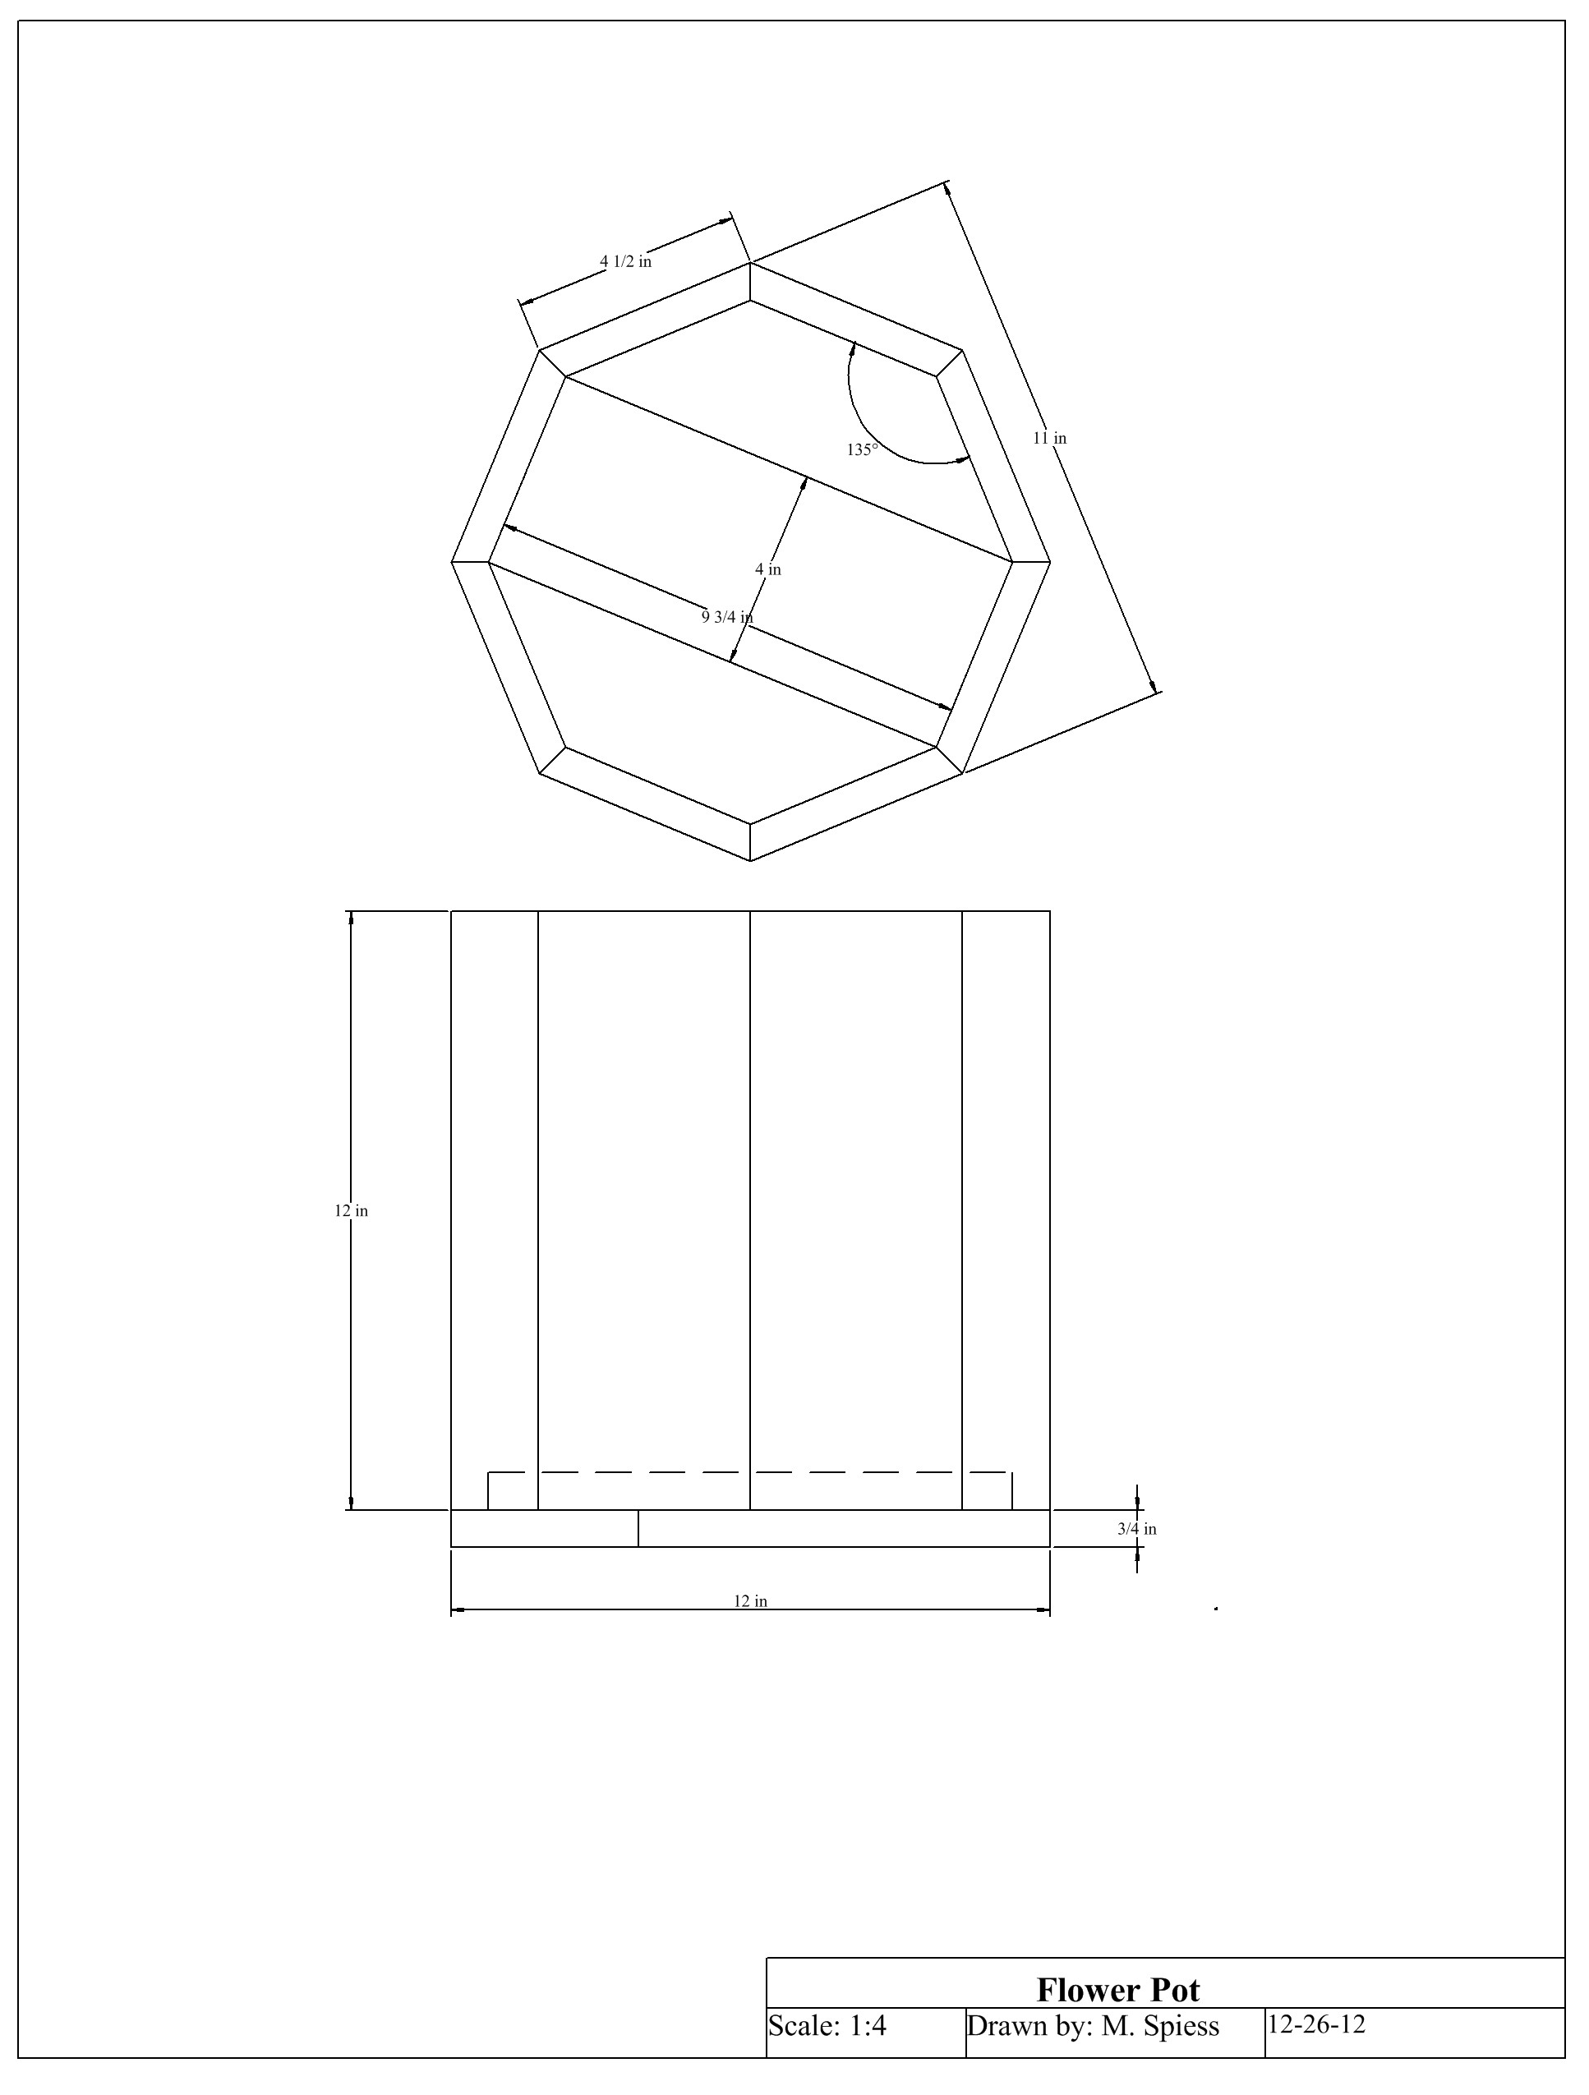
The project can be scaled to make a smaller or larger pot. Wall height can be adjusted accordingly.
Wall width | Diameter (vertex to vertex)
11 ½” | 30”
7 5/8” | 20”
5 ¾” | 15”
3” | 8”

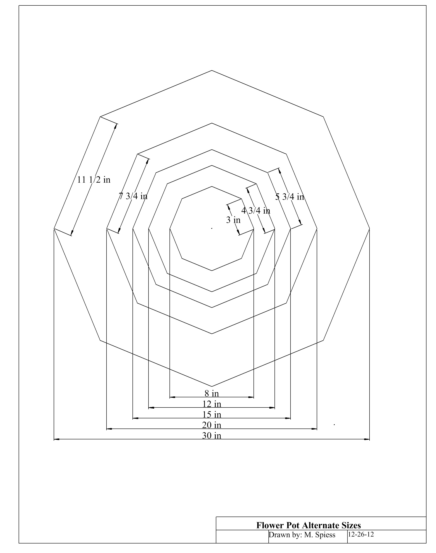

Flower Pot Project- Considerations of Construction
Name: ________________________
Date: ________________________

- You are creating an octagonal planter box. What are the angles (in degrees) of each corner?

- How many degrees should each the beveling on each billet be?

- The plans say that your base must be 14” in diameter. However, you only have 1”x6” boards. Explain how you can still construct the base with the materials you have.

- You will be attaching the base of the planter to the sides. What screws would be best for this procedure?

Grading Rubric:
CRITERIA | POSSIBLE | SCORE
Bevel Angles | 5
Billet Length and Width | 5
Base Width | 5
Billet Bracket Angle | 5
Proper Screw Use and Length | 5
Craftsmanship | 5
Total | 30

Flower Pot Project Teachers Notes:

Agricultural Standards Met:
6.0 Health and Safety. Students understand health and safety policies, procedures, regulations, and practices, including the use of equipment and handling of hazardous materials:
6.1 Know policies, procedures, and regulations regarding health and safety in the workplace, including employers’ and employees’ responsibilities.
6.2 Understand critical elements of health and safety practices related to storing, cleaning, and maintaining tools, equipment, and supplies.
6.4 Maintain safe and healthful working conditions.
6.5 Use tools and machines safely and appropriately.
6.6 Know how to both prevent and respond to accidents in the agricultural industry.
B1.0 Students understand personal and group safety:
B1.1 Practice the rules for personal and group safety while working in an agricultural mechanics environment.
B1.2 Know the relationship between accepted shop management procedures and a safe working environment.

Objectives:
By properly completing this project, students will be able to:
- Read a plan to and layout dimensions.
- Properly use various saws needed.
- Apply a beveled edge to a piece of lumber
- Proper use of a power drill to install screws

Alternative Tools/Methods/Materials:
- Cedar wood can also be used.
- A circular saw could be used for all cuts including cutting walls to length and beveling the sides, but may not be as accurate and students will not get the opportunity to learn beveling with a table saw or proper use of a miter saw.
- The straps can be made from HR strip saving cost and adding a metal component to the project. Use 1/8” x ¾” HR strip cut to 4”. Drill a 3/16”hole in each end and countersink. These must be painted as the bare steel will quickly rust. A complete band of metal can also be fitted but this is a more complex task.

Safety Review:
- Proper use of a table saw (5 minutes)
- Proper use of a miter saw (3 minutes)
- Proper use of a power drill (2 minutes)

Project Time:
Demonstration: | 40 minutes
Build: | 2 hours

Demonstration Notes
- This is a very large project. It might be a good idea to break up the demonstration up into steps.
- Be sure to use a whiteboard to help students visualize what a billet looks like and how to bevel an edge.

Bill of Materials: (complete this spreadsheet)

Project from: Mike Spiess. Plan by: Trevor Airola

