Feed Scoop
Name: _______________
Date:_______________

Description:
Students will properly measure, layout, cut and bend sheet metal into a feed scoop shape. Then they will properly cut wood and attach the handle to successfully make a feed scoop.

Materials:
- 1X4 #3 pine
- 1 inch Dowel
- 26 Gauge Galvanized Sheet Metal
- Wood Glue
- ½” #8 Pan Headed Screw

Tools:
- Miter Saw
- Drill Press
- Screwdriver
- Duck Bill Snips
- Sheet metal brake
- Dividers
- Sheet metal Shear
- Scribe
- Combination Square
- Table Saw
- 1” Forstner Bit
- 1/8” twist drill
- Portable drill

Procedure:

Wood Handle
- Measure 6 inches on the 1 x 4 and cut with the miter saw.
- Measure a one inch dowel 5 ½ inches long and cut with the miter saw. Hold carefully.
- Using the plan and a combination square mark the center of the hole.
- Using the wood drill press and a one inch bit Forstner bit a hole half way into the wood where you marked the center of the hole.
- Drill a hole using 1/8 inch drill bit through center of the hole created with drill press with a portable drill.
- Glue dowel into one inch hole on wood base.
- Make a washer using a small piece of scrap sheet metal (about 1” square). Mark the center with a center punch. Carefully drill a 1/8 inch hole through the metal using the metal drill press.
- Using the power screwdriver insert the screw into the piece of wood on the base (using the scrap sheet metal as a washer) in order to hold the handle in place.

Sheet Metal Scoop
- Sheer a piece sheet metal 11” x 15”.
- Using the plan layout the cut and fold lines on the sheet metal.
- Use the combination square to layout the straight lines.
- Use the dividers to scribe the arc.
- Review your cut lines (compare with the plan).
- Cut out the project using snips.
- Using the sheet metal brake bend the ½ inch sides all the way over on both sides. (WATCH OUT FOR THE TABS)
- Bend the 3 ½ inch line 90° on both sides using the brake.
- Fit the metal to the wood folding the tabs over the wood. Trim the tabs so no sharp corners hang over the wood. Be sure to install the wood right side up.
- Attach the sheet metal scoop to the wood using nails. (Start on the bottom) There should be 3 nails on the bottom, 2 on each side and, 2 on top.

Notes:
____________________________________________________________________________________________________________________________________________________________________________________________________________________________________________________________________________________________________________________________________________________________________________________________________________________________________________________________________________________________________________________________________________________________________________________________________________________________________________________________________________________________________________________________________________________________________________________________________________________________________________________________________________________________________________________________________________________________________________________________________________________________________________________________

Photo/Drawing:
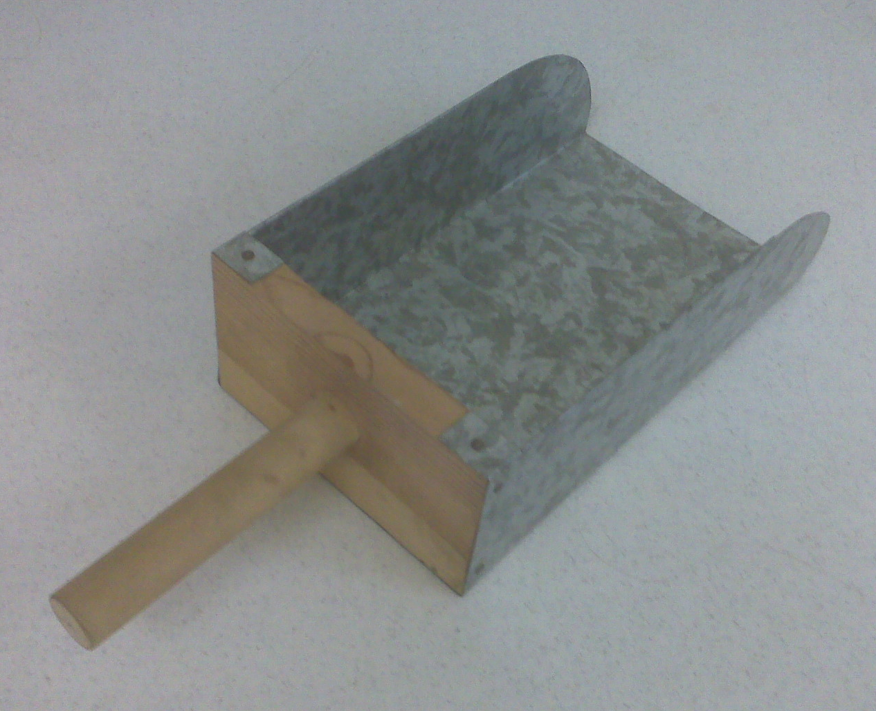

Feed Scoop Worksheet
Name: ________________________
Date: ________________________

Please answer the following questions before heading into the shop.
- The back (word part) of the scoop should be _________ by ___________ pine wood.
- Using the _________________ drill a hole in the the board.
- The handle is made out a dowel that should be ______________inches long.
- The scoop sides should be bent to a ___________ degree angle.
- Use a _____________________________to bend the sheet metal.

Grading Rubric:
CRITERIA | POSSIBLE | SCORE
Length | 5
Width | 5
Quality of the bends | 5
Fit of metal to wood | 5
Handle installation and placement | 5
Workmanship (cuts, finish, no sharp edges, etc) | 5
Worksheet | 10
Total | 30

Feed Scoop Teachers Notes:

Alternative Tools/Methods/Materials:
- Wood parts can be cut with a hand saw.
- Straight Snips or Aviation Snips can be used to cut out.
- Project can be made entirely from sheet metal. Modify the plan make sheet metal back and bend in a box brake. Spot weld the corners. Make the handle oit of 3/8 or ½” pipe. Make a 2” square plate out of 1/8” strip and bolt the handle assembly through the sheet metal back with a carriage bolt.

Agricultural Standards Met:
6.0 Health and Safety. Students understand health and safety policies, procedures, regulations, and practices, including the use of equipment and handling of hazardous materials:
6.1 Know policies, procedures, and regulations regarding health and safety in the workplace, including employers’ and employees’ responsibilities.
6.2 Understand critical elements of health and safety practices related to storing, cleaning, and maintaining tools, equipment, and supplies.
6.4 Maintain safe and healthful working conditions.
6.5 Use tools and machines safely and appropriately.
6.6 Know how to both prevent and respond to accidents in the agricultural industry.
B1.0 Students understand personal and group safety:
B1.1 Practice the rules for personal and group safety while working in an agricultural mechanics environment.
B1.2 Know the relationship between accepted shop management procedures and a safe working environment.
B2.0 Students understand the principles of basic woodworking.
B2.3 Know how to identify, select, and implement basic fastening systems.
B5.0 Students understand agricultural cold metal processes:
B5.1 Know how to identify common metals, sizes, and shapes.
B5.2 Know basic tool-fitting skills.
B5.3 Know layout skills.
B5.4 Know basic cold metal processes (eg, shearing, cutting, drilling, threading, bending)
B5.5 Complete a cold metal project, including interpreting a plan, developing a bill of materials, selecting materials, shaping, fastening, and finishing.

Objectives:
By properly completing this project, students will be able to:
- Read a plan and layout dimensions.
- Cut Sheet Metal
- Bend Sheet Metal
- Cut Wood
- Measure Wood and Sheet Metal

Safety Review:
- Sheet Metal Brake
- Sheet Metal Shear
- Miter saw
- Drill Press
- Sheet Metal Edges (especially in the drill press)

Project Time:
Demonstration: | 1 Hour
Build: | 1 ½ Hours

Demonstration Notes
- Combination Square should be used for the layout
- Using snips to cut through the sheet metal is difficult; cutting well into the snips will givde you more leverage and control. 10" snips are easier for students with smaller hands.
- Cut the 3/4 inch tab line in order to prevent from bending that piece.
- Layout dowel and wood base before cutting to shorten demo and have less trips back and forth from work bench to saw.
- Drill hole through center of already drilled pressed wood before gluing. This makes inserting the screw into the handle easier and more centered.
- To make lines on layout more visible, spray paint sheet metal first then use a scribe to make measurements.
- Do not recommend using sharpie to layout project since the line is wide. Use a scribe.
- Bend ½ inch sides completely over first before bending the sides 90⁰
- Project ca be started with the wood or metal parts.

Feed Scoop Bill of Materials:
Project by: Mike Spiess
Plan by: Krystal Thomas

