Cutting Board Project
Name: ________________________
Date: ________________________

Description:
Construction of the cutting board utilizes scrap lumber to make a useful project. Workmanship is a key part of the project. The cutting board can also be used for a trivet or as lumber for another project. Custom cutting boards make nice side boards for BBQ projects. In building this project you will use common woodworking tools and to identify common woods.

Materials:
Waterproof wood glue
Mineral oil
Sand paper (120 grit, open coat)

Tools:
Power Miter Saw
Table saw
Band Saw or Jig Saw (optional)
Router with 3/8” ¼ round bit.
Surface planer
Palm Sander
Bar or pipe clamps
Flux brush

Procedure:
- Select strips of scrap lumber. Strips need not be the same lengths.
- Layout in an attractive pattern on the work bench. Width cannot exceed __________ inches (the width your surface planer).
- Using the flux brush paint glue on the edges of the strips and place in the bar clamps in the same pattern. Note: Use a clamp near the end and then about every 12”.
- Square one end and tighten the clamps. Wipe off excess glue. Let sit overnight.
- Remove the clamps.
- Use a miter saw or a table saw with a miter gauge to square the ends.
- Run the project through the planer as demonstrated. Plane both sides just enough to smooth all the pieces.
- If desired you may round the corners. Use a round object to trace a line on each corner then cut with a band saw or jig saw. You also can make cutting boards in to shapes (ex. round).
- Clamp the project to a table or sawhorse and use the router to round the edges.
- Use a sanding block or palm sander to sand the completed project.
- Wipe on mineral oil to protect the wood surface.

Notes:
_______________________________________________________________________________________________________________________________________________________________________________________________________________________________________________________________

Photos:
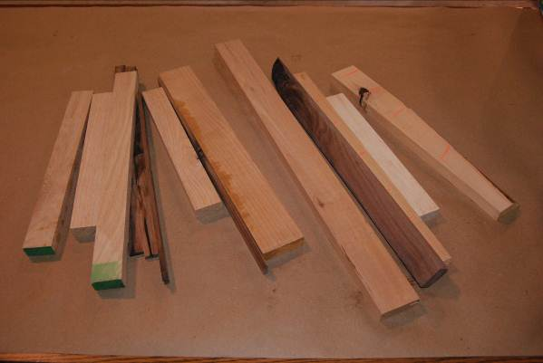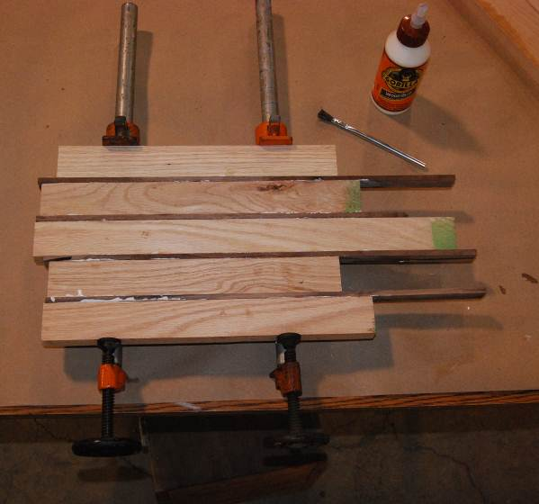
Wood Selection Gluing in pipe clamps
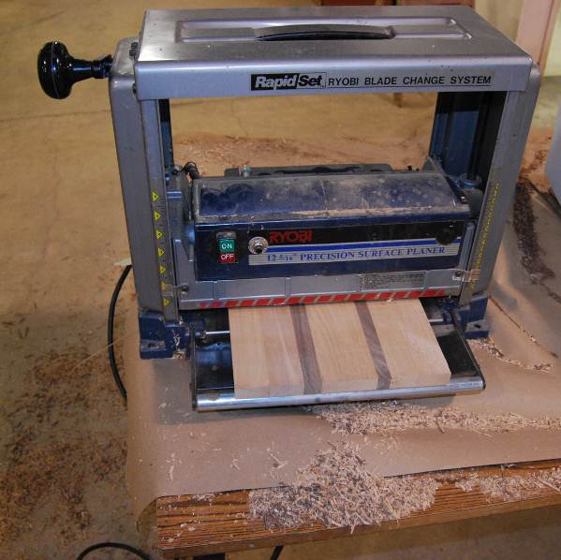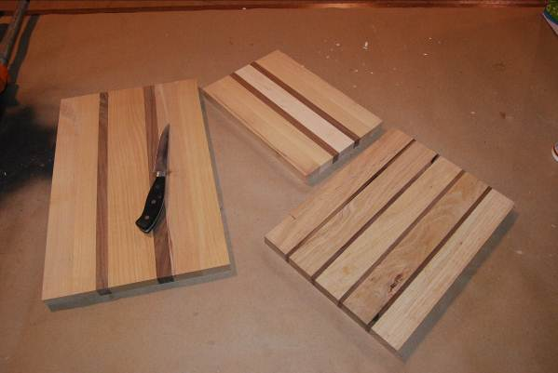
Surfacing Trimmed and surfaced projects

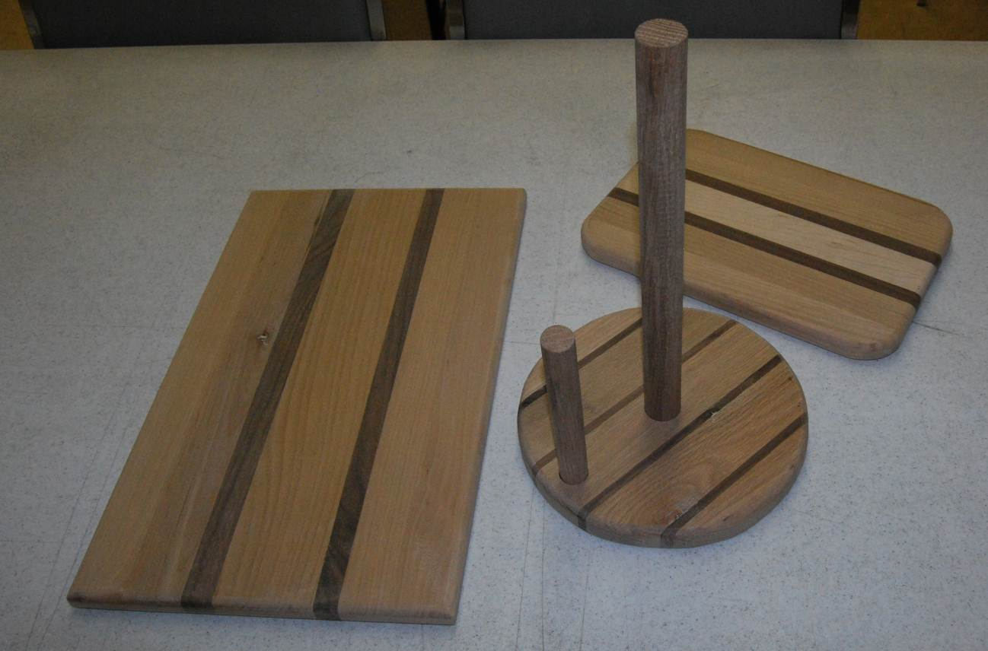
Finished projects

Cutting Board Worksheet
Name: ________________________
Date: ________________________

- Why is wood selection important for this project?

- What types (species) of wood are you using?

- What is the minimum length of board you can safely run through the surface planer?

- Why is it important to clamp the project when routing the edges?

- What is the purpose of the mineral oil?

Grading Rubric:
CRITERIA | POSSIBLE | SCORE
Wood selection (avoid knots, etc) | 10
Finish (surface, edges) | 10
Workmanship (sanding) | 10
TOTAL | 30

Teachers Notes:
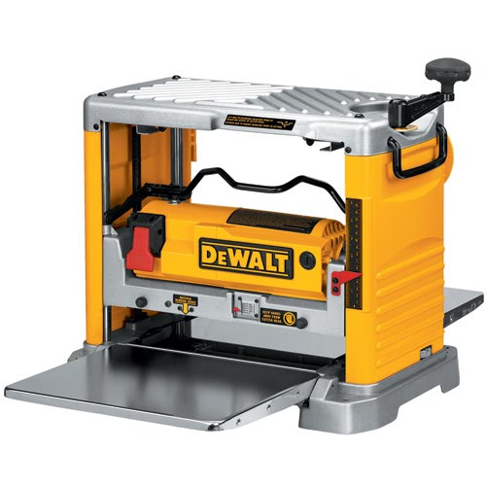
The project is a good project to introduce use of tools, reinforce good shop habits and is a popular present to family members. Small cutting boards are pricy when purchased at local shop so this can also be a fund raiser.
This project utilizes scrap hardwoods. They may be available from your shop, your school’s wood shop, or a local cabinet maker. Portable surface planers are available from $400-600 with a 12” capacity. These are ideal for this project if you don’t have a full wood shop as they can be put on a bench then put away when no longer needed.
Note: thicker cutting boards can be made by gluing the faces of lumber strips together. Use caution when cutting narrow strips on the table saw. Thicker cutting boards can have a groove cut into the perimeter with a router to collect juices.

Agricultural Standards Met:
6.0 Health and Safety. Students understand health and safety policies, procedures, regulations, and practices, including the use of equipment and handling of hazardous materials:
6.1 Know policies, procedures, and regulations regarding health and safety in the workplace, including employers’ and employees’ responsibilities.
6.2 Understand critical elements of health and safety practices related to storing, cleaning, and maintaining tools, equipment, and supplies.
6.4 Maintain safe and healthful working conditions.
6.5 Use tools and machines safely and appropriately.
6.6 Know how to both prevent and respond to accidents in the agricultural industry.
B1.0 Students understand personal and group safety:
B1.1 Practice the rules for personal and group safety while working in an agricultural mechanics environment.
B1.2 Know the relationship between accepted shop management procedures and a safe working environment.

B2.0 Students understand the principles of basic woodworking:
B2.1 Know how to identify common wood products, lumber types, and sizes.
B2.3 Know how to identify, select, and implement basic fastening systems.
B2.4 Complete a woodworking project, including interpreting a plan, developing a bill of materials and cutting list, selecting materials, shaping, joining, and finishing

Objectives:
By properly completing this project, students will be able to:
- Use various power tools saw to work wood.
- Select kinds, grades, and quantity of lumber for a given task.

Alternative Tools/Methods/Materials:
- Softwoods such a fir may be used, but the project will not be very durable. Clear pieces of “2 by” can be used if the lumber is dry. Generally this material is rough on the outside. Surface the edges to be glued in a joiner (pieces longer than 18” for safety) to insure a tight glue joint.
- Project can be constructed with hand tools. Use a hand saw to cut the board square and planes to chamfer the edges. A smoothing plane can be used on the surface; however a surface planer is desirable to smooth the surface. If you wish to use hand tools consider gluing the projects, trimming the ends then having the project surfaced. Allow much more time for construction with hand tools.
- Wider boards can be made by gluing together projects. Be sure to run the parts through the planer together to insure that they are the exact same thickness.

Safety Review:
- Safety Glasses
- Miter Saw Safety
- Table Saw
- Band saw/Jig Saw (blade thickness)
- Router (proper clamping)
- Sander (dust)

Project Time:
Demonstration: | 15-25 minutes
Build: | 1-2 hours

Demonstration Notes:
- Lay a selection of scraps on the bench, ID wood types, point out defects and how to avoid.
- Show a couple of sample layouts with pleasing patterns. Different woods and grains make each project unique.
- Small voids can be filled with wood dough. Patch after surfacing then sand smooth.
- Note: If longer scraps are available projects can be glued by groups of students then cut to shorter lengths after surfacing.
- Show examples of patterns , edge finishing, etc.

Bill of Materials:
Plan by Mike Spiess

