Woodworking- Boot Jack
Name: ________________________
Date: ________________________

Description:
Students will create boot jacks from wood supplied by the shop. The proper tools used for this project will be listed and demonstrated for proper use by the instructor.

Materials:
1” x 6” #2 pine
#6 x 1 5/8” bugle head screws
120 grit sandpaper
Wood Glue

Tools:
Portable hand drill
Miter saw
Band saw
Table saw
Phillips screwdriver bit
1” & ¾” Forstner Bits
Combination Square

Procedure:
Starting cuts:
- Cut the length of the board 15 ½” using the miter saw. This is a rough length.
Station 1: Table Saw
- Angle the table saw blade for a bevel cut to 16 degrees. Trim on end of the board.
Station 2: Miter Saw
- Cut the prop 2” long (long side of the bevel cut).
- Cut the boot jack 12” long.
Station 3: Drill press
- Layout the centers of the two holes.
- Drill the holes on the drill press using the Forstner bits.
Station 4: Band Saw
- Layout the “V” as shown in the drawing.
- Cut out the “V” on the band saw.
Assembly
- Locate the centers of the screws and mark with a nail or scratch awl.
- Glue the prop to the boot jack (8” from the hole side). Hint: let the glue set for a couple of minutes before installing the screws.
- Drill 3 screws to the boot jack to secure the prop in the locations shown on the plan. . Angle the screws so they install straight into the prop.
- Sand the project removing sharp edges.

Cutting List:
Quantity | Size | Material
1 | ¾” x 5 ½”x 12” | #2 pine
1 | ¾” x 2” (long side) x 5 ½” | #2 pine

Notes:
____________________________________________________________________________________________________________________________________________________________________________________________________________________________________________________________________________________________________________________________________________________________________________________________________________________________________________________________________________________________________________________________________________________________________________________________________________________________________________________________________________________________________________________________________________________________________________________________________________________________________________________________________________________________________________________________________________________________________________________________________________________________________________________________

Photo/Drawing:
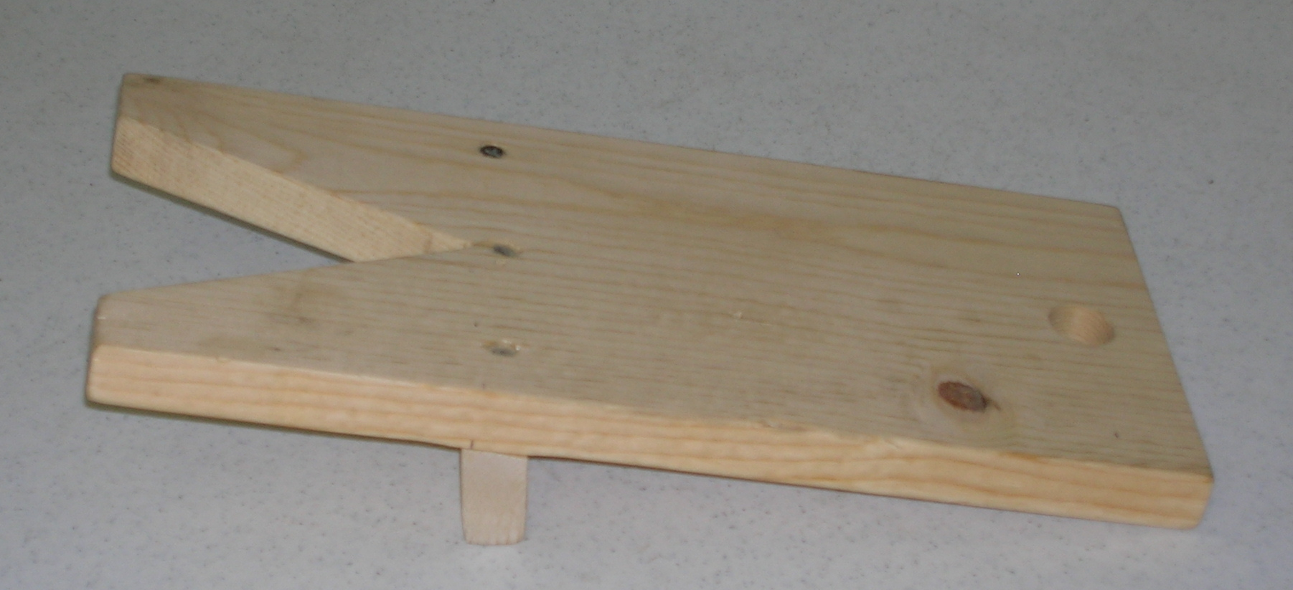

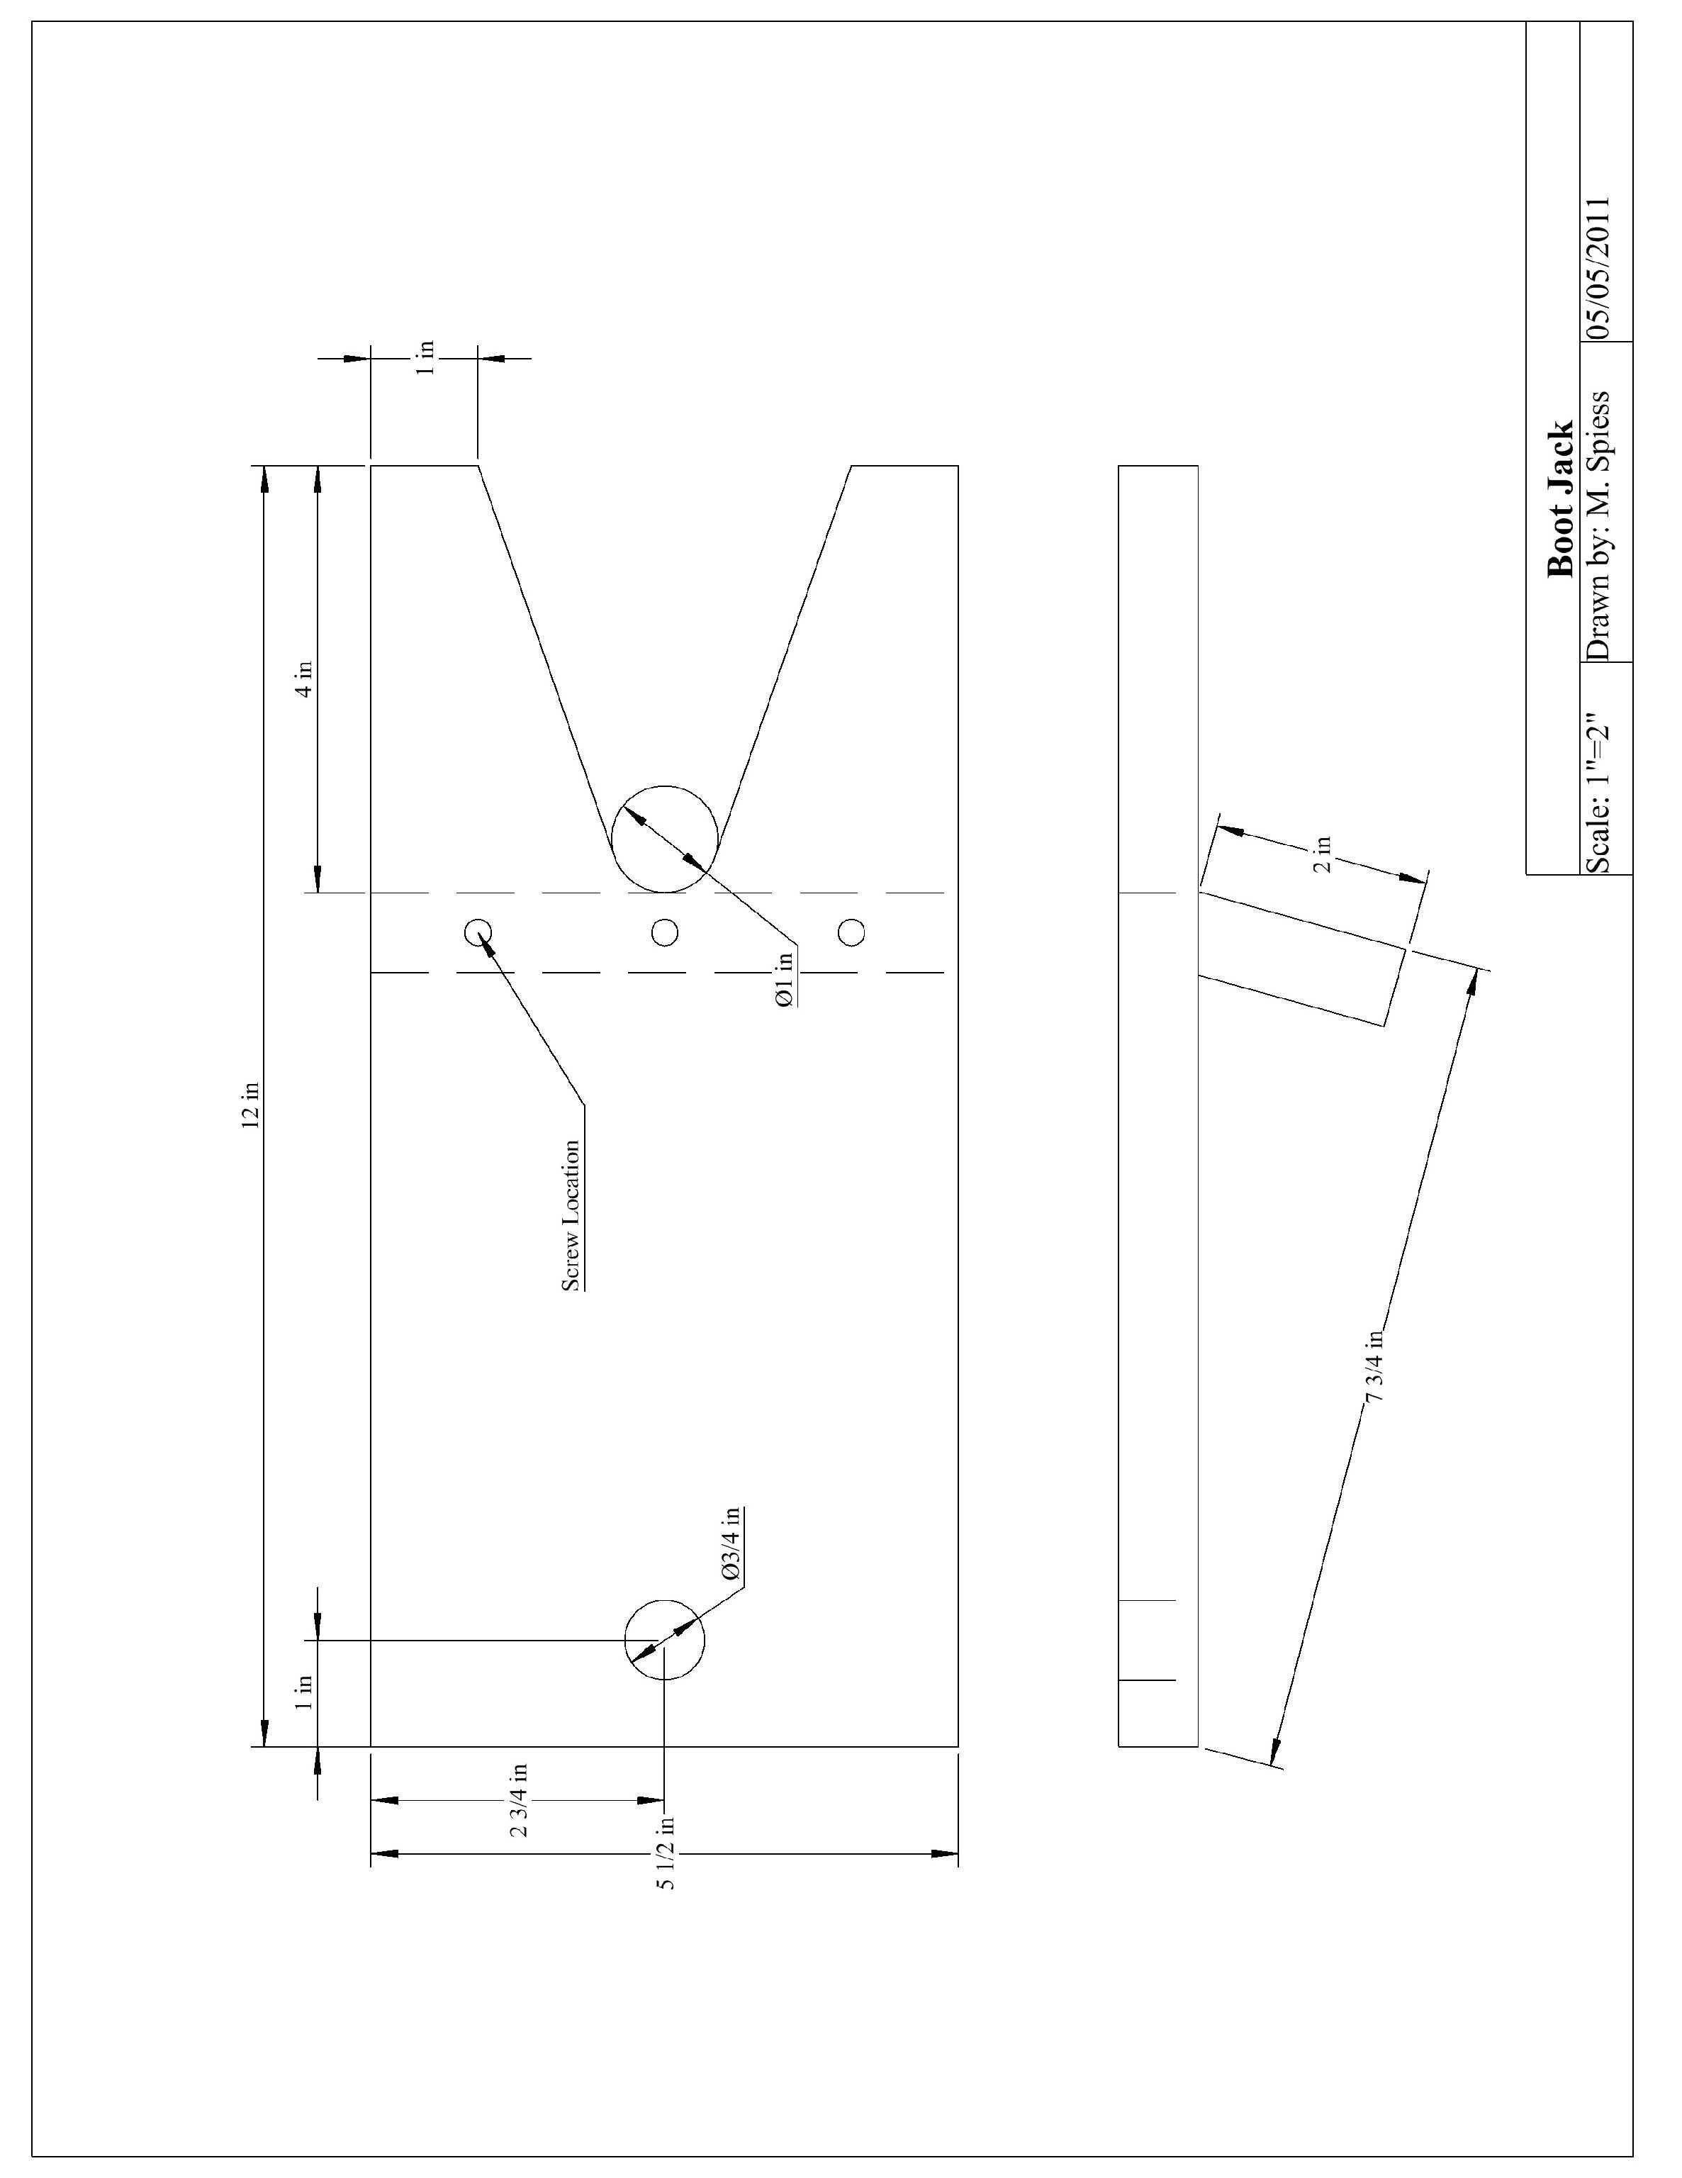

Wood Working: Boot Jack Worksheet
Name: ________________________
Date: ________________________

- What type of drill bit is used? ____________________
- How long is the boot jack? ______________________
- What are the measurements to the center of the two holes?
____________ x ____________ and ___________ x _____________
- What tool is used to cut the bevel? _________________________
- What type of screws will you use (be specific)? _____________________________________

Grading Rubric:
CRITERIA | POSSIBLE | SCORE
Proper length of the Boot Jack | 5
Proper length and angel of the prop | 5
The “V” shape of boot jack depth and cut quality | 5
The “V” shape of boot jack width and centered | 5
Boot Jack hole (placement, etc.) | 5
Overall quality (sanded, fit, level, exposed screws) | 5
Worksheet | 5
Total | 35

Woodworking Boot Jack Project Teachers Notes:

Agricultural Standards Met:
B1.0 Students understand personal and group safety:
B1.1 Practice the rules for personal and group safety while working in an agricultural mechanics environment.
B1.2 Know the relationship between accepted shop management procedures and a safe working environment.
B2.0 Students understand the principles of basic woodworking:
B2.1 Know how to identify common wood products, lumber types, and sizes.
B2.2 Know how to calculate board feet, lumber volume, and square feet.
B2.3 Know how to identify, select, and implement basic fastening systems.
B2.4 Complete a woodworking project, including interpreting a plan, developing a bill of materials and cutting list, selecting materials, shaping, joining, and finishing.
4.0 Technology. Students know how to use contemporary and emerging technological resources in diverse and changing personal, community, and workplace environments:
4.6 Differentiate among, select, and apply appropriate tools and technology.
6.0 Health and Safety. Students understand health and safety policies, procedures, regulations, and practices, including the use of equipment and handling of hazardous materials:
6.2 Understand critical elements of health and safety practices related to storing, cleaning, and maintaining tools, equipment, and supplies.
6.4 Maintain safe and healthful working conditions.
6.5 Use tools and machines safely and appropriately.
7.0 Responsibility and Flexibility. Students know the behaviors associated with the demonstration of responsibility and flexibility in personal, workplace, and community settings:
7.1 Understand the qualities and behaviors that constitute a positive and professional work demeanor.
7.5 Understand the importance of time management to fulfill responsibilities.
7.6 Know how to apply high-quality craftsmanship to a product or presentation and continually refine and perfect it.

Objectives:
By properly completing this project, students will be able to:
- Identify and learn the proper use of the woodworking tools for the project
- Measure and mark wood for cutting and/or drilling
- Cut, assemble, and finish the wood project properly

Alternative Tools/Methods/Materials:
Jig saw- alternative tool to cut the length of the boards and cut the “V” shape of the boot jack. 5d finish nails can be used instead of screws. Spade bits can be used instead of Forstner bits.
Miter saw- alternative tool for the table saw to cut the angle.
Note: Project can be built with hand tools alone (hand saw and brace)

Safety Review:
- Table saw safety
- Miter saw safety
- Band saw safety

Project Time:
Demonstration: | 30 minutes
Build: | 1 hour

Demonstration Notes
- Show lumber selection by selecting a board without knots in a critical area.
- Demonstrate the safe use of the miter gauge to hold the full length board for the bevel cut. NEVER cut short pieces on the table saw or miter saw (hard to hold).
- Show proper use of the combination square for layout. Tip: Set the square to an even inch mark on the fence so you can easily measure.
- Select the proper board; one that does not have knots and has the structural integrity.
- Drilling tips: Setup two drill presses if possible, one with each size bit. Drill into a smooth board to protect the bit and insure that the hole is smooth.
- Band saw tips: Use a ½” blade since the cuts are straight. A wider blade is easier to use for straight cuts.
- Use glue to secure the wood in place and prevent the boot jack from slipping from the prop
- When you drill the screws, place them at a proper angle that will not expose the screws or pierce the wood

Bill of Materials: (complete this spreadsheet)
Project from: M. Spiess
Plan by: Kyle Schaad

