Bookend Project
Name: ________________________
Date: ________________________

Description:
This project consists of building a bookend. General skills used to build this project include drawing, measuring, laying out the project and cutting the materials. Nails and screws are used to fasten different parts together. Sanding is another important skill for this project as well. Finally, drilling is the last and final skill needed to complete this project.

Materials:
4d finish nails
#6 x 1 5/8” course drywall screws (woodscrews)
Sand Paper
1" x 4" x 24" #3 Pine

Tools:
Power Miter Saw
Claw Hammer
Nail set
Portable Drill with Phillips driver
#6 Countersink bit

Procedure:
- Measure, layout and cut your materials following the attached plan
- Use nails to fasten the upright to the base. Countersink the nails.
- Use woodscrews to fasten the brace to the base. Use a square to insure the bookend is square.
- Sand and finish.
- Paint or stain as desired.

Cutting List:
1 | 3/4"x3 1/2"x7" | #3Pine
1 | 3/4"x3 1/2"x6 1/4" | #3Pine
1 | 3/4"x3 1/2"x10" | #3Pine

Notes:
___________________________________________________________________________________________________________________________________________________________________________________________________________________________________________________________________________________________________________________________________________________________________________________________________________________________________________________________________________________________________________________________________________________________________________________________________________________

Photo/Drawing:
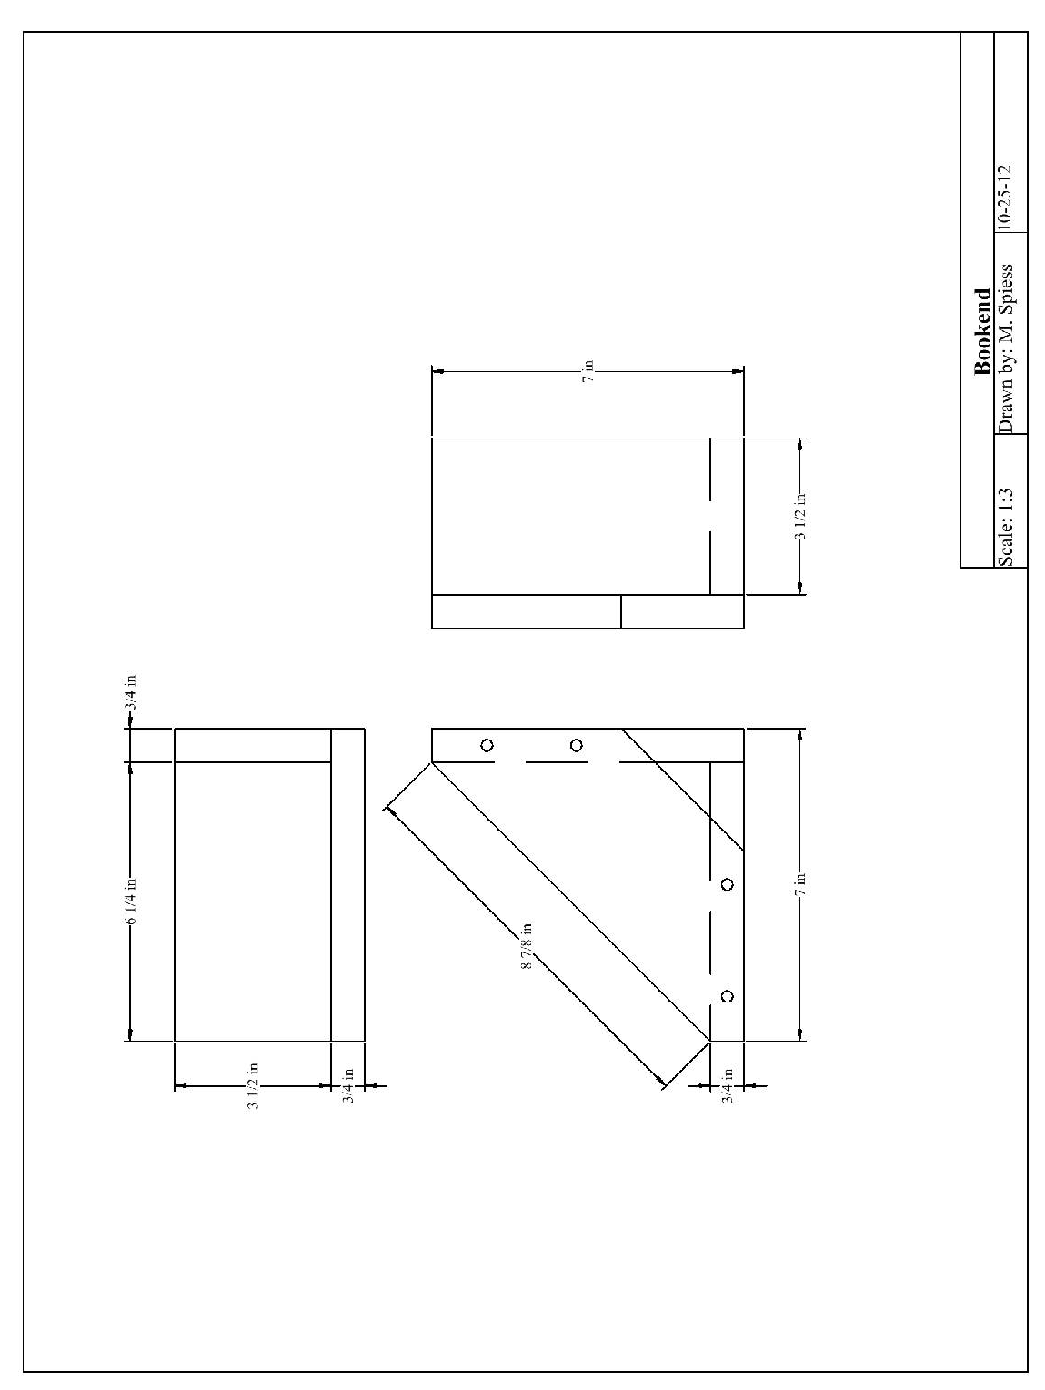
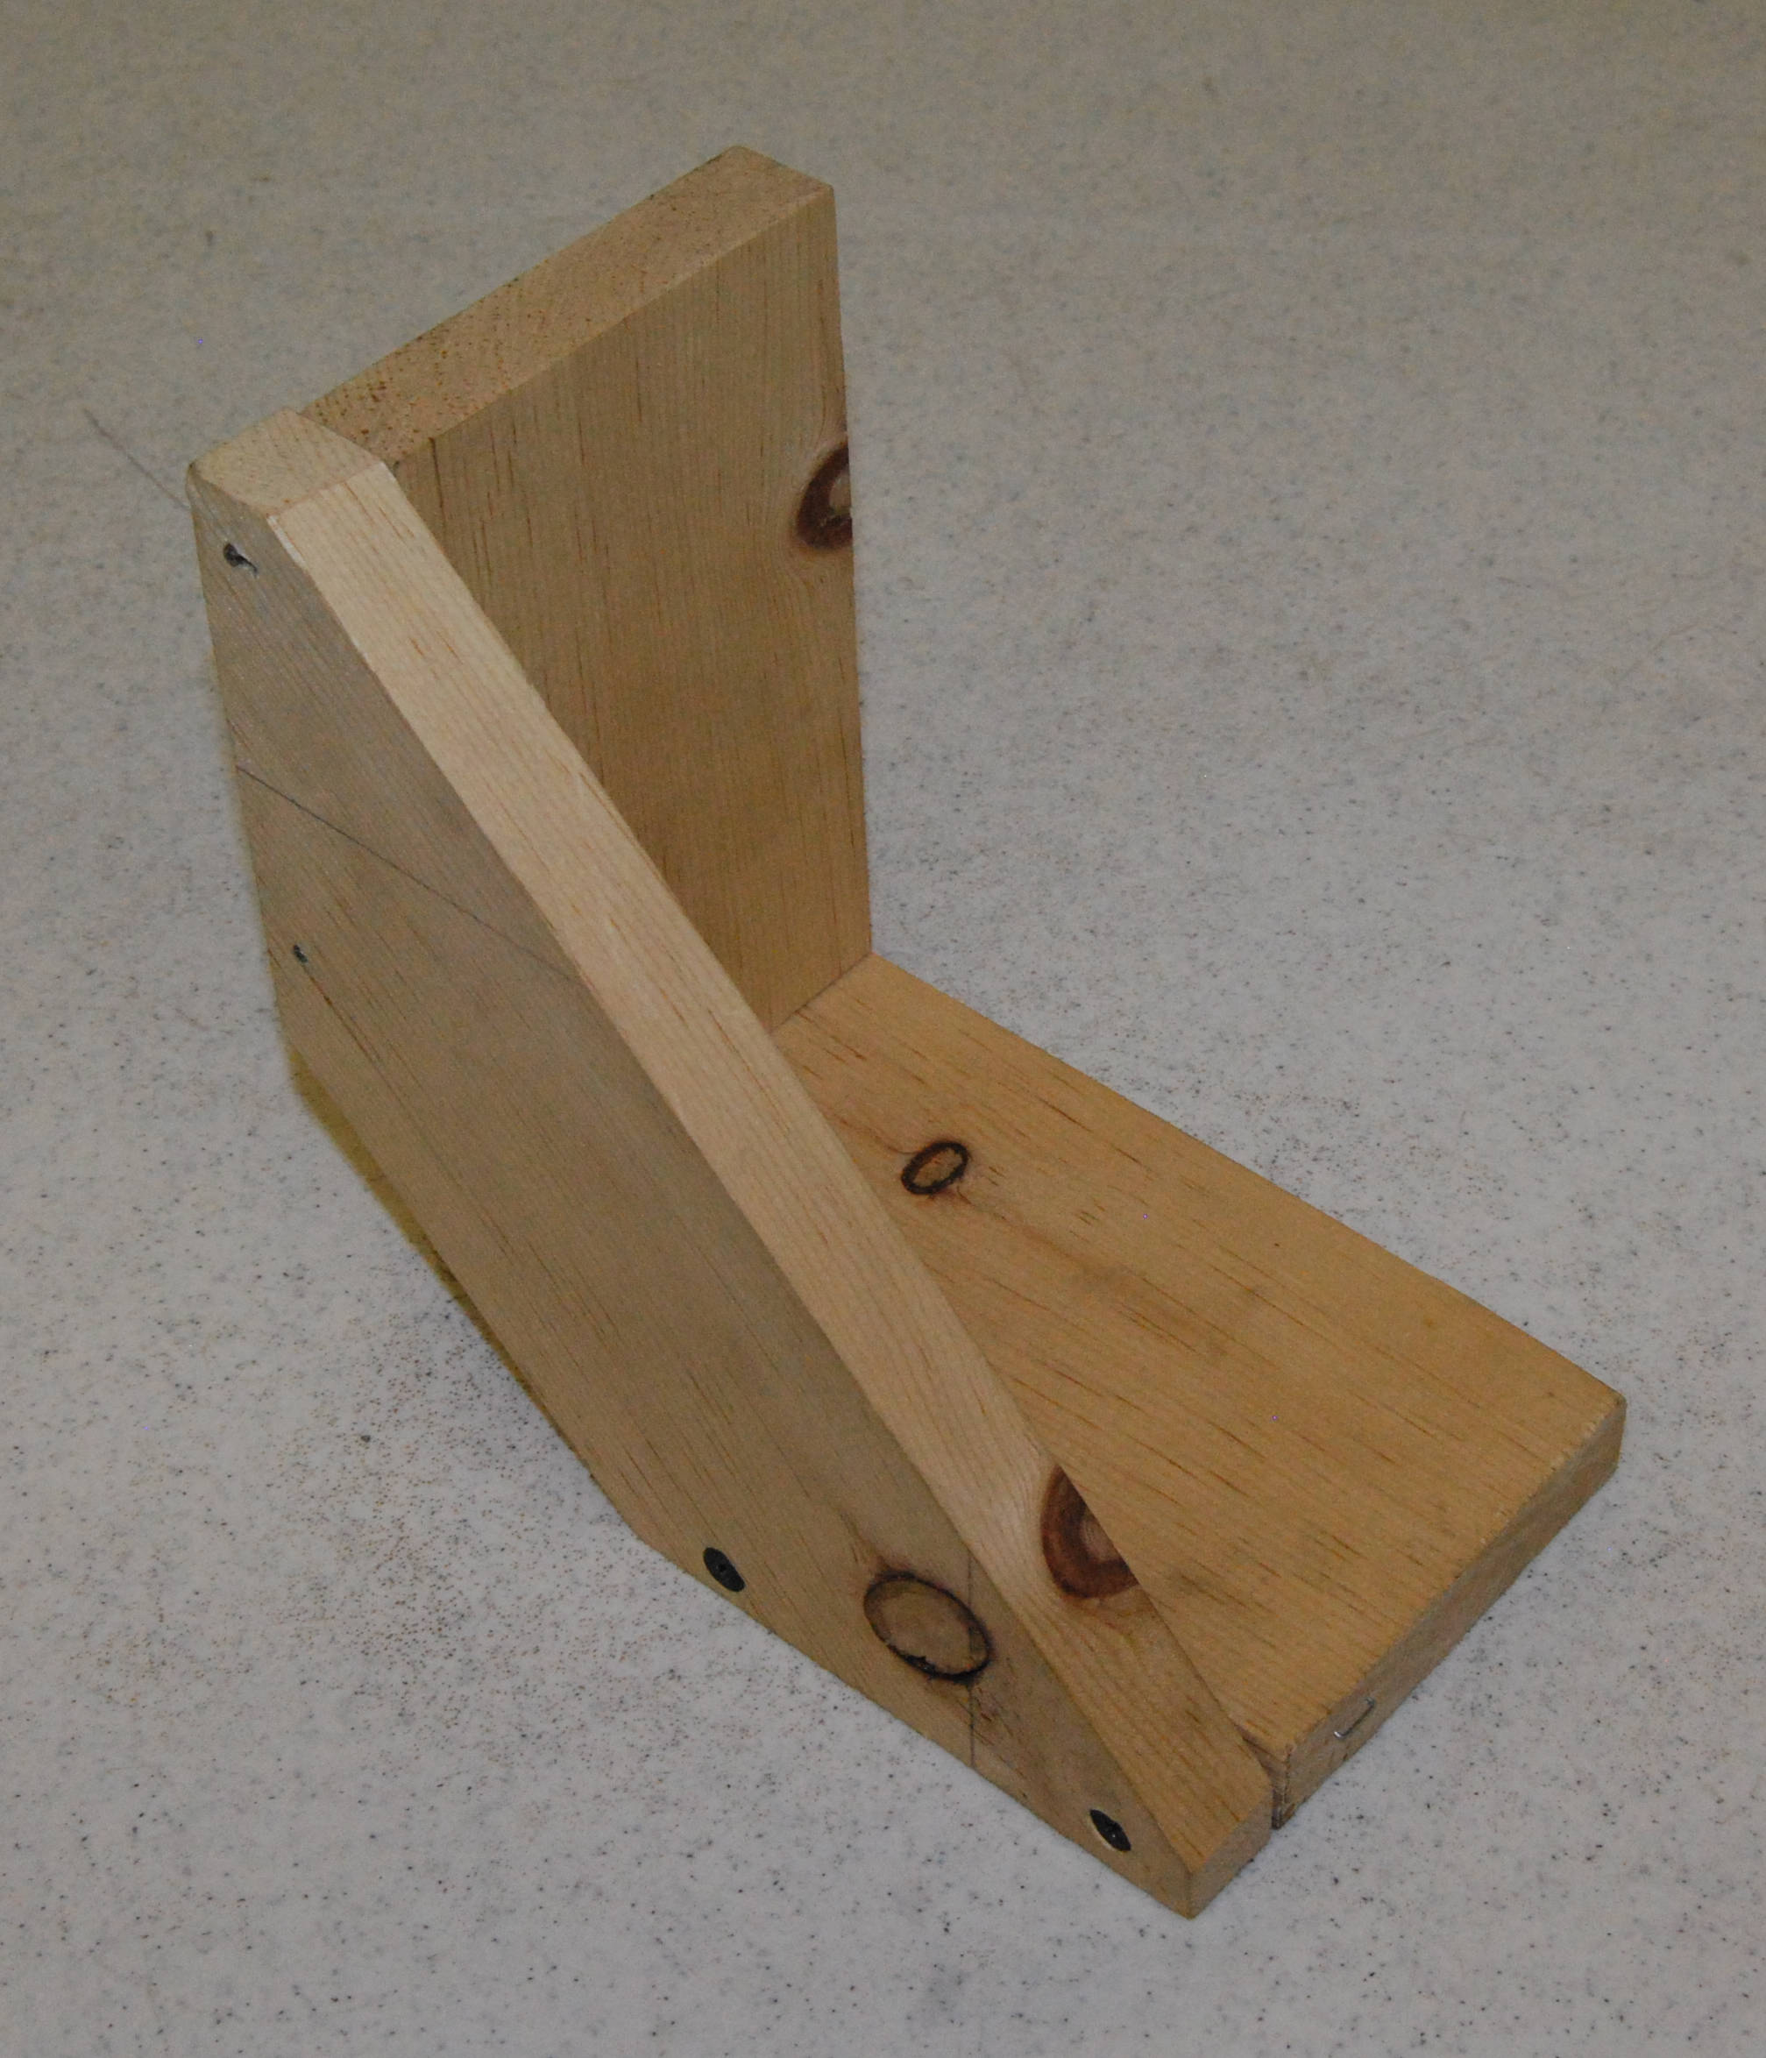

Pre-Building Worksheet
Name: ________________________
Date: ________________________

- Why is wood selection important for this project?

- What nails specifically are used for this project?

- Why is it important to use the spade bit to drill holes before actually putting the screws in?

- What are the three sizes of pine you will need?

- What kind of quality is the wood used for this project?

Grading Rubric:
CRITERIA | POSSIBLE | SCORE
Correct measurements | 5
Brace angles are correct | 5
Screws and nails are counter-sunk | 5
Parts are tightly fit | 5
Workmanship (cuts, sanding) | 5
TOTAL | 25

Teachers Notes:
This project could be built entirely using nails or woodscrews, instead of incorporating both. However, by using two different methods, the students get to demonstrate their knowledge with multiple skills instead of only using one. I believe it more beneficial for students to learn more than one way to complete the project.
This project is also an excellent project for agriculture mechanics programs that do not have a working shop. This project can be built using all hand tools if necessary. A hand saw may be used to cut out the three pieces of wood, and even to angle the back piece. This may alter the construction a little bit, as the edges could potentially not be as straightly cut, but I believe if it is cut a little more than recommended, the pieces can be sanded down, so they smoothly fit together. A hand miter box and

Agricultural Standards Met:
6.0 Health and Safety. Students understand health and safety policies, procedures, regulations, and practices, including the use of equipment and handling of hazardous materials:
6.1 Know policies, procedures, and regulations regarding health and safety in the workplace, including employers’ and employees’ responsibilities.
6.2 Understand critical elements of health and safety practices related to storing, cleaning, and maintaining tools, equipment, and supplies.
6.4 Maintain safe and healthful working conditions.
6.5 Use tools and machines safely and appropriately.
6.6 Know how to both prevent and respond to accidents in the agricultural industry.
B1.0 Students understand personal and group safety:
B1.1 Practice the rules for personal and group safety while working in an agricultural mechanics environment.
B1.2 Know the relationship between accepted shop management procedures and a safe working environment.

B2.0 Students understand the principles of basic woodworking:
B2.1 Know how to identify common wood products, lumber types, and sizes.
B2.3 Know how to identify, select, and implement basic fastening systems.
B2.4 Complete a woodworking project, including interpreting a plan, developing a bill of materials and cutting list, selecting materials, shaping, joining, and finishing

Objectives:
By properly completing this project, students will be able to:
- Read a plan and implement layout dimensions.
- Use a saw to cut wood.
- Fasten all components together using nails and screws.
- Select kinds, grades, and quantity of lumber for a given task.

Alternative Tools/Methods/Materials:
Can be built using all hand tools.

Safety Review:
- Safety Glasses
- Miter Saw Safety
- Proper use of tools (hammer, drill)

Project Time:
Demonstration: | 15-25 minutes
Build: | 1-2 hours

Demonstration Notes:
- Rip the 1 x 12 to 3 ½” strips on the table saw or use 1 x 4.
- Cut a 24” piece. Talk about where knots might fall and plan accordingly.
- Demonstrate how to cut the square pieces using the power miter saw. Pieces are short so caution to keep fingers clear of the blade.
- Using the combination square measure out 8 7/8” in the middle of the remaining piece of lumber.
- Using the 45º fence of the square layout the ¾” distance. Then layout the other 45º cut (at 90º to the ¾” line. This is a good place to engage the class in how it might be laid out before you actually do it.
- Set the miter saw to 45 degrees.
- Being very careful to cut on the outside of the line start with the ¾” line. Then cut the longer line. You will have to swing the saw or mark both sides of the lumber. Practice cutting a couple of times.
- Demonstrate a “dry” fit of the parts to insure everything fits OK. . Key point here is how the overlap works so the legs are of equal length.
- Assemble the legs of the bookend with nails and glue
- Layout the screw holes so they look even (3/8” in from the edge). Drill the countersink holes. Then assemble with the screws. It works well if you have two battery powered drills. Use one with the countersink and one with a screwdriver bit.

Bill of Materials: (complete this spreadsheet)
Project modified from Turlock High School. Plan by Kim Macintosh

