Battery Terminal Puller
Name: ______________
Date:_______________

Description:
Students will be able to construct a Battery Terminal Puller. Students will focus on using cold metal skills, layout skills, and forming the metal into a usable tool in the farm machinery shop.

Materials:
3/8” HR Steel Round (rod)
2” x 3/16” (.188) square tube

Tools:
Hossfeld Bender
Hack Saw
Metal File (Bastard and Mile)
Horizontal Band Saw
3/8” NF Tap, Tap Handle
3/8” NF Die, Die Stock
5/16” Twist Drill

Procedure:
- *Cut a 3/8” in diameter rod 4 ½ ” long.
- Use a Hossfeld bender to bend at 1 ½” on rod at a 90 degree angle into the handle.
- Place the handle in a vise and thread the rod using a 3/8” die.
- *Cut 2” square tubing at ¾” in length with a Band Saw.
- Drill 5/16” hole, centered on one side of the 2” square tubing.
- Use 3/8” tap on 5/16” hole
- Use a hacksaw to cut a ¾” gap in 2” square tubing (opposite 5/16” hole).
- Use a bastard file on the cut ends of the square tubing to file rough edges down.
- Place rod in 5/16” hole and screw together.
- Paint if desired.
* Project may be started here.

Cutting List:
Quantity | Size | Material
1 | 3/8” x 4 ½ ” | HR Steel Round
1 | 2” x ¾” | Square tubing

Notes:
__________________________________________________________________________________________________________________________________________________________________________________________________________________________________________________________________________________________________________________________________________________________________________________________________________________________________________________________________________________________________________________________________________________________________________________________________________________________________________________________________________________

Photo/Drawing:
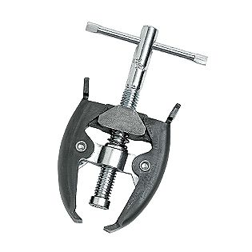
Commercially purchased Battery Terminal Puller
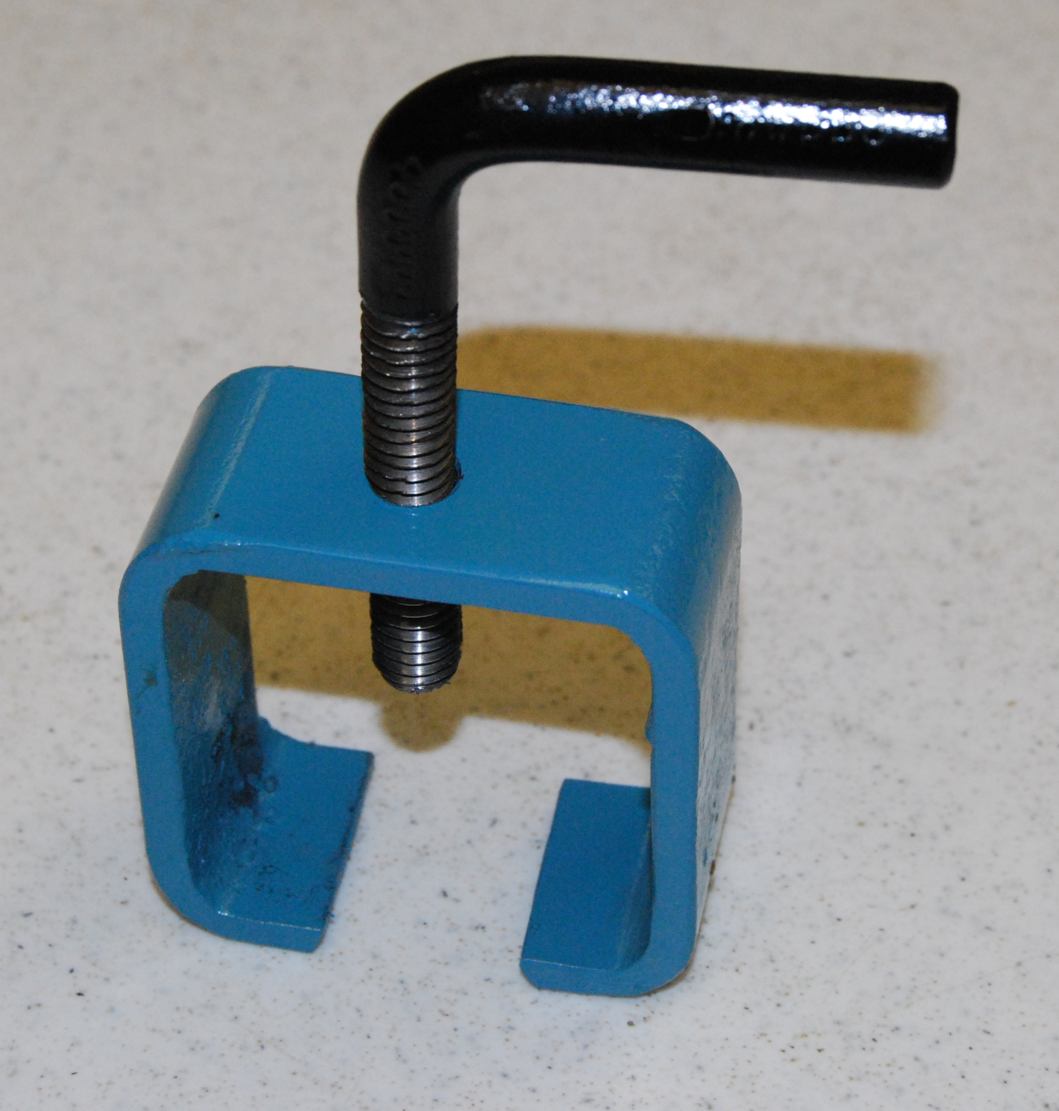
Hand-Made in Shop

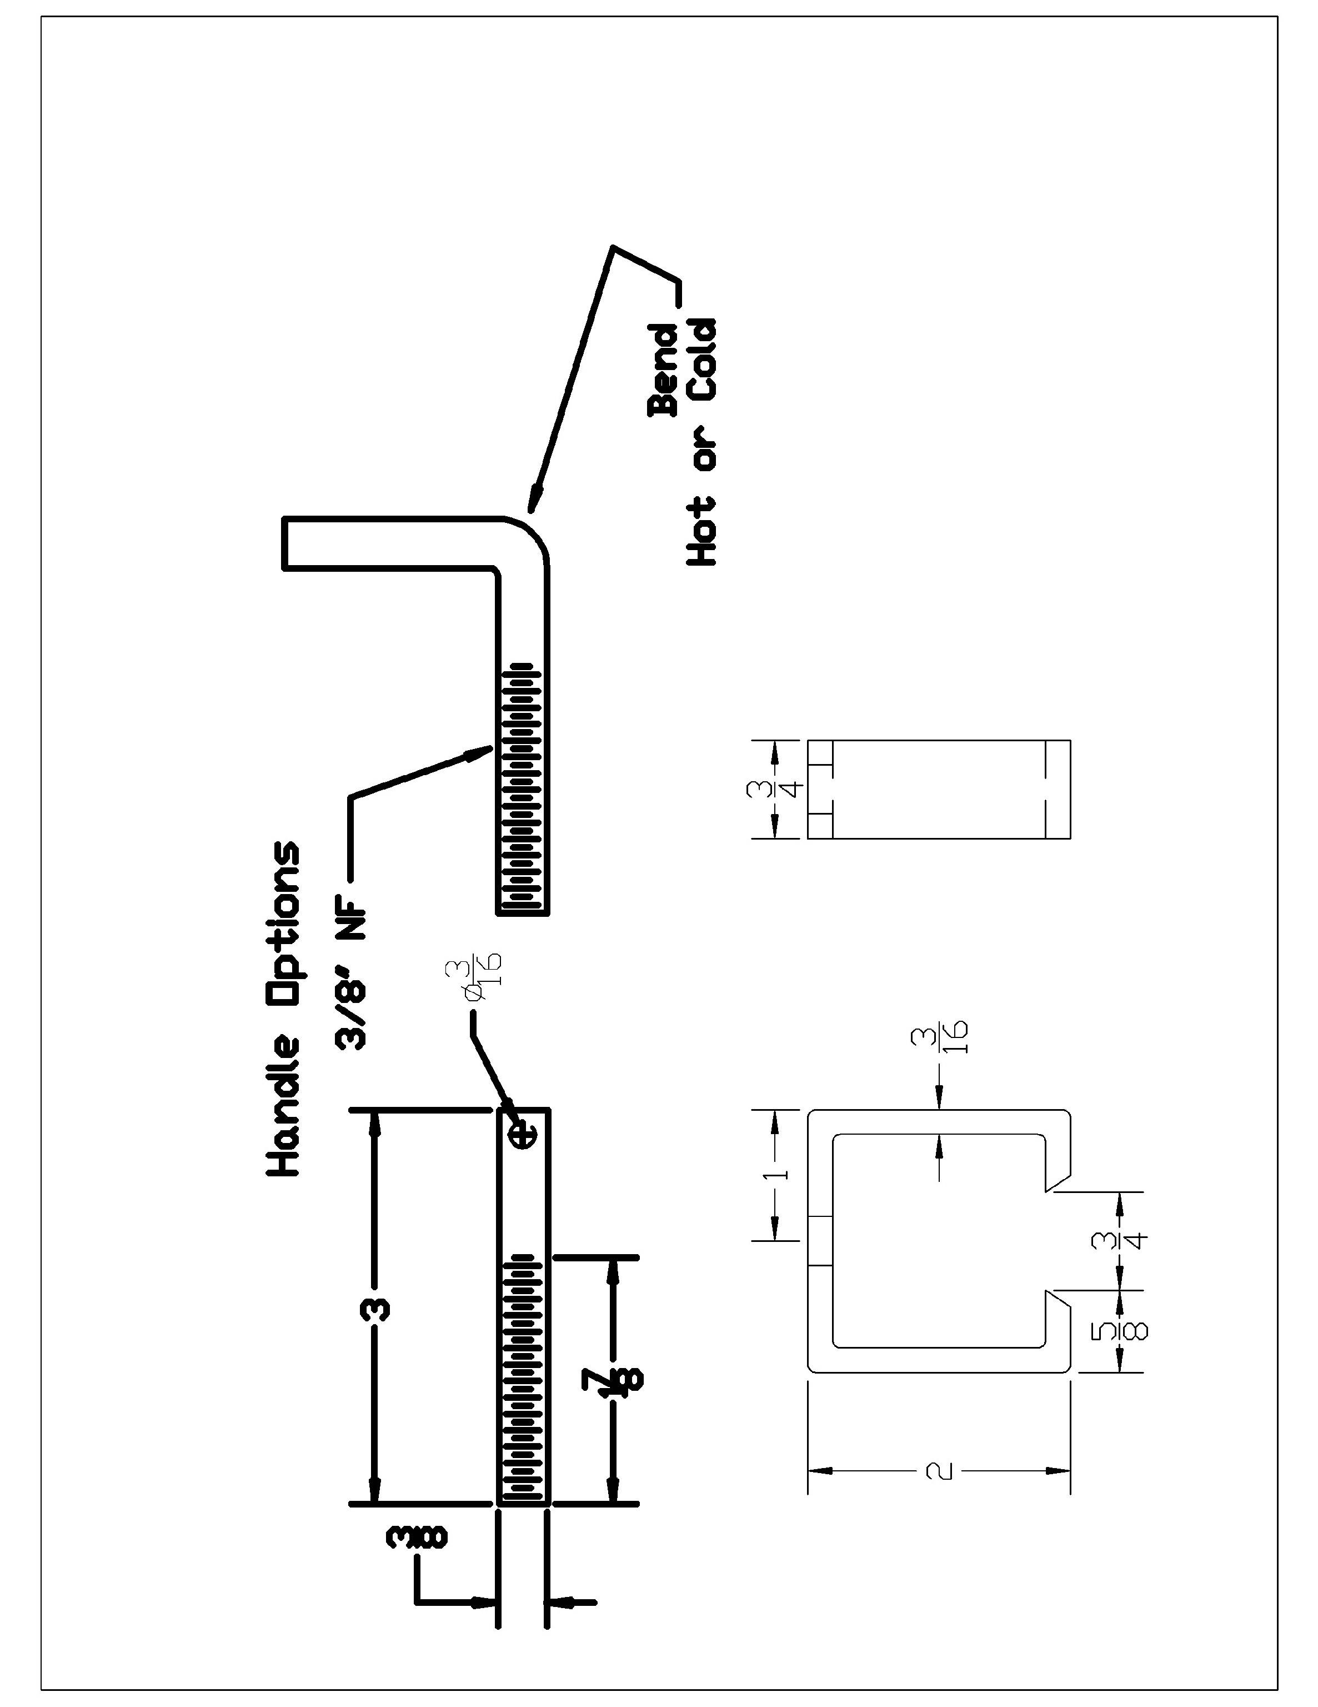

Battery Terminal Puller Student Worksheet:
Name:___________________________

Directions: Complete this worksheet prior to starting the project.
- What are the two metal materials needed?
___________________________ ___________________________
- What are the sizes of the two materials being used?
___________________________ ____________________________
- What equipment in the shop do we use to bend the HR round? ______________________
- How do you start cutting with the Hack Saw on the 2” square tubing?
___________________________________________________________________________
___________________________________________________________________________
- What thread size is used to thread the handle?
___________________________________________________________________________

Grading Rubric:
CRITERIA | POSSIBLE | SCORE
Correct measurement of 2 sq in tubing (width) | 5
Correct measurement of rod | 5
Location of hole and slot on tubing | 5
Hot metal bend, angle is square | 5
Quality of threads | 5
Overall quality and workmanship. | 5
TOTAL | 30

Battery Terminal Puller Teachers Notes:

Agricultural Standards Met:
6.0 Health and Safety. Students understand health and safety policies, procedures, regulations, and practices, including the use of equipment and handling of hazardous materials:
6.1 Know policies, procedures, and regulations regarding health and safety in the workplace, including employers’ and employees’ responsibilities.
6.2 Understand critical elements of health and safety practices related to storing, cleaning, and maintaining tools, equipment, and supplies.
6.4 Maintain safe and healthful working conditions.
6.5 Use tools and machines safely and appropriately.
6.6 Know how to both prevent and respond to accidents in the agricultural industry.
B1.0 Students understand personal and group safety:
B1.1 Practice the rules for personal and group safety while working in an agricultural mechanics environment.
B1.2 Know the relationship between accepted shop management procedures and a safe working environment.

B5.0 Students understand agricultural cold metal processes:
B5.1 Know how to identify common metals, sizes, and shapes.
B5.2 Know basic tool-fitting skills.
B5.3 Know layout skills.
B5.4 Know basic cold metal processes (e.g., shearing, cutting, drilling, threading, bending.).
B5.5 Complete a cold metal project, including interpreting a plan, developing a bill of materials, selecting materials, shaping, fastening, and finishing.

Objectives:
By properly completing this project, students will be able to:
- Demonstrate how to use Hack Saw, Drill Press, Tap and Die, Hossfeld bender properly and safely.
- Demonstrate layout skills and measuring skills.

Alternative Tools/Methods/Materials:
- Powered Hack Saw: Cut the 2” tubing and/or HR metal rod
- Angle grinder with metal cut off wheel: Cut the 2” tubing and/or HR metal rod
- Oxy fuel cutting torch: Bend the HR metal rod to the 90 degree measurement.

Safety Review:
There are a few different pieces of equipment used in this demo where safety needs to be discussed. The equipment used is:
Drill Press Safety:
- Make sure drill press is properly set and a C-clamp is holding the bases together.
- Wood is placed to catch bit if it goes through the metal
- Stand in front of the drill when operating to control safety for others in shop.
- Make sure drill bit is in the drill properly and tight, not too tight.
- Wear safety glasses at all times.
Hack Saw Safety:
- Keep finger and hands in sight and out of the way of saw
- Start slow and get a groove in metal started before you start full sawing strokes.
- Have a sharp blade on saw, always!
- Fully secure what you are sawing
- Wear safety glasses at all times.
Tapping Safety:
- Fully secure rod before tapping
- Keep lubed with oil to ensure metal pieces do not clog tap or cut your fingers
- Have a secure grip on tap when applying access pressure
- Don’t use bare hands when sweeping metal, could cause splinters of metal in fingers and hands
- Wear safety glasses at all times.

Project Time:
Demonstration: | 30-45 mins
Build: | 3 hours

Demonstration Notes
- It is important to make preparations for your students before they start this project. You DO NOT want to turn them loose with these plans and say “have at it.”
- Instructional tips before stepping in the shop:
  - Go over each piece of equipment with students; test if necessary.
  - Run over safety with each piece of equipment (Listed above, and more).
  - Students can start on the handle or tubing. This will help spread out students.
- A great activity for the students would be to have them create a Bill of Materials. This is an awesome way to have the students understand what it cost to do this project and to give them some ownership and not waste the material.
- Implement Time Cards with this project. This will hold students accountable for reporting to the foreman or you about how they spent their day in class; there is no way you can get to all students during one period to check up with all of them.

Procedure Tips:
- You can do this project in any order you prefer. When doing this project it is important to give students a couple tips for doing each of the steps, this makes it a lot easier for them to accomplish this task.
- 3/8” Rod
  - Take the 4” long rod and file the rim of both sides of the rod
  - This will help when you thread the rod because it helps the tap go onto the rod easier and start the threads even.
  - Next bend the rod.
  - This order is not required but will help to bend before you thread. If you thread before you bend then you are putting the vice tight on the threads, which could mess up your nice threads.
  - Place the rod vertical in the vice.
  - This will help you make an even thread and allow you to apply pressure evenly when threading the rod.
  - Keep the tap as horizontal when tapping. This will keep your threads even and smooth.
  - When tapping – for every turn of your tap, do a half turn counter-clockwise to remove access scrap metal and keep threads clean as you tap.
  - Thread the rod about half way down the rod.
  - Clean rod and keep oil on rod while threading.
- 2” square tubing:
  - Take a scribe and tape measure and mark a point in the middle of one side of the square tubing- at 1 inch. (Doesn’t matter what side).
  - Use precision when doing the markings, don’t use a fat sharpie marker ☺
  - Make a start point for the drill bit by taking a center punch and hammer to the point you’ve marked with the scribe.
  - When using the hacksaw, get a good groove on the metal before you start getting good stokes going.
  - You need conscious of the width of the groove you started and that you are staying on your measured markings.
  - Measure 5/8” from left side and then from right side for your gap in tubing.
  - Use a bastard file when filing the edges out.
  - Review the proper use of a file (One direction)
  - Review the uses of different files (Fine or rough file)
  - Place tubing in a vice to remain stationary.
- ALWAYS WEAR YOUR SAFETY GLASSES!!! ☺

Bill of Materials:
Note: A 20’ bar of tubing will make about 240 projects. If you don’t stock this materials you get shorter lengths at a steel supply or scrap yard.
Project from: Phil Pacia. Plan by: Meaghan Garrison

