AG MECH OXY-FUEL NAME_______________

LIGHTLING AND SHUTTING DATE_______________
OFF THE TORCH

Lighting the Torch
•Torch valves are located on the torch body.

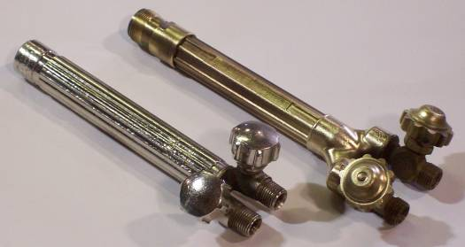

•Cylinder valves are located on the top of each cylinder.

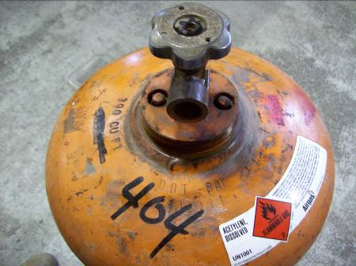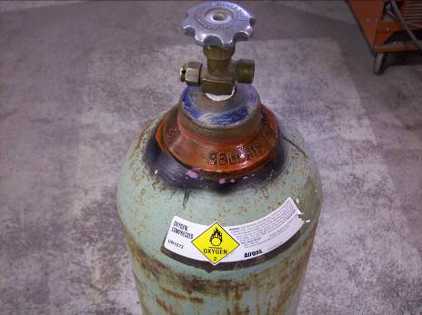

•Regulator adjusting screws are located on the front of each regulator.
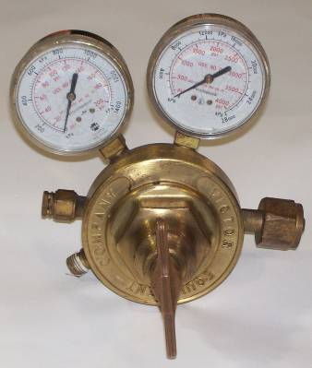
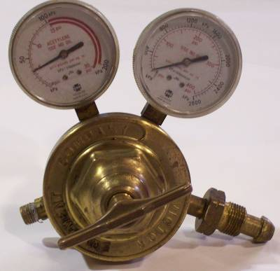

•Knowing the names and locations of these valves and adjusting mechanisms is necessary before attempting to light a torch.

Lighting the Torch
Step 1
•Check that the oxygen and acetylene torch valves are closed by turning them in a counterclockwise direction.

Step 2
•Check that the oxygen and acetylene regulator adjusting screws are turned counterclockwise and move freely.

•Do not turn the adjustment screws too far, or they will come off.

Step 3
•Warning do not stand directly in front of the regulator when opening the cylinder valve. The high pressure gas could burst the regulator and cause injury.
•Slowly open the acetylene cylinder valve, no more than one full turn, so you can quickly shut off the gas in an emergency.

Step 4
•Slowly open the oxygen cylinder valve as far as it will go (all the way), so oxygen cannot leak around the valve stem.

Step 5
•Set the correct working pressure on the acetylene regulator gauge.

•Do this by opening the acetylene torch valve and turning the acetylene regulator adjusting screw unit the desired pressure is reached.

•Close the acetylene torch valve.

Step 6
•Repeat Step 5 to set the oxygen working pressure.

Step 7
•
Open the acetylene torch valve ½ turn.

Step 8
•Using a standard friction (spark) lighter, light the acetylene gas.

•Always use a friction lighter to light the torch. Never use matches or butane lighters. Your hand could be severely injured when the gas fumes are ignited.

•Adjust the flame until it burns turbulently approximately ¾” from the torch tip. Then adjust the flame so no sooty smoke is released.

Step 9
•Slowly open the oxygen torch valve.

•Adjust the oxygen until a small pointed cone appears at the torch tip.

•This is a neutral flame.

•Minor adjustments in the torch valves and regulator pressures may be necessary to obtain a neutral flame.

Shutting Off the Torch
•Whenever the welding torch is not in your hand, it should be shut off.

•If you are leaving the welding area or are finished for the period or day, completely shut down the equipment by following these steps:

Step 1
•Close the acetylene torch valve on the torch body to extinguish the flame.

•Then, close the oxygen torch valve so gas is not being released from the torch tip.

Step 2
Close both the acetylene and oxygen cylinder valves.

Step 3
Open both torch valves on the torch body to release any gas still in the lines (bleed the lines).

Step 4
•Watch the acetylene and oxygen regulators until you see that the high and low pressure gauges on both regulators read zero.

Step 5
•Turn the adjusting screws on both regulators counterclockwise until they turn freely with no tension.

Step 6
•Once the gauges read zero, the adjusting screws are loose, and the torch valves are closed, roll up the hoses, and put the torch away.

