AG MECH OXY-FUEL NAME_______________

EQUIPMENT SAFETY DATE_______________

Identification

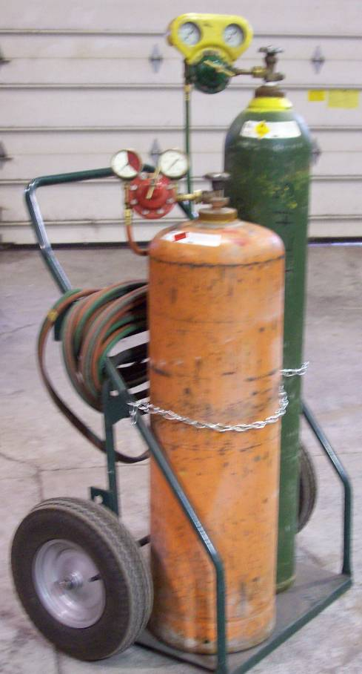
Oxygen Regulator Oxygen Cylinder Valve

Acetylene Regulator Oxygen Cylinder

Acetylene Cylinder Valve

Oxy-Acetylene Hoses Acetylene Cylinder

Oxy-Acetylene Cart Cylinder Safety Chain

Securing the Cylinder
•Always chain or secure cylinders to a cylinder cart, wall or stable work bench
•Always keep cylinders secured properly in a vertical (up-right) position.
•Do not drop, strike, or apply heat to any part of the cylinder or valve.

Cylinder Protective Cap
•Always keep the protective safety caps in place whenever cylinders are moved or are in storage (full or empty).

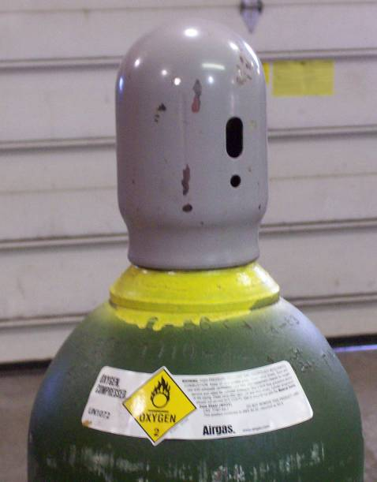
•The cylinder cap has two holes on its sides:

Larger Oval Shaped Hole- Designed to cause a cylinder with a broken-off valve to spin instead of taking-off like a missile.

Smaller Circular Hole- Designed to make a loud whistling noise if the cylinder valve is broken-off, alerting the operator and others in the shop of danger.

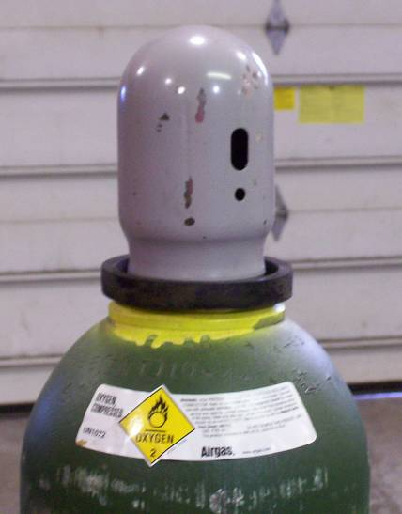
Empty Cylinders
•Mark empty cylinders “EMPTY” or Place a ring around the protective cap.

•Always close cylinder valves completely on empty cylinders.

Cracking the Cylinder Valve
•DO NOT stand directly in front of cylinder valve. Stand behind the cylinder valve while cracking and be aware of others in the shop, aiming in a safe direction.

•Momentarily open and close the cylinder valve “cracking” - this will blow out any dust, dirt, or debris within the cylinder valve and prevent it from entering the regulator and seats.

•Open the cylinder valve slightly. If the valve is opened too much the cylinder could tip over from the pressure.

•If Acetylene cylinders spray a mist when cracked, let sit for 30 minutes allowing acetone to settle.

Inspecting the Cylinder Valve and Regulator
•Make sure the connection seat and threads on the cylinder valve are not damaged.

•A damaged screw thread may ruin the regulator nut, while a poor connection seat will cause the gas to leak.

•Carefully inspect the cylinder valves and regulator threads for traces of grease and oil. *If oil or grease is found DO NOT USE! Report to instructor immediately.

Attaching the Regulator
•Connect the oxygen regulator to the oxygen cylinder and the acetylene regulator to the acetylene cylinder.

•All Oxygen connections have right handed threads.

•Oxygen cylinder valves have male fittings and the oxygen regulator have female fittings.

•All Acetylene connections have left handed threads.

•Acetylene cylinder valves have female fittings and the Acetylene regulator have male fittings.

•Tighten regulators with a close-fitted wrench (open-end wrench). Do not use jawed tools such as pliers, vice grips or channel locks to tighten regulator nuts.

•Do not over tighten regulators to cylinders. Fittings are made of Brass a soft metal and stripping will likely occur.

•Make sure the regulator has the correct pressure rating for the cylinder being used.

Turning on the Cylinder Valve
•Never stand in front or behind a regulator when opening the cylinder valve. Always stand to the side of the cylinder leaving the cylinder between you and the regulator.

•Be certain that the tension on the regulator adjusting screw is released. Unscrew adjusting screw counter clockwise until tension is removed.

•Standing to the side of the cylinder, slowly open the oxygen cylinder valve until the maximum pressure registers on the high pressure gauge. Then open the oxygen cylinder valve all-the-way to seal the valve packing.

•In the same manner, slowly open the acetylene cylinder valve. But only open the Acetylene valve ¾ - 1 full turn. Allowing the operator to quickly turn off the fuel in case of emergency.

Adjusting the Oxygen Regulator
Never Exceed 40 PSI on the working gauge

Working Gauge Cylinder Gauge

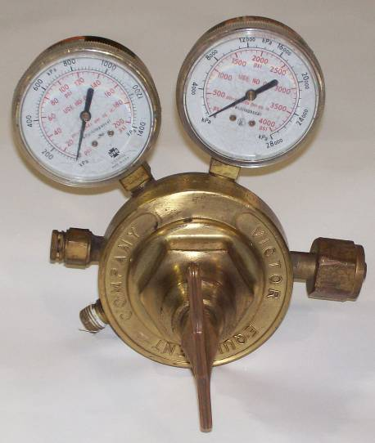
Oxygen Regulator- Female Fitting

Right handed Threads

No Markings on Nut

Oxygen Regulator Adjustment Screw
Slowly Crack the Acetylene Cylinder Valve
Open cylinder valve 3/4 - 1 full turn (quick shut-off)

Adjusting the Acetylene Regulator
Never Exceed 15 PSI on the Working Gauge

Working Gauge Cylinder Gauge

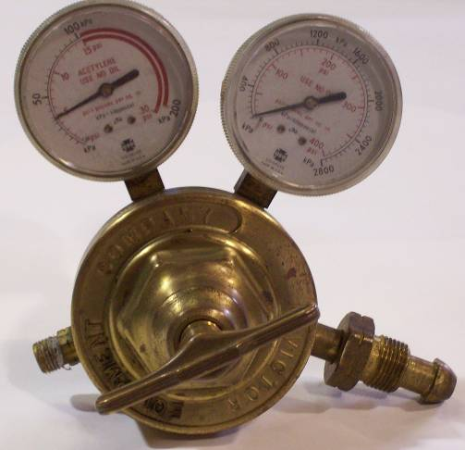
Acetylene Regulator Male Fitting

Acetylene Regulator Left handed threads

Notches on nut indicate left handed threads

Acetylene Regulator Adjustment screw

Oxy-Fuel Hoses
•Oxygen Hoses- Are GREEN in color, have right-handed threads with no markings on the connecting nuts.

•Acetylene Hoses- Are RED in color, have left handed threads, with notched markings on the connecting nuts.

•New hoses should have the preservative talcum powder blown out before the welding or cutting torch is used.

•Hoses are flame retardant, but should still be kept away from open flame, fallen slag, molten metal and sparks.
Check Valves
•Are installed to prevent the reverse flow of gases that would result in a combustible mixture in the welding hose, check valves are mounted to the welding torch handle and at the regulator outlet connection.

•Check valves are necessary safety devices attached between the hoses and the regulator outlets.

Torch Handle
•The torch handle is probably the most frequently used item in a welding shop.

•Cutting attachments, welding tips and heating nozzles are all connected to the torch handle.

•Always inspect the torch handle head, valves and hose connections for oil, grease or damaged parts.

•Oxygen connection is usually marked “OXY”

•Acetylene connection is usually marked “FUEL”

Torch Handle Identification
Torch Head
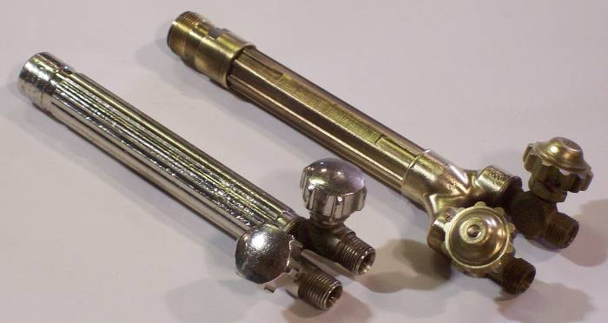
Barrel
Torch Body

Oxygen Control Valve

Acetylene Control Valve

Welding Nozzle
•Inspect the cone end, coupling nut, o-rings and welding nozzle for damage, oil or grease.

•Connect the welding nozzle to the torch handle. Tighten the coupling nut hand-tight only. Wrench tightening may damage o-rings and create a faulty seal allowing leaks.

•Note- There must always be two o-rings on the cone end of the nozzle. The absence or damage of either of these o-rings allows premixing and leaks of oxygen and acetylene.

Heating Nozzle
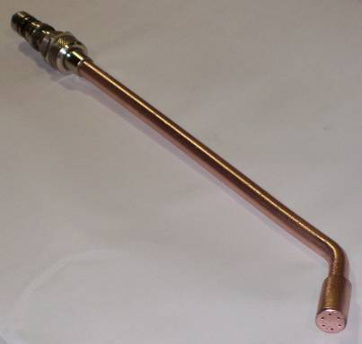

Cutting Head Attachment

Mixing Chamber Cutting Oxygen (top) Coupling Nut

VICTOR
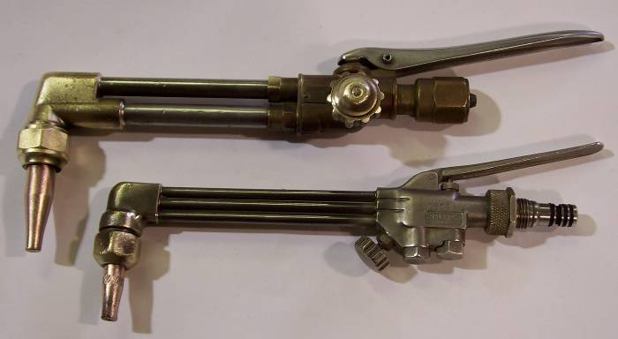

High Pressure Cutting Oxygen Lever

SMITH

Pre-Heat Oxygen __Pre-Heat Oxygen Control Valve
(middle)
Pre-Heat Acetylene__
(bottom)

Cutting Tip

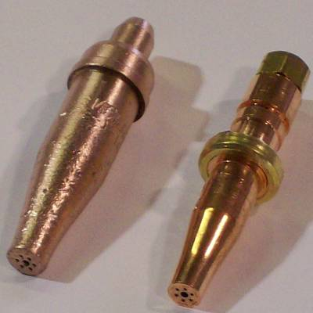
Pre-Heat Orifices
The mixture of Oxygen and Acetylene Gases (6 surrounding holes)

Oxygen Cutting Jet Orifice
Pure Oxygen (center hole)

Oxygen Regulator
Oxygen Regulator Cylinder Pressure Gauge
Located on the right side – closest to cylinder valve

Oxygen Regulator Working Gauge
Located on the left side- above green hose connection
*NEVER EXCEED 40 PSI

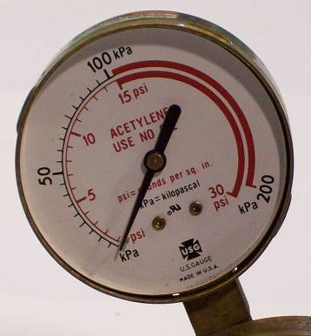
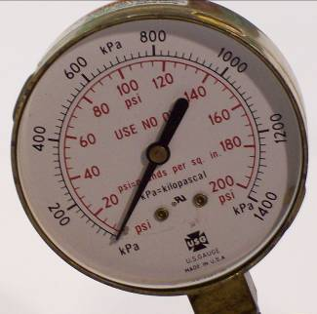

Acetylene Regulator
Acetylene Regulator Cylinder Pressure Gauge
Located on the right side- closest to cylinder valve

Acetylene Regulator Working Gauge
Located on the left side- above red hose connection
*NEVER EXCEED 15 PSI

Protective Wear

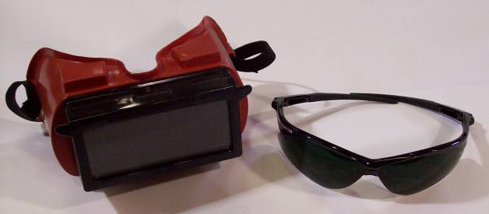
Shade #5 Goggles or
Glasses

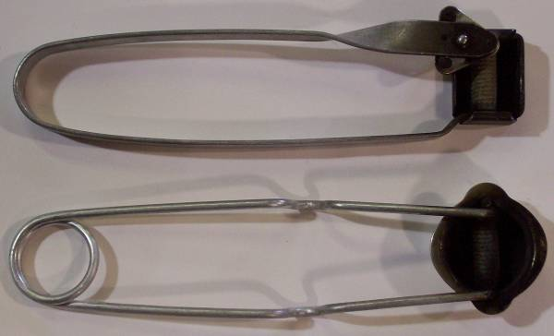

Friction Lighter
(striker)

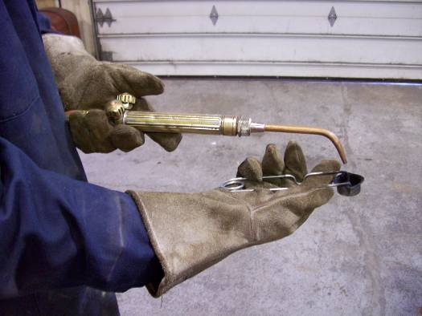

Leather Gloves
and Coveralls

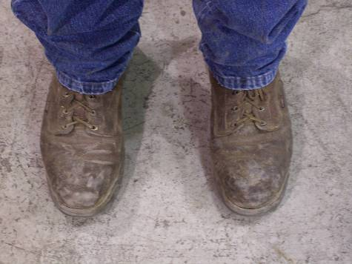
Leather Boots

