AG MECH NAME_______________

RUNNING A BEAD WITH AND DATE_______________
WITHOUT FILLER ROD

The Welding Flame
•A chief advantage of the oxy-acetylene flame is its high operating temperatures.

•This oxy-acetylene flame can easily melt all common metals.

•The proper mixture of oxygen and acetylene burns at 5,589 degrees Fahrenheit, which makes it the hottest oxy-fuel gas flame.

Types of Flames
•Three types of flames can be produced with the oxy-acetylene torch: carburizing, neutral, and oxidizing.

•The operator must be able to recognize each type of flame by its size, shape, and color.

•The operator must also master the adjustment of the oxygen and acetylene hand valves on the welding torch to produce the desired flame.

Carburizing Flame
•Flame contains more acetylene than oxygen.

•This flame is easy to recognize by the outer flame, which has a slim bluish taper with an orange tip.

•Inside this outer flame is a shorter, blue flame called the acetylene feather.

•Flame has a lower temperature than the neutral flame.

•Flames are sometimes used for silver brazing, braze welding, and soldering.

Neutral Flame
•The neutral flame is produced by a proper balance of oxygen and acetylene.

•It is approximately 5,589 degrees Fahrenheit and is the most widely used of the three types of flames.

•As the flame is adjusted from a carburizing flame to neutral flame by adding more oxygen, the light blue acetylene feather disappears.

•At the same time, the brilliant inner cone becomes slightly shorter and more sharply defined.

•When a neutral flame is directed upon a steel surface, the metal melts slowly.

•The molten metal does not boil and few sparks appear.

•The neutral flame protects the molten steel from oxidation, and the weld joint is not burned.

•Extremely strong welds are produced from this flame.

Oxidizing Flame
•Flame contains more oxygen than acetylene.

•Is similar to the shape of the neutral flame, however the inner cone of the oxidizing flame is more pointed, shorter, and purple.

•The flame can also be distinguished from the neutral flame by a loud hissing sound caused by the excess rush of oxygen.

•This flame has very little practical use in welding.

•Its temperature may reach 6,300 degrees Fahrenheit, but the oxides that form when the excess oxygen combines with the molten metal cause problems with the weld.

•Such problems include brittleness, weakness, and hardening around the weld.

Characteristics of the Three Flames
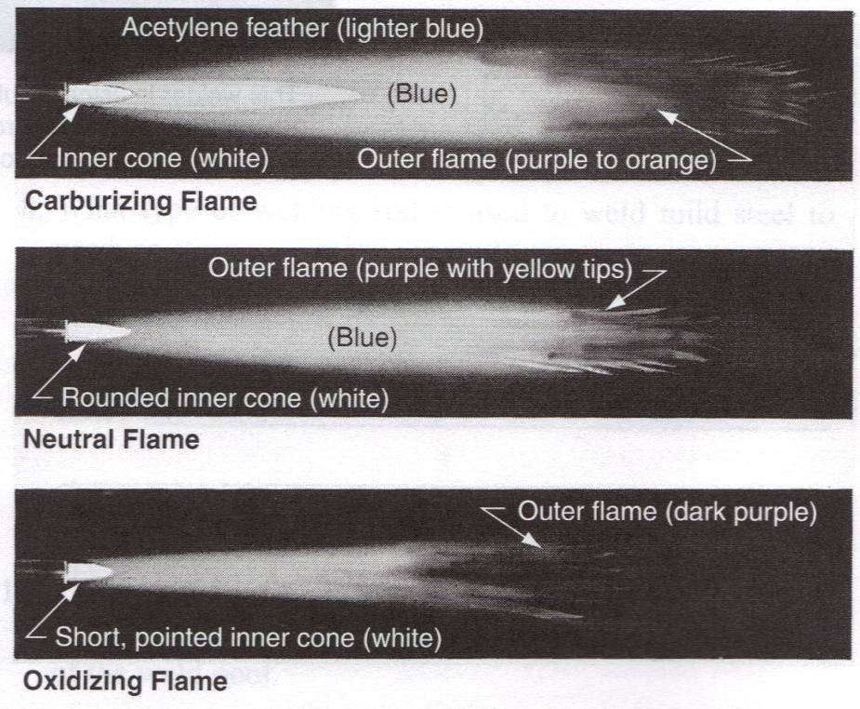

Holding the Torch
•A torch may be held in either one of two ways, depending on which is the more comfortable for you.

•When welding light-gauge metal (under 14 gauge), most operators prefer to grasp the handle of the torch with the hose over the outside of the wrist, in the same manner a pencil ordinarily is held.

•In the other grip, the torch is held like a hammer, with the fingers lightly curled underneath.

•In either case the torch should balance easily in the hand to avoid fatigue.

Pencil Grip Hammer Grip
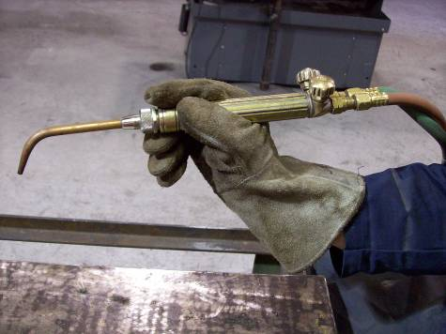
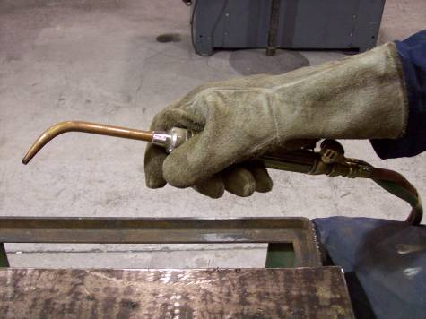

Pushing a Puddle
•Hold the torch so the flame points in the direction you are going to weld and at an angle of about 45 degrees with the completed part of the weld.

•If you are right handed, start the weld at the right edge of the metal and bring the inner cone of the neutral flame to within 1/8” of the surface of the plate.

•The left-handed person reverses this direction.

•Hold the torch still until a pool of molten metal forms.

•Then move (push) the puddle across the plate.

•As the puddle travels forward, rotate the torch to form a series of overlapping ovals or circles (forming a bead)

•Do not move the torch ahead of the puddle, but slowly work forward, giving the heat a chance to melt the metal.

•If the flame is moved forward too rapidly, the heat fails to penetrate far enough and the metal does not melt properly.

•If the torch is kept in one spot too long, the flame will burn a hole through the metal.

Laying a Bead with Filler Rod

•On some types of joints (outside corner welds) it is possible to weld the two pieces of metal without adding metal from a filler rod.

•
The use of a filler rod requires coordination of the two hands.

•One hand must manipulate the torch to carry a puddle across the plate, while the other hand must add the correct amount of filler rod.

•In most instances the use of a filler rod is advisable because it builds up the weld, thereby adding strength to the joint.

•The strength of a weld depends largely on the skill with which the rod is blended, or interfused, with the edges of the base metal.

Selecting the Filler Rod

•Filler rods come in a variety of sizes ranging from 1/16” to 3/8” in diameter.

•The size of rod to use will depend largely upon the thickness of the metal being welded.

•The general rule is to use a rod with a diameter equal to the thickness of the base metal.

•In other words, if a 1/16” metal is being welded, a 1/16” diameter rod should be used.

Laying a Bead with Filler Rod Continued
•The torch is held at an angle of approximately 45 degrees to the base metal, hold the rod at approximately the same
angle as the torch but slant it away from the torch.

•Move the torch tip over the starting edge and rotate the flame near the metal in a circular or semicircular motion until the base metal melts into a small puddle.

•Once a small pool of the base metal is established, dip the tip of the rod in the molten pool.

•ALWAYS DIP THE ROD IN THE CENTER OF THE MOLTEN POOL.

•The molten puddle will melt the rod and add to the puddle, as the rod melts in the pool, advance the torch forward.

•Concentrate the flame on the base metal and not on the rod.

•Do not hold the rod above the pool. If you do this the molten metal will fall through the air to the puddle.

•When this happens it combines with the oxygen in the air and part of it burns up, causing a weak, porous weld.

Common Difficulties
•The beginner often experiences difficulty in holding the welding rod steady which can cause the rod to stick to the base metal

•Instead of inserting the rod in the middle of the puddle where the heat is sufficient to melt it readily, a beginner generally inserts the rod near the edge of the pool where the temperature is lower. The heat at the edge is not enough to melt the rod and the rod will likely stick to the base metal.

•If the rod sticks to the base metal, do not try to jerk it loose.

•Simply place the flame directly over the tip of the rod and the rod will be freed immediately.

Laying a Bead with Filler Rod Continued
•The circular or semicircular motion should be advanced approximately 1/16” per motion until the end of the joint is reached.

•Since the angle of the tip flame is preheating the metals ahead of the weld, the last ½” of weld is critical.
•Slightly raise the welding tip and increase the addition of filler rod to insure a full smooth weld.

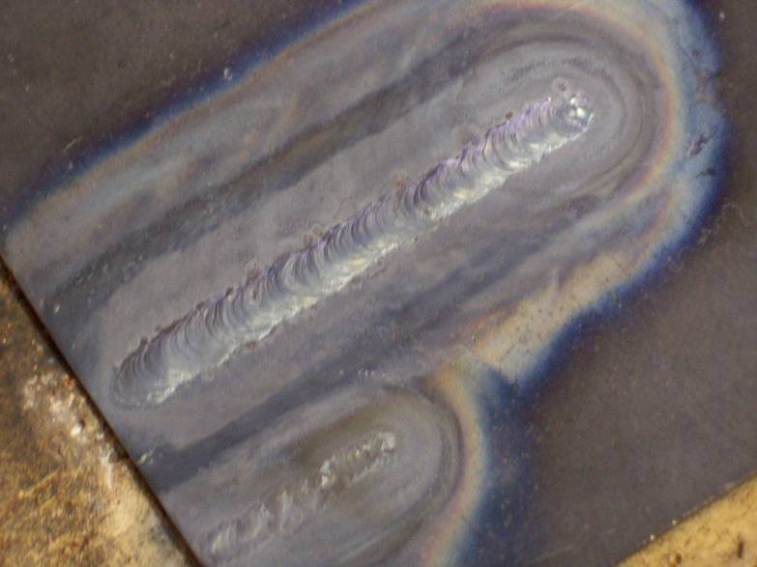
Bead with Filler Rod

Bead without Filler Rod

