AG MECH NAME_______________

OXY FUEL TORCH CUTTING DATE_______________

Cutting Equipment vs. Welding Equipment
•Oxy-Fuel gas cutting equipment is used throughout the metal-working world for cutting steel and ferrous (iron-based) metals.

•The equipment is basically the same for both oxy-fuel gas cutting and oxy-fuel gas welding, except for the torch.

•The cutting torch is a unique and invaluable tool that enables the operator to cut almost any thickness of steel to the required size and shape.

Oxy Fuel Cutting
•Oxy-fuel gas cutting is also referred to as flame cutting.

•Flame cutting is a process of cutting steel by removing material to form a slot, called the kerf.

•The metal is actually removed from the kerf by burning it away.

•Flame cutting is one of the fastest and most efficient methods for cutting thick metal.

Elements for Burning- Fuel
•To understand how metal can be cut quickly with a flame, you must first understand how burning takes place.

•Three essential elements are needed for burning: Fuel, Oxygen, and Heat.

•Fuel can be any material that will chemically combine with oxygen.

•In this case, the steel to be cut is the fuel.

Elements for Burning- Oxygen
•Second, a large quantity of pure oxygen is needed to combine with the fuel.

•The more oxygen present, and the greater the oxygen’s force, the faster burning will take place.

•Therefore, flame cutting requires a jet stream of pure oxygen directed onto the steel.

Elements for Burning- Heat
•Third, heat is needed to raise the temperature of the steel until it reaches its ignition temperature.

•Ignition temperature is the temperature at which the material will burn when oxygen is present.

•The ignition or kindling temperature of steel is 1500 degrees Fahrenheit.

•At this temperature, steel turns cherry red.

•The stream of oxygen is directed onto the hot metal.

•The steel burns rapidly, and a slot is cut through the entire piece.

•The oxygen and hot steel are actually combining to form a chemical reaction called oxidation.

Flame Cutting- How it Works
•The Oxy-Fuel cutting process is accomplished by bringing the base metal to a molten state, then introducing a high-pressure stream of cutting oxygen.

•This will ignite and burn the metal as well as carry away the slag or oxidized residue.

•Oxy-fuel cutting can be applied to plain carbon steels, low-alloy steels and other ferrous metals.

•Nonferrous metals, stainless steels and cast iron are not usually cut using oxy-fuel equipment.

Importance of Torch Cutting

•More people use the oxy-fuel cutting torch than any other welding process.

•The cutting torch is used by workers in virtually all areas including manufacturing, maintenance, automotive repair, railroad, farming, and more.

•It is unfortunately one of the most commonly misused processes.

•Most workers know how to light the torch and make a cut, but their cuts are very poor quality and often unsafe.
•A good oxy-fuel cut should not only be straight and square, but it should require little or no post-cut cleanup.

•Excessive post-cutting cleanup results in extra cost, which is an expense that cannot be justified.

Getting Started- Inspect the Equipment
The Torch
Inspect the cone end, coupling nut, and torch head for dirt, dust, oil, grease, or damaged parts. Dirt and dust can be removed with a clean cloth.

•CAUTION: If oil, grease or damaged parts are detected, DO NOT USE! Report it to the instructor immediately!

The "O" Rings
Inspect the cutting attachment cone end for missing or damaged “O” rings. Damaged or missing “O” rings can allow gases to mix and will cause backfires or backflash.

The Cutting Tips
Inspect the torch head. The tapered seating surfaces must be in good condition.

•If dents, burns or burned seats are present, the seat must be resurfaced.

•If the torch is used with a bad seat, backfire or backflash may occur.

Setting Up the Cutting Head
Connect the cutting attachment to the welding torch handle and tighten the coupling nut, using hand pressure only.

•Wrench tightening may damage “O” rings and create a faulty seal.

Tip Selection
Select the required size and type of cutting tip.

Attaching the Cutting Tip
Insert the tip in the cutting attachment head and tighten securely with an open-end wrench.
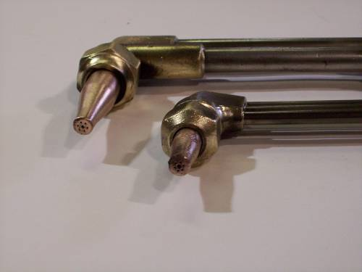

Wrench Tight Connecting Nut

Cutting Tip Chart
Refer to a cutting tip selection chart for correct cutting tip, regulator pressures, and travel speed.

Lighting The Torch
Open the oxygen valve on the welding torch all the way.

Adjust the oxygen regulator to the desired delivery pressure.
•DO NOT EXCEED 40 P.S.I.

10.Adjust the fuel (Acetylene) regulator delivery pressure.
•DO NOT EXCEED 15 P.S.I.

Open the fuel valve on the torch handle approximately one-half turn and ignite the gas with a friction lighter (striker).

•NOTE- Wear protective goggles or glasses (Shade #5) to shield the eyes from the bright light of the flame and leather gloves from potential burns when lighting the torch.

Continue to increase the fuel supply at the torch handle until the flame clears the end of the tip about 1/8”, then reduce the supply slightly to return the flame to the tip.

Slowly open the preheat oxygen control valve on the cutting attachment until the preheat flames establish a sharp inner cone (neutral flame).

Depress the cutting oxygen lever.

•Note- if the preheat flame changes slightly to a carburizing flame, continue to depress the cutting oxygen lever and increase the preheat oxygen at the cutting attachment until the preheat flames are neutral again.

Torch Cutting Precautions
•IMPORTANT: Check where molten metal and sparks will fall.

•Have fire extinguishers available, remove flammable substances, and check where the oxy-fuel hoses are located before starting to work.

•Protective leather boots and gloves should be worn while torch cutting.

Straight Line Cutting
Hold the cutting attachment or torch comfortably in both hands so one hand stabilizes the cutting tip preheat flames approximately 1/8” from the base metal and the other hand is free to depress the cutting oxygen lever.

Direct the preheat flame on the spot where the cut is to be started.

•Before cutting action can start, the base metal must be preheated to a bright cherry red.
•When the red spot appears, depress the cutting oxygen lever slowly.

When the cut has started, move the torch in the direction you wish to cut.

•Note: moving too slowly will allow the cut or kerf to fuse together, and moving too fast will not allow the metal to be preheated and the cut will be lost.

Continue to depress the cutting oxygen lever past the final edge of the base metal for a good “drop cut.”

Recommended Procedure for Flame Cutting of Thick Metal

1.Start to preheat; point tip at angle on edge of plate.  2.Rotate flame back to upright position – keep the dark inner blue flame 1/8” from metal.  3.Press oxy valve slowly; as cut starts, rotate tip backward slightly.  4.Now rotate to upright position without moving tip forward.  5.Rotate tip more - so tip points slightly in direction of cut.  6.Advance as fast as good cutting action will permit.  7.Do not jerk; maintain slight leading angle toward cut direction  8.Slow down; let cutting stream sever corner edge at bottom.  9.Continue steady forward motion until tip has cleared end. | 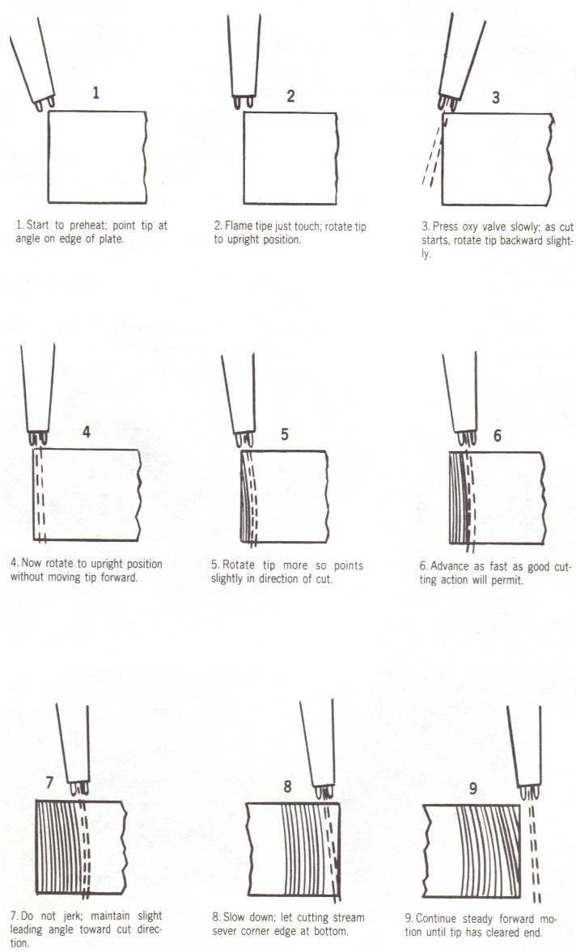

Torch Cutting- Piercing a Hole
To pierce metal, again hold the cutting attachment or torch comfortably in both hands with one hand stabilizing the cutting tip preheat flames approximately 1/8” from the base metal while the other hand is free to depress the cutting oxygen lever.

To prevent the sparks and slag from blowing towards you, tilt the torch tip slightly to one side when the oxygen is depressed.

When the metal is pierced, move the torch steadily in the direction you wish to cut.

•Note- If the metal is not pieced all the way through it probably means that not enough cutting oxygen pressure has been used.

•NOTE- If the cut piece does not fall off at the end of a cut, DO NOT TRY TO RECUT THE KERF

•Simply tap the cut piece of metal with a Chipping Hammer and the piece will generally detach.

Shutting Down the Cutting Outfit
•After the cutting operation is finished, or whenever the cutting torch operator must leave the work area, the oxy-acetylene cutting outfit must be shut down.

Follow these procedures for shutting down the equipment:

Step 1

1.Turn off the acetylene torch valve.

2.Turn off the oxygen torch valve.

3.Turn off the Acetylene cylinder valve.

4.Turn off the Oxygen cylinder valve.

5.Reopen the acetylene torch valve and depress the oxygen cutting lever to release or bleed any gas still remaining in the hoses.

6.When the regulators read zero - shut off the acetylene torch valve.

7.Turn the oxygen and acetylene regulator adjusting screws counterclockwise until no tension remains (loose).

8.Rewrap the Oxy-acetylene hoses on the outfit for proper clean-up and shop organization.

