AG MECH NAME_______________

OXY FUEL TORCH CUTTING DATE_______________

Cutting Equipment vs. Welding Equipment
•Oxy-Fuel gas cutting equipment is used throughout the metal-working world for _____________ and _______________________________________________.

•The equipment is basically the same for both oxy-fuel gas cutting and oxy-fuel gas welding, except ______________.

•The cutting torch is a ________ and _________ tool that enables the operator to cut almost ____________ of steel to the required _______ and ___________.

Oxy Fuel Cutting
•Oxy-fuel gas cutting is also referred to as ______________.

•Flame cutting is a process of ___________ by ___________to form a slot, called the ___________.

•The metal is actually ___________ from the kerf by ___________________.

•Flame cutting is one of the _________ and most ________ methods for _____________________________________.

Elements for Burning- Fuel
•To understand how metal can be cut quickly with a flame, you must first understand how _____________takes place.

•_________ essential elements are needed for burning: __________, _________, and _____________.

•Fuel can be any ___________that will chemically combine with _________________.

•In this case, the _________ to be cut is the fuel.

Elements for Burning- Oxygen
•Second, a large quantity of _______________ is needed to combine with the fuel.

•The _________oxygen present, and the greater the oxygen’s force, the _________________ will take place.

•Therefore, _____________ requires a ____________ of pure oxygen directed onto the steel.

Elements for Burning- Heat
•Third, ________is needed to raise the _______________ _________ until it reaches its ___________- temperature.

•__________________ is the temperature at which the material will burn when oxygen is present.

•The ignition or kindling temperature of steel is ___________ Fahrenheit.

•At this temperature, steel turns __________________.

•The ____________________ is directed onto the hot metal.

•The steel burns ________, and a slot is cut through the entire piece.

•The oxygen and hot steel are actually combining to form a chemical reaction called _____________________.

Flame Cutting- How it Works
•The Oxy-Fuel cutting process is accomplished by ___________________________________, then introducing a high-pressure stream of _________________.

•This will ______________ the metal as well as carry away the ____________________________ residue.

•Oxy-fuel cutting can be applied to _________________, __________________ and ________________________.

•_____________, ______________ and ___________ are not usually cut using oxy-fuel equipment.

Importance of Torch Cutting

•More people use the ______________ than any other welding process.

•The cutting torch is used by workers in virtually _____areas including manufacturing, maintenance, automotive repair, railroad, farming, and more.

•It is unfortunately one of the most commonly ___________ _______________.

•Most workers know how to _____________ and make a cut, but their cuts are very _________ and often _________.
•A good _____________ should not only be __________and ___________, but it should require ____________________ cleanup.

•Excessive post-cutting cleanup results in _________, which is an expense that cannot be justified.

Getting Started- Inspect the Equipment
The Torch
Inspect the _________, _________, and ___________ for _________, ___________, ________, ________, or ____________. Dirt and dust can be removed with a _________________.

•CAUTION: If oil, grease or damaged parts are detected, _________________ Report it to the instructor immediately!

The "O" Rings
Inspect the ____________________________ for missing or damaged __________. Damaged or missing “O” rings can allow gases to mix and will cause ______________ or _____________.

The Cutting Tips
Inspect the _________. The tapered seating surfaces must be in ___________ condition.

•If _______, __________ or _________ are present, the seat must be ________________.

•If the torch is used with a bad seat, ____________ or _______________ may occur.

Setting Up the Cutting Head
____________ the cutting attachment to the ___________ handle and tighten the coupling nut, ___________________.

•________________ may damage “O” rings and create a faulty seal.

Tip Selection
Select the required _________ and _________ of cutting tip.

Attaching the Cutting Tip
Insert the _______ in the _____________ and tighten securely with an ______________________.

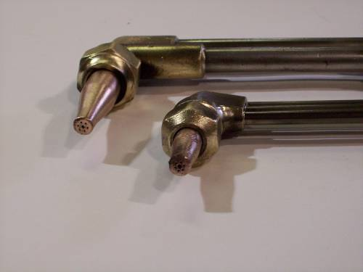

Cutting Tip Chart
Refer to a ________________________ for correct cutting tip, regulator pressures, and travel speed.

Lighting The Torch
Open the ______________ on the welding torch all the way.

Adjust the _______________ to the desired delivery pressure.
•DO NOT EXCEED __________

Adjust the ________________________ delivery pressure.
•DO NOT EXCEED _____________

Open the fuel valve on the __________ approximately ________________and ignite the gas with a ____________.

•NOTE- Wear protective goggles or glasses ___________to shield the eyes from the bright light of the flame and leather gloves from ___________________ when lighting the torch.

Continue to ___________ the fuel supply at the __________
__________ until the flame clears the end of the tip about __________, then reduce the supply slightly to return the flame to the tip.

__________ open the ____________________ on the cutting attachment until the preheat flames establish a _________________________________.

Depress the ___________________________________.

•Note- if the preheat flame changes slightly to a __________ __________, continue to ____________________________ _________________________ at the cutting attachment until the preheat flames are ____________________ again.

Torch Cutting Precautions
•IMPORTANT: Check where ___________ and ___________ will fall.

•Have _____________ available, remove flammable substances, and check where the ______________ are located before starting to work.

•Protective ______________ and _________should be worn while torch cutting.

Straight Line Cutting
Hold the cutting attachment or torch comfortably _________ __________ so one hand stabilizes the ___________. Preheat flames approximately _______ from ____________ and the other hand is free ___________________________.

Direct the preheat flame on the spot where the ___________ _____________.

•Before cutting action can start, the base metal must be ______________________________________________.

•When the ____________ appears, __________ the cutting oxygen lever ________________.

When the cut has started, ________________ in the direction you wish to cut.

•Note: moving too _________ will allow the cut or kerf to ___________, and moving __________ will not allow the metal to be preheated and the cut ___________________.

Continue to depress the cutting oxygen lever past the final edge of the base metal for a good “________________.”

Recommended Procedure for Flame Cutting of Thick Metal

1.Start to preheat; point tip at angle on edge of plate.  2.Rotate flame back to upright position – keep the dark inner blue flame 1/8” from metal.  3.Press oxy valve slowly; as cut starts, rotate tip backward slightly.  4.Now rotate to upright position without moving tip forward.  5.Rotate tip more - so tip points slightly in direction of cut.  6.Advance as fast as good cutting action will permit.  7.Do not jerk; maintain slight leading angle toward cut direction  8.Slow down; let cutting stream sever corner edge at bottom.  9.Continue steady forward motion until tip has cleared end. | 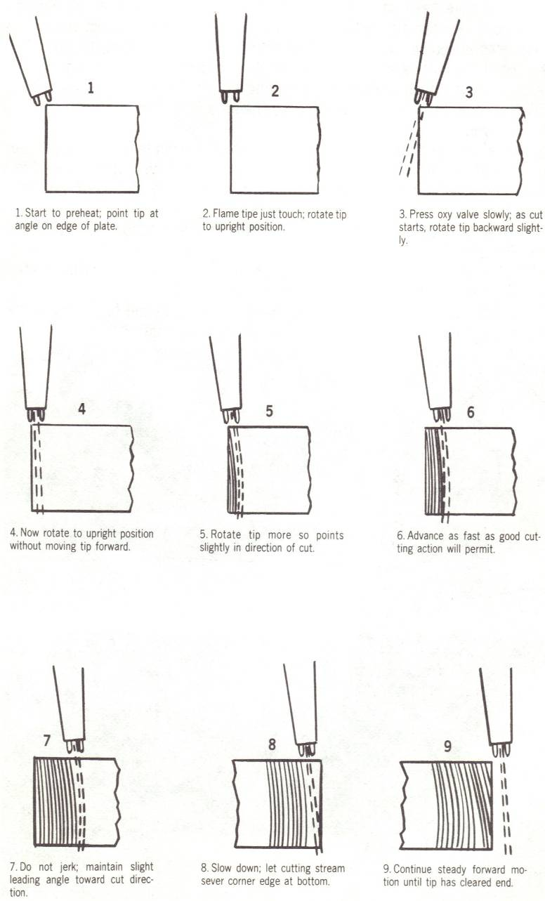

Torch Cutting- Piercing a Hole
To pierce metal, again hold the cutting attachment or torch comfortably in both hands with one hand stabilizing the cutting tip preheat flames approximately _________ from the base metal while the other hand is free to depress the ________________________.

To prevent the _________and __________from blowing towards you, _________the torch tip slightly to one side when the oxygen is depressed.

When the metal is pierced, move the torch __________ in the direction you wish to cut.

•Note- If the metal is not pieced all the way through it probably means that ______________________________
_______________________________________________.

•NOTE- If the cut piece does not fall off at the end of a cut, DO NOT ________________________.

•Simply _____ the cut piece of metal with a _____________ and the piece will generally detach.

Shutting Down the Cutting Outfit
•After the cutting operation ________, or whenever the cutting torch operator ______________, the oxy-acetylene cutting outfit must be _____________________________.

Follow these procedures for shutting down the equipment:

Step 1

1.Turn off the ___________________________________.

2.Turn off the ____________________________________.

3.Turn off the ____________________________________.

4.Turn off the ____________________________________.

5.Reopen the _________________ and depress the ___________________________ to release or bleed any gas still remaining in the hoses.

6.When the regulators read ___________ - shut off the _____________________________________________.

7.Turn the ____________ and ____________regulator _______________________________________________.

8.____________ the Oxy-acetylene hoses on the outfit for proper clean-up and shop organization.

