AG MECH SKILLS II NAME ___________________
SMAW
NOTES DATE ___________________

I. SMAW EQUIPMENT & SAFETY
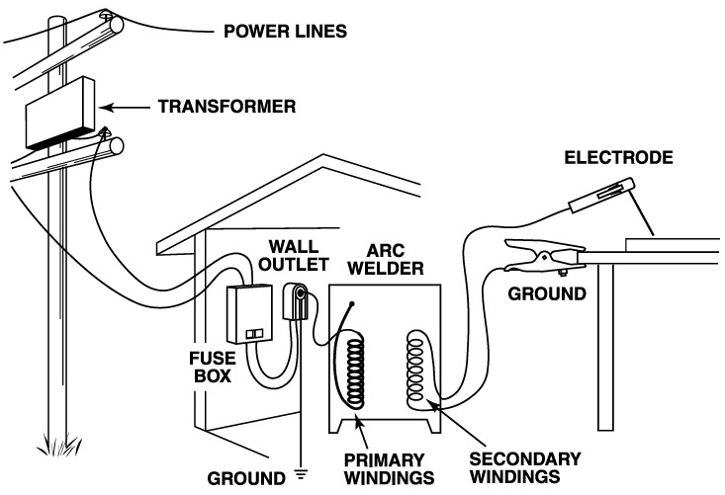
A. Introduction to SMAW
1. SMAW =

- Uses Constant Current Power Sources

2. An arc welding machine joins two metals together by generating an electric arc between a coated metal electrode and a base metal. The heat of the electric arc melts the metal which mixes with the molten deposits of the coated electrode. The coating of the electrode produces a gas which shields the weld from the atmosphere and helps to maintain the weld shape. The slag coating over the weld insulates the hot weld from contaminants in the air during cooling.

B. Equipment Used in SMAW
1. Power Supply
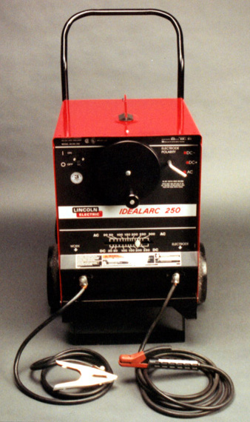

- Creates splatters and uneven welds.
- Three types of power supplies:
- Generator (Portable Welder)

- Transformer (Buzz Box)

- Rectifier

2. Constant Current

- The Power Source Keeps the Current as Constant as Possible even when the Operator Varies the Arc Length

3. Duty Cycle
a.

Duty Cycle Amperes Time Available
30% 250 3 Min/10 Min
40% 225 4 Min/10 Min
50% 200 5 Min/10 Min
60% 190 6 Min/10 Min
70% 180 7 Min/10 Min
80% 170 8 Min/10 Min
90% 155 9 Min/10 Min
100% 140 10 Min/10 Min

5. Ground Clamp
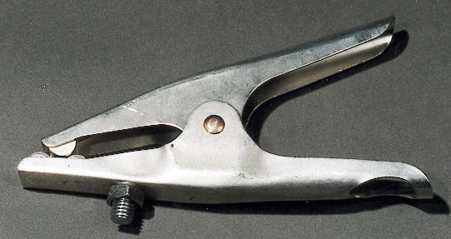

6. Electrode Holder (Stinger)
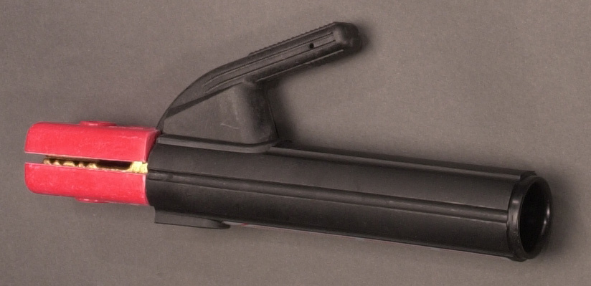
a.

b.

7. Cables
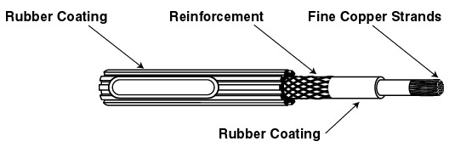
a.

b.

8. Electrode
a.
b.
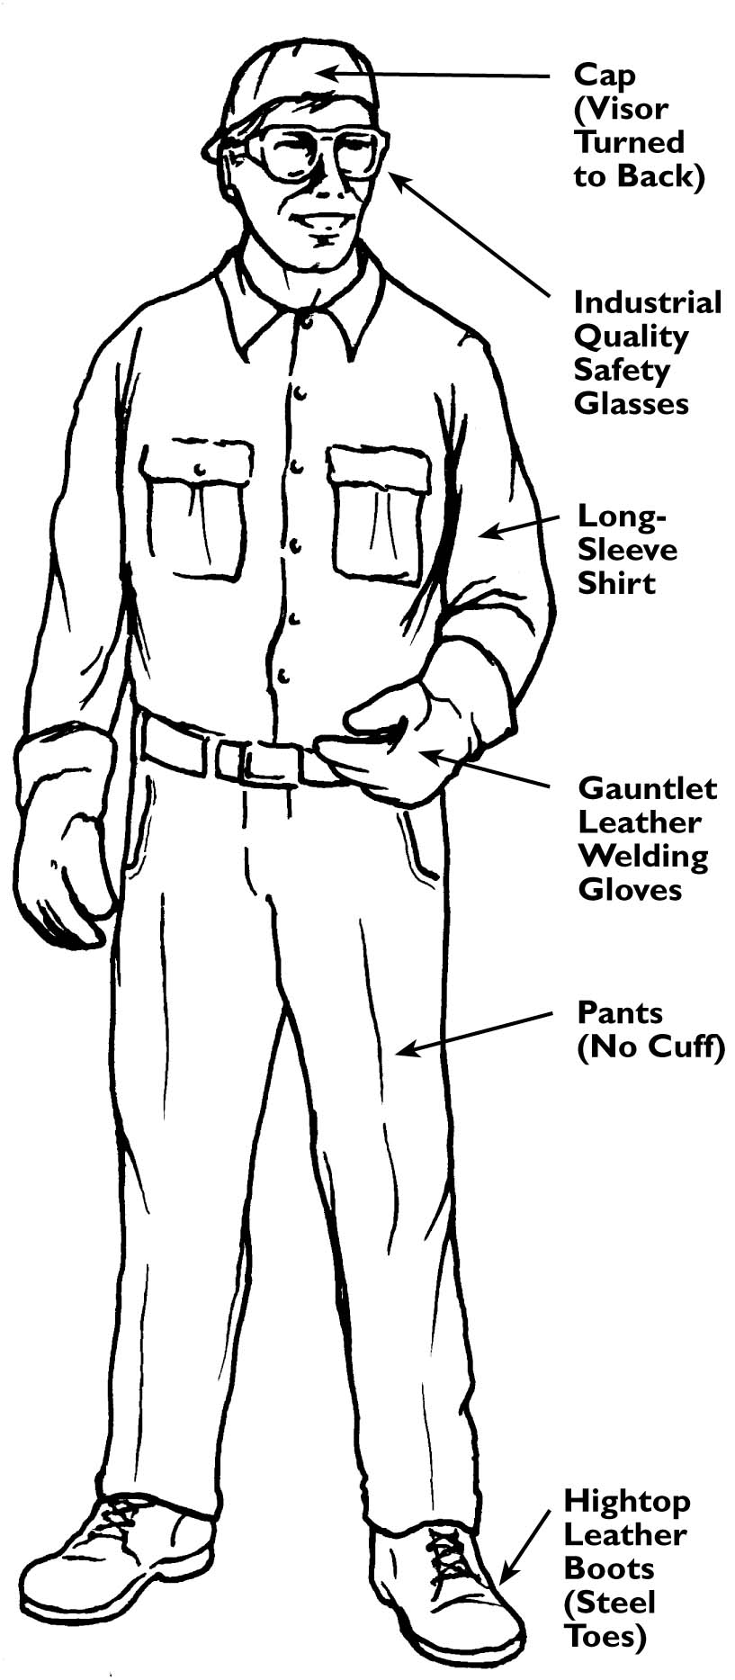

C. Safety
1. Protective Clothing
  - Must be worn at all times when welding. The heat created during arc welding creates flying molten sparks and ultraviolet and infrared rays that can burn the skin.

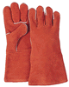
a. Leather Gloves
1)

2)

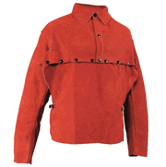
b. Sleeves
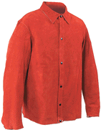
1)
Leather Cape
Sleeves/Bib

c. Body Protection
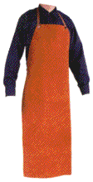
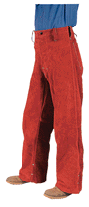
1) Leather clothing items are the best protection from heat and sparks. For light welding operations, coveralls work best but a work shirt will protect the body during arc welding.
2)
Leather Welding
Trousers

d. Footwear
1)
Leather Welding Apron

e. Eye Protection
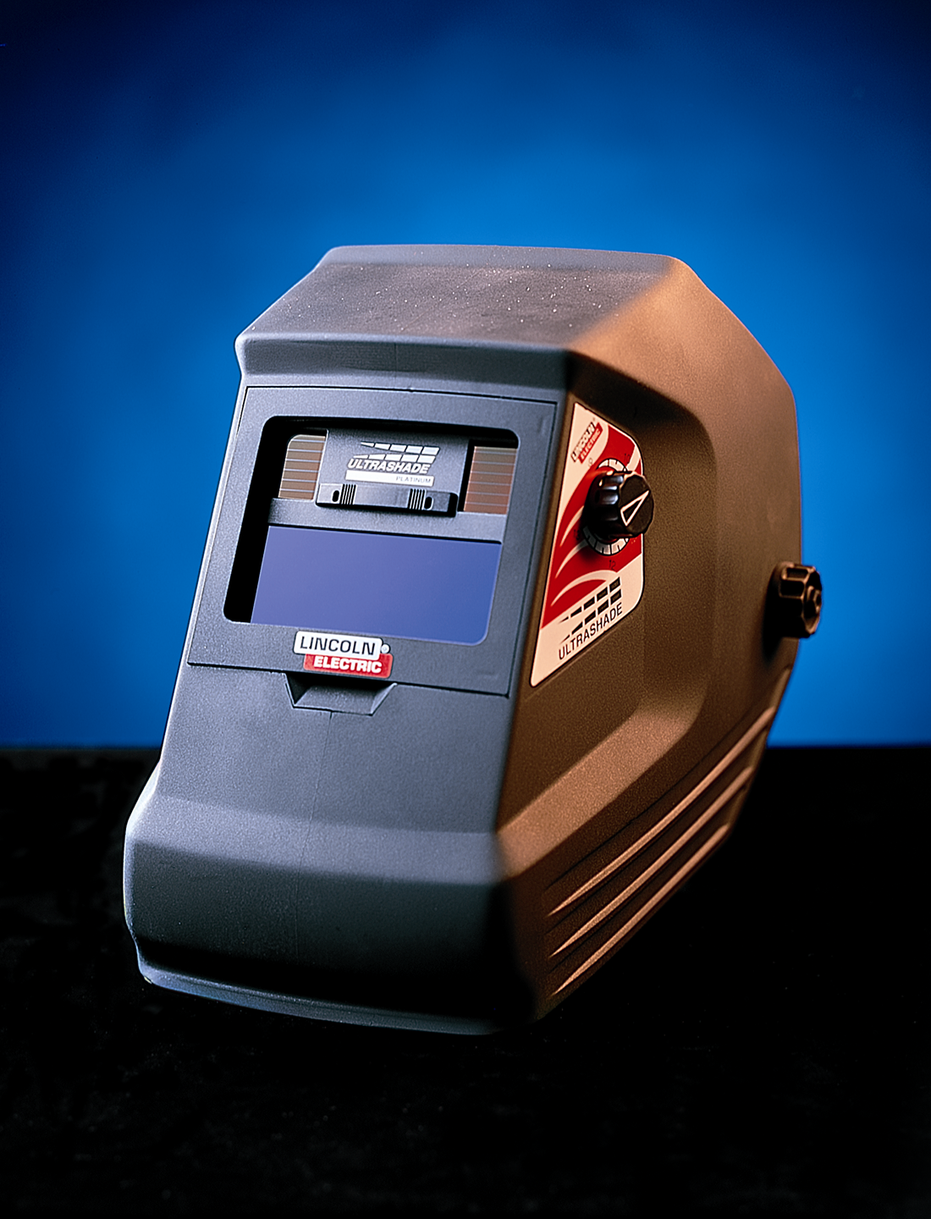
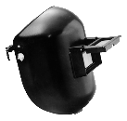
- The brilliant light given off by the electric arc produces invisible ultraviolet and infrared rays which can severely burn the eyes and skin. NEVER LOOK AT THE ARC WITH THE NAKED EYE!

f. Welding Helmet
Welding Helmets
1)

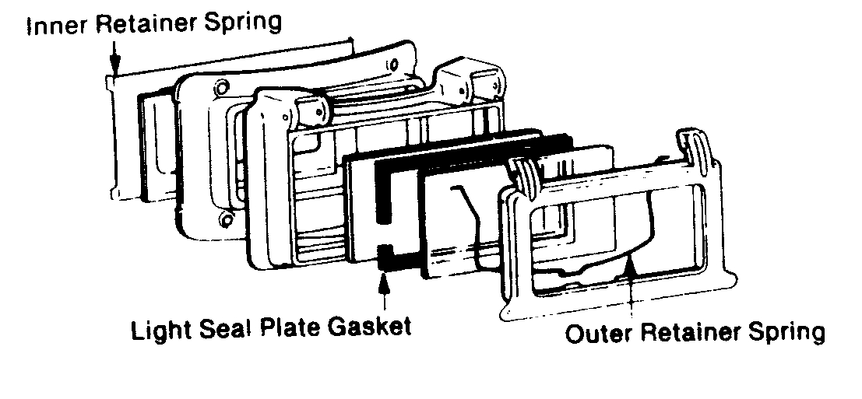
2)

3)

g. Protective Lenses
Different types of welding use different amounts of voltage and current which determine the intensity of light and the amount of ultraviolet and infrared rays produced. Lens shades range from #5 (least protection) to #14 (most protection).
1) Shade 5 -
2) Shade 6&7 -
3) Shade 8 -
4) Shade 10 -
5) Shade 12 -
6) Shade 14 -

h. Cover Lenses
Used to stop flying slag or metal which protects the filter lens.
1)

i. Care of Lenses
1)
2)

2. Additional Welding Equipment
a. Tongs/Pliers
1)

b. Chipping Hammer
1)
c. Steel Brush
1)

C. Safety in Arc Welding
See Handout

