AG MECH SKILLS II NAME
ARC WELDING
UNIT TEST DATE

SCORE: ______ / 130

TRUE/FALSE: Circle “T” if the statement is true or “F” if the statement is false. Read the questions carefully.
(2pts ea)
1. You should caution any other student you see violating a safety rule.
2. Disturbing another student while he is working is dangerous.
3. Do not weld or cut on a closed container.
4. Protect welding leads from sparks, falling metal, and from being walked on.
5. Eye protection for Arc Welding must be at least shade 3 or darker.
6. In arc welding, a high temperature arc melts the electrode but not the base metal.
7. The welding arc is actually a continuous spark.
8. An arc will not start by bringing the electrode near the work; it must be “ignited”.
9. Even though there are different types of welding, all require the same shade lens.
10. When the current setting is too low you will have excessive splatter.
11. The ground clamp should be attached to the work piece.
12. Before welding, make sure the area is free of flammables.
13. Proper clean-up of the welding area will reduce the risk of injuries.
14. The key to becoming a successful welder is practice.
15. The current setting should be equal to the diameter of the electrode, including the flux, in thousandths of an inch.

SHORT ANSWER: Answer the following questions a completely as possible.
1. What is the intent of “arc shielding”? (5 pts)

2. Four things (variables) greatly affect the results obtained in electric arc welding. To make good welds, each one must be adjusted to fit the type of work done and the equipment being used. These variables are: (8 pts)

A.
B.
C.
D.

3. Describe the general “rules of thumb” that help you to adjust, or find a starting point for, each of the variables listed above. (16 pts)

A.

B.

C.

D.

4. Identify the problems with the following welds: (14pts)
A.
B.
C.
D.
E.
F.
G.
a
b
c
d
e
f
g

5. Define “Duty Cycle”. (5 pts)

6. Identify the components of the
B.
C.
welding circuit. (18 pts)
A.

A.
D.
B.
E.
C.
D.
F.
E.
F.
G.
G.
H.
I.
H.
I.

7. Match the Oxy-Acetylene cut description with the correct picture. (18)

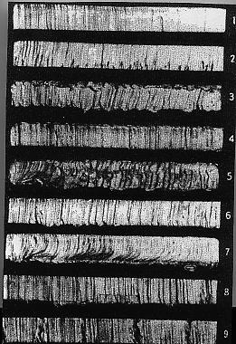
Preheat flames too long, melted top edge,
cut edge irregular, excessive adhering slag.

Cut was lost and not properly restarted,
bad gouges at restart point.

Cutting speed too slow, drag lines irregular
and pronounced

Good quality cut, square edges, drag lines vertical
and not too pronounced.

Oxygen pressure too high, nozzle size too small.

Cutting speed too fast, pronounced break in the
drag line, irregular cutting edge.

Oxygen pressure too low, melted top edge due to
slow cutting speed.

Torch travel unsteady, cut edge wavy and irregular.

Preheat flames too small and speed too slow,
gouging at the bottom of cut.

8. Label the components of
the shielded metal arc
welding process to the right.
D.
E.
(16 pts)
C.

A
F.
B.
B.
C.
G.
D.
E.
H.
F.
A.
G.
H.

