Import a Canvas Gradebook into the Tabulations Program.

Downloading scores:
In Canvas choose Grade then under Actions choose export.
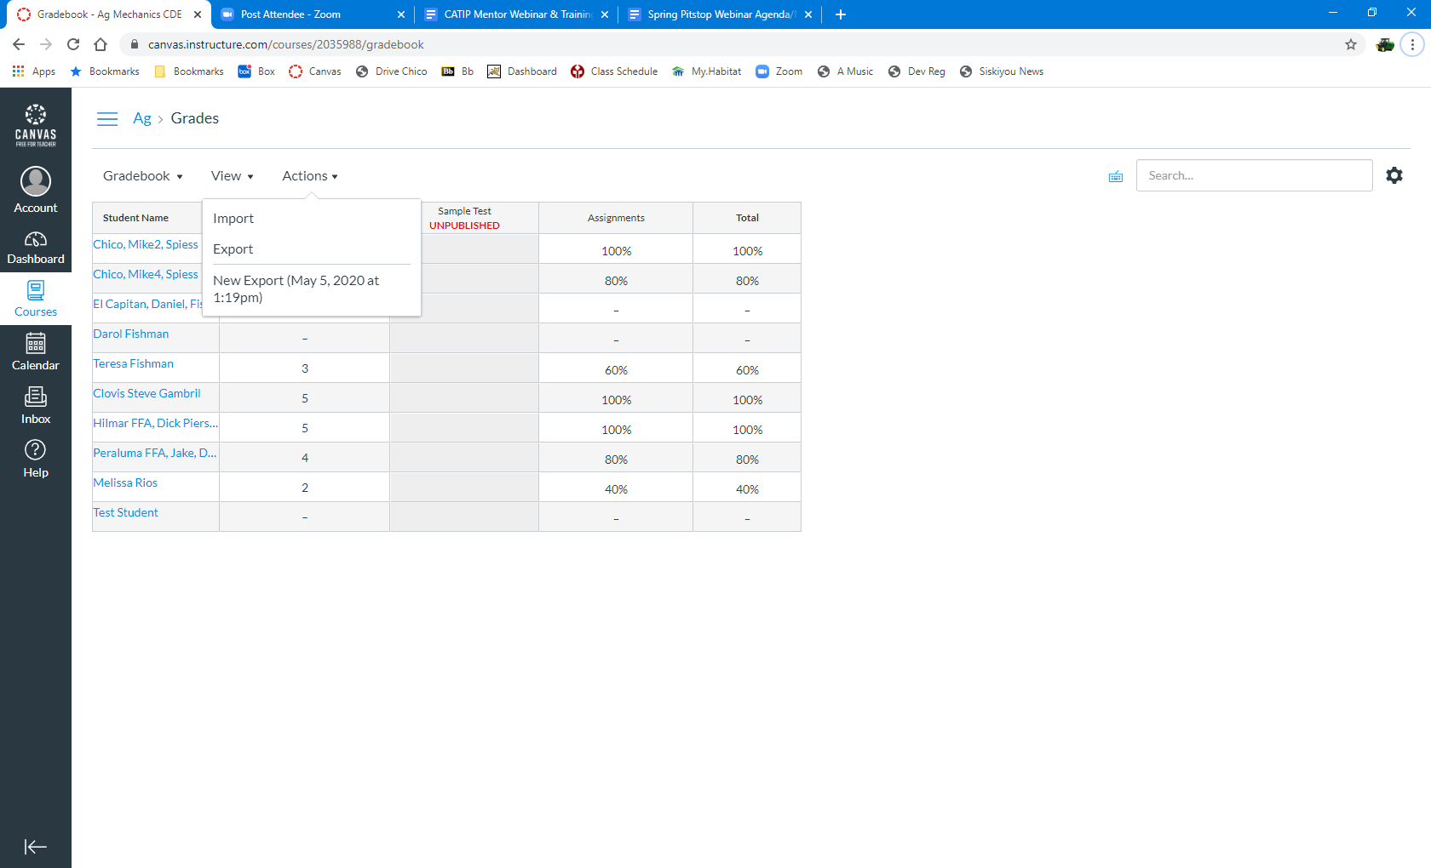
Open the exported file in Excel.
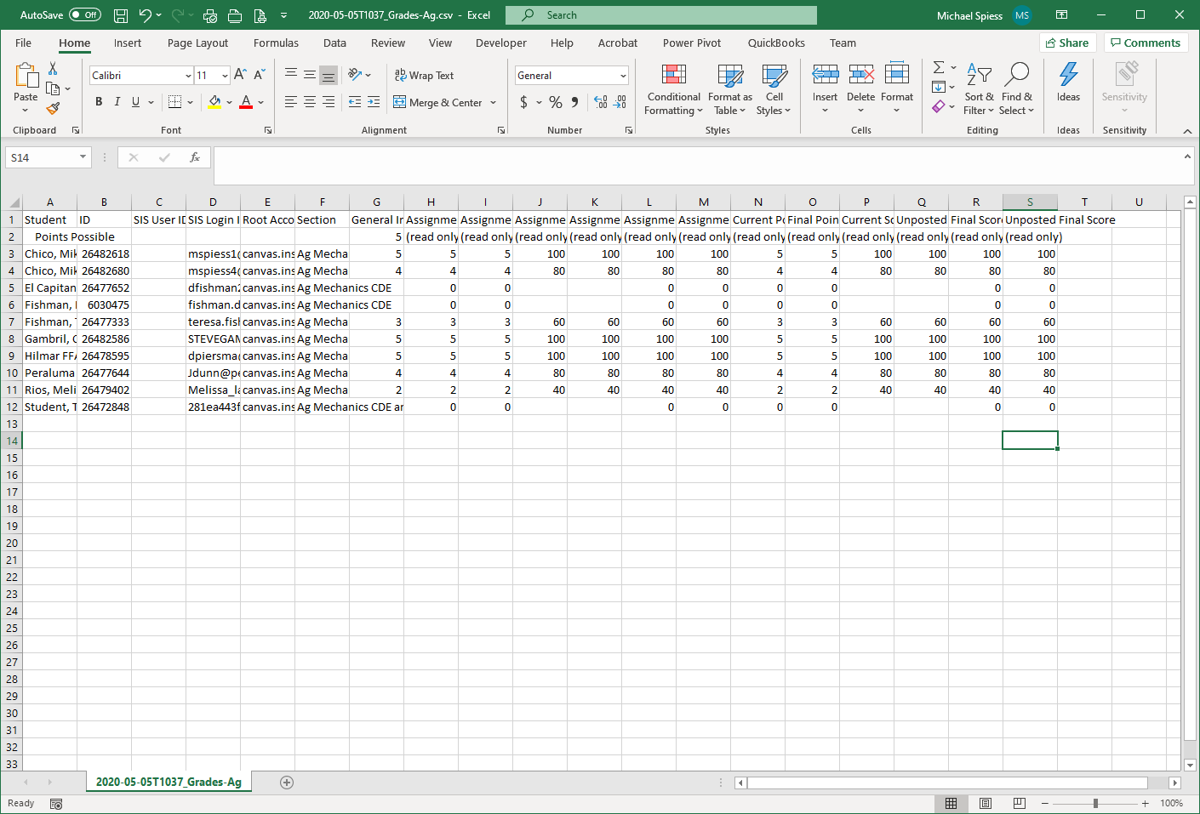
Raw Gradebook

Steps to convert:
- Delete row 1 (we only want a single row with column headings
- Divide the column with the name (A) in to Chapter and Name. This assumes the Name in Canvas is entered as Chapter, Name. If not hand enter the chapter names in a separate column.
  - Select the names.
  - Select from the Data Menu Text to Columns. Choose comma as the delimiter. OK to overwrite the ID column.
- Delete unused columns
- Rename columns.
  - Column A should be “School”, Column B should be “Name”
  - Rename quiz score columns to ClassID (ex. 01, 02) so they will align with tabs program classes.
- Edit names and schools as needed. Teams will be divided based on the “school”. If a school has “A” and “B” teams be sure to edit the school name (ex. Arbuckle A and Arbuckle B). Note that this can be fixed in the tabs program by moving contestants to another team.
- Save the file.
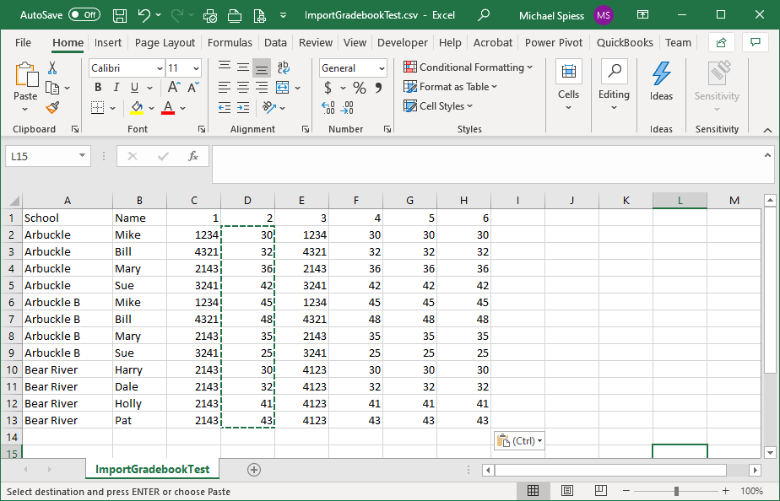
Formatted
NOTE if the score is a “placing”: Placings may be the left three places (ex. 123) or all 4 (ex. 1234). They will be converted to the left 3 upon import.

Tabs setup
- Set up classes to match what you are doing. Omit classes you will not use (or hide)
- Adjust class multipliers to properly weight classes.
- All classes should be type “Normal”. Judging box should not be checked UNLESS You are importing placings (ex. 4231).
- If placing classes are used then enter official scoring (Official Score | Enter Official Placing)

Import & Results
- From the admin menu choose Import Gradebook.
- Check the teams and names (Setup | Contestant List)
- Review the raw scores (Tabulation | Raw scores). Lists scores as imported.
- Review Draft Results (Tabulations | Draft Results). Shows scores with multipliers.
- Print Results as desired. (Use PDF format to send out)

