

About Veris Soil EC Mapping
The Veris system utilizes GPS and the proven technology of soil electrical conductivity to identify areas of contrasting soil properties. The ability to accurately map soil patterns is a powerful tool in precision farming. In non-saline soils, EC values are measurements of soil texture -- the grain size of the soil. Soil texture is directly related to water-holding capacity, cation-exchange capacity, and soil depth. These factors are critical to identify in an effective precision farming system. While EC mapping devices do not directly measure soil fertility, conductivity maps frequently relate to nutrients -- in part because the movement of mobile nutrients is related to soil texture, and also due to the effect soil physical properties have on productivity and subsequently on crop removal of nutrients. Saline soils typically show significantly elevated EC readings, making this an ideal way of planning remediation in these areas.
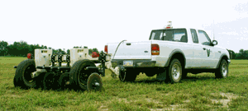
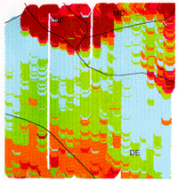
Here's how it works: as the Veris Sensor Cart is pulled through the field, it acquires conductivity measurements at 1 second intervals and geo-references them using DGPS. When used on 60' swaths at speeds of up to 10 mph, the system produces between 80 and 120 samples per acre. The unique design of the 3100 model simultaneously collects a conductivity reading for the 0-1' and the 0-3' layers. This feature is ideal for identifying significant changes between horizons, such as claypan layers or thin topsoil overlaying rock.
The data collected by the Sensor Cart is displayed on the Veris instrument panel along with the lat/long coordinates. The data file is easily downloaded from the instrument in a choice of formats compatible with virtually any ag mapping software program.
This is the result: a map that clearly identifies the contrasting soils in this field. The red/orange colors indicate areas of higher conductivity—the blue/green areas are lowest conductivity. The conductivity is measured in milliSiemens/meter—a standard measurement of bulk soil conductivity. As is evident from this map, there is a striking similarity between the Veris soil map and the USDA soils map-- with the Veris soil map geo-referencing the soil type changes precisely and identifying inclusions within soil units. Armed with this knowledge of soil variability, a precision management system can be devised that truly represents a field's variability.

Frequently Asked Questions about soil electrical conductivity…
Why is soil conductivity important to precision agriculture?
The usefulness of soil conductivity stems from the fact that sands have a low conductivity, silts have a medium conductivity and clays have a high conductivity. Consequently, conductivity (measured at low frequencies) correlates strongly to soil grain size and texture:
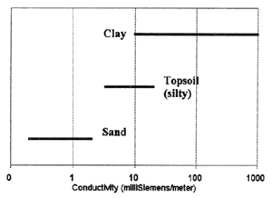
In addition to its ability to identify variations in soil texture, electrical conductivity has proven to relate closely to other soil properties that often determine a field's productivity:
Cation exchange capacity (CEC): soils textbooks record the formula;
CEC = 0.6 × (% clay) +2.0 × (% organic matter)=CEC in milliequivalents (of most corn belt soils)
as a method of calculating CEC. Research bears out the correlation between conductivity and CEC through its relationship to clay.
Depth to claypan: the response of conductivity to the presence of clay has been used to accurately predict the depth of top soil over a clay layer
Water holding capacity/drainage: areas of droughtiness or excess moisture typically have distinct textural differences; these can be identified using electrical conductivity. Soils in the middle range of conductivity which are both medium textured and have medium water-holding capacity may be the most productive.
Organic matter: organic carbon accumulates in the poorly drained soils which have higher clay contents
Salinity: An excess of dissolved salts in the soil is readily detected by electrical conductivity.
How does the Veris system measure soil properties down to a depth of 3'?
As the 3100 cart is pulled through the field, one pair of coulter-electrodes injects electrical current into the soil, while two other pairs of coulter-electrodes measure the voltage drop. While these coulter-electrodes only need to penetrate the soil a few inches, the electrical arrays employed by the Veris system investigate the soil as represented in this schematic. The 2000 XA model measures one depth with one scan of coulter-electrodes.
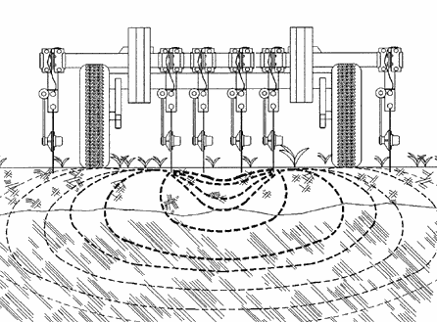
Investigation of soil using electrical arrays such as this are well-described in scientific literature.
Does conductivity correlate to yield?
When the water-holding capacity of the soil is a major factor affecting yield, the yield map will likely show strong correlation to EC. Also, if salinity is affecting yield, the EC responsiveness to salinity will correlate with the yield. Click here to see some yield and Veris EC maps that correlate, and here to see an application using a Veris EC and a yield map in a precision management plan.
What about soil moisture?
Work done at the U.S Salinity Laboratory presents an EC model that describes conductance along three pathways acting in parallel: (1) conductance through alternating layers of soil particles and their bound soil solution, (2) conductance through continuous soil solution, and (3) conductance through or along surfaces of soil particles in direct contact with each other. In the absence of dissolved salts in the free water present in pathway number 2, conductivity, texture, and moisture all correlate well with each other.
The question regarding moisture that seems central to evaluating the usefulness of EC mapping in precision agriculture is: Does a field mapped under different moisture conditions show new zones that change based on different field moisture conditions? For soil EC maps to have value, the patterns and areas identified must be consistent and repeatable. The map below is a silt loam Kansas wheat field that was mapped under four different soil temperature, soil moisture, and surface density conditions in 1997.
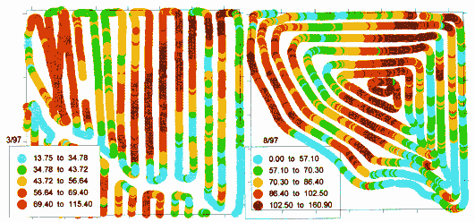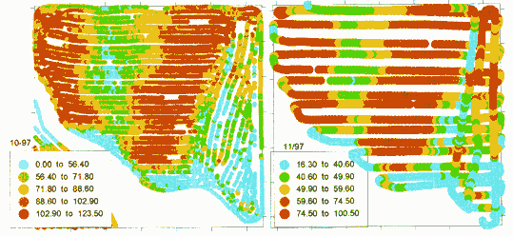
The field was mapped in March when the winter wheat was coming out of dormancy, in July immediately after harvest, in early October after multiple tillage passes, and in November just prior to dormancy. As is evident from the maps, although the conductivity values change, the zones delineated do not. Point-based EC sampling of a field has resulted in a repeatability correlation of .94.
With the exception of almost pure sand, we estimate that the conductivity of soil varies by only 5 to 10 percent with variations in moisture. As a result, variations in soil type can be detected no matter what the moisture condition of the field. On the other hand, this also means that conductivity is not the tool of choice for determining the moisture content of soils.
Does the field have to be in any certain condition?
The Veris® Sensor Cart is designed to operate in tilled or untilled conditions, with minimal soil disturbance. The soil conductivity map of a recently primary tilled field—where the soil is aggressively ripped and/or inverted, often shows the disruptive effects of the tillage on the natural soil pattern. In order to minimize any possible effect of tillage, it is advisable that the Veris map is made either prior to tillage, or when the field is in a uniform tillage condition.
What about the effects of manure?
Areas of a field where extremely high rates of manure have been applied are occasionally visible on a Veris soil map—and typically only in the 0-1' layer.
What about outside interference, such as power lines, on the conductivity reading?
The direct contact method that Veris uses has a distinct advantage over electromagnetic induction technology in this regard. There is virtually no possibility of ambient electrical interference with the Veris direct contact method.
Can I collect soil EC information while completing a tillage or planting operation?
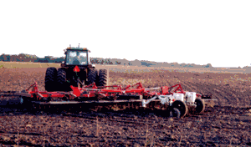
Yes, if the Sensor Cart is attached to the implement, the conductivity information can be obtained as a field operation is being completed.
What is the suggested swath width?
While it is possible to use any swath the operator chooses, it is our experience that a 40' - 60' swath provides a map that adequately identifies the spatial patterns of a field. It also represents a typical spray boom width and consequently the smallest area most growers will variably manage.
What are milliSiemens per meter (mS/M)?
These are the standard units of measure of bulk soil conductivity. A Siemen is a measurement of a material's conductance; expressing the value in mS/meter removes the volume from the equation—just as a material's density is independent of its volume.
The advantage of a standard unit of measure is that it makes the data quantitative. Visual identification of soils can often determine color differences, but cannot attribute quantitative values to those colors. A Veris soil map that shows values of X mS/meter enables you to identify and manage other areas of the field with similar values.
How do Veris soil maps correlate with USDA soil maps?
In virtually every field where the Veris and USDA maps have been compared, there is a definite correlation between the two, which one would expect since soil texture is a key element behind both. There are some important differences that generally occur:
- The Veris soil map identifies inclusions not found on the USDA maps. (USDA Order 2 soil surveys allow for 2 ½ acre inclusions—areas of different soils thought to be too small to identify at the time the maps were created)
- Because the original USDA maps were not geo-referenced with GPS technology, the exact location of the soil unit line is frequently 50-200 feet from where the Veris soil map places the change.
- Because soil changes throughout a field are a continuum, not a set of lines or polygons, the data point/second approach of a Veris map identifies these changes as transition zones -- not lines.
- The Veris soil map identifies areas of contrasting conductivity/texture. Using it in conjunction with a good USDA map provides the ability to benchmark the Veris data against other soil types with similar conductivity values. Also, USDA maps identify other field characteristics such as slope and crop suitability, which layered with a Veris soil map results in a more accurate management tool than either map individually.
Why not use the Veris reading to control a planter or applicator in real time?
The relationship between conductivity and inputs is not simply linear. The highest economic value is in using the Veris soil map in conjunction with other information such as: historical productivity, sample data, and local agronomic knowledge. For example, in some areas, higher conductivity indicates higher clay/CEC, resulting in higher yield goals and additional inputs on those sites. In other regions, the higher conductivity indicates excessive clay, which may limit production—calling for reduced inputs. In both cases, a Veris soil map of the field identifies those sites and allows individual recipes to be created.
What recipes are being created using conductivity maps?
- Corn: variable population and N rates based on site-specific yield goals—based on CEC levels
- Corn population: varied rates based on top soil depth
- Herbicides: varying rates of soil-applied herbicides based on organic matter, texture, and CEC
- Lime: varying lime rates based on zone sampling according to conductivity map
- Wheat, milo, and soybeans: varying population according to texture in order to find optimum rates
- Sodic soils: application of gypsum on sodic areas
For published papers on EC mapping, click on "Send more info" below.

A Division of Geoprobe® Systems
601 N. Broadway, Salina, Kansas 67401
785-825-1978 • fax: 785-825-2097
http://www.veristech.com/

Published Research
Abstracts and Summaries from published research of soil electrical conductivity measurements
Field Measurement and Mapping of Soil Salinity in Saline Seeps
Authors: K.R. Mankin, K.L. Ewing, M.D. Schrock, G.J. Kluitenberg
Kansas State University Manhattan Kansas 66506
Written for presentation at the 1997 ASAE Annual International Meeting
CONCLUSIONS
Both fixed-array and EM sensors produced valuable data for evaluating saline seep extent and creating field-scale soil salinity maps. The Veris system was mobile and highly automated, and collected its data in a fraction of the time of the other methods which used hand-held instruments and collected data at grid-points. Use of a mobile GPS unit like the Veris system would speed collection of data by the other methods considerably while probably retaining adequate resolution for this type of work…

Spatial Prediction of Crop Productivity Using Electromagnetic Induction
Authors: N.R. Kitchen, K.A. Sudduth, S.T. Drummond, and S.J. Birrell
USDA-ARS, University of Missouri Columbia MO 65211
Agronomy Misc. Publication #96-03, College of Agriculture, Food and Natural Resources, University of Missouri, Columbia
ABSTRACT
An inexpensive and accurate method for measuring water-related, within-field soil productivity variation would greatly enhance site-specific crop management strategies. This paper reports on investigations to use an electromagnetic induction (EM) sensor to map claypan (Udollic Ochraqualfs) and alluvial (Typic and Aquic Udipsamments, and Aeric Fluvaquents) soil conductivity variations and to evaluate the relationship of EM measurements to grain crop production…

Using Electrical Conductivity To Provide Answers For Precision Farming
Authors: E.D. Lund, C.D. Christy
Veris Technologies Salina KS 67401
Presented at the First International Conference Geospatial Information in Agriculture and Forestry (1998)
ABSTRACT
The spatial variability of soil properties and the complexity of factors that affect a field’s productivity present significant challenges to the adoption and success of site-specific agricultural technology. Inaccurate assumptions based on sparse systematized sampling patterns, or on coarse soil maps are problematic in precision farming efforts and illustrate the need for improved mapping of soil properties. Electrical conductivity measurements of soil have long been used to identify contrasting soil properties in the geological and environmental fields. The purpose of this paper is to explore the potential of maps created from a mobilized soil conductivity instrument to help interpret yield maps, guide sampling efforts, and provide variable rate recipes for site-specific yield goals.

Soil Electrical Conductivity and Soil Salinity: New Formulations and Calibrations
Authors: J.D. Rhoades, N.A. Manteghi, P.J. Shouse, W. J. Alves
USDA-ARS Soil Salinity Lab. Riverside CA 92501
Published in Soil Science Society of America Journal volume 53, no. 2 (1989)
ABSTRACT
A new model describing the relation between bulk soil electrical conductivity (ECa), volumetric content (0w), and electrical conductivity of soil water (ECw) is given along with supporting evidence for its validity…New empirical relations are provided to estimate the parameters needed in the new and old models in order to utilize them for diagnosing soil salinity, in terms of the electrical conductivity of the extract of saturated soil pastes.

Improved Soil Mapping using Electromagnetic Induction Surveys
Author: Dan Jaynes
USDA-ARS National Soil Tilth Laboratory Ames IA
Published in Precision Agriculture ASA-CSSA-SSSA (1996)
CONCLUSIONS
EMI (electromagnetic induction measurements of soil electrical conductivity) techniques have the potential to gather geo-referenced data quickly and cheaply. This data may be used in several ways to improve our knowledge of the spatial patterns of soil properties across fields. These approaches include using EMI measurements for pre-sampling reconnaissance, as secondary variables for improving estimates of primary variables through geostatistical methods, and as surrogate measures of parameters more costly to measure.

Use Of A Field Level Geographic Information System (FIS) In A Spatial-Data Analysis For Precision Agriculture
Authors: N. Zhang, R. Taylor, M. Schrock, S. Staggenborg
Kansas State University Manhattan KS 66506
Written for presentation at the 1998 ASAE Annual International Meeting
SUMMARY
Application examples of a Field-Level Geographic Information System (FIS) developed at Kansas State University were presented…Normalized yields of a divided field with different crop rotations in three consecutive years were derived using FIS for correlation analysis. Relationship between yield and soil electric conductivity was studied using FIS functions. Color infrared aerial photographs were integrated into FIS database….

RECENT PAPERS ON SOIL EC

Soil Electrical Conductivity as a Crop Productivity Measure for Claypan Soils
Authors: N. R. Kitchen, K. A. Sudduth, and S. T. Drummond
Published in Journal of Production Agriculture Vol. 12, No. 4, 1999
CONCLUSIONS
Soil ECa provided an estimate of within-field differences associated with topsoil thickness, and which for these claypan soils, is a measure of rootzone suitability for crop growth and yield. Significant relationships between potential grain yield and ECa were shown using a form of boundary line analysis, but climate, crop type, and specific field characterization information were required to help explain the relationship for any given site year. Use of the boundary line analysis ECa helped to delineate the magnitude of potential yield loss due to less than ideal conditions in the root zone…

Practical Applications of Soil Electrical Conductivity Mapping
Authors: E. D. Lund, C. D. Christy, P. E. Drummond
Veris Technologies Salina Kansas
Presented at the 2nd European Conference on Precision Agriculture Odense Denmark July 1999
ABSTRACT
The site-specific application of inputs such as seed, fertilizer and crop protection chemicals has the potential to reduce input costs, maximize yields, and benefit the environment. The economic returns currently received by the early adopters of precision farming methods need to be improved before wide-scale acceptance of this practice will occur. These improvements include cost-effective identification and management of the spatial variability of soil and nutrients, applying inputs based on each site's productive capacity, and correct decision-making using the available layers of information. Soil electrical conductivity (EC) measurements have long been used to identify contrasting soil properties in the geological and environmental fields. The purpose of this paper is to discuss the applications in precision farming where EC maps are proving useful in improving economic returns to precision farming.

The following abstracts are from oral and poster presentations at the 4th International Conference on Precision Agriculture (St. Paul Minnesota 1998):
Applying Soil Electrical Conductivity Mapping to Improve the Economic Returns in Precision Farming
Authors: E. D. Lund, C.D. Christy, P.E. Drummond
The site-specific application of inputs such as seed, fertilizer and crop protection chemicals has the potential to reduce input costs, maximize yields, and benefit the environment. The economic returns currently received by the early adopters of precision farming methods need to be improved before wide-scale acceptance of this practice will occur. These improvements include cost-effective identification and management of the spatial variability of nutrients, applying inputs based on each site’s productive capacity, and correct decision-making using the available layers of information. Electrical conductivity (EC) measurements of soil have long been used to identify contrasting soil properties in the geological and environmental fields. The purpose of this paper is to discuss the applications where EC maps are proving useful in improving economic returns to precision farming.

Soil Conductivity Sensing on Claypan Soils: Comparison of Electromagnetic Induction and Direct Methods
Authors: K.A. Sudduth, N.R. Kitchen, S.T. Drummond
Soil electrical conductivity (EC) is influenced by a number of factors, including soil moisture, clay content, and salinity. Because of this, spatial measurements of conductivity can, when properly calibrated, provide indirect indicators of a number of soil parameters important in site-specific crop management. In our work on claypan soils, we have found EC to be strongly correlated with the depth of topsoil above the claypan horizon. Since the claypan restricts water movement and root growth, topsoil depth is closely related to crop yields, especially in the water-limited growing seasons which are common in the claypan soil area. Two types of EC sensors usable in precision agriculture are commercially available. The Geonics EM-38 is a non-contact sensor which measures EC to a depth of approximately 1.5m through the principle of electromagnetic induction. The Veris 3100, a newer product, uses coulters in contact with the soil to provide two simultaneous EC measurements to depths of approximately 0.3m and 0.9 m. We have obtained EC measurements over a number of claypan soil fields using both these instruments. In this paper, the EC information obtained from the two sensors is compared, and the usefulness of such information in estimating topsoil depth and predicting crop productivity is discussed.

Field Comparison of Two Soil Electrical Conductivity Measurement Systems
Authors: R.M. Fritz, T.E. Schumacher, D.D. Malo, D.E. Clay, S.A. Clay, C.G. Carlson, M.M. Ellsbury, and K.J. Dalsted
Bulk soil electrical conductivity (EC) is influenced by soil water content, salts, and parent material. This study evaluated the ability of the EM-38 or Veris 3100 soil mapping system to describe soil parameters. The Geonics EM-38 is a widely used noninvasive soil electromagnetic induction meter that measures soil (EC) for the top 120 cm of soil (vertical configuration 30 cm from soil surface). Veris 3100 sensor cart is a direct contact soil EC meter that measures soil EC for the surface 33 and 100 cm of soil. A comparison was made between both systems at matched GPS location points. Additional information at these points were gravimetric water content and NO3—N concentration. The two measuring systems were highly correlated with each other and water content. The EM-38 and Veris deep reading were similar while the Veris shallow reading was lower than the EM-38 in the dry and wet areas respectively.

