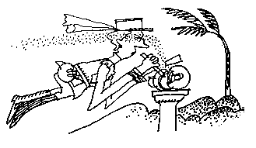
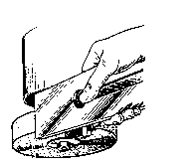
Grinder graphics:
grinding

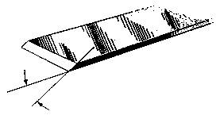
cartoon
plane iron

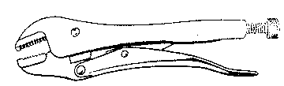
vice grips

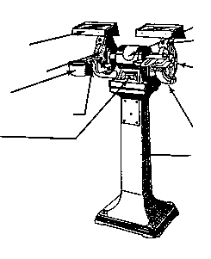
Safety shield
Tool rest
Switch
Motor
Dust chute
Pedestal
Grinding wheel
Wheel guard
Spark deflector
Water pot

Machine 1

1.
2.
3.
4.
5.
6.
7.
8.
9.
10.

Machine2

